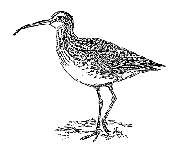
What do you know about Shorebirds?

In the Shorebirds Webinar you will be learning about shorebirds and their habitats. You will meet scientists who do research that help us to keep the habitats for shorebirds and other animals healthy. Before you watch the webinar, let’s see what you already know about shorebirds!

Have you ever seen a shorebird? What do you think a shorebird is?

Draw a picture of a shorebird. Think about what features you think a shorebird might have and label them (features are parts of its body that are important).

Can you think of the names of any types of shorebirds?

Do you know what a wetland is? Describe why you think wetlands might be important.

Can you think of any threats there may be to shorebirds or wetlands?

What did you learn about Shorebirds?

In the Shorebirds Webinar you learnt about shorebirds and their habitats. Did you learn lots of interesting things? Let’s see if you can answer these questions again and show how much you now know about shorebirds!

What is a shorebird?

Draw a picture of a shorebird. Think about what features a shorebird has and label them (features are parts of its body that are important).

What are the names of some types of shorebirds?

What is a wetland? Why are wetlands important?

What are some threats to shorebirds or wetlands?

How can we help shorebirds and their habitats?

