**Information for Judges**

This is our third annual Shorebirds Competition and the first time we have *gone national* – inviting Year 3 to 6 primary students across Australia to participate from 25 March to 14 August. In past years we have run the competition as a school activity and encouraged teachers to provide instructions and accompanying lessons. Due to COVID and the subsequent closure of many schools, we have invited participation from individuals in addition to schools this year.

The competition has provided a worthwhile learning activity for children at home to complete at their own level and pace. To assist teachers during this difficult period we have run several on-line professional development and webinar sessions, and provided curriculum linked lesson plans.

We have been thrilled to connect with primary schools and individuals in all states and territories, for the very first time! For schools, teachers were able to submit 5 entries from each class. This means that the entries received constitute about one quarter of the total number created.

The task was to **create a public awareness poster for a threatened shorebird in Australia**. This provided an opportunity for students to become aware of the birds and environmental impacts in wetlands and coastal areas affecting many species, and provided learning outcomes in science, sustainability, art and literacy.

We asked the students to convey a strong message with their poster. The message could be conveyed entirely by the image, or with the image and up to 30 words. The posters were required to be made by hand with pencils, paint, pen or textas.

**Your role as a judge is to choose what you consider to be the top 7 entries in a category and rank them in order from 1st place to 7th place.** We don’t mind what approach you use to base your preferences and we don’t require you to have any knowledge of shorebirds. We will be adjusting scores for accuracy, with assistance from shorebird experts, after the judging has taken place.

If you would like to view our online map to see the schools and towns that participated, or to learn more about shorebirds or the competition, please see our competition webpage:

<https://www.ansto.gov.au/education/primary/competitions/shorebirds-competition-2020>

We hope you enjoy seeing the efforts of the children and schools who participated from many places across our great nation and thank you very much for your time.

Warm regards,

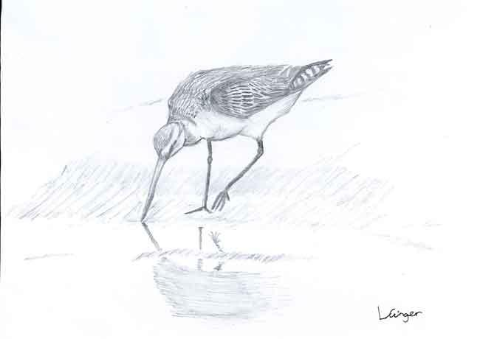Stephanie McCready, Janelle Townsend and Kim Whitbread

ANSTO Education Team

28 August 2020