PROGRAM
Real world applications of nuclear science: Monitoring air pollution
Science teacher professional development session 1
Monday 26 October, 2020
Time | Details
4.00pm – 4.05pm | Official welcome and introductions
4.05pm – 4.15pm | Presentation 1: ‘Real world applications of nuclear science: Develop your own lesson’ course introduction
 | Speakers: Bridget Murphy and Tina Baradaran, ANSTO Discovery Centre
4.15pm – 4.25pm | Presentation 2: Insights into urban air quality variability provided by naturally-occurring radioactive tracers
 | Speaker: Dr Scott Chambers, Atmospheric Scientist, ANSTO
4.25pm – 4.35pm | Presentation 3: Air quality monitoring at Liverpool Girls High School: An introduction and teaching resource
 | Speaker: Jack Simmons, Associate Research Fellow at the Centre for Atmospheric Chemistry, University of Wollongong
4.35pm – 4.45pm | Presentation 4: Atmospheric fine particulate matter measurements in the Asia-Pacific region
 | Speaker: Dr Armand Atanacio, Senior Accelerator Scientist, ANSTO
4.45pm – 5.00pm | Question and answer session
 | Chaired by: ANSTO
5.05pm – 5.10pm | Refresh break
5.10pm – 5.25pm | Teaching air pollution monitoring in the classroom
Presented by: Tina Baradaran and Julie Mulholland, ANSTO Discovery Centre

An introduction to resources developed by ANSTO’s education team and a discussion about how teachers can use them to build their own lesson on monitoring air pollution. Instructions will also be given on the post TPD work required to be eligible to receive 7 NESA or TQI accredited hours.
5.25pm – 5.30pm | Evaluation and wrap up
 | Final questions and feedback

Speaker profiles:
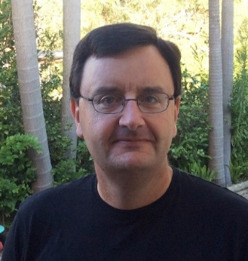 | Dr Scott Chambers, Atmospheric Scientist, ANSTO  Dr Scott Chambers was awarded a PhD in Atmospheric Chemistry from the Flinders University of South Australia (Institute for Atmospheric and Marine Science) in 1996, for which he investigated the local climatic effects of clearing native vegetation for agricultural purposes. He then completed post-doctoral studies at the University of California Berkeley, during which he investigated local and regional climatic effects of wildfire disturbance of boreal forest regions in Alaska and Siberia. Since May 2000 Dr Chambers has been a research scientist at the Australian Nuclear Science and Technology Organisation (ANSTO) where he has helped develop, test and install high-sensitivity atmospheric Radon-222 detectors for outdoor environmental monitoring purposes. Over the past decade he has specialised in using ²²²Rn as a tracer of atmospheric pollution transport and mixing studies on local to global scales. Local investigations have primarily involved urban climate, urban air quality and greenhouse gas emission estimates. Hemispheric to global investigations have involved using radon to constrain long-term trends in background greenhouse gas concentrations, and investigating anthropogenic pollution transport to Antarctica and the remote Southern Ocean.
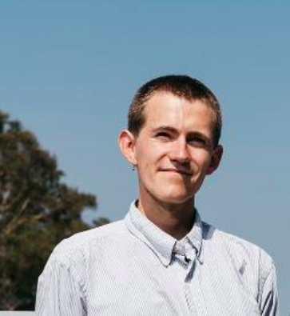 | Jack Simmons, Associate Research Fellow, Centre for Atmospheric Chemistry, University of Wollongong, ANSTO  Jack Simmons is an Associate Research Fellow at the Centre for Atmospheric Chemistry, University of Wollongong. He works under the supervision of Professor Clare Murphy with a focus on air quality research. Jack was extensively involved with the planning, logistics and completion for the COALA-2020 field campaign which took place in summer 2020. Jack is currently working on analysing bushfire smoke measurements from the COALA-2020 measurements and creating an air quality data analysis resource for use in high schools.
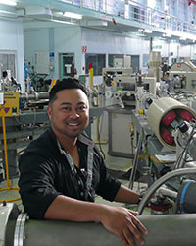 | Dr Armand Atanacio, Senior Research Scientist, ANSTO  Dr Armand Atanacio is a senior scientist in ANSTO’s Centre for Accelerator Science (CAS). He has 15 years of experience in the application of ion beam analysis (IBA) techniques across a wide range of research fields from Archaeology to Zoology, with a specific scientific focus over the past 10-years on fine particulate matter air pollution research as a key member of ANSTO’s long-term aerosol sampling program (ASP) team. Armand has co-authored over 80 peer-reviewed papers including 2 book chapters (h-index: 16 with over 1000 citations), regularly delivers invited scientific talks at both national and international conferences and has recently served as an expert for the International Atomic Energy Agency (IAEA).
Bridget Murphy, Education Manager, has a background in biological science and science education and has worked in the ANSTO Education Team for ten years. Bridget is responsible for developing and delivering new programs for high school students and professional development for teachers.
Julie Mullholland, Education Officer, has a wealth of experience in science education, with a career teaching high school chemistry, physics and maths for nearly 30 years. Julie is instrumental in developing our data set resources for high school students.
Tina Baradaran, Education Officer, has a background in medical physics and as a secondary teacher. A recent member of the ANSTO Education Team, Tina uses her secondary expertise to assist the development of new education programs and professional development sessions for secondary teachers.

