PROGRAM
Real world applications of nuclear science: Radiometric dating
Science teacher professional development session 2
Tuesday 27 October, 2020
Time | Details
4.00pm – 4.05pm | Official welcome and introductions
4.05pm – 4.15pm | Presentation 1: ‘Real world applications of nuclear science: Develop your own lesson’ course introduction
 | Speakers: Bridget Murphy and Tina Baradaran, ANSTO Discovery Centre
4.15pm – 4.25pm | Presentation 2: Using particle accelerators for radiocarbon dating
 | Presented by: Dr Vladimir Levchenko, Research Scientist, ANSTO
4.25pm – 4.35pm | Presentation 3: Radiocarbon dating and recent applications
 | Presented by: Dr Quan Hua, Environmental Scientist, ANSTO
4.35pm – 4.45pm | Presentation 4: Radiometric dating for sustainable use of groundwater
 | Presented by: Dr Karina Meredith, Research Scientist, ANSTO
4.45pm – 5.00pm | Question and answer session
 | Chaired by: ANSTO.
5.05pm – 5.10pm | Refresh break
5.10pm – 5.25pm | Teaching radiometric dating in the classroom
Presented by: Tina Baradaran and Julie Mulholland, ANSTO Discovery Centre

An introduction to resources developed by ANSTO’s education team and a discussion about how teachers can use them to build their own lesson on radiometric dating. Instructions will also be given on the post TPD work required to be eligible to receive 7 NESA or TQI accredited hours.
5.25pm – 5.30pm | Evaluation and wrap up
 | Final questions and feedback

Speaker profiles:
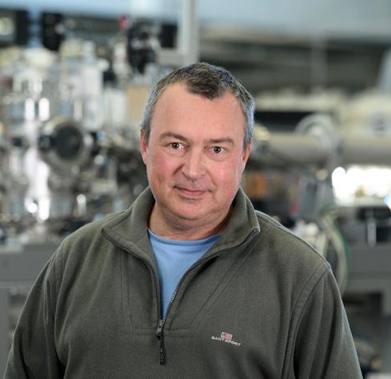 | Dr Vladimir Levchenko, Research Scientist, ANSTO  Vladimir Levchenko is an expert in radiometric dating at ANSTO’s Centre for Accelerator Science. He has worked on a wide range of projects including dating Aboriginal rock art using ancient mud wasp nests, dating kidney stones, investigating fossil remains, understanding the biology of the lens of the eye, and determining the age of groundwater.
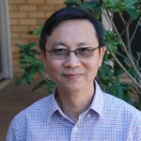 | Dr Quan Hua, Environmental Scientist, ANSTO  Quan Hua is a Principal Research Scientist within the Environmental Research Theme at ANSTO. He has over 25 years working experience in radiocarbon dating and its applications in Quaternary and climate change studies. His current research focuses on radiocarbon calibration, and high resolution proxy records of climate series from coral, speleothems, tree rings and sediments. He has also contributed to developing the capability in preparing ultra-small radiocarbon samples for AMS analysis.
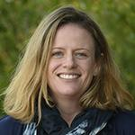 | Dr Karina Meredith, Research Scientist, ANSTO  Karina is a research scientist in the Isotopes for Water project. She is working in the fields of hydrochemistry, hydrogeology and isotope hydrology on a variety of projects located throughout Australia. Her research interests lie in applying a variety of stable, radiogenic and cosmogenic isotopic tracers to investigate groundwater resource sustainability and the suitability of aquifer systems as potential low resolution climate archives.
Bridget Murphy, Education Manager, has a background in biological science and science education and has worked in the ANSTO Education Team for ten years. Bridget is responsible for developing and delivering new programs for high school students and professional development for teachers.
Julie Mullholland, Education Officer, has a wealth of experience in science education, with a career teaching high school chemistry, physics and maths for nearly 30 years. Julie is instrumental in developing our data set resources for high school students.
Tina Baradaran, Education Officer, has a background in medical physics and as a secondary teacher. A recent member of the ANSTO Education Team, Tina uses her secondary expertise to assist the development of new education programs and professional development sessions for secondary teachers.

