Draft PROGRAM
Understanding Aboriginal and Torres Strait Islander Histories and Cultures
Science Teacher Professional Development
Wednesday 24th March 2021
Time | Details
4:00pm – 4:05pm | Official welcome and introductions
4:05pm – 4:15pm | Presentation 1: The continuum of Koori science and engineering
 | Presented by Brett Rowling, Analytical Chemist, ANSTO
4:15pm – 4:25pm | Presentation 2: Using radiometric dating to understand Aboriginal culture
 | Presented by Dr. Vladimir Levchenko, Research Scientist, ANSTO
4:25pm – 4:35pm | Presentation 3: Using nuclear and spectroscopic methods to investigate Aboriginal Australian natural mineral pigments
 | Presented by Prof. Rachel Popelka-Filcoff, Rock Art Australia Minderoo Chair in Archaeological Science, University of Melbourne
4:35pm – 5:05pm | Presentation 4: A real history of Aboriginal Australians, the first agriculturalists
 | Presentation by Guest Speaker Prof. Bruce Pascoe, an award-winning Aboriginal Australian writer, editor and anthologist, University of Melbourne
5:05 – 5:20pm | Question and answer session
 | Chaired by: ANSTO
5:20pm – 5:30pm | Teaching Aboriginal and Torres Strait Islanders histories and cultures in the classroom
Presented by Tina Baradaran and Julie Mulholland, ANSTO Discovery Centre

An introduction to resources developed by ANSTO’s education team and a discussion about how teachers can use them to build their own lesson on Aboriginal and Torres Strait Islanders Histories and Cultures. Instructions will also be given on the post TPD work required to be eligible to receive 7 NESA or TQI accredited hours. Show teachers an example lesson template.
5:30pm – 5:35pm | Final questions, feedback, and survey form

Speaker profiles:
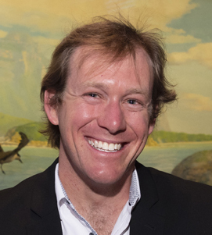 | Brett Rowling, Indigenous Analytical Chemist, ANSTO  Brett Rowling is an analytical chemist from Australia’s Nuclear Science and Technology Organisation (ANSTO), which collaborates with universities and industries globally. He has over a decade of experience developing and applying novel analytical techniques to a variety of samples including ground and surface waters, soils and biota. The results of these works have resulted in peer-reviewed presentations and publications furthering our understanding of water chemistry from both natural and man-made sources.  Brett is also an active descendent of Bungoree and Matora from the Wannungine/Guri Ngai nation of the central coast of NSW, whose people are part of Australia’s first scientists, mathematicians and engineers. His primary activities are to identify and promote these cultural parallels which could enhance current engineering and scientific practices towards more sustainable options in the Australian context. More formally this is recognised through the Indigenous Engineers Group of Engineers Australia and the Indigenous Engineering Summer Schools coordinated by Engineering Aid Australia.
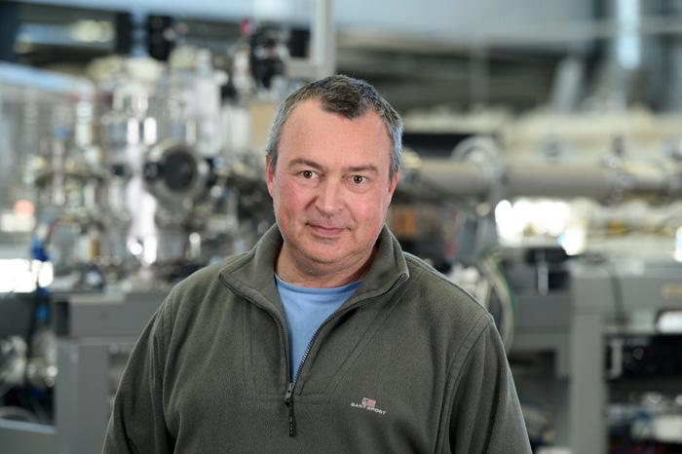 | Dr Vladimir Levchenko, Research Scientist, ANSTO  Vladimir Levchenko is an expert in radiometric dating at ANSTO’s Centre for Accelerator Science. He has worked on a wide range of projects including dating Aboriginal rock art using ancient mud wasp nests, dating kidney stones, investigating fossil remains, understanding the biology of the lens of the eye, and determining the age of groundwater.
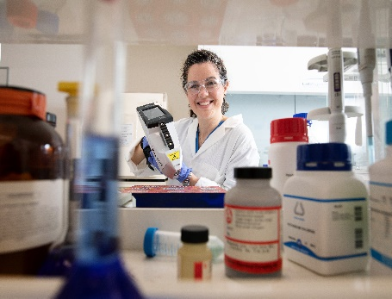 | Prof. Rachel Popelka-Filcoff, Rock Art Australia Kimberley Foundation Minderoo Chair in Archaeological Science, University of Melbourne  Rachel Popelka-Filcoff (FRACI) is the Rock Art Australia Minderoo Chair in Archaeological Science at the University of Melbourne. Her laboratory integrates advanced nuclear and spectroscopic approaches into multidisciplinary projects, including cultural heritage chemistry and archaeological science. Her research is to the first comprehensive integrative characterisation of Australian natural mineral pigments on cultural heritage materials by several analytical methods to answer questions about provenance and composition. From 2009-2020, she was at Flinders University, including 2010-2016 where she was an AINSE Senior Research Fellow. Rachel is the Past President of the Society for Archaeological Sciences, and on the editorial board of Journal of Archaeological Science. She has had her research profiled in several scientific and general media outlets such as Cosmos Magazine, Chemistry in Australia, and Chemistry World, and radio and television interviews.
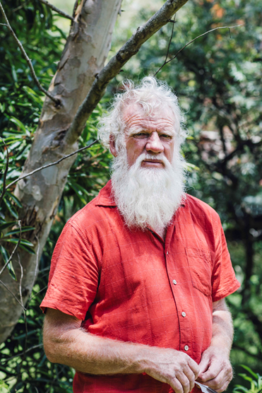 | Prof. Bruce Pascoe, an award-winning Aboriginal Australian writer, editor and anthologist, University of Melbourne  Published and Edited Australian Short Stories magazine 1982-1999, winner Australian Literature Award (Shark) 1999, Radio National Short Story 1998, FAW Short Story 2010, Prime Minister’s Award for Literature (Young Adult) 2013, NSW Premier’s Book of the Year, Dark Emu, 2016. Books include: Night Animals, Fox, Ruby Eyed Coucal, Shark, Ocean, Earth, Bloke, Cape Otway, Convincing Ground, Little Red Yellow and Black Book, Fog a dox and Dark Emu.  Yuin, Bunurong and Tasmanian Man. Board member of First Languages Australia and Twofold Aboriginal Corporation. Past Secretary Bidwell-Maap Aboriginal Nation. His most recent books are: Bloke, published by Penguin in 2009, Chainsaw File, Oxford, 2010, Fog; a dox, Magabala 2012 (2013 PM’s Award, and shortlisted for the WA Premier’s Award and the Deadlies Award). Dark Emu the history of Aboriginal agriculture was published in 2014 and was shortlisted in the Victorian and Queensland Literature awards and won the NSW Premier’s book of the Year 2016, Sea Horse, young adult novel, Magabala 2015, Mrs Whitlam, YA, 2016.  Young Dark Emu published (Magabala) 2020 and won both the CBCA Award and Australian Bookseller’s Award. Loving Country (Hardie Grant) published 2021.  Received Australia Council’s lifetime Achievement Award for Literature in 2018. Lives at Mallacoota in Far East Gippsland. Two children, four grandchildren.
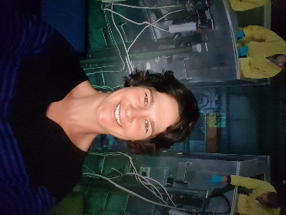 | Bridget Murphy, Education Manager, has a background in biological science and science education and has worked in the ANSTO Education Team for ten years. Bridget is responsible for developing and delivering new programs for high school students and professional development for teachers.
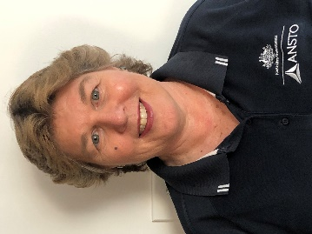 | Julie Mullholland, Education Officer, has a wealth of experience in science education, with a career teaching high school chemistry, physics and maths for nearly 30 years. Julie is instrumental in developing our data set resources for high school students.
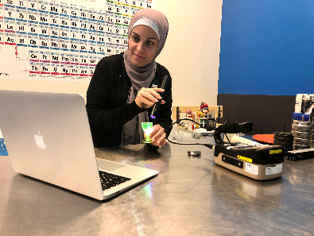 | Tina Baradaran, Education Officer, has a background in medical physics and science communication education. A recent member of the ANSTO Education Team, Tina uses her secondary expertise to assist the development of new education programs and professional development sessions for secondary teachers.

