**What are Shorebirds?**

Shorebirds are also called “waders” and they make up about 10% of Australia’s bird species.

They are a group of birds that wade in shallow water and look for food on coastal mudflats, estuaries and along the edges of inland wetlands.

**Coastal Mudflats Estuaries Inland wetlands**

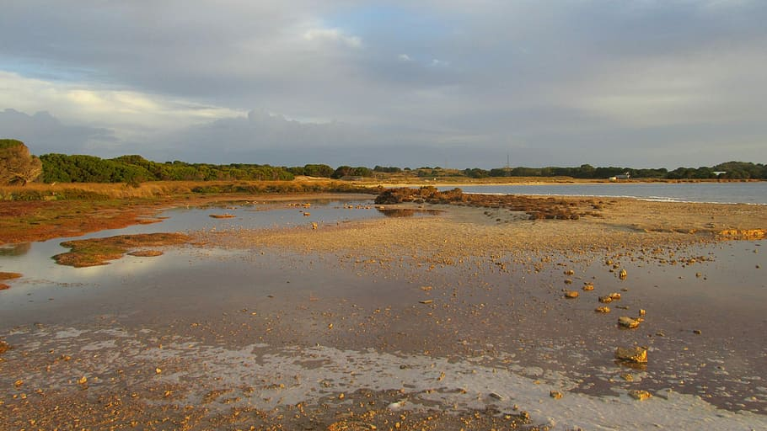 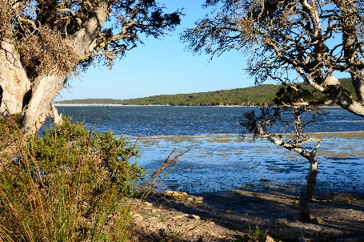 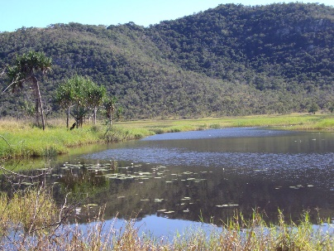

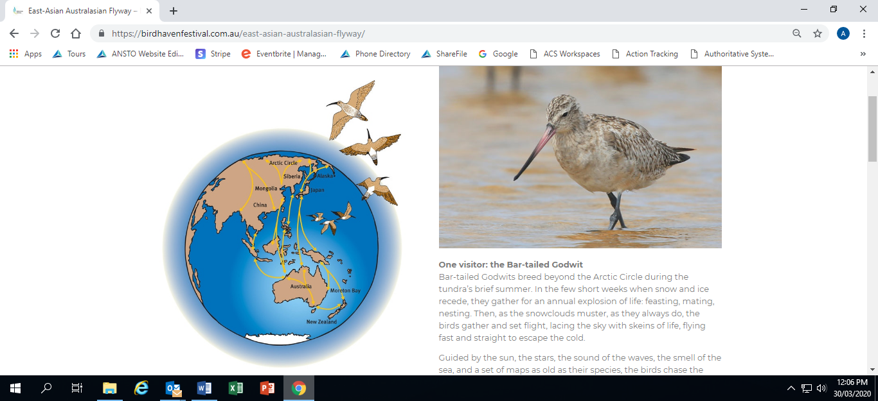Shorebirds have long legs in relation to their bodies and unlike seabirds, don’t have webbed feet and don’t swim. They live their lives entirely on shores. Have you seen a shorebird? Take a look at the [Shorebird ID Booklet](http://birdlife.org.au/documents/Shorebird_ID_Booklet_V3.pdf) to find out what shorebirds live near you!

**Amazing Migrations!**

Some shorebirds live on Australian shores all year round – these are called resident shorebirds. But most of Australia’s shorebirds are *migratory*. They breed in the Northern Hemisphere and when it starts to get cold fly over **10,000 km** to our shores in Australia, arriving in September - October. They “overwinter” on our shores until April - May, then fly back to the Northern Hemisphere to breed and repeat the cycle.

The route they travel is called the East Asian-Australasian Flyway and each year millions of shorebirds make this journey.

The bar-tailed godwit, holds the world record for the longest flight without a break – flying over 11,000km! In its lifetime it will have flown the equivalent distance as going to the moon and back … more than three times!!



**RECORD**

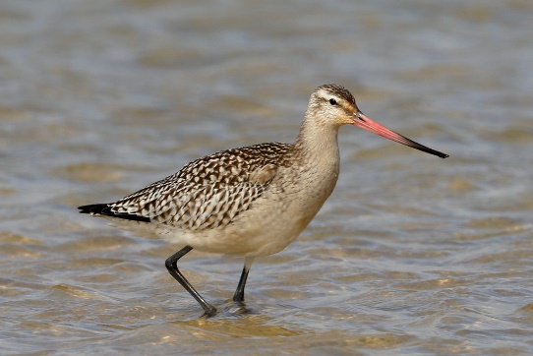**Bar-tailed godwit**

**Why do we need to protect shorebirds?**

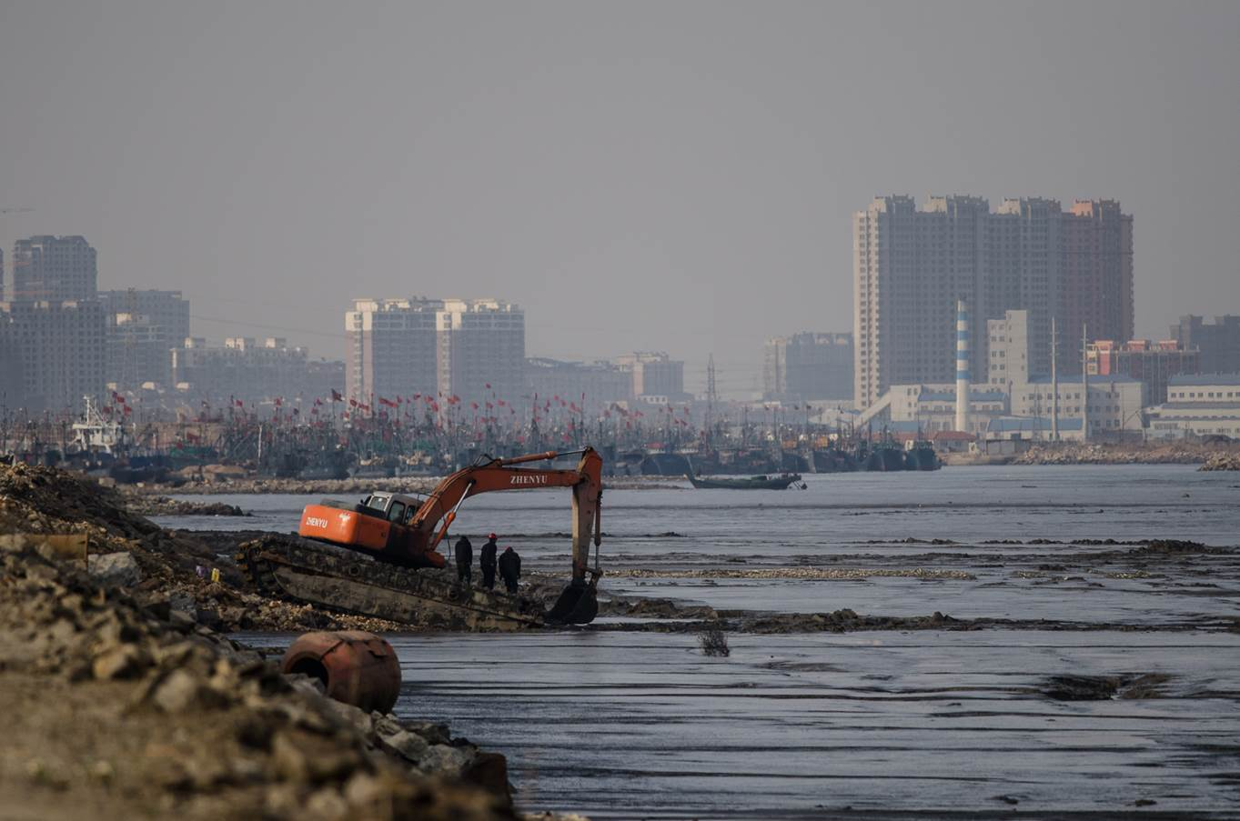Migratory shorebirds are Australia’s most endangered group of birds. Some are listed as “threatened” in Australia. This means they face the threat of extinction. Some reasons for this are caused by people: domestic animals, vehicles and building in and around the natural habitat of shorebirds.

**What can we do to help Shorebirds?**

We can all play a part to help the survival of these amazing birds. Entering a competition like the ANSTO Shorebirds competition helps to raise awareness of shorebirds. The more people who know about shorebirds, the more we can positively change the way we interact with their habitats.

Ecotourism posters encourage people to want to visit or protect the natural environment for shorebirds and other animals. Choose a wetland or coastal area close to you, or one in your State or Territory, and find out about the shorebirds that live there. Draw the area, include a shorebird and provide a message (up to 30 words) to encourage people to want to visit or look after the area and its shorebirds. This is your opportunity to make a difference and help the survival of shorebirds in Australia.

**Get started!**

Ask an adult to help you select a local wetland or coastal area and a shorebird that lives there. There is information to help on the competition website: <https://www.ansto.gov.au/education/primary/competitions/shorebirds-competition-2021>

Have fun learning about shorebirds and their habitats and ***good luck***!

**Image acknowledgements**

<https://www.pxfuel.com/en/free-photo-eqyts>

<https://en.m.wikipedia.org/wiki/File:Wellstead_Estuary,_2018_(08).jpg>

<https://www.flickr.com/photos/82134796@N03/9732389467>

<https://birdhavenfestival.com.au/east-asian-australasian-flyway/>

<https://www.flickr.com/photos/blachswan/46769492032>

<https://www.uq.edu.au/news/article/2017/04/citizen-scientists-help-identify-shorebird-extinction-threat>