2021 Shorebirds Competition Accompanying Unit
Years 3-4 Science

This unit of work has been prepared to develop student learning and understanding of the interdependence of living things in coastal and wetland environmental areas in Australia, and support participation in the 2021 ANSTO Shorebirds Competition. In this unit, students will study migratory shorebirds and their habitats, also incorporating the life cycle and survival of living things. They will consider ways in which they can contribute to the preservation of wetland environments and thus the ongoing survival of the ecosystems they support.
The unit is based on one 50-minute science lesson per week; however, activities can be adapted to suit individual class requirements.
Additional information and resources for teachers have been included at the end of the lesson outlines.
Strand | Sub-strand | Content Description | Lesson
Science Understanding | Biological Sciences | - Living things have life cycles (ACSSU072)  - Living things depend on each other and the environment to survive (ACSSU073) | 1, 2, 3  4, 5, 6, 7
Science as a Human Endeavour | Nature and development of science | - Science involves making predictions and describing patterns and relationships (ACSHE050)  - Science involves making predictions and describing patterns and relationships (ACSHE061) | 2, 3, 4, 5, 6, 7  2, 3, 4, 5, 6, 7
 | Use and influence of science | - Science knowledge helps people to understand the effect of their actions (ACSHE051)  - Science knowledge helps people to understand the effect of their actions (ACSHE062) | 4, 5, 6, 7  4, 5, 6, 7

Cross-curriculum Priorities and General Capabilities
- Sustainability  - Critical and Creative Thinking  - Ethical Understanding | - Information and Communication Technology (ICT) Capability | - Literacy  - Personal and Social Capability

Suggested Learning and Teaching Sequence
Lesson | Activity |  | Resources
1 | Amazing Migrations  Ask students to consider and share answers: What is migration? Why do animals migrate?  Do you know some animals that migrate? What do you know about birds that migrate?  We are going to learn about some amazing birds that can fly over 11,000 km without stopping! These birds travel the distance from Earth to the moon and back in their lifetimes. One shorebird, the bar-tailed godwit, holds the world record for the longest non-stop flight ever recorded for any bird species!  Pack Your Bags  In groups, make a list of everything you and your family do to prepare for a long trip away somewhere.  Students share responses and these are noted on a table on the board.  As a class, discuss similar ways migratory birds might prepare before a long flight (ie – pack your bag with correct clothing = change in feathers; pack food = feed and store extra weight; pack a map = use instinctive navigational route [East Asian-Australasian Flyway]; get your family together = migratory birds travel together at the same time and take turns leading the flock; sleep well the night before= rest before flight).  Complete Activity Sheet 1 with students, labelling the essential things a shorebird does to help prepare for a long flight. |  | See Teacher Resources for background reading  Activity Sheet 1
2 | Life cycle of a Shorebird  First reading: Circle by Jeannie Baker. Read text to class, giving students time to view the illustrations.  In small groups, have students re-tell the story of the bar-tailed godwits life to each other.  What is a life cycle?  Discuss the text in the context of it telling the lifecycle of these birds.  Life cycle wheel  Using the information provided in the text, students use Activity Sheet 2 to label and construct a life cycle wheel for the bar-tailed godwits.  Extension activity: Students mark the migration path of the bar-tailed godwits on a world map. |  | Circle by Jeannie Baker  Alternative picture books:  Windcatcher: Migration of the Short-tailed Shearwater by Diane Jackson Hill and Craig Smith  Red Knot by Nancy Carol Willis  Activity Sheet 2
3 | Threatened Shorebirds  The bar-tailed godwit is an Australian threatened species.  What is a threatened species? What is a threat?  When we read Circle, pay close attention to what might be a threat to the bar-tailed godwits (look closely at the images of the text for extra information)  Second reading: Circle  As a class, discuss what students noticed are the threats to the bar-tailed godwit in this text.  In student workbooks, draw a table to list the threats to the bar-tailed godwits from nature and caused by humans.  Discuss what students have recorded. Are there any threats to the bar-tailed godwit that we can reduce? |  | Refer teacher resources for background reading  Threats to bar-tailed godwits  Natural threats Threats caused by humans
4 | Food Chains and Food Webs  Using the example of the bar-tailed godwits in Circle, explain how a food chain is a transfer of energy from one living thing to another. Use illustrations to assist, such as the following example:  The sun -> Algae -> Polychaeta (eg bristle worms) -> Godwits  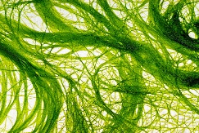  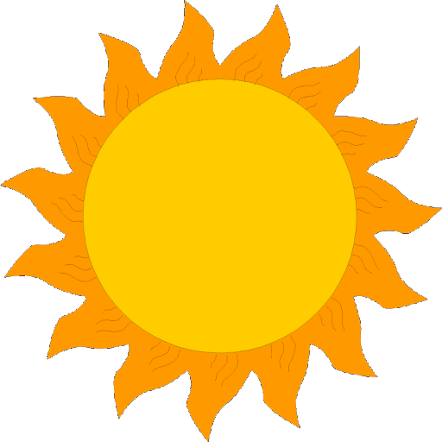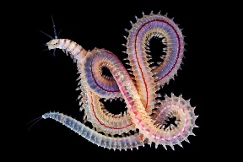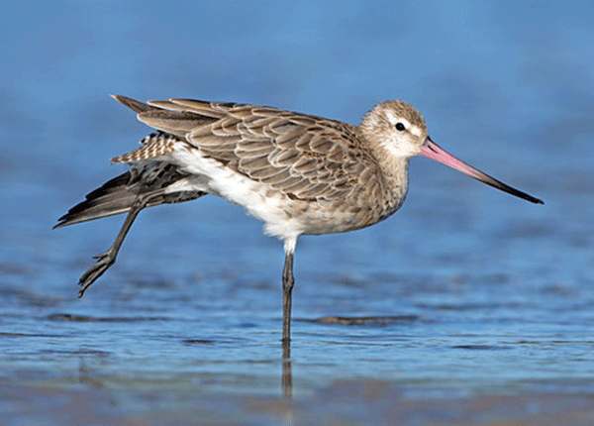  Now explain how a food web is like a complex food chain, and instead of going in one direction like the example shown, it goes in many directions. To illustrate this further, have students sit in a circle. Select one person to be the “Sun” and give them a ball of string to hold. Use an example that children will be familiar with, such as the ocean, and have them put up their hand if they can think of a living thing in the ocean that receives energy from the sun to help it grow (eg seaweed). The “Sun” student holds on to the end of the string and passes the ball over to the student who gave an answer. Now ask students to suggest a living thing that gets energy from seaweed (eg fish). The student holding the ball of string holds onto their spot on the string and passes the ball on. Some living things may transfer energy to many living things and this should be reflected in how the string is passed around (or extra balls of string could be used). For example fish are eaten by sharks and seals, so the string connection will need to be made to both of these creatures. The final result will be a rather messy looking spider web!  Have students reflect on what they see and what this means for different environments.  What happens if one part of the web is removed? Demonstrate with the students– how does this impact other living things in the web? |  | Printed images (the images provided can be expanded for use).  Ball of brightly coloured string.  This video produced by Melbourne Water gives an example of a simple wetland food web: Animals of the wetland - YouTube  Image sources:  Sun  Algae  Polychaeta  Bar-tailed Godwit
5 | Shorebird Habitats  2021 marks the 50th anniversary of the Ramsar Convention on wetlands – an international environmental agreement to protect wetland habitats for migratory waterbirds. Australia’s Cobourg Peninsular in the Northern Territory was the world’s first Ramsar site. Explain the significance of Ramsar sites to students and view the video celebrating Cobourg Peninsular.  Allow students to discuss and share their ideas for why this place is significant. Why would it be important to shorebirds?  Select a shorebird environment to study with your class (a wetland/coastal area that is close to your school or a Ramsar listed site in your State or Territory – see Teacher Resources below for links to locate relevant areas).  Provide students with information or allow them to conduct their own research to learn more about this site using Activity Sheet 3.  Extension activity: students complete the second page of this activity sheet by drawing a food web from the environmental area being studied.  Note: this is a great time to introduce the 2021 ANSTO Shorebirds Competition to your students. |  | Refer to Teacher Resources for additional information on Ramsar sites.  Cobourg Peninsular video: Cobourg Peninsula – the world’s first Ramsar wetland - YouTube  Activity Sheet 3
6 | Continue with research. Share and discuss findings as a whole class.
7 | Assessment task  Using what they have learnt about the chosen environmental area, students should consider what they can do to help preserve this important site. Students work in pairs or individually to complete Activity Sheet 4 and use this as a planning sheet to develop a specific way to manage at least one threat to the environmental area studied. They can then build a model, draw a design, create a presentation or short film to present their idea to the class. |  | Activity Sheet 4
8 | Continuation from previous lesson. May also include presentation to class.
Assessing student learning
Formative |  | Monitor students’ developing understanding throughout the unit.
Summative |  | Assessment task: Investigate and design a way to address a threat faced by an environmental area. Students should consider the interdependence of living things and how threats to one species can affect others. This activity will allow students to demonstrate their knowledge and understanding of the interdependence of living things with their environment, the survival of living things and the impact of humans.

Additional activity ideas for other Key Learning Areas:
English | Write an information report on a shorebird of own choice.  Create a persuasive eco-tourism poster to convince people to protect an environmental area.  Create a poem about your favourite species of animal from a specific environmental area.
Mathematics | Create a map with the flying route of a shorebird outlined. Use compass directions to describe the path the birds fly.  Visit a local park or wetland area and collect data on birds sighted (use a bird ID program to help http://www.birdsinbackyards.net/finder). Record data in a table and graph.
Geography | This unit could be adapted to be included into The Earth’s Environment content areas: Perception of environments; and Protection of environments.

Resources for Teachers
Information on migratory shorebird species that visit Australia https://wingthreads.com/about/
Video made by a shorebird enthusiast regarding shorebirds in southern Sydney Birdlife Southern Presentation Port Hacking Shorebirds
Migratory shore birds information https://www.youtube.com/watch?v=fSRrDlrB26w
ABC News article regarding some of the threats faced by shorebirds https://www.abc.net.au/news/2016-06-17/flying-for-your-life-ann-jones/7459288
40th Anniversary of the world's first Ramsar site, Cobourg Peninsula, NT | Department of Agriculture, Water and the Environment
Ramsar Wetlands of Australia (environment.gov.au)
Bird ID http://www.birdsinbackyards.net/finder
Citizen science project: Aussie Backyard Bird Count 19-25 October https://aussiebirdcount.org.au/
Bird monitoring citizen science projects https://birdlife.org.au/get-involved/citizen-science

Activity Sheet 1 – How do Shorebirds prepare for a long flight?

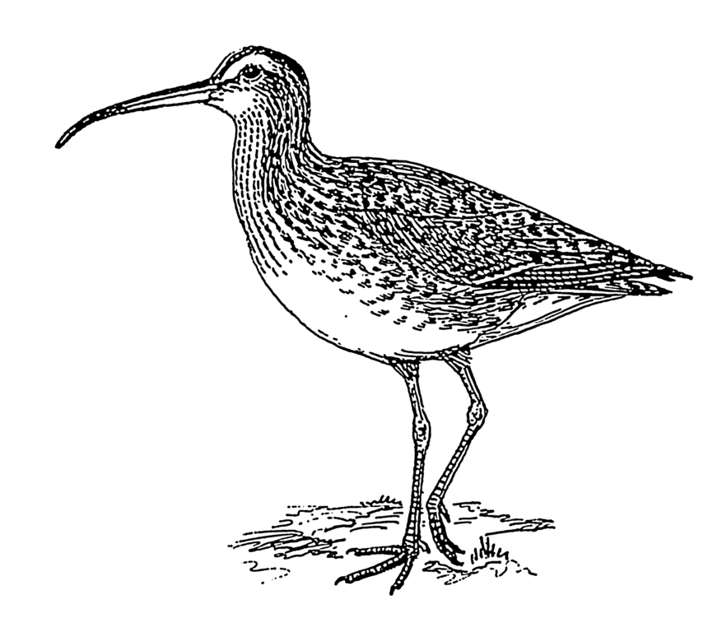

Image: https://commons.wikimedia.org/wiki/File:Curlew_(PSF).png
Activity Sheet 2 –The life cycle of a bar-tailed godwit
Instructions:
Cut around the outside of both circles. Use a split pin to connect the top circle to the bottom.
In each of the sections of the divided circle, describe the next part in the life cycle of a bar-tailed godwit.
Choose from the list below (be careful – it has been jumbled!).
Add a picture to each section.
- Migration North
- Migration South
- Rest and feed in Australia
- Rest and feed in South East Asia
- Migration North
- Breeding grounds in Alaska
Cut out
Image: https://www.flickr.com/photos/internetarchivebookimages/20427605908/
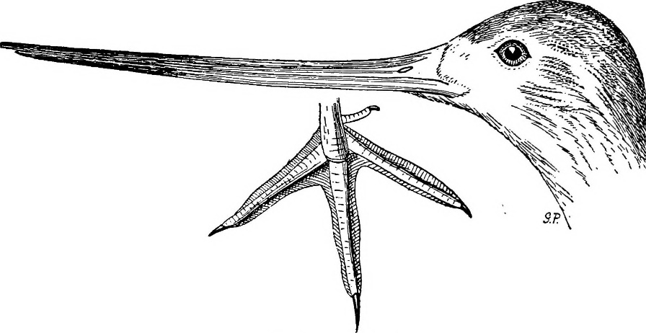
Life cycle of a
bar-tailed godwit
Activity Sheet 3 – Environment Study

What is the name of the wetland or coastal area you will study? _______________________________________
Where is this site located? | What species of shorebird use this environment?
What other creatures live there? | What threats does this environment have?
Interesting facts. | How are people looking after this environment?
Activity Sheet 3 – Environment Study Extension.
Use the information you have found on your chosen environmental area to draw a Food Web in the space below. Include a shorebird in your web!
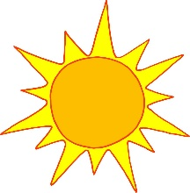
Sun
Activity 4 – How can you help protect important environmental areas?
What is the name of the environmental area you will protect?

What are some species of shorebirds and other animals that live there?

What is the threat you want to protect this environmental area from?

What is your idea to reduce this threat?

How will it work?

Why is it important to protect special environmental areas?

