

Rottnest Island groundwater resource

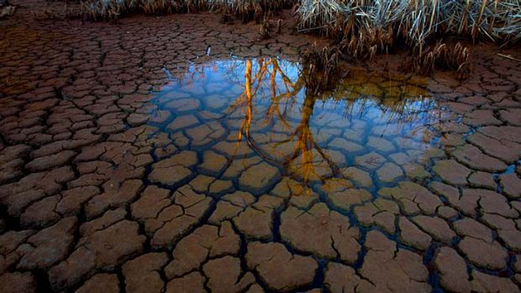
This document and its accompanying MS Excel workbook ‘Rottnest Island groundwater study’ enable students to analyse research data about the sustainability of groundwater on Rottnest Island. These activities are suitable for students in Years 7 to 10.
Students will:-
- understand the concepts of groundwater and aquifers and the role of the water cycle
- use MS Excel to construct simple graphs
- interpret and analyse graphs and other representations of data
- investigate the effects of a changing climate on groundwater resources
- distinguish between correlation and causation

Australian Curriculum Content Descriptions and Skills
The activities provided address the following Australian Curriculum content descriptions:
- Some of Earth’s resources are renewable, including water that cycles through the environment, but others are non-renewable (ACSSU116)
- considering timescales for regeneration of resources
- investigating factors that influence the water cycle in nature

- Solutions to contemporary issues that are found using science and technology, may impact on other areas of society and may involve ethical considerations (ACSHE120)
- considering issues relating to the use and management of water within a community
- considering how human activity in the community can have positive and negative effects on the sustainability of ecosystems

- Science knowledge can develop through collaboration across the disciplines of science and the contributions of people from a range of cultures (ACSHE223)
- identifying the contributions of Australian scientists to the study of human impact on environments and to local environmental management projects
The activities provided address the following Australian Curriculum skills outcomes:
- Construct and use a range of representations, including graphs, keys and models to represent and analyse patterns or relationships in data using digital technologies as appropriate (ACSIS129/144)
- Summarise data, from students’ own investigations and secondary sources, and use scientific understanding to identify relationships and draw conclusions based on evidence (ACSIS130/145)
- Use scientific knowledge and findings from investigations to evaluate claims based on evidence (ACSIS132/234)
- Communicate ideas, findings and evidence based solutions to problems using scientific language, and representations, using digital technologies as appropriate (ACSIS133/148 )
Each activity requires a 60 minute lesson to complete. The activities are suitable for students in Years 7 to 10.

Contents

Background Information
Groundwater – a hidden essential natural resource 4
Rottnest Island story 5
Rottnest Island groundwater research 6

Activity 1: Rainfall, groundwater abstraction and groundwater levels 7
The water cycle 7
Graphing rainfall 9
Comparing rainfall and abstraction 10
Groundwater levels of well 15-90 13

Activity 2: Freshwater lens 15
What is meant by Total Dissolved Solids (TDS)? 15
Salinity of well water 16
The extent of the freshwater lens – a mapping activity 17

Activity 3: Modelling Rottnest Island groundwater system 21

EXTENSION ACTIVITY – Groundwater recharge 24
Questions and activities 25

Groundwater – a hidden essential natural resource
Fresh water is essential to the survival of plants, animals and humans. Although Earth has a lot of water, 96.5 % of it is saltwater in oceans and seas. We can take the salts out of saltwater to make it drinkable using a process called desalination, however, this process is expensive. Because only 3.5% of the Earth's water is fresh, with most of it being locked up in glaciers and polar ice caps, available freshwater is one of the most precious resources on our planet.

A huge amount of the world’s fresh water exists in the ground below your feet. Groundwater is stored far below the Earth’s surface, in rocks that are able to hold the water in their openings and cracks, like a sponge. These spaces need to be connected to allow the water to flow. This underground layer of permeable rock which is saturated with water is called an aquifer. Aquifers are huge storehouses of fresh water. The boundary between the soil surface and the water-saturated rock of the aquifer is called the water table.

Groundwater is naturally recharged by rainwater and snowmelt. The rainwater moves through the soil and rock to refill the groundwater aquifer, and is known as recharge. After entering an aquifer, the water flows slowly toward lower lying places under the influence of gravity, and eventually is discharged (released) from the aquifer through springs, and by seeping into streams and lakes. People can also take freshwater from the aquifer using wells and bores. This is called groundwater abstraction.

At the edge of a coastal aquifer, fresh groundwater mixes with saline groundwater (saltwater) originating beneath the ocean floor. The seaward movement of freshwater prevents saltwater from invading the freshwater. The boundary where freshwater and saltwater mix is referred to as the transition zone. If the fresh groundwater in the aquifer is reduced, then saltier water trickles in, filling the gaps in the rocks where the fresh water used to be. This is called saltwater intrusion (Figure 1). Saltwater intrusion is caused by a decrease in groundwater levels, which can result from groundwater pumping from underground bores or climate change producing a drier climate, or by a rise in seawater levels.
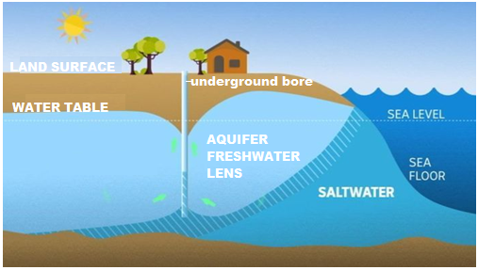
Figure 1.
This diagram shows how groundwater can mix with salt water near the coast and may increase the salinity of groundwater abstracted from underground bores. Image credit: ABC News 2018.

Despite the importance of groundwater as a freshwater resource, there is a limited amount of information about its availability, current state and use. This has consequences for every living thing that relies on the water in the aquifer, so having reliable data is critical to effectively manage groundwater aquifers.

Rottnest Island story

Rottnest Island is a small limestone island located about 18 km off the coast of Perth in Western Australia. It is about 10 km long and up to 4.5 km wide. The island is known for its stunning natural beauty, especially its beaches. Salt lakes are scattered across the landscape, which is a protected reserve of nearly 200 hectares. First Nations peoples were caretakers of Rottnest Island for thousands of years. Europeans arrived upon Rottnest Island upon the Dutch ship Vergulde Draek. The Island was explored for another 100 years before the British settled on the island in 1929.
Rottnest Island is a popular family-friendly holiday destination. Approximately 250 permanent residents live on the island and it attracts around half a million visitors per year. Families often make weekend pilgrimages to ‘Rotto’ – as it is called by the locals - in the summer months, to enjoy snorkelling, surfing, whale watching and hiking in this island wilderness. Visitors can moor their boats in the designated mooring sites along the island. The island also has an airport, allowing visitors to arrive by plane.

Rottnest Island is also home to the Quokka, known as the “happiest animal on Earth”. Quokkas are very familiar with visitors on the island and have made appearances in adorable Instagram selfies with tourists.
Large numbers of tourists inevitably put pressure on the natural resources of Rottnest Island, like fresh water. The region has a Mediterranean climate with hot dry summers and mild wet winters, and because the island is made of porous limestone, the rainfall that does fall, infiltrates directly underground meaning surface water is limited.
Image Credit: Rottnest Island Authority | (ria.wa.gov.au)

Rottnest Island is composed of Tamala limestone having a total thickness of about 115 m, of which around 70 m is below sea level. Tamala limestone is highly permeable, so rain seeps from the surface down through the soil and rock and fills the spaces in the limestone to form an aquifer. This groundwater aquifer is present in the form of a shallow freshwater lens, named because of its oval shape. The freshwater floats on more saline water due to a difference in density, with a transition or mixing layer found in between, as can be seen in Figure 2a on the following page.
In 2014, when this study started, approximately 75 per cent of the island’s drinking water was supplied by a desalination plant. The desalination plant, built in 1995 and powered predominately by wind turbines, produces approximately 500 kL of water per day. The remainder of the drinking water was being sourced through groundwater abstraction from the freshwater lens.
The groundwater from the freshwater lens is also used by natural ecosystems on the island. The native fauna and flora rely solely on this groundwater for their survival, especially during the dryer months. The freshwater lens feeds natural springs on the island that are used by the island’s fauna including quokkas and reptiles. Since the 1960s there has been a significant decline of around 20% in winter rainfall, influenced by regional climate trends. The decline in rainfall is impacting the volume of water otherwise known as recharge that the freshwater lens receives.

Rottnest Island Groundwater research
ANSTO environmental scientist, Dr Karina Meredith, was part of a team of scientists who studied the groundwater aquifer of Rottnest Island. The research investigated the island’s groundwater system and assessed the sustainability of this groundwater resource to plan for the future.
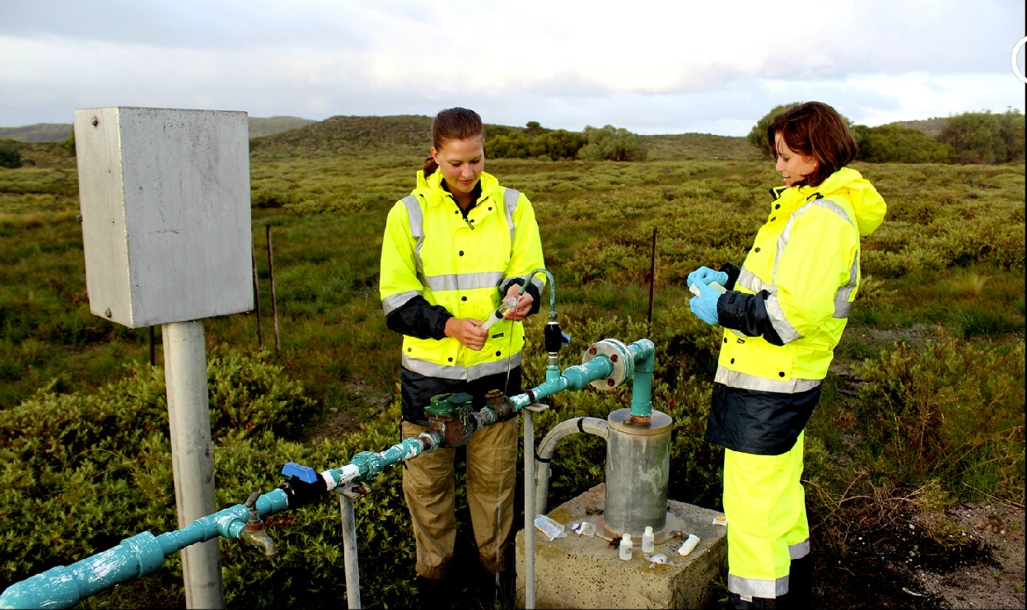
Dr Karina Meredith and Eliza Wells collecting groundwater samples on Rottnest Island, WA

The research began in 2014 and involved field work over five years, sampling groundwater from 29 production and monitoring wells across the island, as well as rainwater and seawater collection. The diagram below shows the structure of the groundwater aquifer of Rottnest Island (Figure 2a), and the map at the bottom of the page shows the location of these wells and collection sites (Figure 2b).
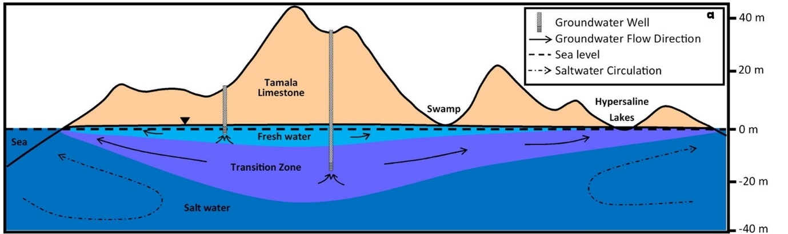
Figure 2a: A simplified east-west cross section of Rottnest Island showing groundwater flow directions and the circulation of seawater which is caused by the mixing of freshwater and saltwater in the mixing zone.

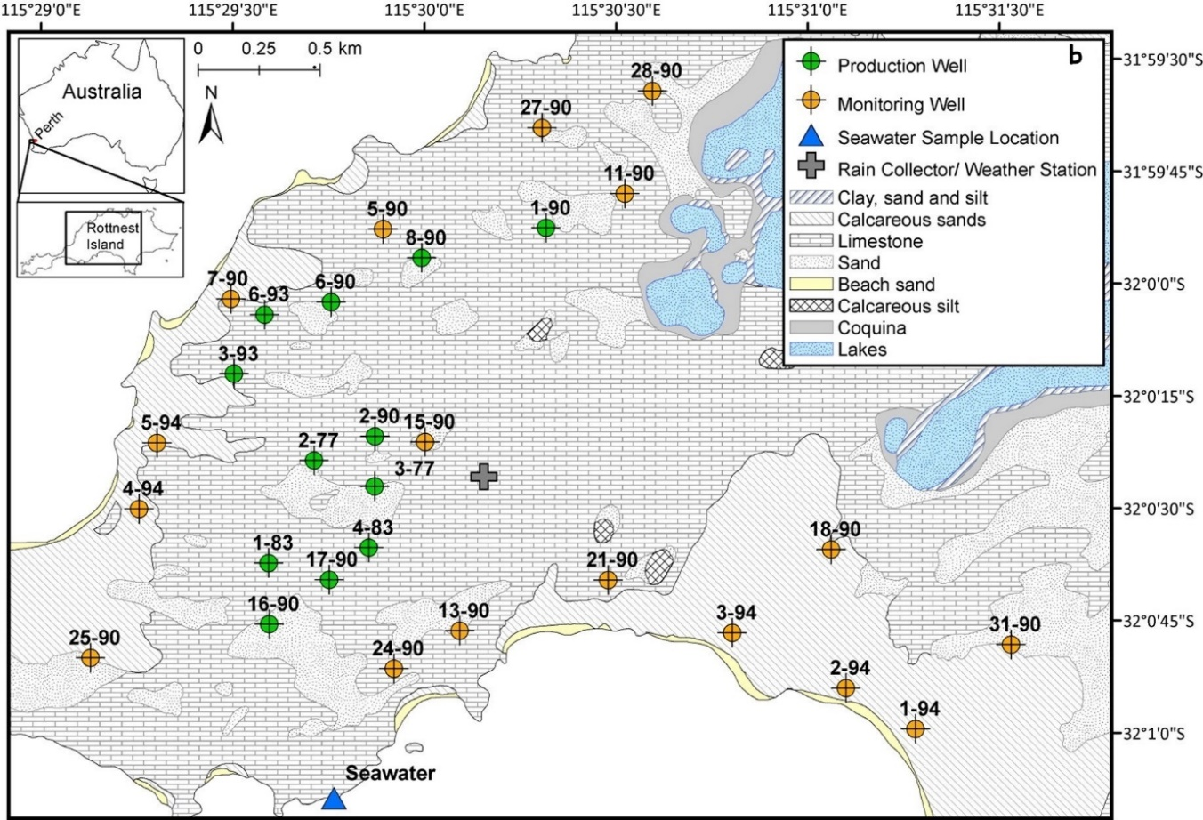
Figure 2b: Location of the study area showing sample and water logger locations, weather station and rainfall collector location and the predicted lens areas in 1977.

rainfall, groundwater abstraction and groundwater levels
In this section you will investigate the effect of rainfall and abstraction of groundwater (the process of taking water from a ground source) on the ground water level at one of the monitoring wells in the study, 15-90 (Central).

The water cycle
Rainfall is the only source of freshwater recharge to the aquifer freshwater lens. Earth has the same amount of water as it had hundreds of thousands of years ago. This water is continually moving through the natural water cycle, which uses physical processes to move water from the surface of the Earth to the atmosphere and back again. The diagram below shows these physical processes.

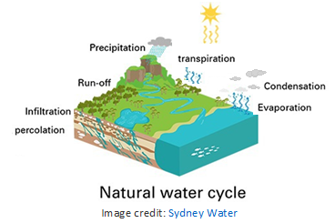
Figure 3:
This diagram shows the processes of the water cycle.
Image Credit: Sydney Water

- Figure 3 above shows the processes of the water cycle. Use the diagram to
match each of these physical processes with the correct description of that process.

percolation, run-off, transpiration, precipitation, infiltration, condensation, evaporation.
Name of physical process | Description of physical process
 | Water is changed from a liquid state into a gas called water vapour which rises into the air.
 | Plants release water vapour into the atmosphere through numerous openings in their leaves. This process occurs mostly during the day.
 | Water vapour in the air cools and turns back into a liquid. Water vapour condenses onto small airborne particles to form dew, fog, or clouds.
 | Any and all forms of water particles, rain, snow or hail, fall from the atmosphere and reach the ground.
 | Water flows over the ground and into creeks, rivers and oceans.
 | Water falls on the ground and soaks into the soil.
 | Water seeps deeper and deeper into tiny spaces in the soil and rock. Once underground, the water is moved by gravity.

- Choose from the following list of words to complete the cloze passage which describes how the aquifer freshwater lens under Rottnest Island is replenished. Each word can only be used once. You should refer to the diagram on the following page to help you.

vapour, heat, freshwater, cloud, rain, rock, condenses, evaporates, percolates, transpire

………………………………………. from the sun ………………………………………. water from the sea and land, and causes the plants to ………………………………………. producing water vapour, an invisible gas. The water ………………………………………. rises in the atmosphere where it cools and ………………………………………. on small airborne particles, like dust, forming tiny liquid water droplets. Large numbers of these water droplets gather together and form a ………………………………………. .
Eventually the water falls from the clouds to the ground as ………………………………………. and soaks into the soil. The water, moved by gravity, ………………………………………. deeper and deeper into tiny spaces in the soil and ………………………………………. finally reaching and replenishing the ………………………………………. lens.

- On the following diagram, add arrows to show the movement of the water and write the names of the physical processes (listed in question a.) to indicate how water moves from the surface of Rottnest Island to the atmosphere and back to recharge (refill) the island’s aquifer freshwater lens.

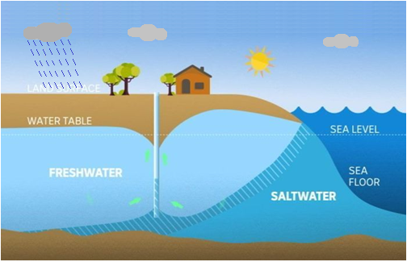
Graphing rainfall

Use the data supplied in the MS Excel ‘Groundwater’ spreadsheet provided, in the sheet titled ‘Rainfall Sept 2014-15’, to complete the following tasks.

- Add a new column to the table by clicking in cell C1 and typing the heading ‘season’. For each of the months in the table, indicate the season in which it falls by typing the name of that season - Spring, Summer, Autumn or Winter – in the new column. Remember, Rottnest Island is just off the coast of Western Australia!

- Use MS Excel to create a column graph of the data to show the rainfall (mm) on Rottnest Island between September 2014 and August 2015.

HINT: To construct your graph you can follow the instructions below:
- Click in cell A2 and, holding the mouse button down, drag the cursor from cell A2 to cell B13, then release the mouse button. This should highlight all the data in columns A and B, except for the column headings.
- Select insert tab and choose column graph from the Charts shown, and click on the first 2-D column graph in the dialog box.

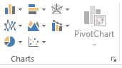
- Select Chart Design tab, and click on Add Chart Element, scroll down to highlight Chart Title, then choose Above Chart. Click in the chart title box on the graph, delete the text, and type the title ‘Rainfall (mm) on Rottnest Island for each month between September 2014 and August 2015’.
- Click on Add Chart Element, scroll down to highlight Axis Titles, then choose Primary Horizontal. Click in the axis title box on the graph, delete the text, and type the title ‘month and year’.
- Click on Add Chart Element, scroll down to highlight Axis Titles, then choose Primary Vertical. Click in the axis title box on the graph, delete the text, and type the title ‘rainfall (mm)’.

- Examine the graph you’ve created. How does the rainfall on Rottnest Island for the year from September 2014 to August 2015 vary with the seasons?

………………………………………………………………………………………………………………………………………………………………………………………………………………………………………………………………………………………………………………………………………………………………………………………………………………………………………………………………………………………………………………………………………………………………………………………………………………………………
Comparing rainfall and abstraction
- In the background information “Groundwater – a hidden essential natural resource” the following terms are shown in bold.

Match each of the terms below with its correct meaning in the table.
abstraction, permeable, aquifer, recharge, groundwater, bore, saline,
saltwater intrusion, water table, desalination

Term | Meaning
 | Salty; containing salt
 | the process of removing dissolved salts from salt water including seawater
 | water that is located underground in aquifers
 | able to be penetrated or passed through
 | an underground layer of permeable rock where groundwater saturates spaces between sediments and cracks in rock.
 | an underground boundary between the soil surface and the aquifer
 | the process of obtaining or removing something from a source
 | the movement of seawater into freshwater aquifers due to natural processes or human activities.
 | a deep hole made in the ground, especially to find water
 | rainwater that moves through the soil and rock to refill the freshwater lens aquifer

- Use the words below to label the processes and objects on the diagram below.

groundwater bore, groundwater abstraction, rainfall, recharge, freshwater lens,
saline groundwater.

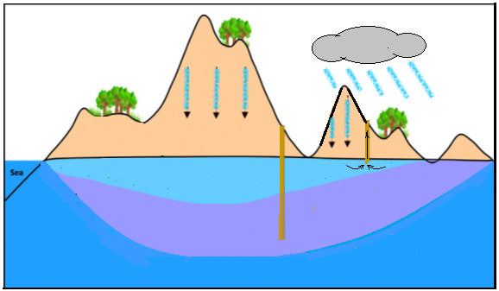

- Figure 4 below is a composite graph. It shows:
- the rainfall in mm on Rottnest Island from September 2014 to October 2015 as blue columns with the scale indicated on the left-hand side, and
- the abstraction in cubic metres (m³), that is, the water which is pumped out of the freshwater lens from the bores over the same time period, as orange columns with the scale indicated on the right-hand side. 1 cubic metre of water (1m³) is equal to 1,000 litres.
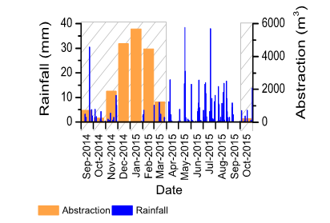
Figure 4:
This graph shows the rainfall in mm and the groundwater abstraction in m³ on Rottnest Island from September 2014 to October 2015

- In which season did the greatest amount of abstraction of groundwater from the freshwater lens occur? Give a reason why this happens.
………………………………………………………………………………………………………………………………………………………………………………………………………………………………………………………………………………………………………………………………………………………………………………………………………………………………………………………………………………………………………………………………………………………………………………………………………………………………

- Compare the pattern shown in the abstraction graph (orange columns) with the pattern shown by the rainfall graph (blue columns). State one difference between these patterns.
………………………………………………………………………………………………………………………………………………………………………………………………………………………………………………………………………………………………………………………………………………………………………………………………………………………………………………………………………………………………………………………………………………………………………………………………………………………………

The groundwater levels of well 15-90
Figure 5 below shows the ground water levels, measured in metres above (positive value) and below (negative value) sea level, of one of the monitoring wells, 15-90 (Central), from October 2014 to September 2015. The grey crosshatched area on the graph  indicates periods of groundwater abstraction.
Groundwater levels at the 15-90 (Central) groundwater well were representative of changes that occurred across most wells on the island.

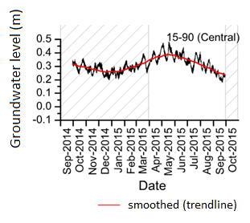
Figure 5:
This graph shows the groundwater levels of one of the monitoring wells, 15-90 (Central), from October 2014 to September 2015.

- How does the groundwater level at the 15-90 (Central) monitoring well change over the year from October 2014 to September 2015?
(HINT: describe the changes shown by the red smoothed trendline, that is, the months when the level is at its highest and lowest, and when it is increasing or decreasing)

………………………………………………………………………………………………………………………………………………………………………………………………………………………………………………………………………………………………………………………………………………………………………………………………………………………………………………………………………………………………………………………………………………………………………………………………………………………………

- Compare the graphs of Figure 4 on the previous page, which shows rainwater and groundwater abstraction from September 2014 to October 2015, with the graph of Figure 5 shown above, which indicates groundwater level in well 15-90 over the same time period.

Do you think the rainfall and groundwater abstraction may have affected the groundwater levels at the 15-90 (Central) monitoring well? Give reasons for your answer.
(HINT: consider the amount of rainfall and groundwater abstraction occurring when the groundwater level in well 15-90 is highest and lowest, and explain how each affects the groundwater level)

………………………………………………………………………………………………………………………………………………………………………………………………………………………………………………………………………………………………………………………………………………………………………………………………………………………………………………………………………………………………………………………………………………………………………………………………………………………………
………………………………………………………………………………………………………………………………………………………………………………………………………………………………………………………………………………………………………………

- Rainfall records, which have been recorded since 1880, indicate declining rainfall on Rottnest Island since the mid-1960s.
Predict the effect of a continued decline in rainfall on the groundwater level in the wells on Rottnest Island.

………………………………………………………………………………………………………………………………………………………………………………………………………………………………………………………………………………………………………………………………………………………………………………………………………………………………………………………………………………………………………………………………………………………………………………………………………………………………

- In 2014 when this research was conducted, groundwater abstraction supplied approximately 25% of the island’s drinking water, with the rest supplied by a desalination plant.
Based on this research what recommendation would you make to the Rottnest Island Authority (RIA) about the provision of drinking water for the island. Give a reason for your recommendation.
………………………………………………………………………………………………………………………………………………………………………………………………………………………………………………………………………………………………………………………………………………………………………………………………………………………………………………………………………………………………………………………………………………………………………………………………………………………………
………………………………………………………………………………………………………………………………………………………………………………………………………………………………………………………………………………………………………………

Freshwater lens

In this section you will investigate any changes in the salinity of the water from 27 production and monitoring wells across the island between 1977 and 2014, and the effect of these changes on the extent (coverage) of the freshwater lens.

What is meant by Total Dissolved Solids (TDS)?
When you add table salt (the chemical name for table salt is sodium chloride) to water and stir, the salt dissolves to form a solution. The salt which is dissolved in the water is called a dissolved solid. There are many different salts that dissolve in water.
Groundwater often contains high concentrations of dissolved solids. This is because, when groundwater moves through the rocks and sediments, some of the salts in those rocks and sediments dissolve in a process called weathering. These salts can include calcium carbonate from the limestone of Rottnest Island, as well as chemicals from pesticides, road salts and fertilizers.
Scientists can determine the amount of dissolved solid in water by testing the electrical conductivity of the solution. Water with large amounts of dissolved solids can conduct electricity very well, whereas pure water does not conduct electricity.
Salinity is another term commonly used to describe the dissolved solids content of water. High salinity (that is, high concentrations of salt) can cause poor health or death of native vegetation and this can potentially alter ecosystems and the plant and animal species they support. The freshwater lens on Rottnest Island feeds natural springs which are used by the island’s fauna such as quokkas and reptiles. Detrimental changes to the freshwater lens would pose a threat, not only in terms of losing an important resource, but potential harm to the animals and plants that rely on the groundwater.

Salinity of well water
Use the data supplied in the MS Excel ‘Groundwater’ spreadsheet provided, in the sheet titled ‘Well ID, Total Dissolved Solids’.
The table in this spreadsheet displays the values for total dissolved solids, in mg/L, for each groundwater well on the island. These measurements were recorded in 1977, and again in 2014.
In this study the sampled water was classified as Fresh, Brackish or Saline according to the concentration of total dissolved solids, as shown below.
TDS type | TDS range (m/L)
Fresh | < 1 000
Brackish | 1 000 – 10 000
Saline | 10 000 – 100 000

The type of groundwater (fresh, brackish or saline) for each of the wells for the 1977 TDS data is already indicated in the spreadsheet table.

- Identify the type of groundwater (fresh, brackish or saline) for each of the wells for the 2014 TDS data using the classification table shown above.
To do this, add a new column to the table by clicking in cell E1 and typing the heading ‘2014 TDS type’. Observe the value for the 2014 TDS (mg/L) for each well and, from the table above, choose the TDS range in which this value falls. Type the name of the TDS type matching the chosen range in the correct cell in column C.
HINT: You can also do this using the IF function in MS Excel using the instructions below. You need to type the formula into the cell exactly as it is shown below with no spaces.
- Click in cell E2 and type the following formula with no spaces.
=IF(D2<1000,”Fresh”,IF(D2<10000,”Brackish”,”Saline”))
The formula above states that if the value for the 2014 TDS shown in cell D2 is less than 1000 then the answer shown will be “fresh”, if it is less than 10000 (but greater than 1000) then the answer will be “brackish”, otherwise the answer will be “saline”.
- Click in cell E2. Hover the mouse icon over the bottom right hand corner of cell E2 and the fill handle (+) will appear.
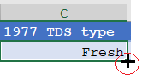
- Click, and whilst holding the mouse button down, drag the fill handle to the bottom of the column, cell E28, then release the mouse button to fill the formula down the column.

- Determine the percentage change in salinity from 1977 to 2014.
To do this, add a new column to the table by clicking in cell F1 and typing the heading ‘percentage change in salinity (%)’. Use Excel to calculate the percentage change in salinity for each well where
Percentage change in salinity (%) = 2014 TDS (mg/L) x 100
1977 TDS (mg/L)

HINT: To calculate the percentage change in salinity (%) for each well you can follow the instructions below:
- Click in cell F2.
- Type the equal sign =, click in cell D2, type forward slash /, click in cell B2 and press enter. The first value will appear in the cell.
- Click in cell F2 and in number, on the tool bar, click %
- Hover the mouse icon over the bottom right hand corner of cell F2 and the fill handle (+) will appear.
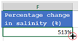
- Click, and whilst holding the mouse button down, drag the fill handle to the bottom of the column, cell F28, then release the mouse button to fill the formula down the column.

The extent of the freshwater lens – a mapping activity
- On the map on the following page, colour the circle for each well according to whether it is fresh (colour it blue), brackish (colour it green) or saline (colour it red). You can print this page and colour the well circles by hand or you can use the ‘illustrations’ tools of MS word.

- The blue dotted line on the map represents the extent (coverage) of the main freshwater lens on the island in 1977.
Draw a smooth curved line around the wells containing freshwater in 2014 to show the extent (coverage) of the freshwater lens in 2014.
HINT: To complete a. and b. above using the ‘illustrations’ tools of MS word follow the instructions below:
- Choose Insert from the tool bar, click on shapes and choose the circle from the drop down menu. Click and drag to draw a circle over the appropriate well.
- Under Shape Format, click Shape Fill and choose an appropriate colour for your circle following the key provided. Repeat until all wells listed in the table are covered by an appropriately coloured circle.
- To draw the smoothed curve around the freshwater wells, choose Insert from the tool bar, click on shapes and choose the curve from the drop down menu. Click and drag to draw a line then click and drag to change the direction of the line. Continue to click and drag to complete the shape, then double click to finish.
- Under Shape Format, click Shape Fill and choose No Fill.

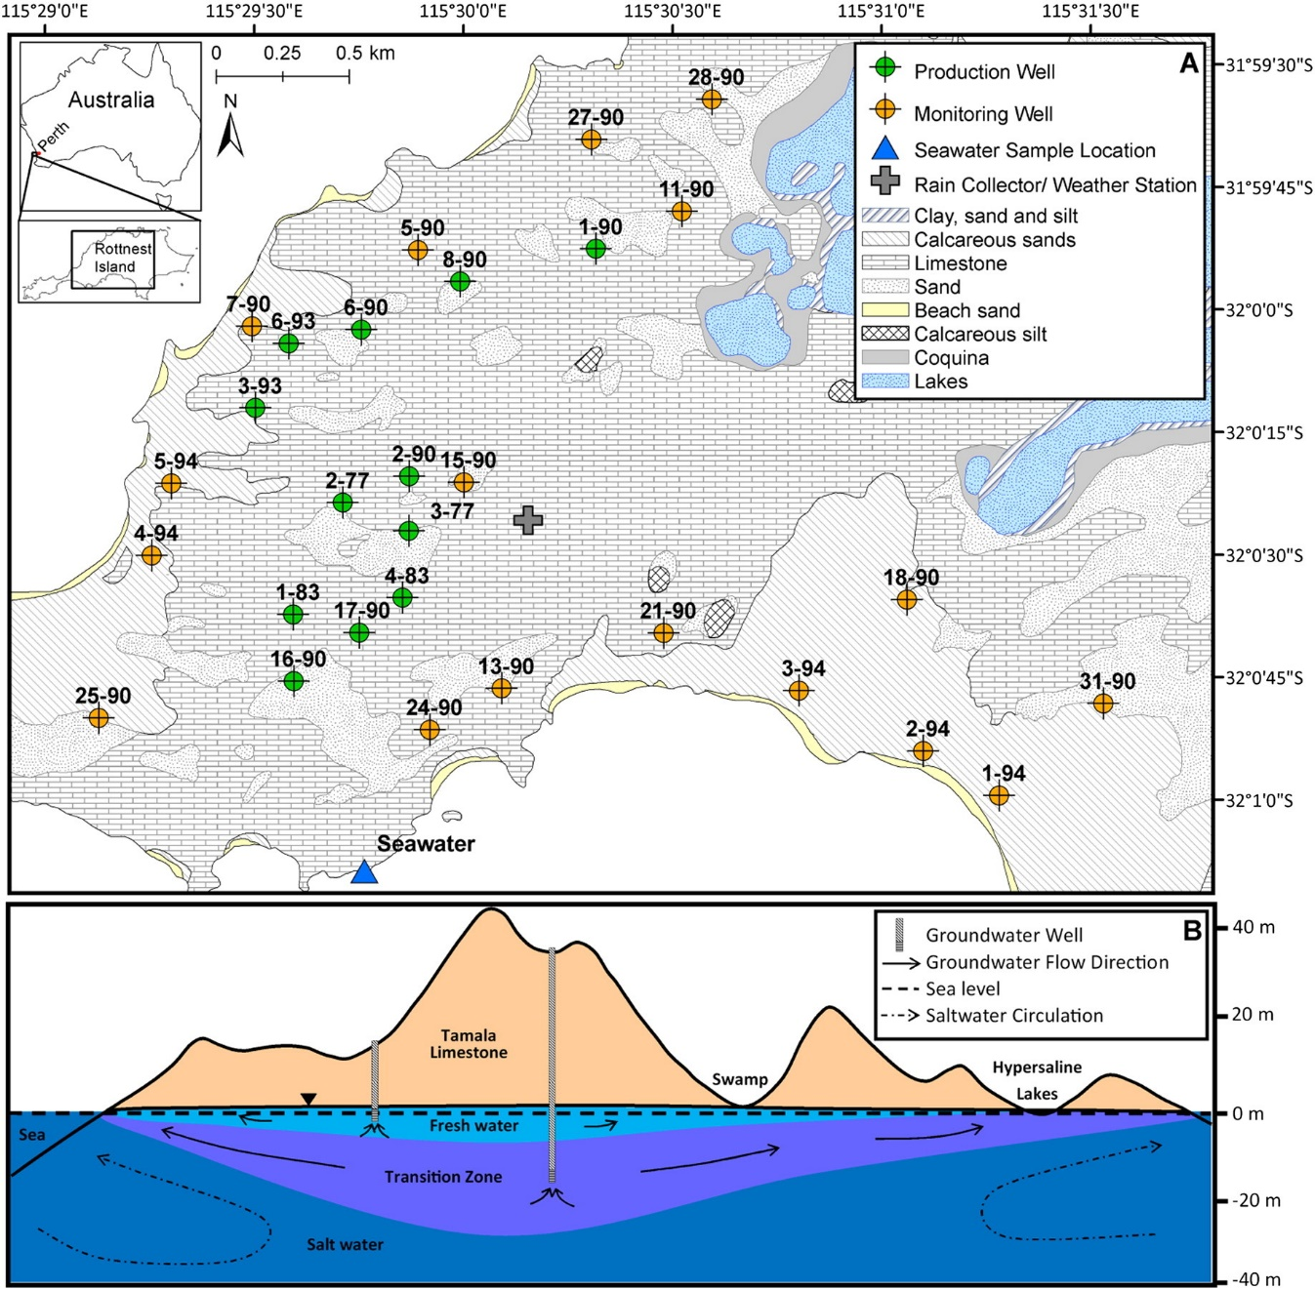

- What changes do you see in the extent (coverage) of the main freshwater lens in 2014 when compared to its extent in 1977?

………………………………………………………………………………………………………………………………………………………………………………………………………………………………………………………………………………………………………………………………………………………………………………………………………………………………………………………………………………………………………………………………………………………………………………………………

- Production wells are used to abstract groundwater for use on the island. In general, groundwater for use needs to be freshwater with < 1000 mg/L total dissolved solids (TDS). Which production wells are no longer classified as ‘fresh’ for the 2014 data?

………………………………………………………………………………………………………………………………………………………………………………………………………………………………………………………………………………………………………………………………………………………………………………………………………………………………………………………………………………………………………………………………………………………………………………………………

- (i) Which two wells have had the greatest percentage change in salinity? Draw a star to identify each of these wells on your map.

HINT: To identify these wells using MS word you can follow the instructions below:
Choose Insert from the tool bar, click on shapes and choose a star shape from Stars and Banners from the drop down menu. Click and drag to draw a star over the appropriate well.
………………………………………………………………………………………………………………………………………………………………………………………………………………………………………………………………………………………………………………………………………………………………………………………………………………………………………………………………………………………………………………………………………………………………………………………………

(ii) Give ONE possible reason why the total dissolved solids (TDS) in the water from each of these two wells has increased so much from 1977 to 2014.

………………………………………………………………………………………………………………………………………………………………………………………………………………………………………………………………………………………………………………………………………………………………………………………………………………………………………………………………………………………………………………………………………………………………………………………………

- Using the background information provided in this resource, give a reason why the area covered by the freshwater lens has changed from 1977 to 2014.

………………………………………………………………………………………………………………………………………………………………………………………………………………………………………………………………………………………………………………………………………………………………………………………………………………………………………………………………………………………………………………………………………………………………………………………………

- Predict what will happen to the freshwater lens in the future, and explain the possible effect of your prediction on the animals and plants that live on Rottnest island.

………………………………………………………………………………………………………………………………………………………………………………………………………………………………………………………………………………………………………………………………………………………………………………………………………………………………………………………………………………………………………………………………………………………………………………………………

- Suggest one possible way to help protect the freshwater lens for the future. What could you do?

………………………………………………………………………………………………………………………………………………………………………………………………………………………………………………………………………………………………………………………………………………………………………………………………………………………………………………………………………………………………………………………………………………………………………………………………

activity 3 – Modelling Rottnest Island Groundwater

In this section we are going to demonstrate how density works and identify how this relates to the various water layers in the Rottnest Island aquifer.

Density of a material refers to the amount of matter or mass there is in a particular space or volume. All materials are made up of very tiny particles. So density is a basically a measure of how many particles are packed into a certain space. In general, materials with tightly packed particles are more dense than those where the particles are spread out.

Another thing we need to consider when thinking about density, is the amount of matter or mass of the particles that make up the material. For example, gold particles have more mass than aluminium particles, and, if we have cubes of aluminium and gold that are exactly the same size, the gold cube will be heavier. Generally the more dense an object is, the heavier it feels.

In this activity we are going to model the groundwater of Rottnest Island using coloured sugar solutions of different concentrations. Each of the solutions has a different mass of molecules packed into the same volume of liquid. This results in the different solutions having different densities.

- The following diagrams represent sugar solutions of different concentrations, where the blue circles represent sugar molecules. Which of the solutions has the greatest density? Give a reason for your answer.
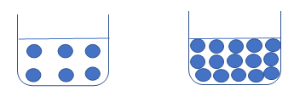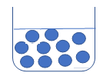
Solution B
Solution A
Solution C

………………………………………………………………………………………………………………………………………………………………………………………………………………………………………………………………………………………………………………

- Follow the procedure below to create a model of the Rottnest Island groundwater.

- Set up three clear plastic or glass containers.
- Leave the first container as it is, add 2 level tablespoons of caster sugar to the second container, and 4 level tablespoons of caster sugar to the third container.
- Add 3 tablespoons of warm water to each of the containers, and keep stirring in the containers containing caster sugar until the sugar crystals have completely disappeared and the sugar has dissolved in the water.
- Add 3 drops of blue food colouring to the first container and stir to mix, 3 drops of green food colouring to the second container and stir, 1 drop of red food colouring to the third container and stir. Let your solutions cool.
- To make your model, firstly pour the red solution into a clear glass or plastic container.
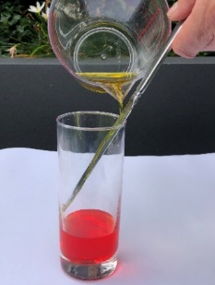
- Hold a flat utensil, like a dinner knife or a spatula, in the container so that the end is just above the red sugar solution. Using a pouring jug, place the tip of the spout against the flat surface and tip the jug to very slowly pour the green sugar solution down the flat surface. You will now have two layers in your container.
- Finally, use the pouring jug to very slowly pour the blue solution down the flat surface.

- Compare your model with Figure 2a of the Rottnest Island aquifer shown on page 6 of this resource. What does the sugar in your model represent in terms of the Rottnest Island aquifer?
………………………………………………………………………………………………………………………………………………………………………………………………………………………………………………………………………………………………

- Draw a labelled diagram of your model, identifying the least dense layer and the most dense layer.

- Explain how your model represents the Rottnest Island aquifer. (HINT: what does each layer in your model represent in the Rottnest Island aquifer and why does it represent this.)
………………………………………………………………………………………………………………………………………………………………………………………………………………………………………………………………………………………………………………
………………………………………………………………………………………………………………………………………………………………………………………………………………………………………………………………………………………………………………
………………………………………………………………………………………………………………………………………………………

- Since the 1960s there has been a significant decline of around 20% in winter rainfall. The decline in rainfall is impacting the volume of recharge the freshwater lens receives.
Use a teat pipette to extract some blue liquid from the top to show a decrease in the amount of the rainwater recharging (refilling) the freshwater lens.
What effect does removing some of the blue layer (“Freshwater”) have on the overall composition of the groundwater?
………………………………………………………………………………………………………………………………………………………………………………………………………………………………………………………………………………………………………………

- Scientists have estimated the average volume of water that flowed each year into the freshwater lens under Rottnest Island between 1911 and 1970, shown in column 1 in the graph below. They have also estimated the yearly decrease in the volume of rainfall (recharge volume) that has occurred since the 1960s shown in column 3 in the graph. The graph also shows the average volume of groundwater extracted each year from 2005 to 2014.
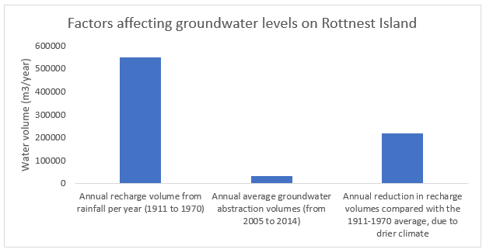
In 2017, after the completion of this research, managing authorities decided not to extract any more groundwater, instead relying on the island’s desalination plant for its water supply.
By referring to the graph above, and the background information provided in this resource, will this decision to completely stop groundwater extraction stop the freshwater lens under Rottnest Island from shrinking further? Justify your answer.
………………………………………………………………………………………………………………………………………………………………………………………………………………………………………………………………………………………………………………………….
………………………………………………………………………………………………………………………………………………………………………………………………………………………………………………………………………………………………………………………….
…………………………………………………………………………………………………………………………………………………………………………………………………………………………………………………………………………………………………………………………
……………………………………………………………………………………………………………………………………………………………

EXTENSioN ACTiviTy: Groundwater REcharge
The water molecule, H₂O, is formed from the elements hydrogen and oxygen. The most common atom of hydrogen has one proton in its nucleus at the centre of the atom, and is referred to as protium or hydrogen-1, and the most common atom of oxygen has 8 protons and 8 neutrons in its nucleus. However, both elements also have isotopes.
An isotope is an atom with the same number of protons, but a different number of neutrons in its nucleus. The number of electrons in the atom is the same as the number of protons, so isotopes of an element also have the same number of electrons. Tritium is a naturally occurring isotope of hydrogen, that has one proton and two neutrons in its nucleus. The diagram below compares an atom of tritium and an atom of protium (common hydrogen).
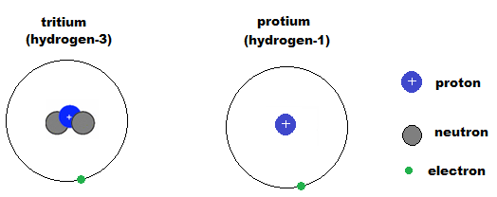
Tritium forms in the upper atmosphere and, like hydrogen-1, tritium reacts with oxygen to form water. Tritium is a radioactive isotope of hydrogen, which means it changes into something else over time. The changing process is called “radioactive decay”.
The concentration of tritium in surface waters is constant, because water molecules in surface water regularly evaporate and circulate through the atmosphere where fresh tritium is incorporated. However, groundwater has a lower concentration of tritium than surface water because it no longer has contact with tritium being formed in the atmosphere, and the tritium in the water decays away. So older groundwaters will have less tritium than younger groundwaters that are regularly recharged with rainwater containing more tritium.
We know it takes 12.3 years for half of all the tritium in a sample of water to decay away and change into another element called helium. This means that after 12.3 years, only half (50%) of the original amount of tritium remains as radioactive tritium. In another 12.3 years only one quarter (25%) of the original amount of tritium will remain in the water sample. Since tritium was formed, it has been decaying at this same rate, ticking along regularly like a clock, and so it can be used to determine the age of young groundwaters. Tritium concentrations are expressed using tritium units (TU), where one TU corresponds to a ratio of one tritium atom per 108 atoms of hydrogen. So water samples with a small TU number will be older than samples with a high TU number.

- Observe the atom diagrams of the isotopes of hydrogen, tritium and protium, in the information presented on the previous page.

- Describe any similarities and differences between these atoms.

………………………………………………………………………………………………………………………………………………………………………………………………………………………………………………………………………………………………
………………………………………………………………………………………………………………………………………………………………………………………………………………………………………………………………………………………………
………………………………………………………………………………………………………………………………………………

- Why are these atoms classed as isotopes?

………………………………………………………………………………………………………………………………………………………………………………………………………………………………………………………………………………………………

- Oxygen is one of the elements that make up water. The most common atom of oxygen has 8 protons and 8 neutrons in its nucleus.
One naturally occurring isotope of oxygen is oxygen-18 which has 10 neutrons in its nucleus. Complete the diagram below to show an atom of oxygen-18. Remember, only two electrons are allowed in the first electron shell and up to 8 electrons in the second electron shell.

nucleus
First electron shell
Second electron shell

- Why would you expect to find less tritium in groundwater than in surface water?
(HINT: Include a description of where tritium is produced, how it becomes part of rainwater, how tritium ends up in groundwater, and what happens to tritium over time)

………………………………………………………………………………………………………………………………………………………………………………………………………………………………………………………………………………………………
………………………………………………………………………………………………………………………………………………………………………………………………………………………………………………………………………………………………
………………………………………………………………………………………………………………………………………………………………………………………………………………………………………………………………………………………………
………………………………………………………………………………………………………………………………………………………………………………………………………………………………………………………………………………………………

- Use the data supplied in the MS Excel ‘Groundwater’ spreadsheet provided, in the sheet titled ‘Radioactive decay of tritium’, to complete the following task. The table shows the percentage of radioactive tritium atoms remaining after the stated years.

- Create a connected scatter graph (scatter with smooth lines and markers) of the data, using MS Excel, to show the percentage of radioactive tritium atoms over time.

HINT: To construct your graph using MS Excel you can follow the instructions below:
- Click in cell A2 and, holding the mouse button down, drag the cursor to cell B7. This should Highlight the data in Column A (time) and Column B (Percentage of radioactive tritium atoms remaining) from cell A2 to cell B7.
- Select insert tab and click on scatter graph from the Charts shown, and click on scatter with smooth lines and markers (the second scatter graph in the dialog box)

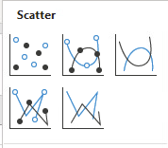

- Select Chart Design tab under Chart Layouts, and click on Add Chart Element, scroll down to highlight Chart Title, then choose Above Chart. Click in the chart title box on the graph, delete the text, and type the title ‘Percentage of radioactive tritium atoms remaining over time’ and click outside the box to finish.
- Click on Add Chart Element, scroll down to highlight Axis Titles, then choose Primary Horizontal. Click in the axis title box on the graph, delete the text, and type the title ‘Time (years)’ and click outside the box to finish.
- Click on Add Chart Element, scroll down to highlight Axis Titles, then choose Primary Vertical. Click in the axis title box on the graph, delete the text, and type the title ‘Percentage of radioactive tritium atoms remaining (%)’ and click outside the box to finish.

- From your graph, determine the percentage of tritium remaining if a sample of groundwater is 30 years old.

………………………………………………………………………………………………………………………………………………

- You can date groundwater using tritium up to an age equal to 5 half-lives of tritium. What is the age of the oldest groundwater that can be dated using tritium?

………………………………………………………………………………………………………………………………………………

- From your graph, determine how old a sample of groundwater is if the percentage of tritium remaining in the sample is 10%.

………………………………………………………………………………………………………………………………………………

- Use the data in the MS Excel ‘Groundwater’ spreadsheet provided, in the sheet titled ‘Amount of Tritium and Elevation’, to complete the following task.

The table shows the elevation, that is, the height below sea level (as indicated by the negative value) of each of the wells, given in metres AHD. AHD stands for Australian Height Datum and is the national reference system for measuring height above or below sea level. The reference sea level used is based on the mean (average) sea level observation from 1966-1968 at 30 tide gauges around the Australian coast.

The table also shows the amount of tritium (3H) remaining in tritium units (TU) in water taken from each of the wells, which is a measure of the age of the water.

The total dissolved solids (TDU) in the water from each well and the water type (fresh, brackish and saline) is stated.

- Sort the data in the table according to the water type.

HINT: To sort the data using MS Excel you can follow the instructions below:
- Click in cell A1 ‘Well ID’ and, holding the button clicked, drag the curser to cell E18. This should Highlight all the data in the table from cell A1 to cell E18.
- Select DATA tab and click on sort. A dialog box will open.



- In the dialog box, choose Water type in the ‘sort by’ drop down menu under the Column heading, for Sort On choose Cell Values, and for Order choose A to Z.
- Click OK and the table should show the data grouped according to water type – brackish, fresh then saline.

- Using Excel tools, construct a scatter graph of the Elevation (m AHD) versus the tritium remaining (TU) for all the wells shown in the MS Excel spreadsheet. Your graph should also indicate the type of water for each of the wells using different colours (brackish - green, fresh- blue or saline - red) to plot each data point.

HINT: To construct your graph you can follow the instructions below:-
- For the brackish water wells, click in cell B2 and, holding the button down, drag the curser from cell B2 to cell C7. This should highlight the data in Column B (Amount of tritium) and Column C (elevation) for the brackish water type.
- Select insert tab and choose scatter graph from the Charts shown, and click on the first scatter graph in the dialog box.

- Right click in the plot area of the chart and choose ‘select data’ in the dialog box that opens.
- In the second dialog box, click on series 1 and then edit, and, in the new dialog box that opens, type “brackish” in the box for series name. Click OK.
- Select Add in the dialog box.
- In the second dialog box that opens type in the series name “fresh”.
- Click in the series X values box, then click and drag from cell B8 to cell B13 to highlight the column B (Amount of tritium) data for the wells that have ‘fresh’ groundwater.
- Click in the series Y values, delete ={1}, then click and drag from cell C8 to cell C13 to highlight the column C (Elevation) data for the wells that have ‘fresh’ groundwater. Click OK.
- Again select Add in the dialog box. In the new dialog box that opens type in the series name “saline”.
- Click in the series X values, then click and drag from cell B14 to cell B18 to highlight the column B (Amount of tritium) data for the wells that have ‘saline’ groundwater.
- Click in the series Y values, delete ={1}, then click and drag from cell C14 to cell C18 to highlight the column C (Elevation) data for the wells that have ‘saline’ groundwater. Click OK, and click OK to finish.
- Select Chart Design tab under Chart Layouts, and click on Add Chart Element, scroll down to highlight Chart Title, then choose Above Chart. Click in the chart title box on the graph, delete the text, and type the title ‘Amount of tritium (TU) at different groundwater elevations’ and click outside the box to finish.
- Select Design tab under Chart tools, click on Add Chart Element, scroll down to highlight Axis Titles, then choose Primary Horizontal. Click in the axis title box on the graph, delete the text, and type the title ‘Amount of tritium (TU)’ and click outside the box to finish.
- Click on Add Chart Element, scroll down to highlight Axis Titles, then choose Primary Vertical. Click in the axis title box on the graph, delete the text, and type the title ‘Elevation (m AHD)’ and click outside the box to finish.
- Click on Add Chart Element scroll down to highlight Legend, then choose Right.

- Observe your graph. How does the salinity (saltiness) of the groundwater change with the depth of the groundwater? Give a reason for this trend.

(HINT: remember the deeper the groundwater the greater the negative elevation. Also refer to Figure 2a on page 6 of this resource.)

………………………………………………………………………………………………………………………………………………………………………………………………………………………………………………………………………………………………
………………………………………………………………………………………………………………………………………………………………………………………………………………………………………………………………………………………………

- From your graph, what can you say about the amount of tritium and the depth of the groundwater? Remember the larger the negative number for elevation, the deeper the groundwater.

………………………………………………………………………………………………………………………………………………………………………………………………………………………………………………………………………………………………
………………………………………………………………………………………………………………………………………………………………………………………………………………………………………………………………………………………………

- The amount of tritium in the water is a measure of the age of the water. From your graph, what can you say about the age of the freshwater lens? Give a reason for the age of the freshwater lens.

………………………………………………………………………………………………………………………………………………………………………………………………………………………………………………………………………………………………
………………………………………………………………………………………………………………………………………………………………………………………………………………………………………………………………………………………………

- The outlier on the graph is well 7-90. Compare the age of the saline water in 7-90 to the age of water in the other saline wells shown on the graph. Give a reason for your answer.

………………………………………………………………………………………………………………………………………………………………………………………………………………………………………………………………………………………………
………………………………………………………………………………………………………………………………………………………………………………………………………………………………………………………………………………………………

- In Activity 2 Freshwater Lens, you identified each of the wells according to whether the water from the well in 2014 was fresh (blue), brackish (green) or saline (red). You also drew a smooth curved line around the wells containing freshwater in 2014 to show the extent (coverage) of the freshwater lens in 2014.
Locate well 7-90 on your map. From the location of the well, propose a possible reason for the difference in age of the saline water in well 7-90 when compared to the age of the water in the other saline wells.
………………………………………………………………………………………………………………………………………………………………………………………………………………………………………………………………………………………………
………………………………………………………………………………………………………………………………………………………………………………………………………………………………………………………………………………………………
………………………………………………………………………………………………………………………………………………………………………………………………………………………………………………………………………………………………

