Applying for beamtime at the AS XAS beamline 12-ID

Guidelines prepared by the XAS Program Advisory Committee and the XAS beamline scientist team;   
July 2018

**Summary:**

Please ensure that you read this entire document. Failure to follow these guidelines is likely to render your proposal uncompetitive. To help you submit a competitive proposal, make sure that you address each point in the 5-point checklist below.

Beamtime applications will first be assessed against technical feasibility and safety (Yes/No pass criterion). The primary way of documenting parameters of your experiment in the proposal is the sample table as part of the experimental section. In the proposal webform, you will find the experimental section under the “Beamline” tab.

Applications will further be scored and ranked according to: Quality of the scientific proposal (includes clarity and scientific merit); National benefit and application of the proposed research; Track record relative to opportunity; and Need for synchrotron radiation.

For further information on scoring criteria, see also <https://www.synchrotron.org.au/images/20160616--Australian-Synchrotron-access-model.pdf>

**Fill in below checklist BEFORE submitting your proposal**

If you answer “NO” to any of these questions, please go back and take the necessary steps to permit a “YES” answer before submitting your proposal. Failure to answer “YES” to all five questions is likely to render your proposal uncompetitive.

|  |  |  |
| --- | --- | --- |
| Does the experimental plan include a table of samples and experimental conditions as outlined in the proposal guidelines? | **YES** | **NO** |
| If you have not used the AS XAS beamline over the past three years, have you contacted the beamline scientist team to discuss the feasibility of your experiment? | **YES** | **NO** |
| If you are proposing an experiment for Hutch C (non-standard), have you contacted the beamline scientist team to discuss the feasibility of your experiment? | **YES** | **NO** |
| If you are applying for more than 6 shifts (2 days), are at least 3 people listed as *attending*? | **YES** | **NO** |
| If you are new to the XAS method or the XAS Beamline, and if you have not yet talked to the beamline scientist team, are there more than 5 working days left to the proposal deadline? | **YES** | **NO** |

1. Tips for preparing a proposal

* Give yourself plenty of time to develop your proposal. A proposal “hastily thrown together” may save you time, but may not be competitive and thus waste the time of the reviewers and members of the program advisory committee.
* If you need to consult with the beamline scientist team, give them enough time to work with you ahead of the proposal deadline. You are not the only person wanting their input.
* Be clear, concise and to the point. Avoid irrelevant information.
* Make sure you propose an experiment that is feasible (see below for more detail).
* Consider the skills required to make a beamtime successful. Who would be attending the experiment? Will the right people be available? - If you do not (yet) have the skills or knowledge in your team, consider collaborating with someone experienced in your field. Feel free to ask the beamline team for advice.
* Check you proposal PDF before you submit it! Make sure the relevant information is complete and easily found by the reviewers.

1. Resubmissions

Is your proposal a re-submission of a previously unsuccessful one? If yes, please provide concise information (max 50 words) on how this proposal was improved or changed. Upload this as a short list of dotpoints as a figure with sufficient resolution.

1. Technical feasibility and your proposed experiment

For the most current information on beamline capabilities, please consult the beamline’s webpage:

<http://www.synchrotron.org.au/index.php/aussyncbeamlines/beamline-update>

Listed below are common reasons why a proposal may be marked *technically* *infeasible* and get rejected. This can almost always be avoided by talking to the beamline scientist team first.

* **Safety concerns.** Explicitly say what the potential risks are that are associated with your experiment or equipment. Examples of problems encountered in the past include: Your experiment uses high pressure, toxic gases, high voltage, etc, and you have not contacted us to discuss safety; your experiment produces toxic gases, but you do not tell us how much; we note that there are electrical hazards, but there is not enough information to be sure; etc. Remember: Risk = Hazard x Exposure.
* **Wrong beamline.** Past occurrences include proposals for NEXAFS experiments at the Soft X-ray beamline (e.g., C-K edge studies) and XANES imaging measurements at the XFM beamline.
* **Insufficient experimental detail.** Most often this means there is no table giving detail on samples, detection mode, concentrations, edges, scan times, etc. Thus, we do not know what you are trying to do and how long it should take.   
  Other examples include: you mention *in-situ* setups or measurements but have not talked to the beamline scientists about this; you bring a specialised apparatus, but it is unclear whether or how it will fit into the beamline environment; etc.
* **Conflicting or confusing information.** The experimental plan is confusing or conflicting with the rest of the proposal. It is thus unclear what the experimental parameters are.
* **Closely spaced absorption edges and/or overlapping fluorescence lines from different elements in your sample.** The mix of sample elements means that the corresponding absorption edges are too close together to perform the measurements you need to answer your scientific questions. In the case of fluorescence XAS, there are overlapping fluorescence lines, which means signals from two elements cannot be separated. Watch out for first row transition elements or complex mixtures of lanthanide group elements.
* **Highly diffracting materials.** XAS does not work well on crystalline materials. Especially in case of films on a crystalline substrate, there are issues with fluorescence detection. Talk to the beamline scientist team first.
* **Liquid or moist samples at room temperature.** The X-ray beam almost always generates bubbles in liquids, thus rendering XAS spectra unusable. In wet or moist samples, radiation damage sets in very quickly. These samples need to be frozen in the sample cryostat, and for liquids a glassing agent is needed. Talk to the beamline scientist team first.

1. Writing the experimental section

For the experimental section, consider these important points:

* **Insert the correct text under the appropriate headings.** The experimental section is not an extension of the ‘Scientific Purpose’ or ‘National Benefit’ sections – please only provide information that is **relevant to the *measurements***. Information about the scientific merit or national benefit placed in the experimental section will be ignored.
* **Sample table: A quick reference guide to your experiment.** The table needs to show details such as, sample type (sample, reference), absorption edge, intention (number of scans, duration), state (e.g. solid, powder, liquid), measurement temperature (RT, cyro), estimated time and detection method. Be concise, sample grouping is permissible and encouraged. The **template provided below** shows a non-exhaustive range of possibilities to supply the information required. Once filled in, either cut-and-paste it into the webform or upload it as a screenshot/figure. **An example of a simple experimental section and corresponding table is shown at the end of this document.**
* A rough guide to **estimating experiment overheads**:

|  |  |
| --- | --- |
| **Activity** | **Typical time required** |
| 1x sample rod change using the cryostat | 15 min |
| 1x sample holder change using the room temperature sample box | <5 min |
| Sample alignment after changing samples | 5-10 min per sample holder |
| Time for radiation hardness testing and optimising | 1-4 hrs (sample dependent) |
| Setup time for *in-situ* experiments | 4-24 h (strongly depends on setup complexity; consult with the beamline team) |

* The XAS Beamline operates across **different energy “modes”** (see below and [website](http://www.synchrotron.org.au/index.php/aussyncbeamlines/beamline-update)). If you need access to absorption edges in different modes, please submit a separate proposal for each mode. It is a good idea to indicate in the corresponding proposal title that this is a split proposal (e.g.: *“Title of Your Study – Part 1: Iron”, “Title of the Study – Part 2: Antimony”*).You can copy-paste the relevant information across to save preparation time. In the experimental section, make adjustments according to the range you are using.

|  |  |
| --- | --- |
| **“Mode”** | **Energy Range** |
| Mode 1 | 5 – 9 keV (Hutch-B)  7 – 9 keV (Hutch-C) |
| Mode 2 | 8.5 – 18.5 keV (Hutch-B & C) |
| Mode 3 | 15 – 31 keV (Hutch-B & C) |

* Consider whether your experiment is suited to **Hutch-B or Hutch-C** ([http://www.synchrotron.org.au/index.php/aussyncbeamlines/x-ray-absorption-spectroscopy/techniques-available](http://www.synchrotron.org.au/index.php/aussyncbeamlines/x-ray-absorption-spectroscopy/publications-and-resources)). If you are unsure what this means or if you know you need access to Hutch-C, contact the beamline scientists. Please also note that experiments in Hutch C are only possible above the Fe K-edge (> 7 keV).
* **Radiation damage** occurs quite frequently at the XAS beamline due to the high X-ray flux density delivered to the sample. If you expect radiation damage to be an issue, comment on strategies to mitigate (e.g., use of the cryostat, focus on XANES only, repeat scans on fresh *sample spots, etc). If you are unsure, set aside some time (as shown your sample table) to test the issue.*
* If you have **complementary data from other techniques** that will aid in assessing the viability of your proposed experiment, describe such results. Include figures as required. Please do not include irrelevant information.
* The first few hours of beamtime are routinely required for beamline conditioning and user training even when the beamline is running smoothly. Estimate a 4 hr overhead for said activities (8 hr if you are a new to the XAS beamline).
* For most experiments, we use **standard sample holders** made of Al or PMMA. Please consider making your own as there is a limited stock of sample holders available at the XAS Beamline.   
  The relevant dimensions are shown below. Screw holes are 4 unthreaded M3s. Thickness is 1mm (Al) or 2mm (PMMA). The sample/hole size is variable; please consult for further details if required.



**Sample table template showing fill-out examples** for your convenience; see last page of this document for an example. For fluorescence experiments (“F”), please express concentrations in either *wt-%, ppm* or *mM*.

For transmission experiments (“T”), please use the absorption step (*d*) and total absorption above the edge (*t*). You can conveniently calculate edge steps and total absorption using the *XAFSmass* freeware by Konstantin Klementiev (<https://intranet.cells.es/Beamlines/CLAESS/software/xafsmass.html>; for instructions see there).

|  |  |  |  |  |  |  |  |  |
| --- | --- | --- | --- | --- | --- | --- | --- | --- |
| **Sample** | **Edge** | **F/T** | **Concentration;**  **incl. edge step (in transmission)** | **K max** | **Temperatures** | **Scans** | **Time/Scan**  **(hrs)** | **Total**  **(hrs)** |
| 12 GaAs  powders | Ga K | T | d = 1, t = 2 | 12 | 20, 50, 100 K | 27x 3  = 36 | 0.5 | 18 |
| 21 Cd containing soils | Cd K | F | 5 – 50 ppm | 12 | 10K | 21x 3  = 63 | 0.75 | 47 |
| Tissue samples (x8) | Br K | F | 0.1 to 0.5 mM | 16 | 10K | 8x 4  = 32 | 1 | 32 |
| 5 Cr model compounds | Cr K | F | diluted to  1000 ppm | XANES only | 10K | 5x 1  = 5 | 0.3 | 1.5 |
| 15 Ir/Al2O3 catalysts | Ir L3 | F | 0.1 wt% | XANES only | room temp | 2x 15  = 30 | 0.3 | 10 |
| Radiation hardness testing (hrs) | | | | | | | | 2-3 |
| Beamline conditioning and training (hrs) | | | | | | | | 4 |
| **Total time requested** | | | | | | | | **72 hr / 9 shifts** |

1. Outcome of previous Australian Synchrotron experiments (past 3 years)

Include **tabulated information** about publication and outcomes of past beamtime using below template. If there are no outcomes yet, provide information when they can be expected. If previous results are insufficient for producing outcomes, give reasons.

Please note, the list of papers auto-generated by the proposal system is not a substitute for this section.

|  |  |  |  |
| --- | --- | --- | --- |
| **Proposal ID, round** | **PI name, institution** | **# of shifts** | **Outcomes** |
| M9999, 2019/3 | Dr. Seuss, Oxford | 9 shifts | e.g.: publication X, or data analysis continuing, or no usable data obtained (give reason), or insufficient data for publication, or presentation at conference X, etc, etc |

**If you are new to synchrotron radiation experiments**, provide evidence of your experience in your field, list your key publications and describe how synchrotron radiation will advance your science. Note that if you are a student you cannot be the Principal Investigator.

1. The need to use Synchrotron Radiation

Justify why XAS measurements are required for your samples and why the information you seek cannot be obtained using other techniques. Since XAS is not a laboratory-available technique, the need for access to synchrotron radiation to perform XAS measurements is considered a given, so in this section focus on why you need to perform an XAS experiment.

1. Experimental needs, special requirements and hazards

Be as specific and as concise as possible, particularly if you intend to use your own equipment. User-supplied equipment *must* comply with the safety requirements of the facility *before* arrival on site. Please be aware that the standard XAS experimental arrangement in Hutch B (first experimental hutch) can normally not be modified. As such, most user-supplied equipment can only be accommodated for in Hutch C (the second experimental hutch). If you seek to use your own equipment or perform a ‘non-standard’ experiment, you have to consult with the beamline scientist team *before* submitting your application.

(continued next page)

1. Example experimental section

Example of a basic experimental section for a XAS proposal. For more complex experiments (e.g., *in-operando* studies), additional detail needs to be included. Please consult with the beamline scientist team to discuss details or questions.

Screenshot from the webform (“Beamline” tab)

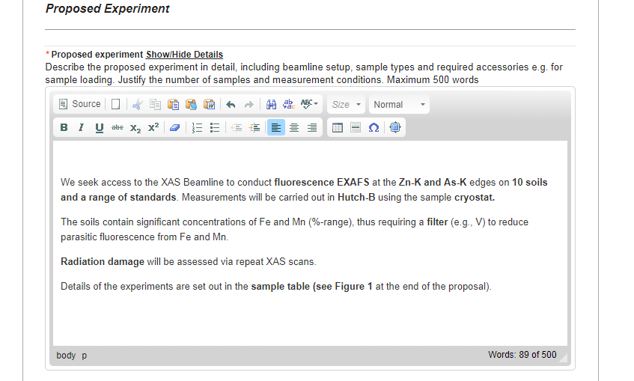

Corresponding sample table for upload as a figure

