**Equipment list**

You can choose any of the equipment below to perform your experiment:

**Radiation Detection and Measuring Equipment**

**Digital Scintillation Counter:** This device measures radioactivity in counts per second. It makes different sounds when alpha, beta and gamma radiation hit the detector.

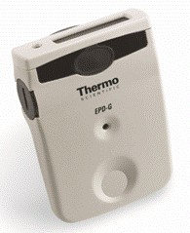

An **Electronic Personal Dosimeter (EPD)** measures radiation dose, in microsieverts and microsieverts per hour, which is the potential biological effect of radiation on living things. The EPD continuously monitors radiation which sounds a warning alarm at preset levels and live readout of dose accumulated. It can be reset to zero after use.

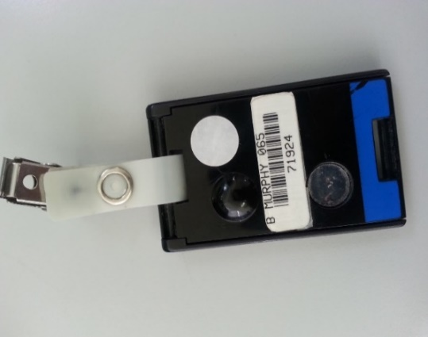

**Thermoluminescent dosimeter (TLD)** is a personal dosimeter used for monitoring radiation. It is worn for up to 3 months, then processed to determine the biological dose received.

A **30 cm ruler** can be used to measure distance between a source of radiation and the radiation detector.

**Alpha, beta and gamma radiation sources:**

We have three discs, 3 cm in diameter, each containing a different radioactive source. The sources are:

Americium-241 (an alpha and gamma emitter)

Half-life 432.2 years

Strontium-90 (a pure beta emitter)

Half-life 29 years

Cobalt-60 (a beta and gamma emitter)

Half-life 5.3 years

**Radioactive Sources**

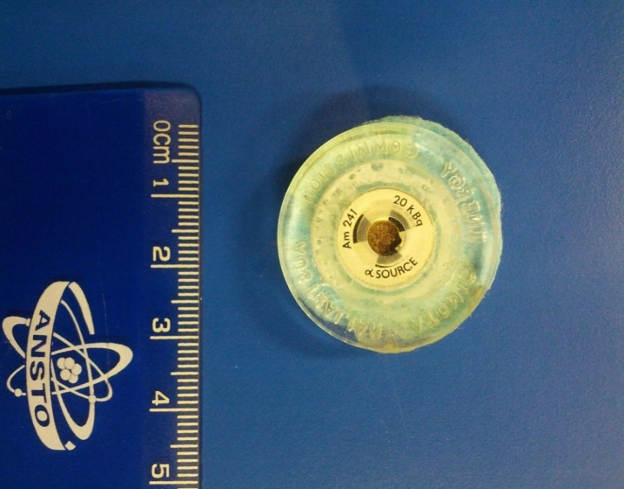

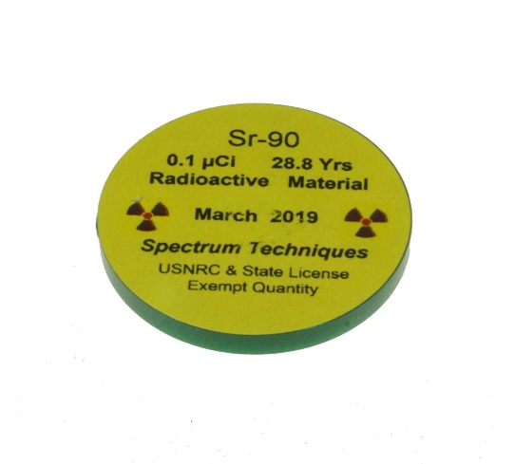

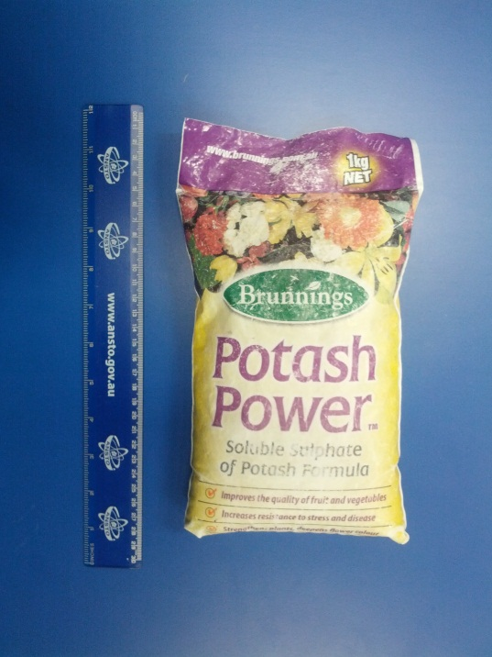**Radioactive Objects**

**Potash fertiliser:** This fertiliser contains potassium sulfate and is used to promote growth in flowering and fruiting plants. It is radioactive because 0.01% of all potassium atoms are the radioactive isotope potassium-40.

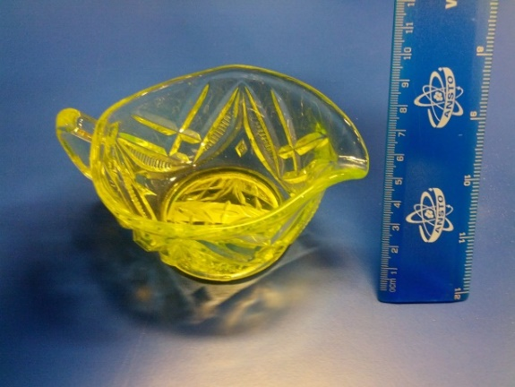

**Uranium glass:** This type of glass was made by adding uranium and calcium to clarify the glass mix before melting. The uranium makes the glass a yellow colour, and the glass glows green under ultraviolet light. Uranium glass was most popular from the 1880s to the 1920s.

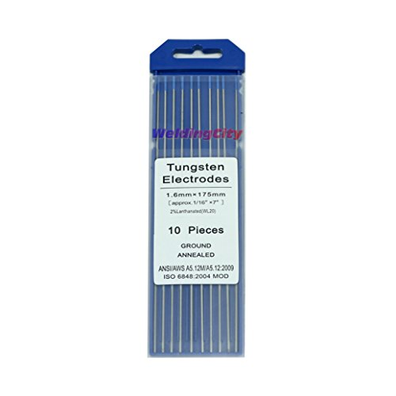

**Tungsten welding rods:**

These tungsten welding rods contain 2% thorium which is enclosed in a tungsten matrix and so there is little radiation emitted externally. The main risk to the welder occurs in the ingestion of the material. This may occur primarily during the inhalation of dust caused during grinding of tips for welding.

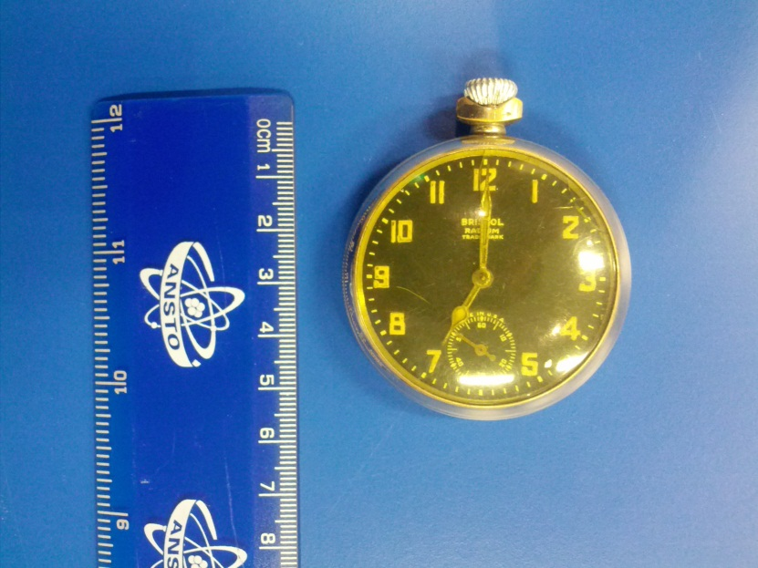

**Radium watch:** Some old watch and clock dials were painted with radioluminescent paint containing radium and a phosphor so that the hands and numbers glowed in the dark. Modern glow-in-the dark paint do not contain radioactive material.

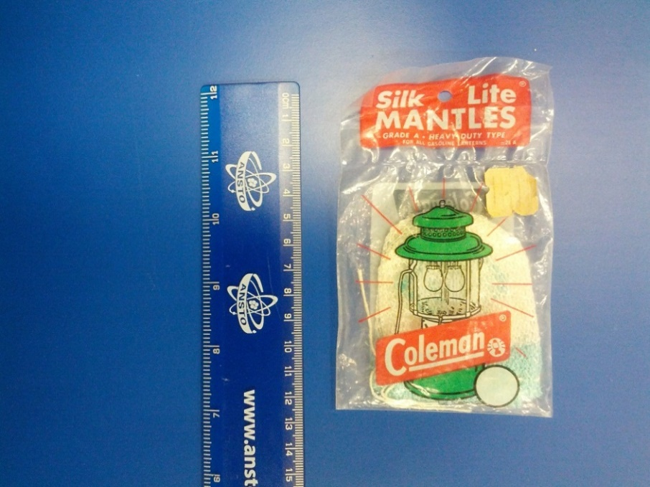

**Gas mantle:** When placed inside a gas lantern, a gas mantle generates a bright white light when heated by a flame. Gas mantles used to contain radioactive thorium, but this has now been replaced by other compounds in most brands

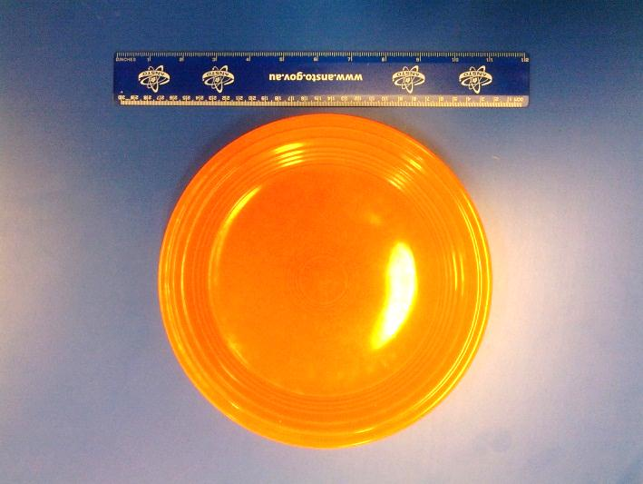

**Fiestaware:** Fiestaware was a brand of brightly coloured orange ceramic plates made in the United States. Up until 1973, the Fiesta company produced their orange-red coloured products by mixing uranium oxide into their ceramic glazes

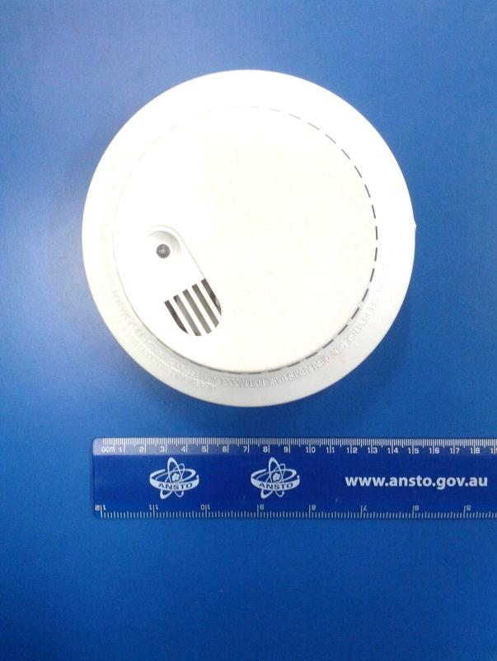

**Smoke detector:** These contain a small amount of radioactive Americium-241 which emits alpha particles. Ionised gas particles formed near the radioactive source complete the electric circuit in the device. If smoke particles interrupt the electrical circuit, then the alarm sounds.

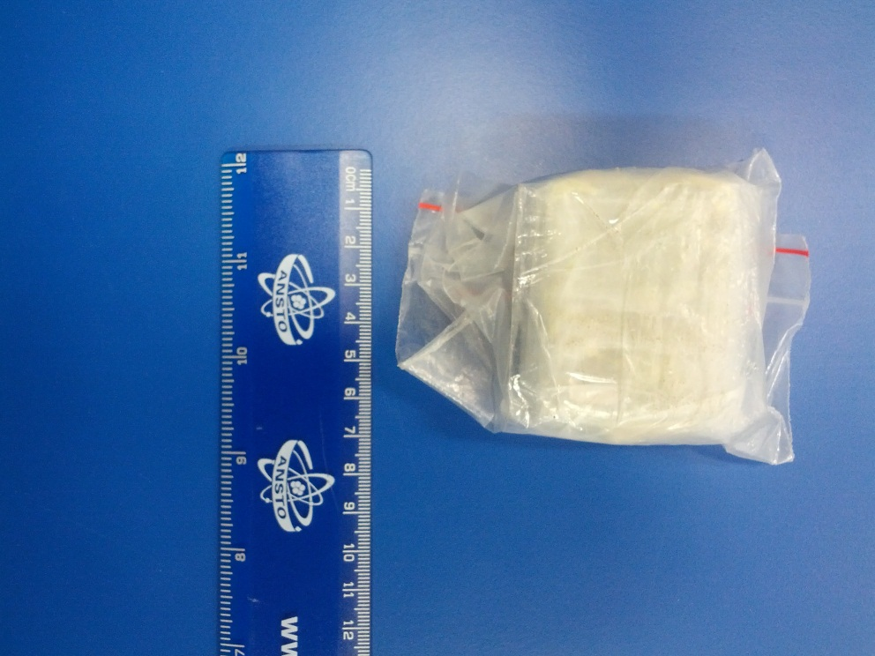

**Uranium ore (Autunite):** Uranium is a radioactive element naturally found in rocks and minerals in the earth’s crust.

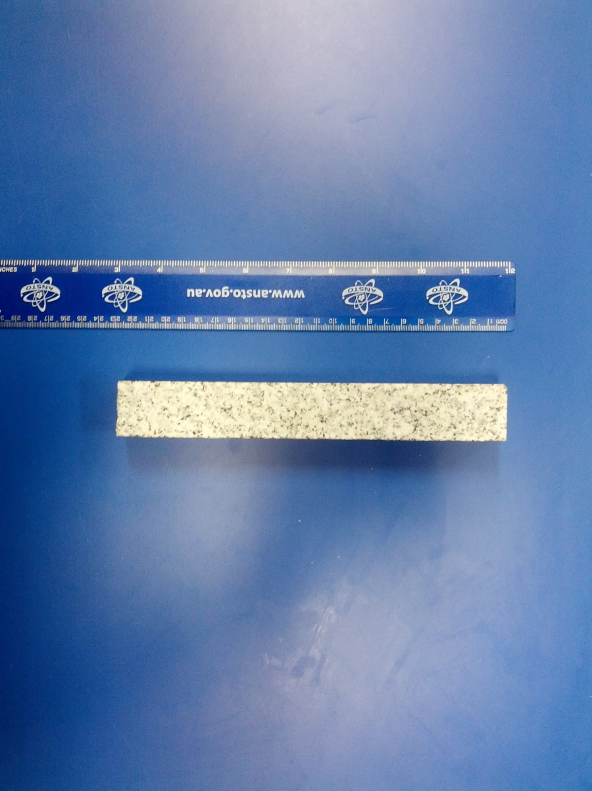

**Granite:** Granite is a popular building material in homes and buildings. It naturally contains varying amounts of radioactive uranium and thorium.

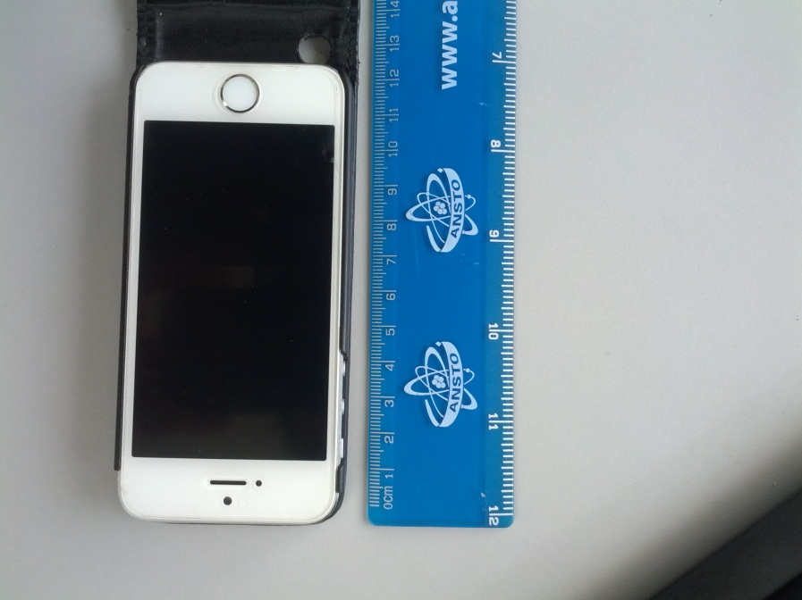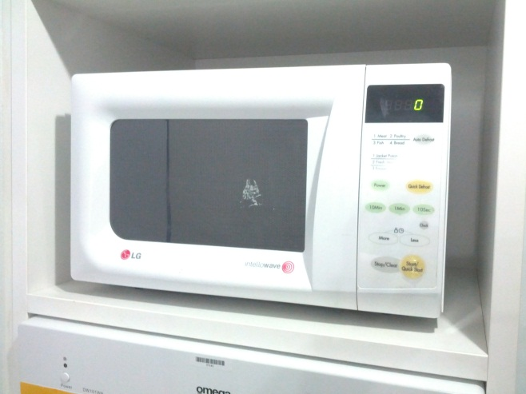

**Microwave oven:** Microwave ovens heat your food using microwave radiation. But are they radioactive?

**Mobile phone:** Mobile phones use electromagnetic radiation in the microwave range. But are they radioactive?

**Radiation shielding**

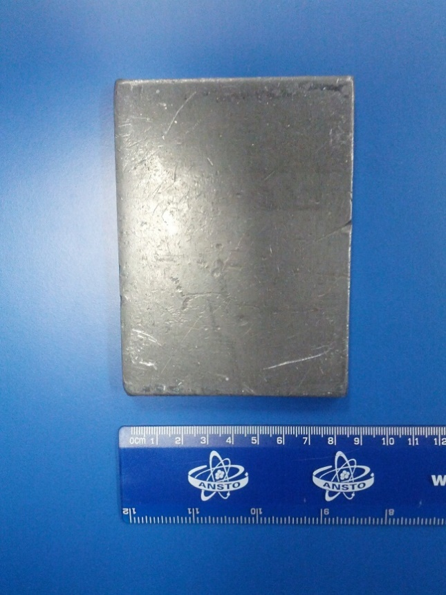

**Lead sheet:** This sheet of lead is about 7 mm thick

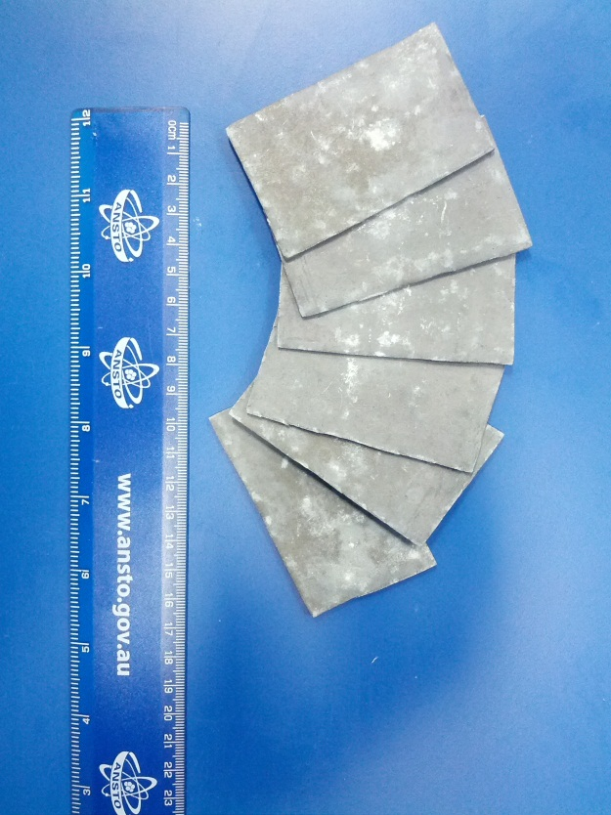

**Lead sheets:** There are 10 sheets of lead, each 1 mm thick

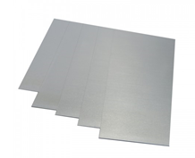

**Aluminium sheets:** There are 10 sheets of aluminium, each 1 mm thick

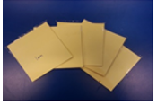

**Paper sheets:** There are 10 bundles of paper post-it notes, each bundle is 1 mm thick

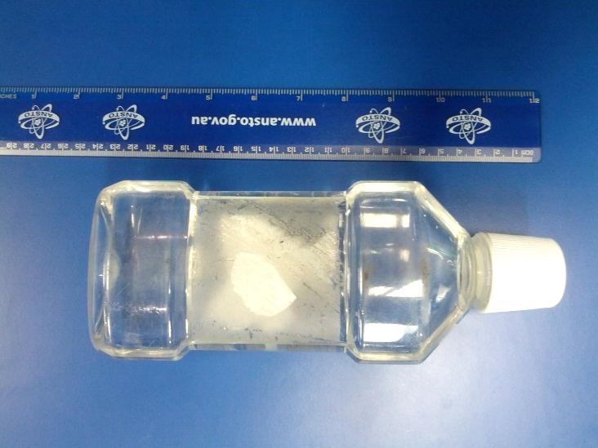

**Plastic bottle of water:** This bottle is filled with tap water. It is approximately 3.5 cm thick in the centre.

**Water-filled zip-lock bag:** We can fill a plastic bag with water up to 1cm thick or a plastic container with water up to 5cm thick.