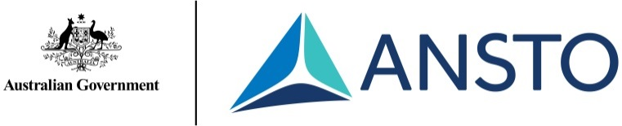

Science at Work! Primary Tour
Tour Outline
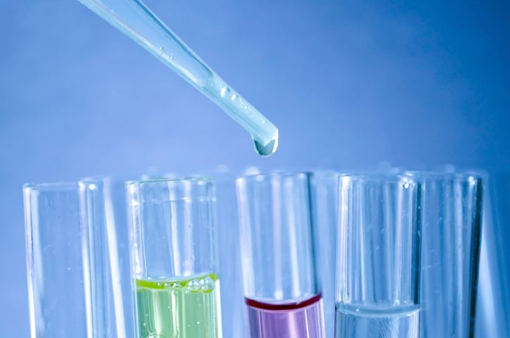

Your tour
The Science at Work! Primary Tour is conducted at ANSTOs Lucas Heights campus in Southern Sydney. It is offered to school groups in Years 3-6 (NSW Stages 2 and 3) and takes 2.5 hours, or 3 hours for large groups.

This tour experience assumes no background science knowledge. Students will be given opportunities to ask questions to clarify their understanding or share any thoughts and knowledge. Our staff are passionate and experienced science-qualified education specialists. They aim to engage primary students (and their teachers!) to inspire a life-long interest in science and learning.

For further enquiries or to book a tour for your primary group, contact the ANSTO Education Team:
Phone: 02 9717 3090 email: tours@ansto.gov.au

Science at Work! Primary School Tour Outline
The primary school tour experience starts at the ANSTO Discovery Centre at Lucas Heights. This large room, open to the public, contains interactive displays and science information and the new ANSTO Virtual Reality (VR) experience.
Students are given some time to engage with the displays and VR headsets upon arrival, before taking a seat in the Discovery Centre Theatre.
Inside the theatre the major functions of ANSTO, as a large public research organisation, are introduced and the important role of science in society is discussed with students. The world of atoms is introduced and some of the solids, liquids and gases making up the Periodic Table of Elements discussed. Students learn how to “build atoms” in an engaging and interactive lesson.
With lights turned off, an enjoyable and informative selection of Colour and Light demonstrations are conducted with student participation. Light is introduced as a small visible portion of the energy rays that surround us. Properties of light, including reflection, refraction, colour-mixing, and glowing materials, are explained.
After a 15-minute break (longer if requested), students commence the site tour. Travel is by bus around ANSTOs 70-hectare site, visiting 2-3 key science facilities.
A live camera is used to view the OPAL reactor and students learn about the importance of nuclear medicine in modern society. Students also visit a key research facility that uses neutron beams produced from the reactor to look inside materials and structures. If time permits, students may also visit one of our four large particle accelerator machines, which are used for carbon-dating material that was once living and for important environmental applications.

SCHEDULE (GUIDE ONLY):
30 mins | Introduction to ANSTO & interactive science lesson: “A World of Atoms”
30 mins | Colour and Light Show
15 mins | Break
75 mins | Site tour, visiting 2-3 key science facilities

Contact the Discovery Centre by phone (02 9717 3090) or email (tours@ansto.gov.au) to discuss how we can accommodate the needs of your group.

Links to the NSW Science and Technology K-6 Syllabus (2017)
The Science at Work! tour gives students an overview of how a large scientific organisation operates across several areas of science and technology and includes different occupations. The content provided is of a broad nature and links to several areas across the science syllabus for Stages 2 and 3 (see below).

Stage 2 - Living World
Classification of living things
- identify that science involves making predictions and describing patterns and relationships (ACSHE050, ACSHE061) SciT
Survival of living things
- describe how living things depend on each other and the environment to survive (ACSSU073) SysT

Stage 2 - Material World
Changes of state
- identify solids, liquids and gases as states of matter SciT
- recognise that a change of state can be caused by adding or removing heat (ACSSU046)
Materials are used for a specific purpose
- investigate how the properties of natural and processed materials influence their suitability and use in products, services and/or environments, for example: (ACSSU074, ACTDEK013) DesT SciT
−elasticity
−thermal conductivity
- identify the roles of people working in science and technology occupations (ACTDEK010)

Stage 2 - Physical World
Energy makes things happen (heat, light and electricity)
- investigate the behaviour of light, for example: (ACSSU080) SciT
−light reflecting in a mirror and on a variety of different surfaces
−shadows resulting from interruption of light by an object
- explore some common sources and uses of electrical energy and describe different ways electrical energy can be generated sustainably (ACSSU219)

Stage 3 - Living World
Growth and survival of living things
- understand that scientific and technological knowledge is used to solve problems and inform personal and community decisions (ACSHE083, ACSHE100) SciT

Stage 3 - Material World
States of matter
- investigate and compare the properties of solids, liquids and gases (ACSSU077) SciT
Properties of materials determine their use
- investigate characteristics and properties of a range of materials and evaluate the impact of their use (ACTDEK023) DesT SciT
- identify and evaluate the functional and structural properties of materials (ACTDEK023)

Stage 3 - Physical World
Transfer and transformation of energy
- identify different types of energy transformations, for example: (ACSSU097)
−heat energy to light energy
- investigate how electrical energy can be transferred and transformed in electrical circuits and can be generated from a range of sources (ACSSU097) SciT SysT
Forces and energy in products and systems
- describe examples where light, sound, heat and electrical energy transform from one type of energy to another ComT SysT

_________________________________________________________________________

