**2025**



Questioning and predicting

What are you investigating? What question do you want to answer in your investigation?

What do you think will happen in your investigation and why? This is called a ‘prediction’.

Explain the reasons you have picked this investigation topic:

Show your question to your teacher. Do they approve of your investigation topic? Teacher’s initials

Planning and conducting your investigation

List the materials and equipment you will need for your investigation:

What are you going to do? List the steps of your investigation. Tip: Think about using numbers to label each step.

How will you conduct a fair test? What one thing will you change in your investigation? What will you keep the same? What will you measure?

Describe how you will conduct the investigation safely:

List the members of your team and explain what their roles in the investigation will be:

Investigation records

Draw a diagram or diagrams (with labels) of what your investigation looked like:

Write down what you observed during your investigation:

Did you take any measurements? If so, record them here:

Processing, modelling and analysing your results

It’s good to put your results in a table or graph so you can show them to others. Use the space below for your table or graph.

What do you notice about the results you have collected?

What patterns and relationships can you see in your results?

Evaluating your investigation

Look back at your prediction. Is it the same or different to your results? For what reasons do you think they are the same or different?

Do you think your investigation was a good way to test your question and prediction? Was it a fair test? Explain your answer.

Is there anything that you would do differently if you did this investigation again?

If you did the same experiment as another team, how did your results compare to others? Did you get the same results or different?

Can you suggest any questions for further investigation?

From your results what is your answer (or conclusion) to your investigation’s question and prediction?

Communicating your investigation

Tip: This is very important! Communicating well is essential for every science investigation.

Use your creativity. Try to make a video that is interesting and enjoyable for the viewer to watch and learn about your investigation.

Create a storyboard of how you will communicate your investigation information in your video. All movies and TV programs use a storyboard to plan their show!

Use this page to plan your video presentation. Decide who in your team is going to speak in each section, what you are going to include in your video for each step and how you are going to do it. You may need a bigger piece of paper! Or use our storyboard planner.

What is the title of your investigation’s video?

Your video needs to tell us all about your investigation and how you have followed all the steps for thinking like a scientist. Here are some ideas to help you. Tick the ones you have included.

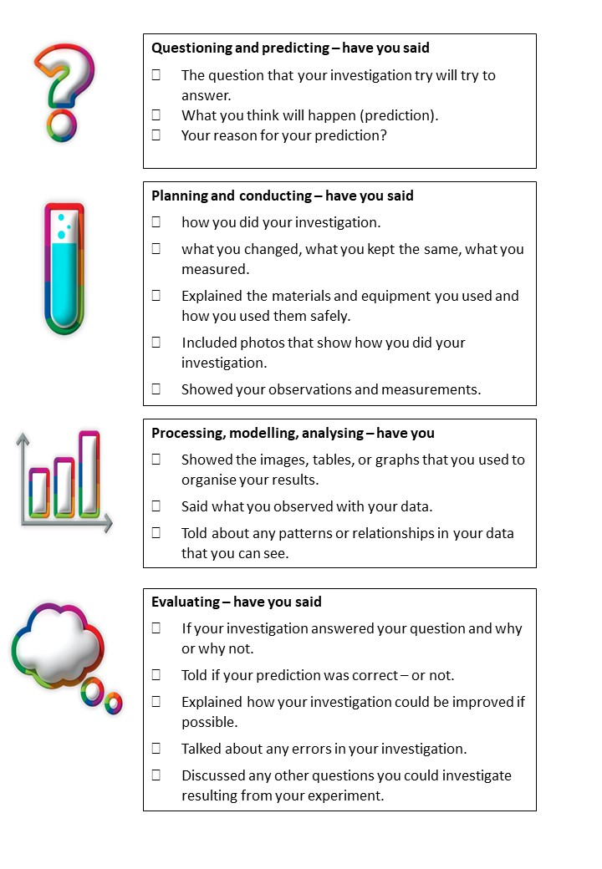

**Finally – Watch your video!** This is very important.

When watching your video look out for the following things. You might like to hold a video show for your family and friends. Ask your viewers what they think about your video. Make sure you have lots of popcorn!

When watching your finished video –

* Can everyone be heard clearly?
* Is everyone speaking at the same speed?
* Are all team members looking at the camera?
* Is only one person talking at a time?
* Is there any background noise? **Tip:** If there is you may need to record again somewhere quieter.
* Is all text, photos, tables and graphs you show large enough for the viewer to see and read? And have you given your viewer enough time to look at them?
* Have you included any creative elements to make your video interesting?
* Is your video between 3 and 4 minutes long?

**Have fun and we look forward to seeing your amazing investigations!**