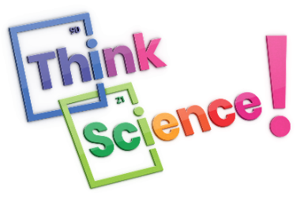

**Think Science! Newsletter 4**

**This month: Evaluating**

**Comparing findings**

After processing and analysing their data, teams need to compare their findings to the prediction (or hypothesis) they made at the start of their investigation. They should state whether their prediction was correct or not, and try to **explain what their results mean or why they are important to the real world**. Secondary students will also need to address relevant scientific concepts from their background research when explaining their results.

Additionally, findings can be compared with those of others. Comparisons can be made with other findings in the class or with published data.

Students should not be discouraged by any unexpected results. These are regarded as an important part of science as they advance learning and can lead to new discoveries! The results themselves will not influence scores in *Think Science!*

**Considering the good and not so good**

There is no such thing as a perfect investigation. Students can be reluctant to identify any flaws in their investigation, thinking that marks will be lost if they highlight these flaws. Students can be assured that **a good evaluation is balanced and reflects on both strengths and weaknesses at each stage**.

Students should identify possible sources of error affecting any results. These could be **consistent errors** that relate to how the experiment was set-up or how measurements were taken that affect results in the same way. An example of a consistent error is if the weighing scale did not read zero when there was nothing on the scale and was not adjusted before weight measurements were taken (see diagram below).

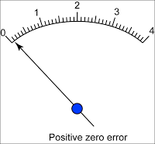

Image credit: [1.4.1 Error in Measurement – user's Blog! (myhometuition.com)](https://content.myhometuition.com/2020/04/16/1-4-1-error-in-measurement/)

**Random errors** can also occur, affecting some of the results, but not all results. An example of a random error is a slight variation in an environmental condition. Students should describe each type of error that possibly affected their investigation.

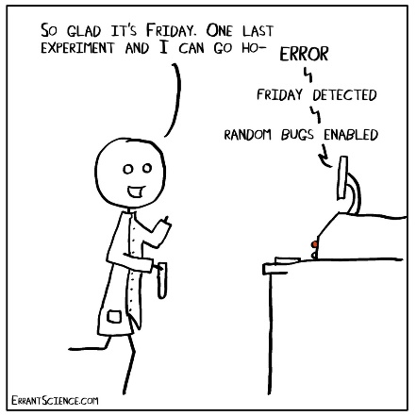

Image credit: <https://errantscience.com/>

**How can we do things better?**

After evaluating sources of error, teams should reflect on what they would do differently if they did this investigation again. They should **suggest specific and relevant ways of improving their investigation**. These improvements could relate to the experimental design, or they could relate to how the data are measured or collected.

**What else would we like to know?**

Science discovery is an ongoing process and unexpected results can be valuable here as they lead to more questions! All teams should identify at least one question for further investigation as part of their evaluation. **All questions for further investigation need to be relevant and testable**.

**In conclusion…….**

A conclusion is normally provided at the end of a science investigation. It should briefly restate the investigation question and **summarise the main finding(s) of the investigation or what was learned**, referring to the variable that was changed and the variable that was measured. The conclusion must be based on the results obtained.

