

Investigating radioactivity in the air we breathe
Information Processing and Data Analysis
Student worksheet
This document and its accompanying Excel workbook provide the opportunity to process and analyse authentic scientific data created at ANSTO. The data, collected in 2020, provide radioactivity readings of both uncharged and electrostatically charged balloons hung in the ANSTO Discovery Centre. We have provided the method for this experiment for students who wish to try it at school.
Students will:
- Propose a hypothesis after reading introductory information
- Analyse data, create a graph, interpret results and evaluate the experiment
- Learn about radon as a natural source of background radiation
This task addresses Science Understanding and Inquiry Skills descriptors in the Australian Curriculum.
Students:
- Understand all matter is made of atoms that are composed of protons, neutrons and electrons; natural radioactivity arises from the decay of nuclei in atoms (ACSSU177)
- Formulate questions or hypotheses that can be investigated scientifically (ACSIS164)
- Analyse patterns and trends in data, including describing relationships between variables and identifying inconsistencies (ACSIS169)
- Use knowledge of scientific concepts to draw conclusions that are consistent with evidence (ACSIS170)
- Evaluate conclusions, including identifying sources of uncertainty and possible alternative explanations, and describe specific ways to improve the quality of the data (ACSIS171)
- Communicate scientific ideas and information for a particular purpose, including constructing evidence-based arguments and using appropriate scientific language, conventions and representations (ACSIS174)
This resource is appropriate for Years 9-12.

Introduction

Background radiation
Ionising radiation comes from both natural and human-made sources. Background radiation from natural sources includes radiation from cosmic rays, radioactive material in rocks and soil, naturally-occurring radionuclides in food and other humans. Ionising radiation from human-made sources is largely from nuclear medical procedures, such as X-rays, PET or SPECT scans, radiotherapy or treatment with a radiopharmaceutical.
A person’s radiation dose from natural background sources of radiation depends on many factors, such as the altitude, latitude and geology of where they live, and their diet. On average, Australians are exposed to 1.5 mSv each year from natural sources. Human-made sources of radiation, mainly from medical diagnostic tests and treatments, contribute, on average, an extra 1.7 mSv to an Australian’s yearly radiation dose.
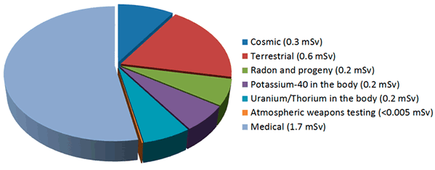
Average yearly radiation exposure in Australia. Source: ARPANSA (https://www.arpansa.gov.au/understanding-radiation/radiation-sources/more-radiation-sources/ionising-radiation-and-health).

Radon gas
Radon gas is radioactive and arises naturally from the radioactive decay of uranium and thorium, normally present in rocks, soil, bricks, mortar, tiles and concrete. When it is released in outside or well-ventilated environments, it dilutes in surrounding air and is not a concern. However, radon gas can accumulate in enclosed spaces, like indoor environments or underground caves, and pose a risk to lung health.
Radon is an inert gas, so it does not stick to the walls of the respiratory tract or travel deep into the lungs when it is inhaled. However, when radon gas decays, it produces atoms of heavy metal elements, which can become attached to extremely small solid particles or very small liquid droplets suspended in air (aerosols). These aerosols and the heavy metal atoms stuck to them remain in the lungs when they are inhaled. The alpha particles produced by some of these radioactive metal atoms when they decay can damage the delicate cells lining the lungs, increasing the risk of lung cancer.
Homes with high levels of radon are often located in regions of a particular geology; areas with lots of granite and shale, which usually contains higher amounts of uranium, may have higher indoor radon levels. Homes in these areas may need radon monitors to ensure that indoor radon levels do not reach hazardous levels. Australia has very low household levels of radon compared to other countries. You can find the average household levels of radon for your area on ARPANSA’s interactive radon map: https://www.arpansa.gov.au/understanding-radiation/radiation-sources/more-radiation-sources/radon-map.

Radon decay
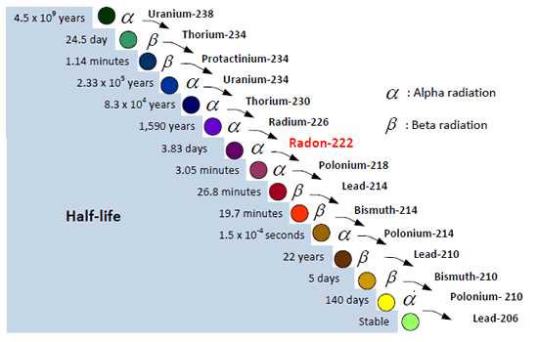
Uranium-238 decay chain. Source: Canadian Nuclear Safety Commission (https://nuclearsafety.gc.ca/eng/resources/fact-sheets/radon-fact-sheet.cfm)

An isotope is an atom of an element with the same number of protons but a different number of neutrons in its nucleus. Hence isotopes of the same element have different atomic masses and we use the mass number (the total number of protons and neutrons in the nucleus) to identify the specific isotope. Radon-222, the most common isotope of radon, comes from the decay of uranium-238 (pictured above). When a radioactive atom decays, it releases particles and/or energy in the form of ionising radiation from its nucleus and often transforms into an atom of a new element. Radon-222 is part of a series of 14 transformations, called a decay chain, which takes billions of years from start to finish. The different products along the decay chain are called daughter products or progeny.
Except for radon-222, the progeny of uranium-238 are all solids at room temperature, and each have different half-lives, ranging from a fraction of a second to thousands of years. Each radioactive decay in the chain emits either alpha or beta radiation, depending on the progeny undergoing decay. The final decay product at the end of the decay chain is lead-206, which is stable and not radioactive.

Precipitating radon progeny from the air using a balloon
Gaseous radon-222 atoms decay into solid polonium-218 atoms, which interact with water molecules or trace gases in the air to form tiny clusters. These charged clusters either attach to aerosol particles and remain airborne, or fall out of the air onto surfaces below. As Po-218 decays, its progeny (Pb-214 and Bi-214) can also remain airborne for several hours before they start to fall and accumulate on surfaces. All these radioisotopes can pose a health hazard if they accumulate in the air at high concentrations.
We can use a balloon to capture and concentrate radon progeny in air. When a balloon is rubbed it gains an overall negative charge due to excess electrons on the balloon surface and is able to attract aerosol particles in the air, some containing radon progeny. Because concentrations of radon progeny are usually highest in indoor environments in places closest to soil or bedrock, since they are produced by uranium and thorium decay, hanging the charged balloon close to the floor maximises the potential concentration of radon progeny that can be accumulated on the balloon. Radon gas itself will not accumulate on the balloon as it is a noble gas and is uncharged.
In the following practical investigation, we explore whether a charged balloon can capture and concentrate radon progeny. We have completed a controlled version of this experiment for you and supplied the data in an EXCEL spreadsheet. Read the background information above and the experiment we conducted (below) to propose your own hypothesis and answer the questions at the end of the experiment.
The following investigation was performed at a desk in the ANSTO Discovery Centre theatre with the windows and doors closed. The results data from the investigation is provided in the EXCEL spreadsheet.

Practical Investigation

Aim

To investigate the effect of charging a balloon which is hung in an enclosed space on its level of radioactivity.

Hypothesis
Propose your own hypothesis:
……………………………………………………………………………………………………………………………………………………………………………………………………………………………………………………………………………………………………………………………………………………………………………………………………………………………………………………………………………………….

Equipment
- Geiger counter
- 12 balloons
- Microfiber cloth or your hair
- Scissors
- String
- Permanent marker
- Tweezers

Risk Assessment

Risks | Safety Precautions
Exposure to radioactivity on the balloon | Levels of radioactivity on the balloon will be low, but to minimise exposure:  - Minimise handling the balloon once it has been deflated by using tweezers  - Don’t touch your face during the experiment  - Dispose of the balloon in the bin after the experiment  - Wash hands after the experiment  - Wipe the Geiger counter detector when finished

Method:
Treatment A: electrostatically charged, inflated balloon hung for 60 minutes
- Choose an enclosed indoor area, ensuring the windows and doors are closed.
- Select six balloons and use the permanent marker to number them A1 to A6.
- For balloon A1, place the Geiger counter directly on top of the uninflated balloon and measure the radioactivity every minute in counts per minute (cpm) for 10 minutes. Determine the average radioactivity of the balloon in cpm over the 10 minute period.
- Inflate balloon A1. Count the number of breaths you used to inflate the balloon. Tie 30 cm of string to the balloon.
- Rub the balloon on your hair for one minute.
- Without touching the balloon, suspend the balloon in the enclosed area so that it hangs within 30 cm of the ground. Leave the balloon in this position for 60 minutes.
- Repeat steps 3 to 6 for balloons A2-A6, leaving a 10 minute time interval between the preparation of each balloon. Inflate each balloon to approximately the same size by using the same number of breaths for each balloon.
- When balloon A1 has hung for 60 minutes, slowly deflate the balloon using scissors to nick an area near the balloon tie.
- Using tweezers to handle the balloon, place the deflated balloon under the Geiger counter and measure the radioactivity every minute in cpm for 10 minutes. Determine the average radioactivity of balloon A1 in cpm over the 10 minute period.
- Repeat steps 8 and 9 for balloons A2 – A6, hanging them in the same enclosed indoor area.

Treatment B: uncharged, inflated balloon hung for 60 minutes
- Use the same enclosed indoor area as for group A.
- For the remaining 6 balloons use the permanent marker to number them B1 to B6.
- For balloon B1, place the Geiger counter directly on top of the uninflated balloon and measure the radioactivity every minute in cpm for 10 minutes. Determine the average radioactivity of the balloon in cpm over the 10 minute period.
- Inflate balloon B1. Count the number of breaths you used to inflate the balloon. Tie 30 cm of string to the balloon.
- Without touching the balloon, suspend the balloon in the enclosed area so that it hangs within 30 cm of the ground. Leave the balloon in this position for 60 minutes.
- Repeat steps 3 to 6 for balloons B2-B6, leaving a 10 minute time interval between the preparation of each balloon. Inflate each balloon to approximately the same size by using the same number of breaths for each balloon.
- When balloon B1 has hung for 60 minutes, slowly deflate the balloon using scissors to nick an area near the balloon tie.
- Using tweezers to handle the balloon, place the deflated balloon under the Geiger counter and measure the radioactivity every minute in cpm for 10 minutes. Determine the average radioactivity of the balloon in cpm over the 10 minute period.
- Repeat steps 7 and 8 for balloons B2-B6.

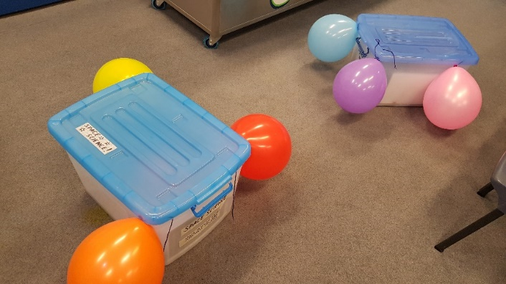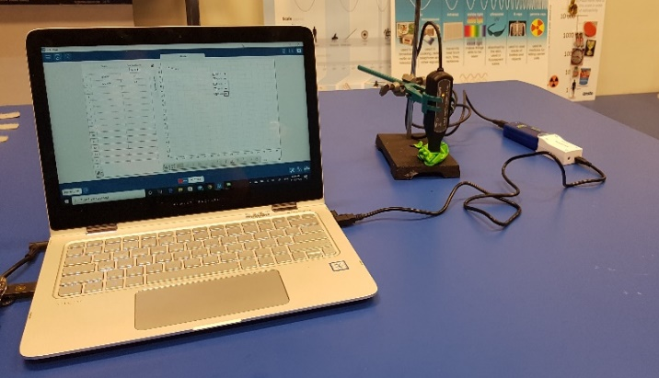
Left: Inflated balloons hanging for 60 minutes within 30 cm of the ground. Right: Measuring radioactivity of balloons using a digital Geiger counter connected to data logger software.

Results
a) Using the data in the supplied Excel spreadsheet, construct a 2D clustered column graph to show the radioactivity of the uninflated and deflated balloons for both Treatments A and B.
Label your axes and include units. Give your graph a title. Insert a copy of your graph in the space below.

HINT: You can use the following steps to create your chart:

- Highlight all the data in column B ‘Balloon number’ by placing the cursor in the first treatment replicate ‘A1’ (cell B3) and clicking and dragging the cursor down to the last treatment replicate ‘B6’ (cell B15).
- Hold down the control button and highlight all the data in column M ‘Uninflated balloon average’ highlighting from cell M3 to M15.
- On the Insert tab, in the Charts group, click the column graph symbol.

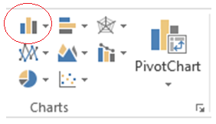

- Choose 2D clustered column graph (first graph under 2D column heading).
- Right click on the chart area, click Select data. Under Legend entries select Edit. Edit Series name to “Uninflated balloons”. Click OK.
- Still in Select data Source dialog box, select Add to add a second series of data. Edit Series name to “Deflated balloons”. Under Series values, click the icon to the right (circled in red below). This will minimise this window. Highlight data in Column X for the average radioactivity of the deflated balloons (X3 to X15), press enter then click OK. Click OK to close the dialog box.
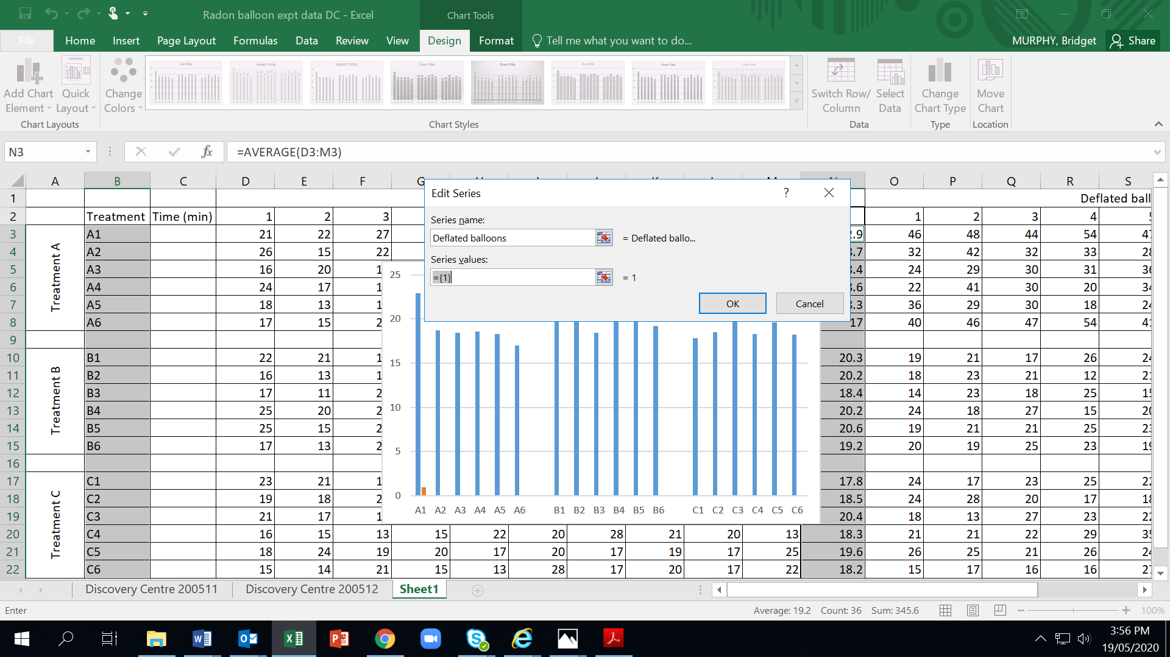
- Add axes titles, chart title and a legend to your graph. Add the title Treatment for Primary Horizontal axis.
Using textboxes, insert two secondary labels on the horizontal axis under each different treatment: Charged (A) and Uncharged (B). Add the title Radioactivity of balloons (cpm) for the Primary Vertical axis.
(For Excel 2013, click on your graph and then click on Design tab in Chart Tools. Add Chart Elements appears on left hand side of tool bar. Click here for Axis Titles and Chart Title.)

b) Describe your results
……………………………………………………………………………………………………………………………………………………………………………………………………………………………………………………………………………………………………………………………………………………………………………………………………………………………………………………………………………………….……………………………………………………………………………………………………………………………………………………………………………………………………………………………………………………………………………………………………………………………………………………………………………………………………………………………………………………………………………………….

Conclusion
c) Write a conclusion for your experiment
……………………………………………………………………………………………………………………………………………………………………………………………………………………………………………………………………………………………………………………………………………………………………………………………………………………………………………………………………………………….

Discussion Questions
Using the background information and the experimental method above, and the excel data sheet provided, answer the questions below:
d) Explain why radon gas is a potential hazard in indoor environments.
……………………………………………………………………………………………………………………………………………………………………………………………………………………………………………………………………………………………………………………………………………………………………………………………………………………………………………………………………………………….……………………………………………………………………………………………………………………………………………………………………………………………………………………………………………………………………………………………………………………………………………………………………………………………………………………………………………………………………………………….

e) Propose THREE factors that could affect the amount of radon gas that accumulates in an indoor environment
……………………………………………………………………………………………………………………………………………………………………………………………………………………………………………………………………………………………………………………………………………………………………………………………………………………………………………………………………………………….…………………………………………………………………………………………………………………………………………………………………………………………………………………………………………………………………………………………………………………………
f) Examine the diagram of the uranium-238 decay chain. Identify which radon progeny are most likely to accumulate on the surface of the balloon. (HINT: Consider the half-lives of these progeny. It is unlikely that solid particles will remain airborne for more than a few days or weeks).
…………………………………………………………………………………………………………………………………………………………………………………………………………………………………………………………………………………………………………………………

g) Why was the initial radioactivity of each balloon measured before it was inflated?
……………………………………………………………………………………………………………………………………………………………………………………………………………………………………………………………………………………………………………………………………………………………………………………………………………………………………………………………………………………….

h) Explain why you rubbed some of the balloons before hanging them for 60 minutes.
……………………………………………………………………………………………………………………………………………………………………………………………………………………………………………………………………………………………………………………………………………………………………………………………………………………………………………………………………………………….……………………………………………………………………………………………………………………………………………………………

i) Explain the purpose of Treatment B in this experiment.
……………………………………………………………………………………………………………………………………………………………………………………………………………………………………………………………………………………………………………………………………………………………………………………………………………………………………………………………………………………….……………………………………………………………………………………………………………………………………………………………

j) Explain why you deflated each balloon before measuring its radioactivity.
……………………………………………………………………………………………………………………………………………………………………………………………………………………………………………………………………………………………………………………………………………………………………………………………………………………………………………………………………………………….……………………………………………………………………………………………………………………………………………………………

k) In similar experiments, other people have recorded levels of radiation on charged balloons that is up to 460 times higher than the radioactivity of the initial uninflated balloon.
Identify THREE factors that might affect the amount of radioactivity that accumulates on the surfaces of the inflated charged balloons. Propose a reason why each factor might affect the radioactivity of the balloons.
Factor | Reason

l) Suggest three ways to improve the experiment.
……………………………………………………………………………………………………………………………………………………………………………………………………………………………………………………………………………………………………………………………………………………………………………………………………………………………………………………………………………………….…………………………………………………………………………………………………………………………………………………………………………………………………………………………………………………………………………………………………………………………………………………………………………………………………………………………………………………………………………………………………………………………………………………………………………………………………………………………………………………….…………………………………………………………………………………………………………………………………………………………………………………………………………………………………………………………………………………………………………………………

m) Evaluate the accuracy, reliability and validity of this experiment. (For definitions of these terms, refer to “Evaluating Scientific Investigations” from the NSW Department of Education)
……………………………………………………………………………………………………………………………………………………………………………………………………………………………………………………………………………………………………………………………………………………………………………………………………………………………………………………………………………………….…………………………………………………………………………………………………………………………………………………………………………………………………………………………………………………………………………………………………………………………………………………………………………………………………………………………………………………………………………………………………………………………………………………………………………………………………………………………………………………….…………………………………………………………………………………………………………………………………………………………………………………………………………………………………………………………………………………………………………………………………………………………………………………………………………………………………………………………………………………………………………………………………………………………………………………………………………………………………………………….…………………………………………………………………………………………………………………………………………………………………………………………………………………………………………………………………………………………………………………………………………………………………………………………………………………………………………………………………………………………………………………………………………………………………………………………………………………………………………………….…………………………………………………………………………………………………………………………………………………………………………………………………………………………………………………………………………………………………………………………………………………………………………………………………………………………………………………………………………………………………………………………………………………………………………………………………………………………………………………….……………………………………………………………………………………………………………………………………………………………

n) There are multiple experiments you could design using electrostatically charged balloons to accumulate radioactivity. Using your knowledge from your background reading, write hypotheses for each of the following aims for potential follow-up experiments, and explain why you might predict that outcome.
(Note: An explanation is normally not required as part of a hypothesis. For this activity, however, we’ve asked for an explanation to help assess your understanding of the background reading)
Aim 1: To investigate the effect of the environment (indoor vs outdoor) on the level or airborne radioactivity collected on a charged balloon.
Hypothesis 1:
………………………………………………………………………………………………………………………………………………………………………………………………………………………………………………………………………………………………………………
Explanation 1:
………………………………………………………………………………………………………………………………………………………………………………………………………………………………………………………………………………………………………………
Aim 2: To investigate if the type of building material (timber or brick) of a dwelling affects the level of airborne radioactivity collected on a charged balloon.
Hypothesis 2:
………………………………………………………………………………………………………………………………………………………………………………………………………………………………………………………………………………………………………………
Explanation 2:
………………………………………………………………………………………………………………………………………………………………………………………………………………………………………………………………………………………………………………
Aim 3: To investigate if ventilation in an indoor environment affects the level of airborne radioactivity collected on a charged balloon.
Hypothesis 3:
………………………………………………………………………………………………………………………………………………………………………………………………………………………………………………………………………………………………………………
Explanation 3:
………………………………………………………………………………………………………………………………………………………………………………………………………………………………………………………………………………………………………………

Further reading:
ANSTO. (2018). What is radiation. Brochure. https://www.ansto.gov.au/sites/default/files/2019-01/What%20is%20radiation%20brochure%202018%20final%20eVersion.pdf
ANSTO. (2017). How radioactive am I? Online game. https://www.ansto.gov.au/education/apps
ARPANSA. (2020). Ionising radiation and health. Website. https://www.arpansa.gov.au/understanding-radiation/radiation-sources/more-radiation-sources/ionising-radiation-and-health
ARPANSA. (2020). Radon map of Australia. Online interactive map. https://www.arpansa.gov.au/understanding-radiation/radiation-sources/more-radiation-sources/radon-map
Images Scientific Instruments. (2007-2020). Geiger Counter Experiment #6. Website. https://www.imagesco.com/nuclear-science/geiger-counter/experiment-6.html

