

Fine Particle Air Pollution
Information Processing and Data Analysis
Student Worksheet
This document and its accompanying MS Excel workbook provide the opportunity for students to process and analyse authentic scientific data created at ANSTO.
The authentic data provides records from February 1998 to December 2019 of the concentration of 12 elements present in fine airborne particulate matter from an air sampling station located in Mayfield in Newcastle, NSW.
Students will:
- construct graphs using MS Excel
- analyse their graphs to determine the trends of fine particle pollution in Newcastle
- process information from suggested videos and background information to determine the source/s of the fine particle pollution and answer the questions provided.
The activities provided address these Australian Curriculum version 9: Science Inquiry Skills:
- select and construct appropriate representations, including tables, graphs, descriptive statistics, models and mathematical relationships, to organise and process data and information (AC9S9I04/ AC9S10I04)
- analyse and connect a variety of data and information to identify and explain patterns, trends, relationships and anomalies (AC9S9I05/ AC9S10I05)
- write and create texts to communicate ideas, findings and arguments effectively for identified purposes and audiences, including selection of appropriate content, language and text features, using digital tools as appropriate ( AC9S9I08/ AC9S10I08)
These activities are suitable for students in Years 9 to 12.

Fine Particle Pollution

On average a person can survive without food for 3 weeks and without water for 3 days, but without air for only 3 minutes! Breathing is something most of us all just do… subconsciously without much thought. But have you ever taken the time to think about just how much air we are actually breathe into our lungs each year? And, more importantly, what is in the “air” we breathe?
When we think of air, we might know that it is mixture of gases including nitrogen (78.09%), oxygen (20.95%), argon (0.93%) and carbon dioxide (0.04%) as well as small amounts of other gases such as radon, ozone, methane, helium, and a variable amount of water vapour. However, in addition to these gases, “air” also contains particles, often referred to as airborne particulate matter. Airborne particulate matter is classified by the size of the particles. The fraction of the smallest particles, which have a diameter of 2.5 micrometres or less, are called fine particles, and are known as PM2.5.
Fine particles are 40-50 times smaller than the diameter of a human hair. While the human eye cannot see these fine particles, high concentrations of them appear as visible atmospheric haze, or smog. They can also cause significant health problems, as the human nose and throat are inefficient at filtering them out, meaning they can penetrate deep into the lungs and even our blood stream.
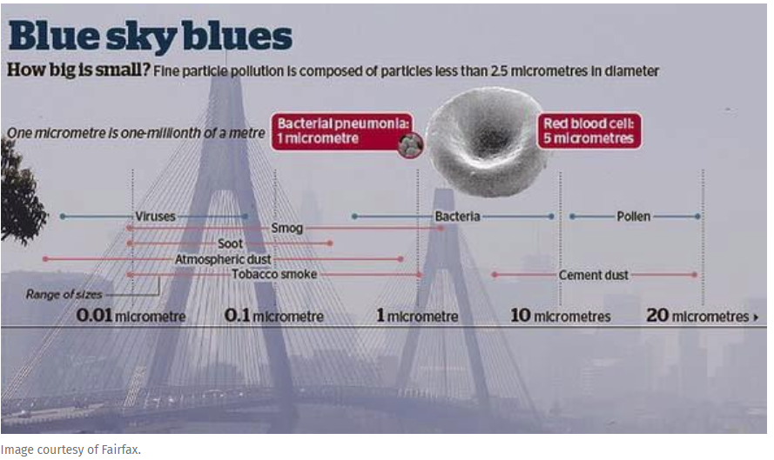
image sourced from https://www.ansto.gov.au/research/programs/other/aerosol-sampling-program

Rapid population growth has created a rise in fine particle pollution. Fine particle pollution is generated by urbanisation, the operation of industry, trucks and cars, coal-fired power stations, wood-burning heaters and other man-made sources. There are also natural sources of fine particle pollution such as sea spray and dust storms, as well as from other naturally occurring events such as volcanic eruptions and bush fires. Many particles are also formed in the atmosphere as a result of complex chemical reactions.
There is mounting evidence that links the inhalation of fine particle air pollution to a range of serious human health implications including respiratory disease and infection, cardiovascular disease, stroke and premature death. A 2014 report from the World Health Organisation (WHO) estimates that approximately 7 million people in 2012 died prematurely as a result of exposure to air pollution– making it one of the world’s largest single environmental health risks*.
Fine particles can be easily transported over long distances across international borders and around the globe. They can influence climate change on a global scale through absorption and scattering of solar radiation. Fine particle pollution also causes environmental damage to stone and other materials.

Method and Study Site

The data for this activity were collected at an air sampling station located in Mayfield, one of Newcastle’s older suburbs. Newcastle is located in NSW on the east coast of Australia, about 150 km north of Sydney. This region was developed as an area for heavy industry, specifically for iron and steel making and steel products, non-ferrous metal manufacture, chemical and fertiliser manufacture, petroleum and coal-tar products. Significant tonnes of coal are also exported annually from Australia to Asia through the port of Newcastle. Mayfield is close to the highly industrialised areas and the port of Newcastle.

Many changes have occurred in the area over the time of the sampling shown in the data. At the end of last century, one of the major BHP steel works in Newcastle closed, shutting down its blast furnaces. Mayfield was also home to a Manganese dioxide plant, Delta Manganese, however this plant closed down as well. In NSW, leaded petrol was withdrawn from sale in January 2001. Lead remains a significant legacy in the community with the accumulation of fine particles of lead in soil, particularly near busy roads, from the times when petrol contained high levels of lead. These fine particles of lead are still being detected in the sampled air, with the concentrations being highest in winter because of the inversion layer which occurs at this time. During extended periods of high pressure in winter months, solar radiation reaches the ground, warming it up. At night, the ground loses heat rapidly and the air closest to the ground becomes colder. The warmer air rises and traps the cooler air below, effectively trapping smog containing these lead particles.

Apart from man-made sources of fine particle pollution, the Mayfield sampling station also detects fine particle pollution from natural sources and natural events such as dust storms, which occur when strong winds lift large amounts of sand and dust from bare, dry soils into the atmosphere, transporting them hundreds to thousands of kilometres away.

ANSTO has been measuring and characterising fine particle pollution from key sites around Australia, including Mayfield, for more than 30 years. Fine particulate matter is collected on thin Teflon filters every Sunday and Wednesday and sent to ANSTO for analysis.
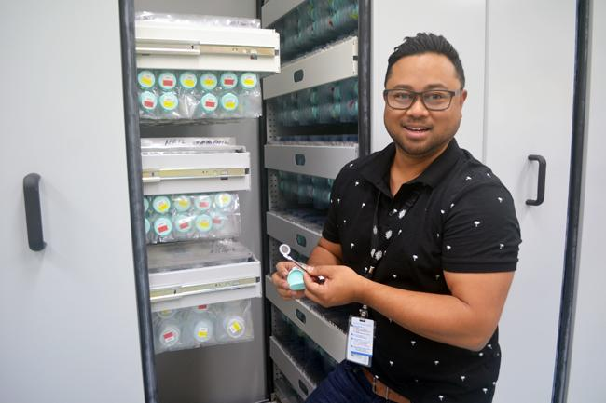
ANSTO’s Dr Armand Atanacio, Senior Accelerator scientist, holds a sample filter in front of the archive of 65,000 samples


Exposed stretched Teflon filter,
specifically designed for IBA
analysis
Using ion beam analysis (IBA) on our 2 MV STAR accelerator, we can simultaneously determine 21 key air pollution elements collected on each filter, with sensitivity down to 1ng/m³ of sampled air. It is a non-destructive test and requires no additional sample preparation. It takes only 5 minutes per filter for the IBA analysis to be completed, making it an ideal technique for the hundreds of samples collected each month as part of the ongoing research program. Using powerful statistical analysis techniques we can identify the sources of these fine particles and correlate events with levels of specific pollutants.

All values given in the spreadsheet (Mayfield PM2.5 Air Pollution Data MS Excel Workbook), including the concentrations of the fine particle pollution, that is for particles with a diameter of 2.5 μm or less (PM2.5), are measured in nanograms per cubic metre of air sampled (ng/m³). The data presented are the mean absolute concentration for each month. Note there are three months in the spreadsheet for which no data (indicated using NA) is provided – Dec-02, Jan-03 and Jan-06.

Further background reading for students
Before beginning the information and data analysis tasks, read the background information provided on Fine Particle Pollution and the Method and Study Site and view the videos and articles listed here.
Use the information presented in these sources to assist you in answering the questions in the tasks.
- https://www.ansto.gov.au/research/programs/other/aerosol-sampling-program
- a video of Prof David Cohen introducing fine particle pollution and revealing the sources of Sydney's air pollution
- a video on how fine particle samples are collected

- https://www.ansto.gov.au/2mv-star-tandem-accelerator
- ANSTO STAR accelerator animation
- SBS The Crew learn about ANSTO's STAR Accelerator video

- https://www.ansto.gov.au/ion-beam-analysis
- Ion beam analysis simulation
- particle induced X-ray emission (PIXE) and particle induced gamma ray emission (PIGE) simulation

- https://www.who.int/mediacentre/news/releases/2014/air-pollution/en/
- *World Health Organisation News Release: 7 million premature deaths annually linked to air pollution

- https://www.abc.net.au/news/2009-09-23/dust-storm-chokes-sydney/1438510
- ABC news article on severe dust storm
https://www.abc.net.au/news/2008-03-20/mayfield-chemical-plant-winds-down/1078548
- ABC news article on closure of Mayfield Chemical Plant

https://www.abc.net.au/news/2009-09-30/newcastle-remembers-steelworks-closure/1084304
- ABC news article on closure of Newcastle Steelworks

Determining the sources and trends of fine particle pollution in Newcastle, NSW

Use the background information and recommended sources to assist you in answering the following questions.
- The amount of air inhaled during a normal breath is around 500 mL. The normal respiratory rate for teenagers (age 12 to 18 years) is about 14 breaths per minute.
Using this information, calculate how much air, in litres and in m³, a teenager would take into their lungs each year. (HINT 1000 L = 1 m³). Is this number realistic, if not why?
…………………………………………………………………………………………………………………………………………………………………………………………………………………………………………………………………………………………………………………………
…………………………………………………………………………………………………………………………………………………………………………………………………………………………………………………………………………………………………………………………
……………………………………………………………………………………………………………………………………………………………

- Suggest THREE variables that would need to be controlled to ensure the samples of fine particulate matter collected on the thin Teflon filters at the Mayfield air sampling station are comparable over the time for which the samples were taken.
…………………………………………………………………………………………………………………………………………………………………………………………………………………………………………………………………………………………………………………………
……………………………………………………………………………………………………………………………………………………………

- Briefly describe how the Teflon filter samples are analysed.
…………………………………………………………………………………………………………………………………………………………………………………………………………………………………………………………………………………………………………………………
…………………………………………………………………………………………………………………………………………………………………………………………………………………………………………………………………………………………………………………………
…………………………………………………………………………………………………………………………………………………………………………………………………………………………………………………………………………………………………………………………
…………………………………………………………………………………………………………………………………………………………………………………………………………………………………………………………………………………………………………………………

- What is meant by non-destructive testing? Describe another example of non-destructive testing.
…………………………………………………………………………………………………………………………………………………………………………………………………………………………………………………………………………………………………………………………
……………………………………………………………………………………………………………………………………………………………
……………………………………………………………………………………………………………………………………………………………
- The units used for the measurement of the elements present on the filter are nanograms per cubic metre of air sampled (ng/m³). Compare 1ng with 1g.
…………………………………………………………………………………………………………………………………………………………………………………………………………………………………………………………………………………………………………………………

- Using the Mayfield data, construct a 2D clustered column graph to show the concentration of Manganese (Mn) in sampled air from February 1988 to December 2019.

Label your axes and include units. Give your graph a title.
Insert a copy of your graph in the space below.

HINT: You can use the following steps to create your chart:

- Highlight all the data in column A ‘1998-2019’, by clicking in the cell of the first date, Feb-98 (cell A8) and simultaneously hold down CTRL +SHIFT + ↓ (Down Arrow) keys. This will highlight the entire column of data in column A.
- Scroll to the top of the spreadsheet and, holding down the control (CTRL) button, click in cell Q8, the first data cell of column Q ‘Mn’. Whilst still depressing the CTRL button, simultaneously hold down the SHIFT + ↓ (Down Arrow) keys to highlight all the data in column Q ‘Mn’.
- On the Insert tab, in the Charts group, click the column graph symbol.

- Choose 2D clustered column graph (first graph under 2D column heading).
- Click on your graph and then click on Chart Design tab from the top tool bar. Add Chart Elements appears on left hand side of tool bar.
- Click on Add Chart Elements and scroll down to Chart Title. Choose above chart, click in the box at the top of the spreadsheet and type the title of your graph -Manganese PM2.5 concentration in air sampled at Mayfield from 1998 to 2019. Press ENTER.
- Repeat for Axis Titles, both Primary Horizontal and Primary Vertical. Add the title Month-Year for Primary Horizontal axis and the title mean monthly concentration of PM2.5 manganese, Mn (ng/m³) for the Primary Vertical axis.
- Right-click the x axis labels (horizontal axis) and select Format Axis in the dialog box. For Axis position choose On tick marks. Click on LABELS select specify interval unit and type 6 in the box. Press ENTER.
- To remove decimal points from y axis scale, right-click the y axis labels (vertical axis) and select Format Axis in the dialog box. Click on NUMBER and for decimal places type 0 in the box.

Insert a copy of your graph in the space below.

- Describe any trends and changes in the concentration of Manganese from February 1998 to December 2019 shown by the graph.

…………………………………………………………………………………………………………………………………………………………………………………………………………………………………………………………………………………………………………………………
…………………………………………………………………………………………………………………………………………………………………………………………………………………………………………………………………………………………………………………………
…………………………………………………………………………………………………………………………………………………………………………………………………………………………………………………………………………………………………………………………
……………………………………………………………………………………………………………………………………………………………

- Account for any trends and changes that you have described in part g.

…………………………………………………………………………………………………………………………………………………………………………………………………………………………………………………………………………………………………………………………
…………………………………………………………………………………………………………………………………………………………………………………………………………………………………………………………………………………………………………………………
…………………………………………………………………………………………………………………………………………………………………………………………………………………………………………………………………………………………………………………………
……………………………………………………………………………………………………………………………………………………………
- Using the Mayfield data, construct a 2D clustered column graph to show the concentration of Iron (Fe) in sampled air from February 1988 to December 2019.

Label your axes and include units. Give your graph a title.
Insert a copy of your graph in the space below.

HINT: Use the instructions provided for the construction of the Manganese graph on page 7 and 8 but, for step 2, hold down the control (CTRL) button, click in cell R8, the first data cell of column R ‘Fe’, and, whilst still depressing the CTRL button, simultaneously hold down the SHIFT + ↓ (Down Arrow) keys to highlight all the data in column R ‘Fe’.

- Account for the change in the concentration of iron in the sampled air at the beginning of the year 2000.

…………………………………………………………………………………………………………………………………………………………………………………………………………………………………………………………………………………………………………………………
…………………………………………………………………………………………………………………………………………………………………………………………………………………………………………………………………………………………………………………………
…………………………………………………………………………………………………………………………………………………………………………………………………………………………………………………………………………………………………………………………
- There are many different oxides found in soil, including silicon dioxide (SiO₂) and aluminium oxide (Al₂O₃). Soil in the atmosphere occurs from natural windblown dust, agriculture and industries such as quarrying.

Construct 2D clustered column graphs to show the concentration of silicon (Si) and aluminium (Al) in sampled air from February 1988 to December 2019 (that is, you will need to construct two separate graphs).

Insert copies of your graphs in the space below.

- Compare the graphs of aluminium (Al) and silicon (Si), and compare these with the graph you constructed for iron (Fe). Account for any similarities.

…………………………………………………………………………………………………………………………………………………………………………………………………………………………………………………………………………………………………………………………
…………………………………………………………………………………………………………………………………………………………………………………………………………………………………………………………………………………………………………………………
…………………………………………………………………………………………………………………………………………………………………………………………………………………………………………………………………………………………………………………………
…………………………………………………………………………………………………………………………………………………………………………………………………………………………………………………………………………………………………………………………

- Using the Mayfield data, construct a 2D clustered column graph to show the concentration of Lead (Pb) in sampled air from February 1988 to December 2019.
Label your axes and include units. Give your graph a title.
Insert a copy of your graph in the space below.

- Describe the trend shown by the graph and account for any changes in the concentration of lead from February 1998 to December 2019.

…………………………………………………………………………………………………………………………………………………………………………………………………………………………………………………………………………………………………………………………
…………………………………………………………………………………………………………………………………………………………………………………………………………………………………………………………………………………………………………………………
…………………………………………………………………………………………………………………………………………………………………………………………………………………………………………………………………………………………………………………………
…………………………………………………………………………………………………………………………………………………………………………………………………………………………………………………………………………………………………………………………

- The graph shows a seasonal variation in the concentration of fine particles of lead. Describe the seasonal variation and explain why this seasonal variation occurs.

(HINT: consider the formation of an inversion layer and when this occurs)

…………………………………………………………………………………………………………………………………………………………………………………………………………………………………………………………………………………………………………………………
…………………………………………………………………………………………………………………………………………………………………………………………………………………………………………………………………………………………………………………………
…………………………………………………………………………………………………………………………………………………………………………………………………………………………………………………………………………………………………………………………
…………………………………………………………………………………………………………………………………………………………………………………………………………………………………………………………………………………………………………………………

- From the graphs you have constructed, and your research using the sources provided, compare the air over Mayfield today with the air over Mayfield in 1998, and evaluate the effect of any changes for the society and environment of Mayfield.
…………………………………………………………………………………………………………………………………………………………………………………………………………………………………………………………………………………………………………………………
…………………………………………………………………………………………………………………………………………………………………………………………………………………………………………………………………………………………………………………………
…………………………………………………………………………………………………………………………………………………………………………………………………………………………………………………………………………………………………………………………
…………………………………………………………………………………………………………………………………………………………………………………………………………………………………………………………………………………………………………………………
…………………………………………………………………………………………………………………………………………………………………………………………………………………………………………………………………………………………………………………………
…………………………………………………………………………………………………………………………………………………………………………………………………………………………………………………………………………………………………………………………
……………………………………………………………………………………………………………………………………………………………………………………………………………………………………………………………………………………………………………………………………………………………………………………………………………………………………………………………………………………………………………………………………………………………………………………………………………………………………………………
…………………………………………………………………………………………………………………………………………………………………………………………………………………………………………………………………………………………………………………………
…………………………………………………………………………………………………………………………………………………………………………………………………………………………………………………………………………………………………………………………

