

Year 9-10 Science
Student excursion workbook

Your visit to ANSTO

At the Discovery Centre, you will:
- Review atomic structure and isotopes, and describe the conditions that cause a nucleus to be unstable
- View an interactive demonstration to investigate the properties of alpha, beta and gamma radiation
- View a demonstration of the use of a scintillation counter to measure radiation from a variety of low level sources
- Represent alpha and beta reactions as nuclear reactions
- Describe nuclear fission
- Investigate nuclear reactions used at ANSTO to make important products
- Investigate the use of radioisotopes in medicine, industry and environmental monitoring

On site, you will visit:
- The OPAL (Open Pool Australian Lightwater) Reactor to investigate the uses of OPAL, including to create radioisotopes for use in nuclear medicine
- The Australian Centre for Neutron Scattering (ACNS) which makes use of neutrons to see inside materials at the atomic scale
- The ANSTO Nuclear Medicine (ANM) facility to investigate a nuclear reaction used to produce an important medical radioisotope, including the raw materials used, the various stages of production and nuclear waste
The tour will conclude at the Discovery Centre.

Contents
Pre-tour Questions

Question 1: Atomic structure review ……………………………………………………………………………………3
Question 2: Isotopes of elements …………………………………………………………………………………………5
Question 3: Radiation from the nucleus ……………………………………………………………………………….5
During Excursion Activities

Activity 1: Nuclear radiation and its uses in medicine 7
Activity 2: Why are some isotopes radioactive? 9
Activity 3: Investigating isotopes 10
Activity 4: It’s elementary! 12
Activity 5: Properties of α, β and γ radiation (during class presentation) ……………………….…..13
Activity 6: Measuring radiation (during class presentation …………………………………………………14
Post Excursion Questions
Question 1: Using nuclear reactions to produce an important nuclear medicine ………………..15
Question 2: Nuclear waste ………………………………………………………………………………………………….16
Question 3: Benefits and considerations for the use of radioisotopes …………………………………17

Pre-Tour Activities
Students should complete this pre-work prior to attending the tour. It explores concepts that are necessary to an understanding of the activities and the science concepts to be covered in the tour.
Question 1: Atomic structure review

Read the following information and use it to complete the activities below:
We all know that matter is made up of atoms, but humans didn’t always know this. And no one has ever seen inside an atom! A lot of scientists contributed in different ways, and performed a variety of experiments, to grow our understanding of the atom and its structure, resulting in the development of the model of the atom we use today.

We now know that an atom is mostly empty space, with an extremely tiny nucleus at its centre. The nucleus of an atom is made up of protons and neutrons, while electrons orbit the nucleus in the empty space that surrounds it. The electrons orbit in regions called electron shells or energy levels, which are often represented as rings around the nucleus in atom models. The first electron shell can hold up to two electrons, the second can hold up to eight, and the third can also hold up to eight electrons for the first 20 elements.

The number of protons in the nucleus of an atom is referred to as the atomic number. Atoms are neutral overall because they contain equal numbers of protons and electrons. This is because electrons have a negative (-1) charge, whereas protons have a positive (+1) charge. Neutrons are neutral and have no charge.

The mass of an atom is measured in atomic mass units, or amu. The nucleus contains nearly all the mass of the atom because protons and neutrons have a similar mass of around 1 amu, whereas electrons have a mass of only 0.0005 amu, which is ¹/₂₀₀₀th the mass of a proton or a neutron! The sum of the protons and neutrons of an atom is referred to as its mass number.

- Use the information in the box above to match the following words with their meaning:

atomic number, electron, neutron, proton, nucleus, mass number

Word | Meaning
 | Extremely small, dense, positively charged centre of an atom
 | Neutral subatomic particle found in the nucleus
 | Positively charged subatomic particle found in the nucleus
 | Number of protons in the nucleus
 | Total number of protons and neutrons in the nucleus
 | Negatively charged subatomic particle that orbits the nucleus

Use the information in the box on page 3 to complete the table below showing the difference in location, charge and mass of the subatomic particles that make up an atom.

Name of subatomic particle in the atom | Location of subatomic particle in the atom | Charge | Relative mass  (atomic mass units, amu)

(i) Use the information on page 3 to assist you to label the parts of an atom on the diagram.

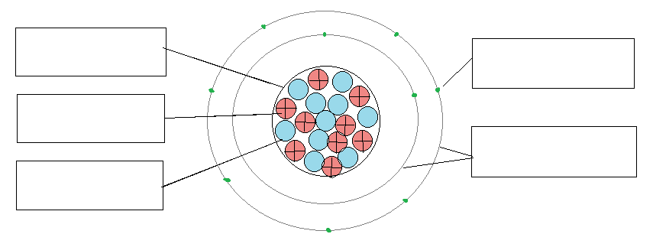
(ii) State the atomic number of this atom. ………………………………………………………………….
(iii) State the mass number of this atom. ……………………………………………………………………

- The periodic table contains information which allows us to work out the number of protons, neutrons and electrons in an atom of that element. Below are two extracts from a periodic table.
Use the information provided to complete a model of an atom for each of the elements indicated.
atomic number
8
2
element symbol
O
He
4.00
16.00
mass number
element name
helium
oxygen

Question 2: Isotopes of elements
The nuclei for the five smallest atoms and their names are shown in the diagram below. Nearly all atoms contain protons and neutrons in their nucleus. The hydrogen atom, hydrogen-1, is the only atom that does not contain neutrons.

Key: proton neutron
++
++
++
++
++
++
++
++
++
Isotopes of helium
Isotopes of hydrogen

hydrogen-1 hydrogen-2 hydrogen-3 helium-3 helium-4
(deuterium) (tritium)


Isotope
notation:
$${}_{1}^{1}H$$

- Using the information above, write a definition for the term ‘isotope’.
HINT: look at the isotopes of hydrogen and the isotopes of helium. What stays the same for each of the isotopes of the element? What changes?
…………………………………………………………………………………………………………………………………………………………………………………………………………………………………………………………………………………………………………………………………………………………
- We use the following notation to represent an isotope:
X is the symbol of element
A is the mass number which is the sum of the protons and neutrons
Z is the atomic number which is the number of protons
X
A
Z

Use this isotope notation to represent each of the isotopes shown in the diagrams above. The first one has been done for you.

Question 3: Radiation from the nucleus
Atoms found in nature are either stable or unstable. An unstable or radioactive atom will attempt to reach stability by releasing radiation from its nucleus. The radiation that comes spontaneously from the nucleus of an unstable isotope is typically alpha, beta, or gamma radiation.
An alpha particle consists of two protons and two neutrons tightly bound together. It is identical to a helium nucleus and so it is written as α or ${}_{2}^{4}{He}$. Alpha particles are relatively large and have a charge of +2 and so are highly ionising, however, they are unable to penetrate very far through matter. They only travel a few centimetres through air and can be stopped by a sheet of paper or the outer layer of dead skin.
A negative beta particle is a high energy, high speed electron, having a charge of -1, and so it is written as β or ${}_{-1}^{0}e$. Negative beta particles are much smaller and much less ionising than alpha particles. However, they have a higher penetrating ability, typically travelling tens of centimetres in air. Negative beta particles can pass through skin and paper, but can be stopped by a small thickness of aluminium or plastic.
Gamma rays, written as ${}_{0}^{0}γ$, are a form of electromagnetic radiation emitted from an excited nucleus. Sometimes a nucleus is still unstable after emitting an alpha or a beta particle and balances itself by releasing a burst of energy in the form of a gamma ray. Gamma rays have the highest energy in the electromagnetic spectrum and the shortest wavelength. Gamma radiation has the highest penetrating ability of all nuclear radiation, passing through skin, paper and aluminium. A thick layer of lead, concrete or several metres of water is needed to stop it.

After reading the information above, complete the following table for the three common types of nuclear radiation.

Radiation type | Alpha | Beta | Gamma
Symbol

Charge
Description
(What is it?)

Penetrating ability  (What materials does it pass through and what material stops it?) | 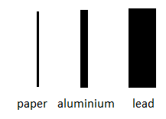

During-excursion activities
You will be allocated to a group to complete FOUR activities. You will have 7 minutes to complete each activity. An ANSTO Education Officer will time each activity and direct each group to their next activity. Do not move on until directed by an Education Officer.

Activity 1: Nuclear reactions

Part A - Modelling alpha and negative beta decay

- Read the information in the box below:

When an unstable nucleus undergoes alpha decay, it shoots out an alpha particle. An alpha particle is a helium nucleus, and is composed of two protons and two neutrons tightly bound together.

When an unstable nucleus undergoes negative beta decay, a neutron in the nucleus transforms into a proton and a beta particle (a high energy, high speed electron). The proton stays in the nucleus, and the beta particle is ejected energetically from the nucleus.

- Place the plastic protons (red) and neutrons (blue) on the model on the laminated sheet to form the radioactive nucleus
- Split up this nucleus to make the TWO products formed from its radioactive decay and place these products in the circles on the right
- Complete the diagrams below by drawing the initial radioactive nucleus on the left and the decay products formed on the right

Alpha decay of a Beryllium-8 nucleus | Negative beta decay of a Nitrogen-16 nucleus

Part B: Nuclear Decay puzzle

Most nuclei that emit alpha radiation are very large and have more than 82 protons. We can use nuclear equations to show alpha decay and negative beta decay. In a nuclear equation we use the following notation to represent each nucleus:
mass number = sum of protons AND neutrons
X
A
Z
symbol of element

atomic number = number of protons

Remember nuclear equations are always balanced. This means the sum of the mass numbers of the products on the right side equals the mass number of the decaying nucleus on the left side,
AND the sum of the atomic numbers of the products equals the atomic number of the decaying nucleus.

Use the information above to complete the nuclear decay puzzle and record your answers below.
Alpha decay (of uranium-238)

+

Beta decay (of carbon-14)

+
Activity 2: Why are some isotopes radioactive?

An isotope is radioactive if it has an unstable nucleus. An unstable nucleus will break down or “decay” over time to become more stable. An atom’s nucleus will be unstable if:
- it is too large and has too many protons and neutrons (all elements with more than 82 protons are radioactive)
- it contains too many neutrons for the number of protons
- it contains too few neutrons for the number of protons
- it has too much energy

Use the “Build an atom” simulator on the iPad to build the isotopes indicated in the table.

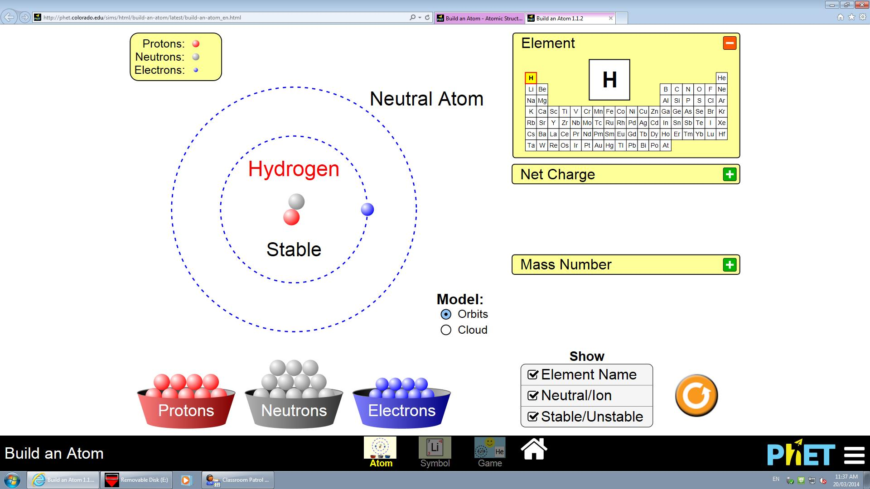
Add electrons to make a neutral atom
Add protons to change the element
Add neutrons to make stable and unstable isotopes of an element
Make sure all of these have a tick √

Isotope | Number of protons  Atomic number | Number of neutrons | Protons + neutrons  (mass number) | Stable or unstable?
hydrogen-1 | 1 | 0 | 1
hydrogen-2
hydrogen-3
carbon-12
carbon-13
carbon-14
fluorine-18
fluorine-19

Which isotopes in the table are unstable? Why are they unstable?
Isotope | Reason why it is unstable

Activity 3: Investigating a nuclear medicine

We use our reactor, OPAL, to create radioisotopes for use in nuclear medicine. One of these radioisotopes is iodine-131.
Using the “Radioisotopes in Medicine” online learning module, follow the journey of patient Indira to find out how iodine-131 is used and complete the questions below.

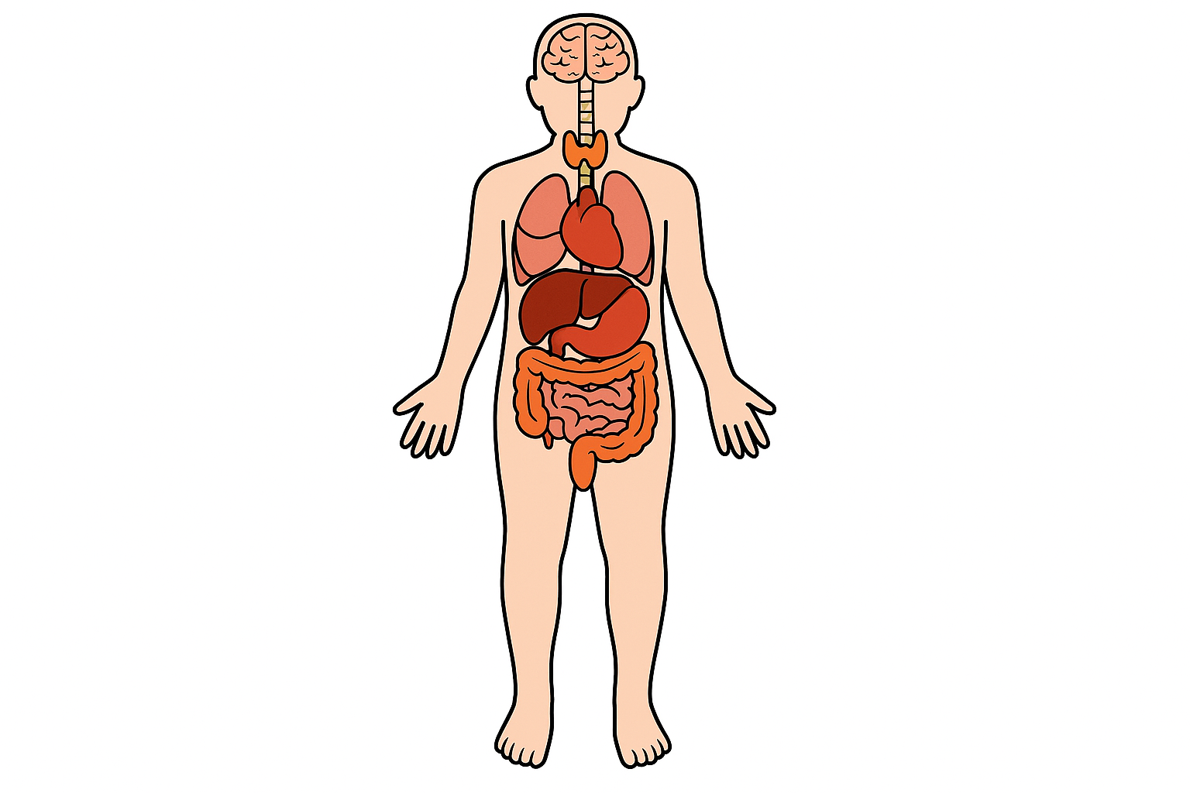
- Circle where the cancer is in Indira’s body.

- Number the steps 1-4 to describe Indira’s treatment.

Iodine-131 accumulates in the thyroid gland
Beta radiation kills tissue in Indira’s thyroid gland
Indira swallows a capsule of radioactive iodine-131
Iodine-131 decays by emitting beta radiation
- Describe the type of decay that Iodine-131 undergoes by annotating the diagram below. Click the Help button on the Iodine-131 decay equation slide to view this diagram.
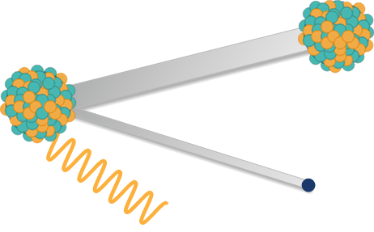
_____________________
_____________________
decays to

_____________________
_____________________

- Complete the decay equation for iodine-131 below.
+

131777

+
0
γ

e

I

53

0

- Complete the table below using what you have learned about Iodine-131.
Radioisotope | Use | Half-life
Iodine-131

Activity 4: Production of a nuclear medicine

Part A – Manufacture and distribution of molybdenum-99

ANSTO manufactures and distributes molybdenum-99, which undergoes radioactive decay to produce the diagnostic medicine technetium-99m.
Place the items in order to show the supply chain for the production and distribution of molybdenum-99.
Use your supply chain model to help you to number the steps below.

Number | Picture | Step in supply chain
 | 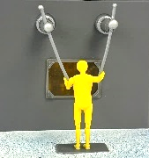 | In hot cells in the ANSTO Nuclear Medicine facility, molybdenum-99 is separated from the target plates and purified. This takes 26 hours.
 |  | Gentech® generators are transported to 250 hospitals and medical centres across Australia.
 | 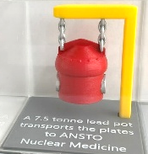 | A 7.5 tonne lead pot is used to transport the irradiated target plates to ANSTO Nuclear Medicine facility
 | 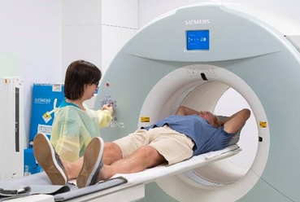 | Technetium-99m administered to patient for SPECT scan imaging
 | 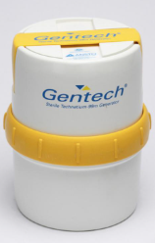 | Molybdenum-99 packaged in Gentech® generator for distribution.
1 | 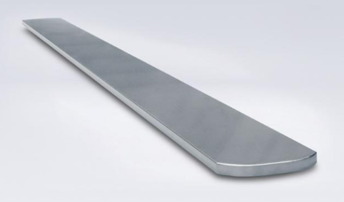 | 12 Uranium alloy target plates are placed in a rig for neutron irradiation
 | 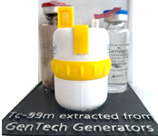 | Technetium-99m is extracted from the Gentech® generator by hospital technician
 | 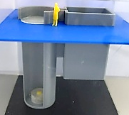 | OPAL reactor is used to irradiate the rig of Uranium alloy target plates for 7-10 days

Part B - The fission process

Molybdenum-99 is produced in our OPAL reactor from the nuclear fission of uranium-235 in the Uranium-235 target plates. Around 6% of the fission reactions produce molybdenum-99 as one of the products.

- Observe the ANSTO animation of nuclear fission on the iPad.
On the right-hand side of the diagram below, sketch what happens to the U-235 nucleus during nuclear fission. (HINT: the streaking particles in the animation are neutrons!)

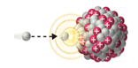
neutron
Uranium-235 nucleus

- How long does it take to irradiate the 12 uranium alloy plates in the OPAL reactor to produce the required molybdenum-99?

…………………………………………………………………………………………………………………………………………

Activity 5: Properties of α, β and γ radiation (during class presentation)

A radiation detector called a scintillation counter can be used to investigate the properties of α, β and γ radiation. In this activity we will investigate what type of radiation is being emitted from the sources by using different types of shielding.

Fill out the table below recording the radioactivity of each source with no cover, paper, aluminium and lead, and use this to determine what type of radiation is being emitted by each source.

Background reading: _____
Source | Radioactivity (counts per second)
Source | No cover | Paper | Aluminium | Lead
A
B
C

What type of radiation is being emitted by Source A? Why do you think this?
………………………………………………………………………………………………………………………….............................................................................................................................................................................................................................................................................................................................................................................................

What type of radiation is being emitted by Source B? Why do you think this?
………………………………………………………………………………………………………………………….............................................................................................................................................................................................................................................................................................................................................................................................

What type of radiation is being emitted by Source C? Why do you think this?
………………………………………………………………………………………………………………………….............................................................................................................................................................................................................................................................................................................................................................................................

Activity 6: Measuring radiation (during class presentation)

A radiation detector called a scintillation counter can be used to measure radioactivity. In this activity the radioactivity of a variety of different objects will be investigated.

Fill out the table below stating the radioactivity of each object and what element makes that object radioactive.

Radiation source | Radioactivity (counts per second) | What makes this radioactive?
Background radiation

Potassium sulfate fertiliser
Uranium glass
Thorium gas mantle
Radium watch

Fiestaware plate

How does the reading on the scintillation counter differ when the detector is close to the radioactive source compared to when it is further away?

………………………………………………………………………………………………………………………….............................................................................................................................................................................................................................................................................................................................................................................................

Post-tour Activities

Activity 1: Using nuclear reactions to produce an important nuclear medicine

You may like to use the information presented on our Molybdenum-99 and Technetium-99m posters found at Microsoft Word - Radioisotope posters to help you to answer these questions.
- If technetium-99m is the radioisotope used for diagnostic scans, why does ANSTO manufacture and distribute molybdenum-99?

HINT: Consider the half-life of each isotope

…………………………………………………………………………………………………………………………………………………………………………………………………………………………………………………………………………………………………………………………………………………………
……………………………………………………………………………………………………………………………………………………………………………
- Irradiated target plates from the OPAL reactor are very radioactive, emitting high energy gamma radiation.
Describe TWO safety measures used at ANSTO to work safely with radiation during the manufacture and distribution of molybdenum-99.

HINT: consider how radioactive material is transported and what special working spaces are used at ANSTO Nuclear Medicine facility during the manufacture of molybdenum-99
…………………………………………………………………………………………………………………………………………………………………………………………………………………………………………………………………………………………………………………………………………………………
…………………………………………………………………………………………………………………………………………………………………………………………………………………………………………………………………………………………………………………………………………………………
- a) Label the parts of ANSTO’s Gentech® generator.
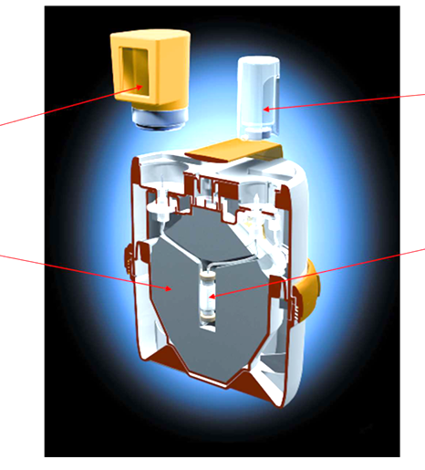
- In the Gentech® generator, molybdenum-99 undergoes beta decay to form technetium-99m. Complete the nuclear equation below to show this decay process.
$${}_{}^{99}{Mo}$$

+
+

- a) Technetium-99m is an important nuclear medicine. What is it used for?

………………………………………………………………………………………………………………………………………………………………………………………………………………………………………………………………………………………………………………………………………………………………………………………………………………………………………………………………………………………………

- What radiation is produced by technetium-99m?

………………………………………………………………………………………………………………………………………………………………

To learn more about the use of this nuclear medicine, follow the journey of the patient Yusuf from our Radioisotopes in Medicine online learning module at https://education.ansto.gov.au/resources/radioisotopesinmedicine/

Activity 2: Nuclear waste

Nuclear (radioactive) waste is generated through the manufacture of molybdenum-99 for the nuclear medicine technetium-99m.
Around 86% of the nuclear waste produced at ANSTO is classified as low level waste which emits radiation at levels which generally require minimal shielding and can be safely handled with standard personal protection equipment (PPE).
The rest is intermediate-level waste which emits higher levels of radiation and requires additional shielding to protect workers and the environment during handling, transport and storage.
ANSTO is constructing their Synroc® Waste Treatment Plant called SyMo for intermediate level waste arising from the production of Molybdenum-99 (Mo-99). This will be a first-of-kind facility globally, linking nuclear medicine production with radioactive waste treatment.
Watch the video under How it works on the ANSTO webpage ANSTO Synroc® Waste Treatment Technology | Nuclear Fuel Cycle | ANSTO to understand the ANSTO Synroc® process.
- Use the information in the video to order the steps on the following page to show how the ANSTO Synroc® process works.

Number | Steps in process
 | The can is loaded into a secondary safety container
 | The slurry is dried, forming a powder
 | Liquid radioactive waste is mixed with tailored additives to make a slurry
 | The container is placed in a hot isostatic press
 | The heated powder is sealed in specially designed cans
 | Liquid radioactive waste from ANSTO Nuclear Medicine facility is transferred to ANSTO’s SyMo waste facility
 | The powder is heated
 | Under heat and pressure, the powder inside the can fuses together and the can is reduced to about half its size

- What happens to the nuclear waste at the end of this treatment process?
……………………………………………………………………………………………………………………………………………………………………………
……………………………………………………………………………………………………………………………………………………………………………
……………………………………………………………………………………………………………………………………………………………………………

Activity 3: Benefits and considerations for the use of radioisotopes

Categorise the following statements as societal benefits or societal considerations of using radioisotopes.

Benefit or Consideration | Statement
 | Nuclear medicines can diagnose and treat diseases such as cancer
 | Spent nuclear fuel, used in reactors to make nuclear medicines, must be shielded and kept cool with water
 | The production of nuclear medicines results in radioactive waste that must be stored safely and securely
 | Industrial radioisotopes used as mining gauges must be stored safely in shielding when in transit
 | Gamma radiation from cobalt-60 can sterilise medical equipment before use
 | Radiocarbon dating can measure the age of groundwater, ensuring it can be used sustainably
 | Nuclear medicines need to be transported in specialized, multi-layered, and shielded containers to prevent radiation leakage and ensure safety
 | Radioisotopes such as phosphorus-32 and nitrogen-15 can be used to determine how much fertiliser is taken up by plants.

