

Year 11 Chemistry
Excursion workbook
Your visit to ANSTO
At the Discovery Centre, you will:
- explore why some atoms are radioactive
- investigate different devices used to detect and measure radiation
- observe a demonstration, using a scintillation counter, to investigate the properties of alpha, beta and gamma radiation
- understand the operation and uses of OPAL (Open Pool Australian Lightwater) Research Reactor
- collect data during a demonstration of a radiation experiment, using low level radioactive sources and radiation detection equipment.

On site, you will visit:
- The OPAL (Open Pool Australian Lightwater) Research Reactor
- The Australian Centre for Neutron Scattering
- The Centre for Accelerator Science
- The ANSTO Nuclear Medicine Facility

The tour will conclude at the Discovery Centre.

Year 11 Chemistry: Nuclear Science Depth Study
We recommend that this excursion becomes the starting point for a nuclear science depth study. ANSTO’s Year 11 Chemistry excursion helps students cover the following syllabus content:
Module 1: Properties and structure of matter
Students:
- investigate the basic structure of stable and unstable isotopes by examining:
  - their position in the periodic table
  - the distribution of electrons, protons and neutrons in the atom
  - representation of the symbol, atomic number and mass number (nucleon number)
- calculate the relative atomic mass from isotopic composition
- investigate the properties of unstable isotopes using natural and human-made radioisotopes as examples, including but not limited to:
  - types of radiation
  - types of balanced nuclear reactions
Working Scientifically
- Questioning and predicting
- Planning investigations
- Conducting investigations

We recommend students use our Year 11 Chemistry Depth Study Guide for ideas and resources for depth study activities after their excursion.

NESA requirements for Depth Studies
- A minimum of 15 hours of in-class time is allocated in both Year 11 and Year 12
- At least one depth study must be included in both Year 11 and Year 12
- The two Working Scientifically outcomes of Questioning and Predicting, and Communicating must be addressed in both Year 11 and Year 12
- A minimum of two additional Working Scientifically skills outcomes, and further development of at least one Knowledge and Understanding outcome, are to be addressed in all depth studies.

Pre-Tour Questions
We expect students to have completed this pre-work prior to attending the tour. It consists of questions on concepts from junior years that are essential to an understanding of the nuclear science to be covered in the tour.

Question 1
Atoms are made up of 3 sub-atomic particles: protons, neutrons and electrons. Choose options from the following lists to complete the table:

in nucleus | negligible | 0
surrounding the nucleus | 1 | +1
in nucleus | 1 | -1

Particle | Location | Mass in atomic mass units (amu) | Charge
Proton
Neutron
Electron

Nuclear Facts To Remember:
- The number of protons in an atom is the atomic number (Z).
- The number of protons plus neutrons is the mass number (A).
- In a neutral atom, the number of protons and number of electrons are equal.

The atomic number, Z, determines what element the atom is, for example:
Z = 1, atom is hydrogen, symbol H
Z = 6, atom is carbon, symbol C

The notation for representing an atom is as follows:
X
A
Z
X = symbol of element
A = number of (protons + neutrons)
Z = number of protons

As the symbol or the Z-number uniquely identifies the element, only one of these must be present.
When naming atoms, we use the name or symbol of the element, followed by the mass number. For example: hydrogen-1 (or H-1) and carbon-12 (or C-12). The notation for these is:
₁ ₁₂
H and C
¹ ⁶

Question 2
Use the online Atom Builder program (https://www.ansto.gov.au/education/apps) and the Periodic Table poster (https://www.ansto.gov.au/education/resources/posters) to help complete the table.

Name of atom | Number of protons | Number of neutrons | Mass number | Notation
nitrogen-14
 | 3 |  | 7
F
19
9

 |  | 14 | 27

Isotopes of Elements
The nuclei for the five smallest atoms and their names are shown in the diagram below. Nearly all atoms contain protons and neutrons. The hydrogen atom, hydrogen-1, is the only atom that does not contain neutrons.

Key: proton neutron
++
++
++
++
++
++
++
++
++
Isotopes of helium
Isotopes of hydrogen

hydrogen-1 hydrogen-2 hydrogen-3 helium-3 helium-4
(deuterium) (tritium)

Question 3
Using the information above, define the term ‘isotope’
…………………………………………………………………………………………………………………………………………………………………………………………………………………………………………………………………………………………………………………………
Electromagnetic spectrum
The electromagnetic spectrum below shows that radiation occurs in waves. The type of radiation depends on the amount of energy it has. Gamma rays are at the high energy end of the spectrum whilst radio waves are at the low energy end.

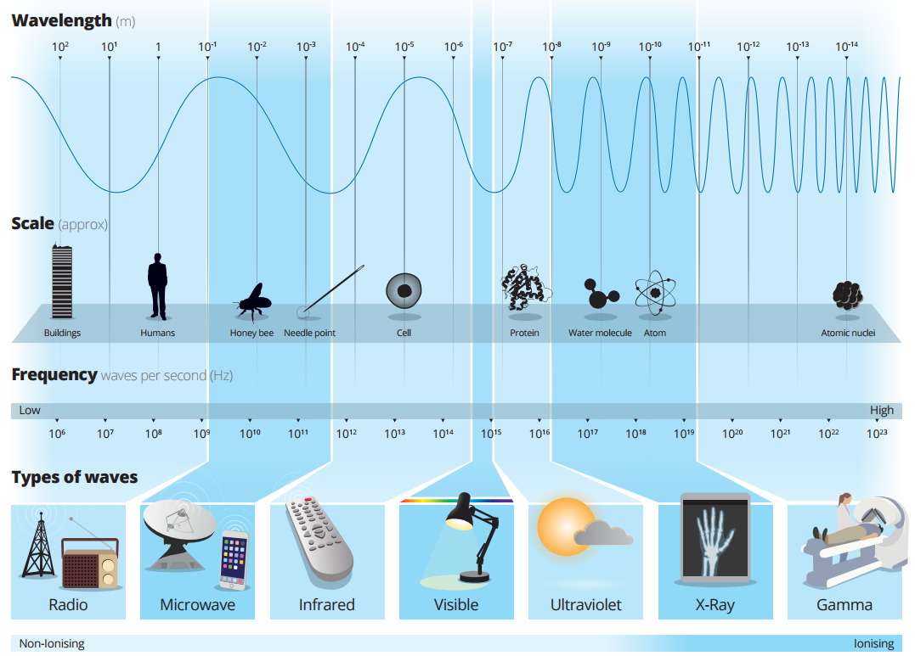

Question 4
Refer to the ANSTO Electromagnetic Spectrum poster (shown above and also at https://www.ansto.gov.au/education/resources/posters) to complete the activities below.

- Delete the incorrect terms in the following sentences.
The shorter the wavelength, the greater/ lower the energy. Therefore ultraviolet radiation has more/ less energy than infrared radiation but more/ less than gamma rays.

- Describe gamma radiation, referring to its wavelength, frequency and energy.
…………………………………………………………………………………………………………………………………………………………………………………………………………………………………………………………………………………………………………………………
…………………………………………………………………………………………………………………………………………………………………………………………………………………………………………………………………………………………………………………………
Nuclear Radiation – Radioactivity
In 1896 French scientist Henri Becquerel discovered a new kind of invisible radiation that seemed to be emitted from a uranium-rich rock. This radiation could not be stopped, increased or decreased. This was nuclear radiation and it was something completely new to science.
Marie Curie, working in Paris, coined the term 'radioactivity' to describe this new property, and discovered three new radioactive elements.
It is the structure of the nucleus of an atom that determines whether it is radioactive, or in other words, unstable. Unstable atoms undergo radioactive decay.
Further studies by New Zealander Ernest Rutherford showed that there are three different types of radioactivity. He named them after the first 3 letters of the Greek alphabet: alpha (α), beta (β) and gamma (γ) radiation.

Alpha radiation (α)
Strong nuclear forces normally hold the protons and neutrons inside a nucleus together. But if the nucleus is too big, it will begin to break down and release an alpha particle.
An alpha particle is made up of two protons and two neutrons, has a charge of +2, and is identical to a helium nucleus.
Alpha particles have high energy when they are first released, but they quickly lose energy as they strike matter. Because alpha particles are relatively large and they are highly ionising, they have a low penetrating ability. They only travel a few centimetres through air and can be stopped by a sheet of paper or the outer layer of dead skin.

Beta radiation (β)
Nuclei are made up of protons and neutrons. If a nucleus contains too many neutrons, one of the neutrons will break down. A neutron breaks down to form a proton (which stays in the nucleus) and an electron (which is emitted as a beta particle).
Beta particles are high energy, high speed electrons. They have a charge of -1, are much smaller and much less ionising than alpha particles, and have a higher penetrating ability, typically travelling tens of centimetres in air. Beta particles can pass through skin, but can be stopped by a small thickness of aluminium or plastic.

Gamma radiation (γ)
Sometimes a nucleus is still unstable after emitting an alpha or a beta particle and balances itself by releasing a burst of energy in the form of a gamma ray.
Gamma radiation consists not of particles but of energy in the form of extremely high-frequency electromagnetic waves.
Gamma radiation has the highest penetrating ability of all nuclear radiation. A thick layer of lead, concrete or several metres of water is needed to stop it.

Question 5
After reading the information above, complete the following table for the three types of radioactive decay.

Name | Symbol | Consists of | Charge | Stopped by
Alpha | α | Two protons and two neutrons  (Helium-4 nucleus)
Beta | β
Gamma | γ |  | 0

Radioactive atoms, called radioisotopes, may emit only one type of radiation but it is more common for an alpha or beta decay to be accompanied by a gamma emission.

Cloud Chamber – Detecting radioactivity
A cloud chamber is a good way to show the background radiation which is present in our environment. It consists of a sealed container, enclosing a supersaturated alcohol vapour. As the ionising radiation passes through, it tears away electrons in some of the atoms of the gas molecules along its path, resulting in a trail of ionized gas particles. Alcohol molecules are attracted to and condense on these ions, leaving a trail of tiny droplets showing the path of the ionising radiation. These tracks disappear almost immediately. It’s a bit like the vapour trails that can be seen when a jet aircraft flies through the high, cold atmosphere.
The charged particles which produce tracks in a cloud chamber are alpha and beta particles (from radioactive atoms), and protons and muons (from space). The type of track left behind by each type of particle is determined by its properties:
- distance travelled in air by charged particle
- amount of kinetic energy, as particles with higher kinetic energy leave straight tracks, and
- ionising power, as particles with higher ionising power leave thicker tracks.

Question 6

- Draw a diagram of what you expect the radiation tracks of alpha and beta particles to look like based on the distance travelled in air, the kinetic energy and ionising power of these two different particles.

- State the reasons for your predicted track.

Type of ionising radiation | Alpha particles | Beta particles
Draw your predicted track for the particles in a cloud chamber
State the reasons for your predicted track.

When you are ANSTO make sure you take a look at our cloud chamber to confirm your predictions!

Question 7
Isotopes are unstable if:
- They have too few neutrons
- They have too many neutrons
- Their nucleus is too large
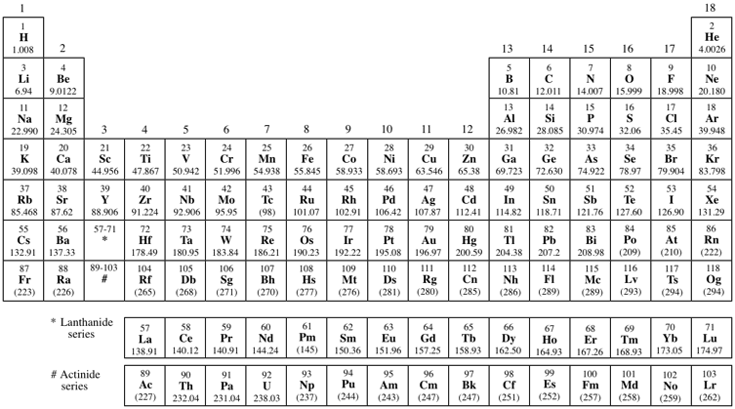
Use the ANSTO periodic table (https://www.ansto.gov.au/education/resources/posters) to identify elements in the periodic table that are always unstable, that is, they have only radioisotopes. Highlight these on the diagram below.

Question 8
Every unstable isotope undergoes radioactive decay at a particular rate. This rate is referred to as the half-life of an isotope. Half-lives may be very short, just a few seconds, or very long, up to many millions of years, depending on the isotope. Carbon-14 has a half-life of 5,730 years.

- Examine the following diagram and, from it, explain the meaning of the term ‘half-life’.
one
half-life
5,730 years
another half-life
another 5,730 years
20 million C-14 atoms
10 million C-14 atoms
5 million C-14 atoms

…………………………………………………………………………………………………………………………………………………………………………………………………………………………………………………………………………………………………………………………
……………………………………………………………………………………………………………………………………………………………

- Fluorine-18 has a half-life of 110 minutes. If you have 10 000 000 atoms of Fluorine-18 initially, how many atoms will be left after 11 hours?
…………………………………………………………………………………………………………………………………………………………………………………………………………………………………………………………………………………………………………………………

During-excursion activities

Activity 1 – Detection of radiation
At ANSTO, we use different portable devices to monitor levels of radiation.
Next to the picture of each device below, write the name of the device and a sentence or two to explain how it works.

Device | Name of the device and how it works
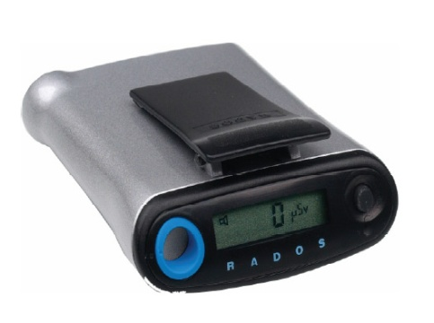
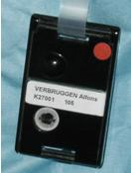
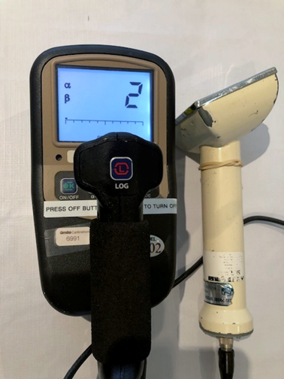

Activity 2: Investigating the properties of alpha, beta and gamma radiation
- View the demonstration and record the radioactivity measured by the scintillation counter in each of the following situations.

Source | Radioactivity (counts per second)
Source | No cover | Paper | Aluminium | Lead
A
B
C

- Use the data you have recorded to identify the type of radiation produced by each source. Justify your choice.
Source | Type of radiation | Justification:  Why do you think it is this radiation?
A
B
C

- Gamma emission usually accompanies alpha or beta decay. Which other form of radiation do you think is being emitted from the gamma source? Give a reason for your answer.
…………………………………………………………………………………………………………………………………………………………………………………………………………………………………………………………………………………………………………………………
…………………………………………………………………………………………………………………………………………………………………………………………………………………………………………………………………………………………………………………………

Activity 3 – A radiation experiment
Your education officer will demonstrate a radiation experiment using the scintillation counter and some radioactive sources.
What you will be investigating:
  - How radioactive are different household objects? Which of these sources should we choose for our experiment and why?
And one of the following experiments:
  - How does radioactivity change with distance from the source?
  - How does the thickness of a shielding material affect radiation penetration?
  - How do different types of shielding material affect radiation penetration?

When you return to school you will need to write an aim, hypothesis, equipment and method for the experiment

Risk assessment:
Name of risk | Ways of managing named risk
Results:

Object | Radioactivity (counts per second, cps) | Why item is radioactive
Background
Potash
Uranium glass
Tungsten welding rods
Gas mantle
Radium watch
Uranium mineral (autunite)
Fiestaware plate

Which object would you select as your radioactive source for the radiation investigation? Justify your choice.
……………………………………………………………………………………………………………………………………………………………………………………………………………………………………………………………………………………………………………………………………………………………………………………………………………………………………………………………………………………………………………………………………………………………………………………………………………………………………………………
Results:

 | Radioactivity (counts per second, cps)
 | Trial 1 | Trial 2 | Trial 3 | Mean



Notes
Use this space to take your own notes about areas of interest relevant to your own depth study

Post-Online Learning Activity 1: Modelling Fission
Models can be used to help scientists visualise things that they cannot actually see. They are used to describe, simplify, clarify or help form explanations. Models can be thought of as thinking tools to aid understanding. However, no model is perfect! So we need to consider the strengths and limitations of any model.

During your tour, you explored the fission process taking place in the core of Australia’s one and only nuclear reactor, OPAL. At ANSTO, we use the neutrons produced in this process to make specific radioisotopes that have the properties we need to detect or treat diseases, such as cancer.

The information below provides a summary of the fission process taking place in OPAL.

The core of ANSTO’s OPAL reactor contains around 30 kg of uranium. 19.75% of this uranium is the fissionable Uranium-235, the rest is the other naturally occurring uranium isotope, Uranium-238, which absorbs neutrons and does not fission. There are about 100 different types of daughter nuclei that can be formed in the fission process. The diagram below shows one example of fission.
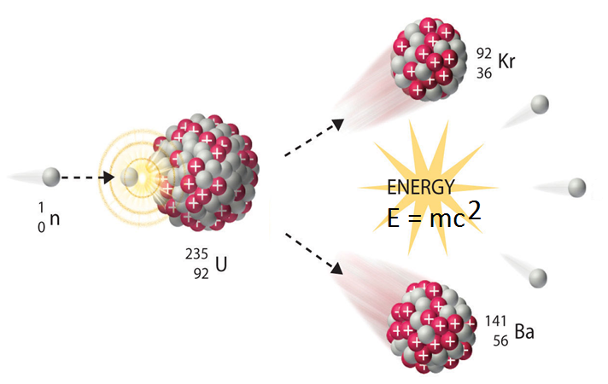
Thermal, low speed neutron
Two or three high energy, high speed neutrons are produced
You’re now going to examine an animation developed by ANSTO that models this fission process, to investigate the strengths and limitations of this animation model.
The ANSTO animation OPAL research reactor animation - YouTube can be found at https://www.youtube.com/watch?v=GooWJywwfgo&t=2s (view animation from 0.45 – 1.21)
Consider the information provided above, and during the ANSTO online learning session, , and use it to evaluate ANSTO’s fission animation model.
- What does this animation model show about the process of nuclear fission in our OPAL nuclear reactor?
…………………………………………………………………………………………………………………………………………………………………………………………………………………………………………………………………………………………………………………………
…………………………………………………………………………………………………………………………………………………………….
……………………………………………………………………………………………………………………………………………………………
…………………………………………………………………………………………………………………………………………………………….
- What are the limitations of this model of nuclear fission for our OPAL nuclear reactor? What is missing from or is not strictly correct in this model?
…………………………………………………………………………………………………………………………………………………………………………………………………………………………………………………………………………………………………………………………
…………………………………………………………………………………………………………………………………………………………….…………………………………………………………………………………………………………………………………………………………………………………………………………………………………………………………………………………………………………………………

- Does it simulate a controlled or uncontrolled fission reaction?
…………………………………………………………………………………………………………………………………………………………….
- Describe how the fission reaction is controlled in the OPAL reactor.
HINT: Watch the whole of the video to answer this question and question 5.
…………………………………………………………………………………………………………………………………………………………………………………………………………………………………………………………………………………………………………………………
…………………………………………………………………………………………………………………………………………………………….
…………………………………………………………………………………………………………………………………………………………….
- What is the role of the reflector vessel in OPAL in terms of the fission reaction?

…………………………………………………………………………………………………………………………………………………………………………………………………………………………………………………………………………………………………………………………
…………………………………………………………………………………………………………………………………………………………….
…………………………………………………………………………………………………………………………………………………………….
- Suggest an improvement you would make to the ANSTO animation model of fission to give people a better understanding of the fission process taking place in the OPAL reactor.

…………………………………………………………………………………………………………………………………………………………………………………………………………………………………………………………………………………………………………………………
…………………………………………………………………………………………………………………………………………………………….
…………………………………………………………………………………………………………………………………………………………….

Post-Online Learning Activity 2: Properties and uses of radioactive isotopes

At ANSTO, you will learn about the properties and uses of different natural and human-made radioisotopes. Refer to information about each isotope in our online radioisotope posters to complete the table below (https://www.ansto.gov.au/education/secondary/workbooks).
Isotope name | Number of protons | Number of neutrons | X  A  Z | Half-life | Balanced nuclear decay equation (including the types of radiation produced when it decays) | Use
Molybdenum-99

Technetium-99m

Iodine-131

Cobalt-60

Carbon-14

Uranium-235

Beryllium-10

Chlorine-36

Suggested videos
Viewing the following videos will also help you to get the most out of our online learning session (https://www.youtube.com/user/ANSTOVideos):

- Echidna: High speed powder diffractometer: This video shows how neutrons from inside the OPAL reactor are used in neutron diffraction instruments to study material structure at the atomic level.

- Radiocarbon dating on ANSTO’s VEGA accelerator: This video shows how VEGA particle accelerator is used to determine the age of artefacts and environmental samples up to 50,000 years old.

- Safely managing Australia’s radioactive waste: Nuclear research and medicine produced by ANSTO has benefited generations of Australians since the 1960s. With benefits, come responsibilities, and the by-products of nuclear research and medicine includes radioactive waste. ANSTO responsibly manages this waste in both the long and short term.

