

Year 12 Investigating Science
Student excursion workbook

Your visit to ANSTO
ANSTO’s Investigating Science tour of the Lucas Heights campus addresses the following syllabus content from the NSW NESA Stage 6 Investigating Science Syllabus:
- Module 6: Technologies – specifically the inquiry question “How have developments in technology led to advances in scientific theories and laws that, in turn, drive the need for further developments in technology?”
- Module 8: Science and society – specifically the inquiry questions “How do science-related events affect society’s view of science?”, “Why is scientific research regulated?” and “How do economic, social and political influences affect scientific research?”.
During the tour, students will:
- discover how to monitor radiation using several detection technologies
- observe radiation emitted from selected domestic objects
- understand the design, operation, and primary function of the OPAL (Open Pool Australian Lightwater) research reactor and compare it with power reactors
- investigate the creation of key products of the nuclear industry, including nuclear medicines, and their significance to society
- using historical nuclear research experiments, understand the technology that was used in the science discoveries and how that led to enhanced technology that is used today
- investigate some major nuclear incidents and public reaction to them
- discuss economic, social, and political factors that affect the regulation and funding of scientific research.
During the tour your Education Officer will provide students with information from which they will be required to select and process the appropriate material to complete the activities and answer the questions.

Year 12 Investigating Science: Nuclear science depth study
We recommend that this tour becomes the starting point for a nuclear science depth study. We also suggest that students use our Year 12 Investigating Science Student Excursion Workbook (which is accessible on the ANSTO website) for ideas and resources for depth study activities after their tour.
ANSTO’s Year 12 Investigating Science tour covers the following syllabus content:

Module 6: Technologies
Students:
- using examples, assess the impact that developments in scientific theories, laws and models have had on the development of new technologies, including but not limited to:
  - radioactivity and radioactive decay on the development of radiotherapy and nuclear bombs.
- using examples, assess the impact that developments in technologies have had on the accumulation of evidence for scientific theories, laws, and models, including but not limited to:
  - technology to detect radioactivity and the development of atomic theory.

Module 8: Science and society
Students:
- investigate case studies of past events to consider how they have affected the public image of science, including but not limited to:
  - meltdowns of nuclear reactors.
- investigate and assess ethical issues surrounding current scientific research in, for example:
  - use of radiation.
- investigate the need for the regulation of scientific research in, for example:
  - products and processes of the nuclear industry.
- evaluate how scientific research aids economic development and human progress in relation to, for example:
  - nuclear power generation.
- evaluate the impacts of scientific research, devices and applications and world health and human wellbeing.
We recommend students use our Year 12 Investigating Science Depth Study Guide for ideas and resources for depth study activities after their excursion.

NESA requirements for depth studies
- A minimum of 30 hours of in-class time is allocated in both Year 11 and Year 12.
- At least one depth study must be included in both Year 11 and Year 12.
- The two Working Scientifically outcomes of Questioning and Predicting, and Communicating must be addressed in both Year 11 and Year 12.
- A minimum of two additional Working Scientifically skills outcomes, and further development of at least one Knowledge and Understanding outcome, are to be addressed in all depth studies.

Questions to be attempted before your visit
We expect students to have completed this pre-work prior to visiting ANSTO. These six questions are a review of radioactivity essential for an understanding of the basic nuclear science during the session.

Question 1: Parts of an atom
Atoms are made up of 3 subatomic particles: protons, neutrons, and electrons. Complete the table using the most appropriate option from the list below:
- Location can be: “in nucleus”, or “surrounding the nucleus”
- Mass can be: “negligible”, or “1 amu”
- Relative charge can be: “0”, or “+1”, or “-1”
Particle | Location | Mass in atomic mass units (amu) | Relative charge
Proton
Neutron
Electron

Nuclear facts to remember:
- The number of protons in an atom is the atomic number (Z).
- The number of protons plus neutrons is the mass number (A).
- In a neutral atom, the number of protons and number of electrons are equal.
The atomic number, Z, determines what element the atom is, for example:
- $\text{Z}=1$, atom is hydrogen, symbol H
- $\text{Z}=6$, atom is carbon, symbol C
The notation for representing an atom is as follows:
X
A
Z
X = symbol of element
A = number of (protons + neutrons)
Z = number of protons
Individually, either the symbol or the Z-number will uniquely identify the element. Hence only one of them must be present; the other one is not required.

Question 2: Naming an atom
Use the online Atom Builder program (https://www.ansto.gov.au/education/apps) and the Periodic Table poster (https://www.ansto.gov.au/education/resources/posters) to help complete the table:
Name of atom | Number of protons | Number of neutrons | Mass number | Notation
nitrogen-14
 | 3 |  | 7
 |  |  |  | $${}_{9}^{19}{\text{F}}$$
 |  | 14 | 27

Question 3: Isotopes of elements
The nuclei for the five smallest atoms and their names are shown in the diagram below. Nearly all atoms contain protons and neutrons. Hydrogen-1 is the only isotope that does not contain neutrons.
++
++
++
++
++
++
++
++
++
Key:
proton
neutron
Hydrogen-1
(protium)
Hydrogen-2
(deuterium)
Hydrogen-3
(tritium)
Helium-3
Helium-4
Isotopes of hydrogen
Isotopes of helium
Using the information above, define the term ‘isotope’.

Question 4: Nuclear radiation – radioactivity
In 1896, French scientist Henri Becquerel discovered a new kind of invisible radiation that seemed to be emitted from a uranium-rich rock. This radiation could not be stopped, increased, or decreased. This was nuclear radiation, and it was something completely new to science.
Marie Curie, working in Paris, coined the term ‘radioactivity’ to describe this new property, and discovered three new radioactive elements.
It is the structure of the nucleus of an atom that determines whether it is radioactive, or in other words, unstable. Unstable atoms undergo radioactive decay.
Further studies by New Zealander Ernest Rutherford showed that there are three different types of radioactivity. He named them after the first 3 letters of the Greek alphabet: alpha ($α$), beta ($β$) and gamma ($γ$) radiation.

Alpha radiation (α)
Strong nuclear forces normally hold the protons and neutrons inside a nucleus together. But if the nucleus is too big, it will begin to break down and release an alpha particle.
An alpha particle is made up of two protons and two neutrons, has a charge of +2 and so is highly ionising, and is identical to a helium-4 (He-4) nucleus.
Alpha particles have high energy when they are first released but quickly lose energy as they strike matter. Because alpha particles are relatively large, they have a low penetrating ability. They only travel a few centimetres through air and can be stopped by a sheet of paper or the outer layer of dead skin.

Beta radiation (β)
Nuclei are made up of protons and neutrons. If a nucleus contains too many neutrons, one of the neutrons will break down. A neutron breaks down to form a proton (which stays in the nucleus) and an electron (which is emitted as a beta particle).
Beta particles have a charge of -1 making them moderately ionising, are much smaller than alpha particles, and have a higher penetrating ability. Beta particles can pass through skin but can be stopped by a small thickness of aluminium or plastic.

Gamma radiation (γ)
Sometimes a nucleus is still unstable after emitting an alpha or a beta particle and balances itself by releasing a burst of energy in the form of a gamma ray.
Gamma radiation consists not of particles but of energy in the form of extremely high-frequency electromagnetic waves, and so is weakly ionising.
Gamma radiation has the highest penetrating ability of all nuclear radiation. A thick layer of lead, concrete or several meters of water is often needed to stop it.

After reading the information above, complete the following table for the three types of radioactive decay.
Name | Symbol | Consists of | Charge | Penetration | Stopped by | Ionising power
Alpha
Beta
Gamma

Radioactive atoms, called radioisotopes, may emit only one type of radiation but it is more common for an alpha or beta decay to be accompanied by a gamma emission.

Question 5: Half-life
Every unstable isotope undergoes radioactive decay at a particular rate. This rate is referred to as the half-life of an isotope. Half-lives may be very short, just a few nanoseconds, or very long, up to many millions of years, depending on the isotope. Carbon-14 has a half-life of 5,730 years.
Examine the following diagram and, from it, explain the meaning of the term ‘half-life’.

one half-life
5,730 years
another half-life
another 5,730 years
20 million
C-14 atoms
10 million
C-14 atoms
5 million
C-14 atoms

Question 6: Benefits of nuclear science
ANSTO uses nuclear science in many ways. Our OPAL reactor produces nuclear medicines for hundreds of thousands of patients every year, irradiates silicon for the electronics industry, and produces neutrons for investigating materials at the atomic and molecular level. Our scientists and engineers use nuclear science to advance our understanding of the environment, human health, and new materials.
Read a selection of pages from the ANSTO website and briefly summarise three examples of how nuclear science is used to benefit society at ANSTO.

Two relevant web pages are identified below: there is much more additional information available on other pages:
- ANSTO: Nuclear medicine product list (www.ansto.gov.au/products-services/nuclear-medicine/product-list)
- ANSTO: Benefits of nuclear science (https://www.ansto.gov.au/education/nuclear-facts/benefits-of-nuclear-science).

Questions to be considered while on-site

Question 7: OPAL research reactor
- In the space below, sketch what happens to a U-235 nucleus during fission.

- Does OPAL generate electricity?

- OPAL’s primary role is to release very many subatomic particles. What are these particles, and which part of the atom do they come from?

- Name one isotope that is produced in OPAL and used in medicine.

- What type of particle/radiation is used to diagnose medical problems in several different organs of a human patient?

- What type of particle/radiation is better suited to treat a human disease such as cancer?

Question 8: ANSTO Nuclear Medicine
- What percentage of the fission products generated in the target plates is Mo-99 (molybdenum-99)?

- How would you describe the remaining material after Mo-99 extraction?

- How does ANSTO manage that material?

- What is the half-life of Mo-99?

- What is the decay product of Mo-99, and what is its half-life?

Questions to be considered during the presentation
Complete your answers to the following questions in point form. Only capture enough information so that you can write proper answers after the presentation.
More detailed information is available on the ANSTO website at https://www.ansto.gov.au/.

Question 9: Radiation detectors
At ANSTO, we use different portable devices to monitor levels of radiation.
Next to the picture of each device below, write the name of the device and its purpose. Purpose is EITHER to record radiation received by the wearer, OR to measure the radioactivity of an object.
Device picture | Name of device and its purpose
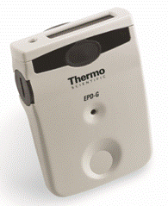
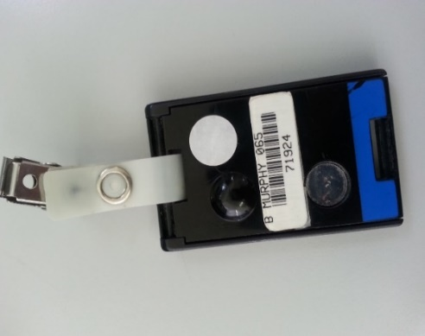
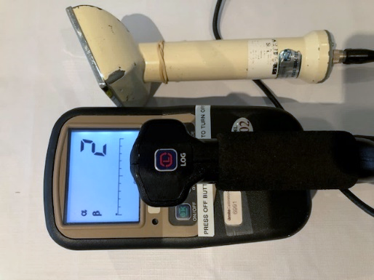

Question 10: Measuring radioactivity
View the experiment and record the radioactivity measured by the scintillation counter when the detector is placed close to each radioactive object.
Note which type of radiation comes from each object and identify the object that emits the most penetrating radiation
(Students should ask the Education Officer to ensure that the instrument emits sounds to indicate the type of radiation being detected)
Object | Radioactivity  (counts per second) | Extra notes
Background
Potash fertiliser
Uranium glass
Tungsten welding rods
Gas mantle
Radium watch
Uranium mineral (autunite)
Fiestaware plate

Question 11: Impact of nuclear meltdowns on public perception
Serious nuclear accidents have had significant negative consequences for the public perception of nuclear science. Poor public perception of accidents with nuclear technology has had significant repercussions for the nuclear industry and, in some cases, global politics!
For each nuclear incident listed below write the year and the country in which it occurred and identify the major social or political consequence of that incident (select A, B, or C from the list below):
- Contributed to the collapse of the former Soviet Union
- Complete phase out of Germany’s nuclear power reactors by 2022. Germany’s gap in energy needs met by extra coal-fired power plants.
- Pressure from the public on decision-makers meant that very few new nuclear power plants were approved for construction in the US after this nuclear incident.
Reactor | Year | Country | Major consequence  (A, B, or C)
Three Mile Island
Fukushima
Chernobyl

Question 12: Incidence of thyroid cancer
In the years following the Fukushima-Daiichi nuclear accident in Japan in 2011, one team of scientists reported that the incidence of thyroid cancer in the Fukushima population was 30 times higher than before the accident. Explain why this reported result was misleading.

Question 13: Allocating research funds
When allocating funds for research, in which order do you believe the following criteria should be applied? Number from 1 (the most important) through to 5 (the least important).
Please note that:
- The answers are subjective: there is no right or wrong answer
- You are encouraged to debate this topic with your peers and teachers
- You may find it instructive to explore the Australian Research Council process of allocating funds for research in this country.
Rank number (1 – 5) | Criteria
 | The research could benefit society and/or the environment significantly
 | It could make a lot of money for those that can use the research results
 | The research project will be led by a scientist with a good track record and lots of publications
 | It aligns with the priorities of the government
 | It is supported by powerful multi-national companies

Compare your rankings with another student. Are they the same or different? Are there any other criteria that should be on the list?

Notes for your future use
Use this space to take your own notes about areas of interest relevant to your own depth study, including information gleaned from any discussions during the tour.

