

Year 12 Earth & Environmental Science
Excursion workbook
Your visit to ANSTO
At the Discovery Centre, you will:
- explore why radioactive isotopes are useful in dating and sedimentology studies
- investigate different devices used to detect and measure radiation
- observe a demonstration, using a scintillation counter, to investigate the properties of alpha, beta, and gamma radiation
- collect data to understand elemental analysis through a mineral fluorescence experiment
- Analyse sedimentological and geochronology data as an environmental scientist to solve a 50 year old mystery

On site, you will visit:
- The OPAL (Open Pool Australian Lightwater) Research Reactor
- The Australian Centre for Neutron Scattering (ACNS)
- The Centre for Accelerator Science (CAS)
- The Environmental Radioactivity Measurement Centre

The tour will conclude at the Discovery Centre.

Year 12 Earth and Environmental Science
ANSTO’s Earth and Environmental excursion helps students cover the following syllabus content:

Presentation:
Year 11
Module 1: Earth’s resources
- describe relative and absolute dating of the geosphere

Year 11
Module 1: Earth’s resources
Rocks, Minerals, and the Rock Cycle
- investigate the physical properties of minerals that are used to assist in classification

Year 12
Module 5: Earth’s processes
Fossil Formation and Stratigraphy
- extrapolate how the principles of uniformitarianism and superposition as well as fossils and absolute dating can be used to date events of geological significance, for example:
  - mass extinction events

Sustainability
- investigate human activities that affect sustainability, including but not limited to water pollution
Working Scientifically
- Questioning and predicting
- Planning investigations
- Conducting investigations
- Processing data and information
- Analysing data and information

On-site Tour:
Year 12
Module 5: Earth’s processes
Development of the Biosphere
- investigate the evidence for the development of photosynthetic life, including cyanobacteria and stromatolites

Fossil Formation and Stratigraphy
- investigate and model processes of fossil formation by examining a variety of methods in rock, including mould formations, cast formations, trace fossils

Module 6: Hazards
Impact of Natural Disasters on the Biosphere
- investigate how human activities can contribute to the frequency and magnitude of some natural disasters, including bushfires

Module 7: Climate Science
Evidence for Climate Variation
- identify and explain more recent evidence of climate variation, including but not limited to:
  - ice cores containing gas bubbles and oxygen isotopes
  - isotope ratios shown in stalagmites, stalactites, and corals

Influence of Human Activities on Changes to Climate
- distinguish between the natural greenhouse effect and any anthropogenic greenhouse effects
- investigate any influence that human activities may have had on the environment since the Industrial Revolution, for example increases in greenhouse gases
Learning across the curriculum
- Asia and Australia’s Engagement with Asia
- Sustainability
- Ethical Understanding
- Intercultural Understanding
- Literacy
- Numeracy
- Civics and Citizenship
- Work and Enterprise

NESA requirements for Depth Studies:
- A minimum of 15 hours of in-class time is allocated in both Year 11 and Year 12
- At least one depth study must be included in both Year 11 and Year 12
- The two Working Scientifically outcomes of Questioning and Predicting, and Communicating must be addressed in both Year 11 and Year 12
- A minimum of two additional Working Scientifically skills outcomes, and further development of at least one Knowledge and Understanding outcome, are to be addressed in all depth studies.

Pre-Excursion:
At ANSTO we understand that the study Earth and Environmental Science enables an appreciation and understanding of geological and environmental concepts that explain the changing face of the Earth over time.
Watch this 7-minute video outlining just some of the environmental science being conducted at ANSTO: www.youtube.com/watch?v=Nc-Y3j5v8qM

We encourage students to have completed the following questions prior to attending the Earth and Environmental Science Tour.
It consists of questions on concepts from junior years that are essential to an understanding of the nuclear science methods presented on the tour, relevant to Earth and Environmental Science.

Understanding atoms

This first section covers some basics about atoms. This knowledge will give you a fundamental understanding to why a little bit of basic chemistry is a great skill for any budding earth and environmental scientist.

Download your very own periodic table here: www.ansto.gov.au/education/resources/posters

Question 1
Atoms are made up of 3 sub-atomic particles: protons, neutrons and electrons. See Figure 1 below that shows the structure of an atom and complete Table 1.
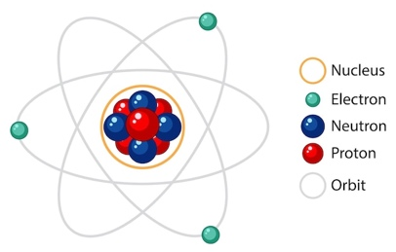
Figure. General structure of an atom

Choose options from the following lists to complete Table 1:

in nucleus | negligible | 0
surrounding the nucleus | 1 | +1
in nucleus | 1 | -1

Table 1. Location and some properties of protons, neutrons, and electrons in an atom.
Particle | Location | Mass (in atomic mass units, amu) | Charge
Proton
Neutron
Electron
Atomic notation and nuclear science
Nuclear science is related to the science concerning the nucleus of the atom (Figure 1).
We know the nucleus is made up of protons and neutrons.

The number of protons in an atom determines the element:
e.g., Hydrogen = 1 proton, Helium = 2 protons, Carbon = 6 protons

We have notation to represent an atom, which shows the number of protons (atomic number) and the overall mass (protons + neutrons).

The notation for an atom is as follows:
X
A
Z
X = symbol of element
A (mass) = number of (protons + neutrons)
Z (atomic number) = number of protons

E.g., Carbon:
Mass number (protons + neutrons)
C
12
6
Symbol for carbon
Atomic number (no. of protons)

- Atomic number (Z) = number of protons, therefore if:

Z = 1, the atom has 1 proton and is hydrogen (H)
Z = 6, the atom has 6 protons and is carbon (C)

- Mass number (A) = The number of protons + neutrons in an atom

Note: mass (concerning protons and neutrons) is different to charge (positive or negative).
In a neutral atom (one with no charge), the number of protons and number of electrons are equal.

When naming atoms, we use the name or symbol of the element, followed by the mass number. For example: hydrogen-1 (or H-1), carbon-12 (or C-12) etc.

The name and notation for the above examples are shown below:
C
12
6
H
1
1

hydrogen-1: carbon-1:

Question 2
Use the online Atom Builder program (https://www.ansto.gov.au/education/apps) and the Periodic Table poster (https://www.ansto.gov.au/education/resources/posters) to help you complete Table 2 below.

Table 2. Naming and notation for atoms
Name of atom | Number of protons  (i.e., atomic number / Z) | Number of neutrons | Mass number | Notation
Cu
63
29

 |  | 29 | 54
Lead-210
Csf
137
55

Isotopes of elements
We know that the number of protons (atomic number) in an atom (element) are fixed and specific to each element. However, you should know that the number of neutrons in an atom are not fixed. Sometimes there can be more neutrons or less neutrons relative to protons in an atom’s nucleus, which will change the atoms overall mass.

For example, below are diagrams of the Nuclei (plural term for nucleus) for the five lightest (in mass) atoms. Their names are also listed below each.

Key: protons
++
Neutrons
Isotopes of helium
++
Isotopes of hydrogen
++
++
++
++
++
++
++
hydrogen-1 hydrogen-2 hydrogen-3 helium-3 helium-4
(protium) (deuterium) (tritium)
Note that hydrogen-1 (protium) does not contain any neutrons. It is the only isotope of an element without any neutrons.

Question 3
Use the information above to define the term ‘isotope’ and then complete Table 3 below.
…………………………………………………………………………………………………………………………………………………………………………………………………………………………………………………………………………………………………………………………
Table 3. Examples of isotopes useful in studying Earth’s history.

Hint: You can google the answers for parts a and b.

Element (symbol) | a. What is the most common isotope?  Hint: Google ‘what is the most abundant isotope of…’ | b. Name one radioactive (unstable) isotope | c. Which isotopes (stable or unstable) are useful in studying Earth’s biological and geological history and why? E.g., Dating recent/ancient rocks or fossils, evidence for past life, past temperatures.
Lead (Pb) |  |  | Hint: www.ansto.gov.au/media/1276/download
Carbon (C) |  |  | Hint: www.ansto.gov.au/our-facilities/centre-for-accelerator-science/radiocarbon-dating
Oxygen (O)

Radioactive isotopes (radioisotopes), radioactive decay and half-life
Radioactive isotopes are unstable and will decay to become stable (i.e., they will change into a more stable element!). An example of this is carbon-14, which decays to Nitrogen-14 by changing one of its neutrons into a proton. During this decay process (carbon-14 to nitrogen-14), some energy will also be emitted (i.e., radiation). Hence, carbon-14 is a radioactive isotope (radioisotope).
In general, Isotopes are unstable (radioactive) when (see Figure 1 below):
- They have too few neutrons
- They have too many neutrons
- Their nucleus is too large (mass is too big)

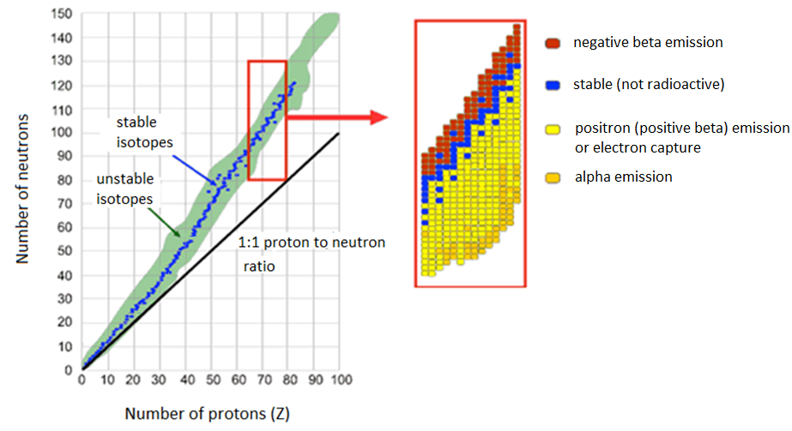
Figure 1. Ratio of neutrons to protons of atoms

Question 4
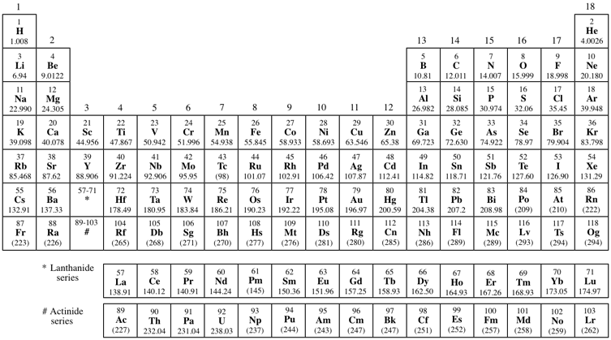
Use the ANSTO periodic table (https://www.ansto.gov.au/education/resources/posters) to identify elements that are always unstable, that is, they have only radioisotopes (radioactive isotopes). Highlight these on the diagram below.

Question 5
Every unstable isotope undergoes radioactive decay at a particular rate. This rate is referred to as the half-life of an isotope. Half-lives may be very short, just a few seconds, or very long, up to many millions of years, depending on the isotope.

- Examine the following diagram representing the radioactive decay of carbon-14, which has a half-life of 5,730 years and explain what ‘half-life’ means.

Second
half-life
First
half-life

5,730 years
another 5,730 years

20 million carbon-14 atoms

5 million carbon-14 atoms remain

10 million carbon-14 atoms remain

You can also watch this short 2-minute video explaining half-life: www.youtube.com/watch?v=tzM6aK5QbSU
Explain the meaning of the term ‘half-life’.
………………………………………………………………………………………………………………………………………………………………………………………………………………………………………………………………………………………………………………
………………………………………………………………………………………………………………………………………………………
Choose from the below half-lives in the table to answer parts b) and c).
22.2 years | 4.5 billion years

- What is the half-life of Pb-210?
……………………………………………………………………………………………………………………………………………………..
- What is the half-life of U-238?
……………………………………………………………………………………………………………………………………………………..

Nuclear Radiation – Radioactivity
In 1896 French scientist Henri Becquerel discovered a new kind of invisible radiation that seemed to be emitted from a uranium-rich rock. This radiation could not be stopped, increased or decreased. This was nuclear radiation (emitted from the nucleus of an atom) and it was something completely new to science.
Marie Curie, working in Paris, coined the term 'radioactivity' to describe this new property, and discovered three new radioactive elements.
It is the structure of the nucleus of an atom that determines whether it is radioactive (i.e., unstable). Unstable atoms undergo radioactive decay.
Further studies by New Zealander Ernest Rutherford showed that there are three different types of radioactive emissions (radiation). He named them after the first 3 letters of the Greek alphabet: alpha (α), beta (β) and gamma (γ) radiation.

Alpha radiation (α)
Strong nuclear forces normally hold the protons and neutrons inside a nucleus together.
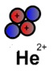But if the nucleus is too big, it will begin to break down and release an alpha particle.
An alpha particle is made up of two protons and two neutrons, has a
charge of +2, and is identical to a helium-4 nucleus as illustrated here:
Alpha particles have high energy when they are first released, but they quickly lose energy as they strike matter. Because alpha particles are relatively large and they are highly ionising, they have a low penetrating ability. They only travel a few centimetres through air and can be stopped by a sheet of paper or the outer layer of dead skin.

Beta radiation (β)
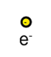Nuclei are made up of protons and neutrons. If a nucleus contains too many neutrons, one of the neutrons will break down. A neutron breaks down to form a proton (which stays in the nucleus) and an electron (which is emitted as a beta particle).
Beta particles are high-energy, high-speed electrons as illustrated here:

They have a charge of -1, are much smaller and much less ionising than alpha particles, and have a higher penetrating ability, typically travelling tens of centimetres in air. Beta particles can pass through skin but can be stopped by a small thickness of aluminium or plastic.

Gamma radiation (γ)
Sometimes a nucleus is still unstable after emitting an alpha or a beta particle and balances itself by releasing a burst of energy in the form of a gamma ray.
Gamma radiation consists not of particles but of energy in the form of extremely high-frequency electromagnetic waves (light waves) as illustrated here:

Gamma radiation has the highest penetrating ability of all nuclear radiation. A thick layer of lead, concrete, or approximately 5 metres of water is needed to stop it.

Question 6
After reading the information above, complete Table 4 below for the three types of radioactive decay emissions (ionising radiation).
Table 4. Alpha, beta and gamma radiation properties

Name | Symbol | Consists of | Charge | Stopped by
Alpha | α | Two protons and two neutrons  (Helium-4 nucleus)
Beta | β
Gamma | γ |  | 0

Radioactive atoms, called radioisotopes, may emit only one type of radiation but it is more common for an alpha or beta decay particle to be accompanied by a gamma ray.

Electromagnetic (EM) spectrum
The electromagnetic spectrum below shows that EM radiation occurs as light waves (called photons). The type of radiation depends on the amount of energy it has. Gamma rays are at the high energy end of the spectrum whilst radio waves are at the low energy end. We can only see mid-range energy EM waves called visible light.

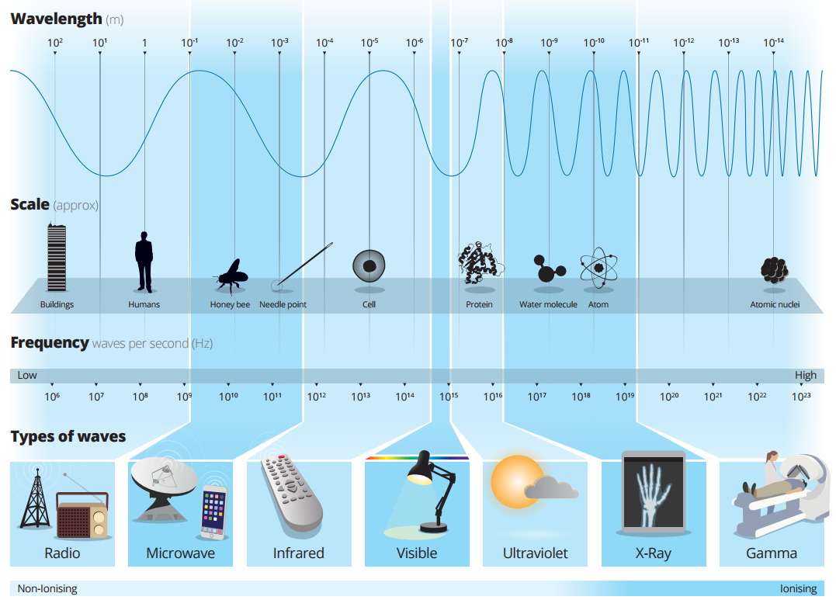

Question 7
Refer to the ANSTO Electromagnetic Spectrum poster (shown above and at https://www.ansto.gov.au/education/resources/posters) to complete the questions below.
- What is the wavelength range of X-rays? ………………………………………………………………………

- X-ray Fluorescence (XRF) is a very useful technique commonly used by Earth and Environmental Scientists to look at the chemical composition of rocks and fossils.
This is a non-destructive analysis.

Circle either minerals or elements to make the below statement correct.

Scientists can use XRF to determine what minerals / elements exist in rocks, fossils, or sediments.

- X-ray Diffraction (XRD) can also be used by scientists to look at the chemical composition of rocks and fossils. This is a destructive analysis as the sample must be powdered.

Circle either minerals or elements to make the below statement correct.

Scientists can use XRD to determine what minerals / elements exist in rocks, fossils, or sediments.
Notice that on the EM spectrum, X-ray wavelength range matches the scale (size) of single atoms as well as molecules (compounds of atoms), which is why we can use these X-rays to determine elements and minerals inside samples.

Measuring radioactive decay and radiometric dating (absolute dating)

Question 8

- What radioactive isotope of carbon emits beta radiation when it decays to nitrogen-14? (Hint: https://www.ansto.gov.au/media/2237/download?inline)

…………………………………………………………………………………………………………………………………………………
- What method is used with lead-210 dating?
(Hint: www.ansto.gov.au/media/1276/download)
…………………………………………………………………………………………………………………………………………………

- What is the SI unit of a becquerel (Bq) used to measure?
…………………………………………………………………………………………………………………………………………………

During Excursion:

Experiment 1
Investigating the properties of alpha, beta, and gamma radiation

Learning objective: To understand how we can measure radioactive decay and date the age of rocks and fossils, we must first understand that radiation is a natural product which can be measured. The following experiment allows us to indirectly observe radiation emitting from various radioactive materials.

- View the demonstration and record the radioactivity measured by the scintillation counter in Table 1.1 below.
Table 1.1
Source | Radioactivity (counts per second or cps)
Source | No cover | Paper | Aluminium | Lead
A
B
C

- Use the data you have recorded to identify the type of radiation produced by each source. Justify your choice in Table 1.2 below.
Table 1.2
Source | Type of radiation | Justification:  Why do you think it is this radiation?
A
B
C

- Gamma emission usually accompanies alpha or beta decay. Which other form of radiation do you think is being emitted from the gamma source? Why?
…………………………………………………………………………………………………………………………………………………………………………………………………………………………………………………………………………………………………………………………

Experiment 2
Using fluorescence to identify elements

At ANSTO in the Environmental Radioactivity measurement Centre we combine radiometric dating techniques with chemical analyses to monitor the environment.
The picture below shows the ITRAX micro-X-ray fluorescence (μ-XRF) instrument used to measure element concentrations in rocks, fossils, and recent sediments. ITRAX is located in the Environmental Radioactivity Measurement Centre at ANSTO, Lucas Heights.
The instrument can scan the surface of a rock or fossil, or a sediment core to map elements in the sample.

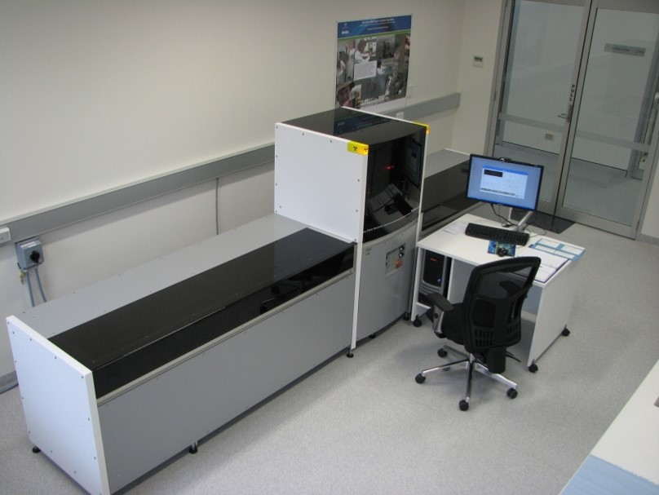
Figure 2.1 ITRAX micro-X-ray fluorescence scanner (left) with an example of a sediment core scanned (right).

The term ‘fluorescence’ was coined by George Gabriel Stokes in 1852 who noticed that fluorite glowed blue when exposed to ultraviolet (UV) light. Stokes decided to call this phenomenon fluorescence after fluorite and mineralogists now use the term widely for any mineral that glows under UV light.

How fluorescence works
Fluorescent material will absorb electromagnetic (EM) radiation (photons/light waves) of many different wavelengths, and then emit radiation of (usually) one specific wavelength, characteristic of the element (like a fingerprint). This emitted light can be in the visible range (which we can see) or the emitted light can be in the X-ray range which we can’t see but it can be detected by instruments like ITRAX.

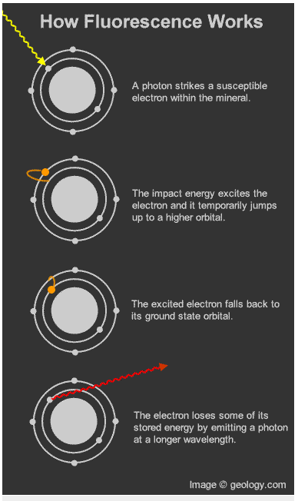
Figure 2.2 A schematic showing how the physical interaction of Electromagnetic (EM) radiation (photons/light waves) can cause a material to fluoresce. The emitted light is characteristic to a specific element (like a fingerprint). We can detect and measure the emitted EM radiation to tell us what elements are present in the material.

Learning objective: Here we will observe how short-wave UV light can interact with elements within minerals to make them fluoresce. The colour they emit can help us to identify the mineral samples.

- View the demonstration and record the fluorescent colour observed in the rock sample.
Table 2.1 Observational data.
Mineral sample | Fluorescent colour | What mineral could this be and why?
A
B

C
D

- Use the data you have recorded and the data in Tables 2 and 3 below to identify the mineral in the rock samples.
Table 2.2 Elements in our samples and the colour they fluoresce.
Elements in our samples  causing fluorescence | Colour under UV in some minerals
Zinc | Green
Europium | Blue
Lead | Yellow
Possibly S₂ | Orange

Table 2.3 Fluorescent minerals and their chemical compositions.
Mineral | Chemical name and formula  (± some common impurities)
Willemite | Zinc silicate - Zn₂SiO₄
Fluorite | Calcium fluoride - CaF₂  (± Europium)
Calcite | Calcium carbonate - CaCO₃  (± Lead, Copper, Cobalt, Chromium, Manganese)
Sodalite | Chloride-containing sodium aluminosilicate  Na 8(Al₆Si₆O₂₄)Cl₂  (± Sulphur, Iron, Titanium)

Case study: Using radioisotopes and element analyses to assess water contamination from 50 years ago
The Environmental Protection Agency wishes to prosecute a chemical company, for polluting a lake with copper and manganese slurries. The company denies this.
However, there are rumours that 50 years ago, around 1970, the company was in fact polluting the river.

Your job as an environmental scientist is to
collect and assess evidence to support or refute this accusation.

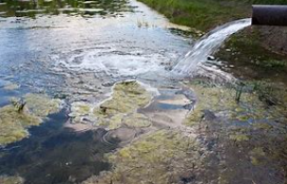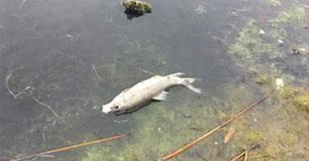
http://www.healthnewsreview.org
https://regina.ctvnews.ca
Figure 3.1 Images from the lake where the sediment core was sampled.

Learning objectives:
- Develop investigative skills used to reconstruct the history of recent lake deposits
- Evaluate and combine datasets to understand past environmental changes and assess for pollution

- Use data from Table 3.2 and Figure 3.2 below to fill in Table 3.1.
  - Determine and record if there is an anomaly in the ITRAX element data
  - Record the depth of these anomalies
  - Determine the age at that depth in the sediment and list the radioisotopes used
Table 3.1 Observational data. Are there any anomalies in the element data?
Element | ITRAX counts (anomalies) | Depth (cm) | Age of sediment and radioisotopes used
Cu
Mn

- How do we know our age data is correct?
___________________________________________________________________

- Is there evidence that the chemical company polluted the lake in the 1970’s?
_____________________________________________________________________________________________________________________________________________
Below are two datasets that you will need to use to complete the questions above. Table 3.2 provides data on the concentration of copper and manganese in the sediment core sampled. Figure 3.1 provides absolute age data using lead-210 and caesium-137, which is correlated with the depth (m) from the sediment core.

Table 3.2 Element data correlated with depth data from the sediment core
 | ITRAX counts
Depth (cm) | Copper (Cu) | Manganese (Mn)
0 | - | -
0.5 | 1036 | 156
5.5 | 944 | 147
10.5 | 1110 | 198
15.5 | 5886 | 11809
17.5 | 544 | 247
20.5 | 684 | 21
25.5 | 1064 | 285
30.5 | 661 | 145

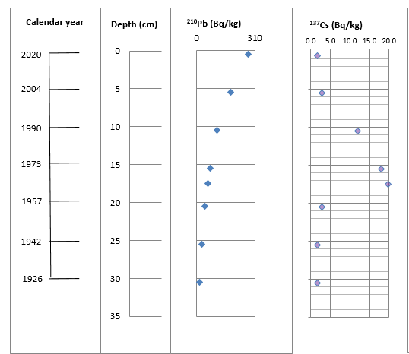
Figure 3.2 Radiometric age data using lead-210 and caesium-137, correlated with sediment core depth data.

