

Radioactivity and its applications
Online learning workbook

The online class addresses the following content from the Australian Curriculum for Science:

Year 9 Science Understanding

Chemical Sciences: All matter is made of atoms that are composed of protons, neutrons and electrons; natural radioactivity arises from the decay of nuclei in atoms (ACSSU177)

During the ANSTO online class
Students will:
- Investigate the properties of the types of radiation (alpha, beta and gamma)
- Learn about OPAL, Australia’s only nuclear reactor, and how it is used to make radioisotopes
- Understand that radioisotopes have a wide variety of uses, including in medical scans, tr radiotherapy and for dating First Nations cultural artefacts
- Collect data during a demonstration of a radiation experiment, using low level radioactive sources and radiation detection equipment.

Before your online class

We expect students to have completed this pre-work prior to the online class. It consists of questions on concepts from junior years that are essential to an understanding of the nuclear science to be covered in the videoconference.

Question 1: Structure of atoms

Atoms are made up of 3 sub-atomic particles: protons, neutrons and electrons. Choose options from the following lists to complete the table:

in nucleus | negligible | 0
surrounding the nucleus | 1 | +1
in nucleus | 1 | -1

Particle | Location | Mass | Charge
Proton
Neutron
Electron

Question 2: Isotopes of Elements
The nuclei for the five smallest atoms and their names are shown in the diagram below. All atoms contain protons and nearly all atoms contain neutrons. The hydrogen atom, hydrogen-1, is the only atom that does not contain neutrons.

Key: proton neutron
++
++
++
++
++
++
++
++
++
Isotopes of helium
Isotopes of hydrogen

hydrogen-1 hydrogen-2 hydrogen-3 helium-3 helium-4
(deuterium) (tritium)

Using the information above, define the term ‘isotope’.
…………………………………………………………………………………………………………………………………………………………………………………………………………………………………………………………………………………………………………………………

Question 3: Representation of isotopes
Nuclear Facts To Remember:
- The number of protons in an atom is the atomic number (Z).
- The number of protons plus neutrons is the mass number (A). Protons and neutrons are referred to as nucleons.
- In a neutral atom, the number of protons and number of electrons are equal.

The atomic number, Z, determines what element the atom is, for example:
Z = 1, atom is hydrogen, symbol H
Z = 6, atom is carbon, symbol C

The notation for representing an atom is as follows:
X
A
Z
X = symbol of element
A = number of nucleons (protons + neutrons)
Z = number of protons

When naming atoms, we use the name or symbol of the element, followed by the mass number. For example: hydrogen-1 (or H-1) and carbon-12 (or C-12).
The notation for these is ${}_{1}^{1}H$ and ${}_{6}^{12}C$

Use the online Atom Builder program (https://www.ansto.gov.au/education/apps) and the Periodic Table poster (https://www.ansto.gov.au/education/resources/posters) to help complete the table.

Name of atom | Number of protons | Number of neutrons | Mass number | Notation
nitrogen-14
 | 3 |  | 7
 |  |  |  | $${}_{9}^{19}F$$
 |  | 14 | 27

Question 4: Half-life
Every unstable isotope undergoes radioactive decay at a particular rate. This rate is referred to as the half-life of an isotope.
Half-lives may be very short, just a few seconds, or very long, up to many millions of years, depending on the isotope. Carbon-14 has a half-life of 5,730 years.

Examine the following diagram and, using the diagram explain the meaning of the term ‘half-life’.
one half-life
5,730 years
another half-life
another 5,730 years
20 million C-14 atoms
10 million C-14 atoms
5 million C-14 atoms

……………………………………………………………………………………………………………………………………………………………………………………………………………………………………………………………………………………………………………………………………………………………………………………………………………………………………………………………………………………………………………………………………………………………………………………………………………………………………………………
Extension activity: Fluorine-18 has a half-life of 110 minutes. If you have 10 000 000 atoms of Fluorine-18 initially, how many atoms will be left after 11 hours?
…………………………………………………………………………………………………………………………………………………………………………………………………………………………………………………………………………………………………………………………

Activities addressed during the online class
- Investigating the properties of alpha, beta and gamma radiation
View the demonstration and record the radioactivity measured by the scintillation counter in each of the following situations.

Source | Radioactivity (counts per second)
Source | No cover | Paper | Aluminium | Lead
A
B
C

Use the data you have recorded to identify the type of radiation produced by each source. Justify your choice.

Source | Type of radiation | Justification: Why do you think it is this radiation?
A
B
C

Give a reason why the radioactivity of the gamma source decreases when the 1 mm thick piece of aluminium is placed over this source.
…………………………………………………………………………………………………………………………………………………………………………………………………………………………………………………………………………………………………………………………

- Radioisotopes for medicine
Nuclear medicines play an important role in supporting Australian health helping to accurately diagnose and treat diseases. Every Australian is likely to benefit from nuclear medicine, and on average will have at least two nuclear medicine procedures in their lifetime.

Nuclear medicines are designed to emit specific types of radiation, depending on their use in the body. You will watch three videos about different nuclear medicines. Fill out the table below after each video:

Nuclear medicine | Purpose | Type of radiation emitted
Technetium-99m | Diagnose disease during medical scans
Iodine-131 | Treat thyroid cancer
Scandium-47 | A theranostic medicine to diagnose and treat cancers at the same time

- Radioisotopes for studying ancient cultures
Living things contain carbon-14 and carbon-12 in a ratio that is the same as in the atmosphere at the time. When the organism dies, the ratio of carbon-14 to carbon-12 decreases, as carbon-14 decays away.
Using carbon dating, scientists can calculate how much carbon-14 decay has occurred by measuring the ratio of carbon-14 to carbon-12 in the sample. The extent of carbon-14 decay will reveal the age of the sample.

Listen to how ANSTO scientists use carbon dating to determine the age of ancient Aboriginal rock art. Use this information, as well as the graph above, to answer the following questions:

- Where does the carbon come from in the mud wasp nest?
………………………………………………………………………………………………………………………………………………………
- Circle the correct answer: Rock paintings drawn on top of a fossilised mud wasp nest must be:
  - older than the nest
  - younger than the nest

- Circle the correct answer: Rock paintings underneath a fossilised mud wasp nest must be:
  - older than the nest
  - younger than the nest

- The oldest dates suggested that the rock art was about 17,000 years old. What percentage of the original carbon-14 remains in the mud-wasp nests today?
………………………………………………………………………………………………………………………………………………………

Radiation Investigation
Your education officer will demonstrate a radiation experiment using the scintillation counter and some radioactive sources.
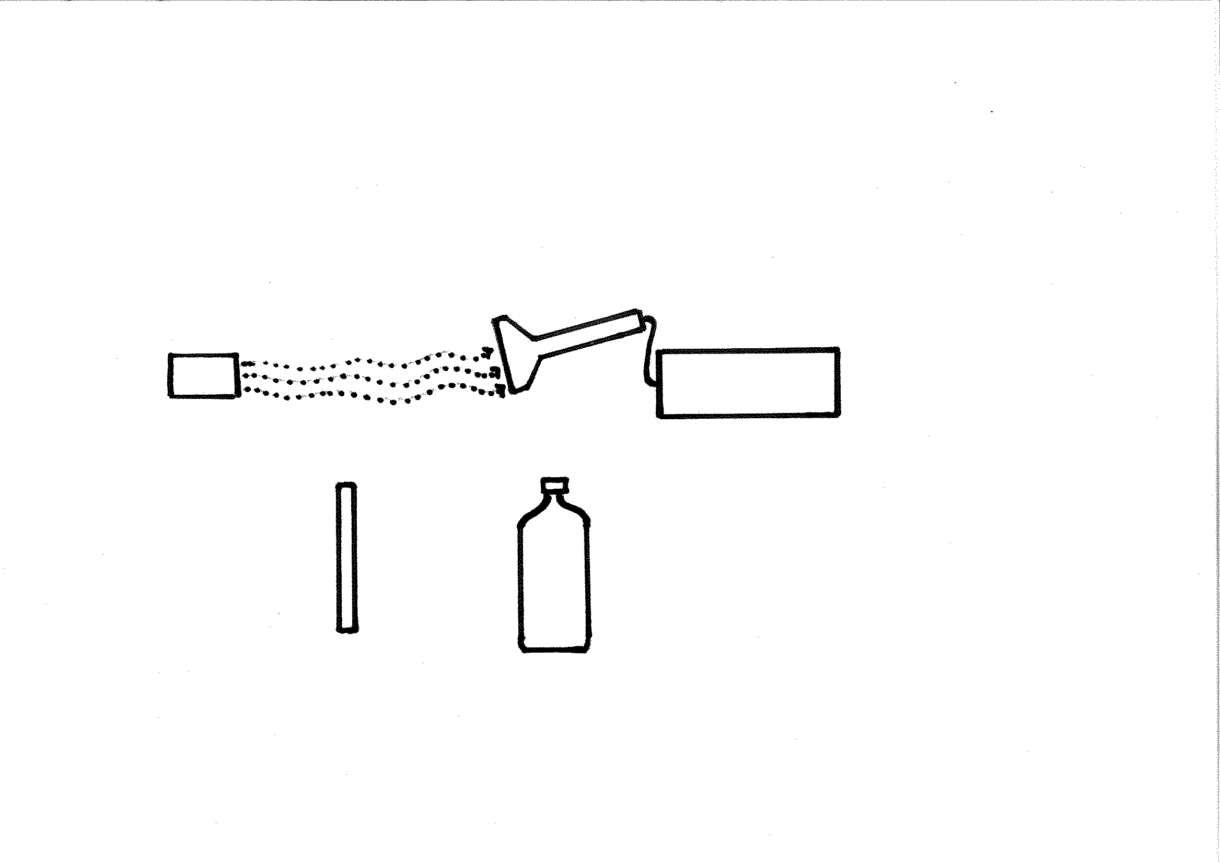
Aim: To determine how radioactivity changes at different distances from the detector.
Uranium
Scintillation counter
1 cm
2 cm
4 cm
Measure also at 0 cm (at contact), 8 cm, 16 cm and 32 cm

Write a hypothesis for this experiment
………………………………………………………………………………………………………………………………………………………
………………………………………………………………………………………………………………………………………………………

Results: Write down the results of your experiment during the online class
Distance  (cm) | Radioactivity (counts per second, cps)
Distance  (cm) | Trial 1 | Trial 2 | Trial 3 | Mean
0
1
2
4
8
16
32

Write a conclusion for this experiment
………………………………………………………………………………………………………………………………………………………
………………………………………………………………………………………………………………………………………………………

Extension activity: Graph your results below. Make sure you choose an appropriate graph type and include a graph title and axis titles.

Further Notes

Use this space to take your own notes about areas of interest relevant to your depth study and to record any question you may have. The Education Officer will allocate 10 minutes at the end of the presentation for questions.

………………………………………………………………………………………………………………………………………………………………………………………………………………………………………………………………………………………………………………………………………………………………………………………………………………………………………………………………………
………………………………………………………………………………………………………………………………………………………………………………………………………………………………………………………………………………………………………………………………………………………………………………………………………………………………………………………………………
………………………………………………………………………………………………………………………………………………………………………………………………………………………………………………………………………………………………………………………………………………………………………………………………………………………………………………………………………
………………………………………………………………………………………………………………………………………………………………………………………………………………………………………………………………………………………………………………………………………………………………………………………………………………………………………………………………………
………………………………………………………………………………………………………………………………………………………………………………………………………………………………………………………………………………………………………………………………………………………………………………………………………………………………………………………………………
………………………………………………………………………………………………………………………………………………………………………………………………………………………………………………………………………………………………………………………………………………………………………………………………………………………………………………………………………
………………………………………………………………………………………………………………………………………………………………………………………………………………………………………………………………………………………………………………………………………………………………………………………………………………………………………………………………………
………………………………………………………………………………………………………………………………………………………………………………………………………………………………………………………………………………………………………………………………………………………………………………………………………………………………………………………………………

