

Year 12 Investigating Science
Videoconference workbook
This videoconference addresses the following syllabus content from the NSW NESA Stage 6 Investigating Science Syllabus
- Module 6: Technologies, specifically the inquiry question “How have developments in technology led to advances in scientific theories and laws that, in turn, drive the need for further developments in technology?”
- Module 8: Science and society, specifically the inquiry questions “How do science-related events affect society’s view of science?”, “Why is scientific research regulated?” and “How do economic, social and political influences affect scientific research?”
During the ANSTO videoconference
Students will:
- Discover how to monitor radiation using several detection technologies
- Investigate the properties of alpha, beta and gamma radiation and of neutrons
- Collect data during a demonstration of a radiation experiment, using low level radioactive sources and radiation detection equipment and different shielding material
- Understand the design, operation and primary function of the OPAL (Open Pool Australian Lightwater) research reactor and compare it with power reactors
- Investigate the creation of key products of the nuclear industry, including nuclear medicines, and their significance to society
- Using historical nuclear research experiments understand the technology that was used in the science discoveries and how that led to enhanced technology that is used today
- Investigate some major nuclear incidents and public reaction to them
- Discuss economic, societal and political factors that affect the regulation and funding of scientific research

Pre-work Questions – to be attempted before the videoconference
We expect students to have completed this pre-work prior to participating in the videoconference. The first seven questions are a review of radioactivity essential for an understanding of the basic nuclear science on the tour. The remaining questions are about content and skills specific to the Year 12 Investigating Science syllabus.

Question 1
Atoms are made up of 3 sub-atomic particles: protons, neutrons and electrons. Choose options from the following lists to complete the table:

in nucleus | negligible | 0
surrounding the nucleus | 1 | +1
in nucleus | 1 | -1

Particle | Location | Mass in atomic mass units (amu) | Charge
Proton
Neutron
Electron

Nuclear Facts to Remember:
- The number of protons in an atom is the atomic number (Z).
- The number of protons plus neutrons is the mass number (A).
- In a neutral atom, the number of protons and number of electrons are equal.

The atomic number, Z, determines what element the atom is, for example:
Z = 1, atom is hydrogen, symbol H
Z = 6, atom is carbon, symbol C

The notation for representing an atom is as follows:
X
A
Z
X = symbol of element
A = number of (protons + neutrons)
Z = number of protons

Individually, either the symbol or the Z-number will uniquely identify the element. Hence only one of them must be present; the other one is not required.

When naming atoms, we use the name or symbol of the element, followed by the mass number. For example: hydrogen-1 (or H-1) and carbon-12 (or C-12). The notation for these is:
₁ ₁ ₁₂ ₁₂
H or H and C or C
¹ ⁶

Question 2
Use the online Atom Builder program (https://www.ansto.gov.au/education/apps ) and the Periodic Table poster (https://www.ansto.gov.au/education/resources/posters) to help complete the table.

Name of atom | Number of protons | Number of neutrons | Mass number | Notation
nitrogen-14
 | 3 |  | 7 | $$\begin{matrix}7 \\ 3\end{matrix}Li$$
 |  |  |  | $$\begin{matrix} \\ 9\end{matrix}F$$
 |  | 14 | 27 | $$\begin{matrix}27 \\ 13\end{matrix}Al$$

Isotopes of Elements
The nuclei for the five smallest atoms and their names are shown in the diagram below. Nearly all atoms contain protons and neutrons. Hydrogen-1 is the only isotope that does not contain neutrons.
++
++
++
++
++
++
++
++
++
Key: proton neutron
Isotopes of helium
Isotopes of hydrogen

hydrogen-1 hydrogen-2 hydrogen-3 helium-3 helium-4
(deuterium) (tritium)

Question 3
Using the information above, define the term ‘isotope’
…………………………………………………………………………………………………………………………………………………………………………………………………………………………………………………………………………………………………………………………………………
Electromagnetic spectrum
The electromagnetic spectrum below shows that radiation occurs in waves. The type of radiation depends on the amount of energy it has. Gamma rays are at the high energy end of the spectrum whilst radio waves are at the low energy end.

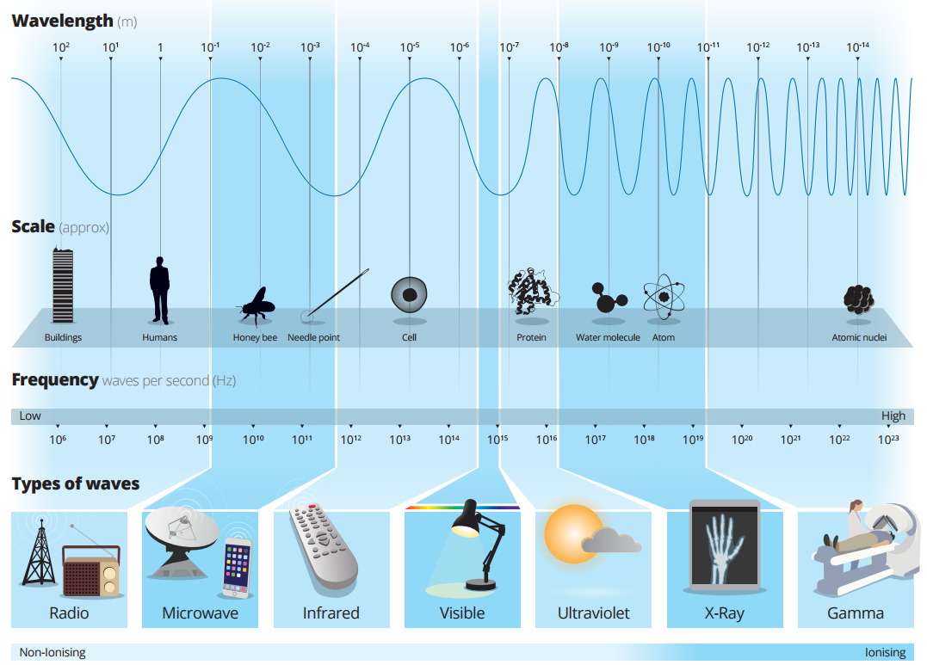

Question 4
Refer to the ANSTO Electromagnetic Spectrum poster (shown above and also at https://www.ansto.gov.au/education/resources/posters ) to complete the activity below:
Delete the incorrect terms in the following sentence.
The shorter the wavelength, the greater/lesser the energy. Therefore ultraviolet radiation has more/less energy than infrared radiation and more/less than gamma rays.
Nuclear Radiation – Radioactivity
In 1896 French scientist Henri Becquerel discovered a new kind of invisible radiation that seemed to be emitted from a uranium-rich rock. This radiation could not be stopped, increased or decreased. This was nuclear radiation and it was something completely new to science.
Marie Curie, working in Paris, coined the term 'radioactivity' to describe this new property, and discovered three new radioactive elements.
It is the structure of the nucleus of an atom that determines whether it is radioactive, or in other words, unstable. Unstable atoms undergo radioactive decay.
Further studies by New Zealander Ernest Rutherford showed that there are three different types of radioactivity. He named them after the first 3 letters of the Greek alphabet: alpha (α), beta (β) and gamma (γ) radiation.

Alpha radiation (α)
Strong nuclear forces normally hold the protons and neutrons inside a nucleus together. But if the nucleus is too big, it will begin to break down and release an alpha particle.
An alpha particle is made up of two protons and two neutrons, has a charge of +2, and is identical to a helium nucleus.
Alpha particles have high energy when they are first released but quickly lose energy as they strike matter. Because alpha particles are relatively large, they have a low penetrating ability. They only travel a few centimetres through air and can be stopped by a sheet of paper or the outer layer of dead skin.

Beta radiation (β)
Nuclei are made up of protons and neutrons. If a nucleus contains too many neutrons, one of the neutrons will break down. A neutron breaks down to form a proton (which stays in the nucleus) and an electron (which is emitted as a beta particle).
Beta particles have a charge of -1, are much smaller than alpha particles, and have a higher penetrating ability. Beta particles can pass through skin but can be stopped by a small thickness of aluminium or plastic.

Gamma radiation (γ)
Sometimes a nucleus is still unstable after emitting an alpha or a beta particle and balances itself by releasing a burst of energy in the form of a gamma ray.
Gamma radiation consists not of particles but of energy in the form of extremely high-frequency electromagnetic waves.
Gamma radiation has the highest penetrating ability of all nuclear radiation. A thick layer of lead, concrete or several meters of water is needed to stop it.

Question 5
After reading the information above, complete the following table for the three types of radioactive decay.
Name | Symbol | Consists of | Charge | Stopped by
Alpha | α | Two protons and two neutrons (Helium-4 nucleus)
Beta | β
Gamma | γ

Radioactive atoms, called radioisotopes, may emit only one type of radiation but it is more common for an alpha or beta decay to be accompanied by a gamma emission.

Question 6
Isotopes are unstable if:
- They have too few neutrons
- They have too many neutrons
- Their nucleus is too large
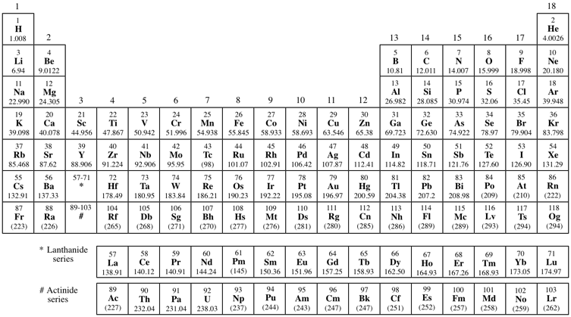
Use the ANSTO periodic table (https://www.ansto.gov.au/education/resources/posters ) to identify elements in the periodic table that are always unstable. Highlight these on the diagram below.
Question 7
Every unstable isotope undergoes radioactive decay at a particular rate. This rate is referred to as the half-life of an isotope. Half-lives may be very short, just a few nanoseconds, or very long, up to many millions of years, depending on the isotope. Carbon-14 has a half-life of 5,730 years.

Examine the following diagram and, from it, explain the meaning of the term ‘half-life’.
one half-life
5,730 years
another half-life
another 5,730 years
20 million C-14 atoms
10 million C-14 atoms
5 million C-14 atoms

………………………………………………………………………………………………………………………………………………………………………………………………………………………………………………………………………………………………………………………………………………………………………………………………………………………………………………………………………………………………………………………………………………………………………………………………………………………………………………………………………………………………………………………………………………………………………………………………………………………………………………………………………………………………………………………………………………………………………………………………………………………………

Question 8: Applications of nuclear science at ANSTO
ANSTO uses nuclear science in many different ways. Our OPAL reactor produces nuclear medicines for hundreds of thousands of patients every year, irradiates silicon for the electronics industry, and produces neutrons for investigating materials at the atomic and molecular level. Our scientists and engineers use nuclear science to advance our understanding of the environment, human health and new materials.
Watch a selection of videos from https://www.youtube.com/results?search_query=ANSTO and briefly summarise three examples of how nuclear science is used to benefit society at ANSTO:

…………………………………………………………………………………………………………………………………………………………………………………………………………………………………………………………………………………………………………………………………………………………………………………………………………………………………………………………………………………………………………………………………………………………………………………………………………………………………………………………………………………………………………………………………………………………………………………………………………………………………………………………………………………………………………………………………………………………………………………………………………………………………………………………………………………………………………………………………………………………………………………………………………………………………………………………………………………………………………………………………………………………………………

Question 9: Research data sets from ANSTO
Some of our scientists have supplied real data sets from their research projects for you to analyse. Select and complete the student worksheet for one of these data sets: https://www.ansto.gov.au/education/secondary/workbooks-and-datasets

Questions to be considered during the presentation

Complete your answers to the following questions in point form as the conference proceeds. More detailed information is available on the ANSTO website at https://www.ansto.gov.au/

Investigating the properties of alpha, beta and gamma radiation
- View the demonstration and record the radioactivity measured by the scintillation counter in each of the following situations.
Source | Radioactivity (counts per second)
Source | No cover | Paper | Aluminium | Lead
A
B
C

- Use the data you have recorded to identify the type of radiation produced by each source. Justify your choice.

Source | Type of radiation | Justification: Why do you think it is this radiation?
A
B
C

- Give a reason why the radioactivity of the gamma source decreases when the 1 mm thick piece of aluminium is placed over this source.
……………………………………………………………………………………………………………………………………………………………………………………………………………………………………………………………………………………………………………………………………………………

Technology for measuring radioactivity
The presenter will illustrate the use of a scintillation counter to measure radioactivity from an object.
At ANSTO, we use different portable devices to monitor levels of radiation.
- Next to the picture of each device below, write the name of the device and a sentence or two to explain how it works.
Name of the device and how it works
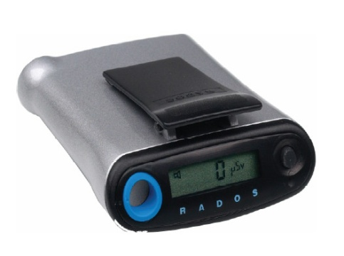
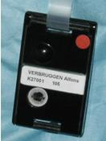
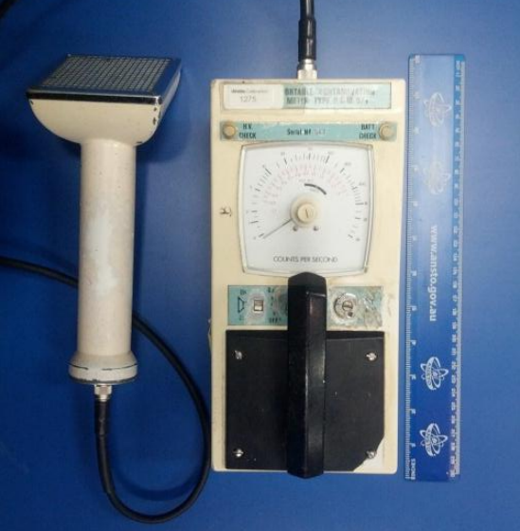

Regulation of the nuclear industry

The nuclear industry and its products are highly regulated. For example, the fission reaction inside nuclear reactors tightly controlled using the reactor components shown in the table below.

- Complete the table below by indicating the function of these components and the material used for these components in ANSTO’s OPAL multipurpose research reactor.

Reactor component | Material used in OPAL | Function
Fuel
Moderator

Control plates
Coolant

- Reactors need to be able to be shut down safely and quickly. Outline the shutdown processes for the OPAL nuclear reactor.

……………………………………………………………………………………………………………………………………………………………………………………………………………………………………………………………………………………………………………………………………………………………………………………………………………………………………………………………………………………………………………………………………………………………………………………………………………………………………………………………………………………

- Identify 3 products produced in OPAL and outline their uses.

Product of OPAL | Use

- Write down one example of a nuclear medicine and describe how it benefits human health

…………………………………………………………………………………………………………………………………………………………………………………………………………………………………………………………………………………………………………………………………………………………………………………………………………………………………………………………………………………………………………………………………………………………………………………………………………………………………………………………………………………………………………………………………………………………………………………………………………………………………………………………

Past events affect the public image of nuclear science
Nuclear accidents have had a very negative impact on the public perception of nuclear science. You will hear about several high-profile nuclear accidents during the videoconference.

- Give two examples of how nuclear accidents affected the future development and directions of the nuclear industry

……………………………………………………………………………………………………………………………………………………………………………………………………………………………………………………………………………………………………………………………………………………………………………………………………………………………………………………………………………………………………………………………………………………………………………………………………………………………………………………………………………………………………………………………………………………………………………………………………………………………………………………………………………………………………………………………………………………………………………………………………………………………………………………………………………………………………………………………………………………………………………………………………………………………………………………………………………………………………………………………………………………………………………………………………………………………………………………………………………………………………………………………………………………………………………………………………………………………………………………………………………………………………………………

Notes
Use this space to take your own notes about areas of interest relevant to your own depth study, including information from the Q&A session after your tour.

………………………………………………………………………………………………………………………………………………………………………………………………………………………………………………………………………………………………………………………………………………………………………………………………………………………………………………………………………………………………………………………………………………………………………………………………………………………………………………………………………………………………………………………………………………………………………………………………………………………………………………………………………………………………………………………………………………………………………………………………………………………………………………………………………………………………………………………………………………………………………………………………………………………………………………………………………………………………………………………………………………………………………………………………………………………………………………………………………………………………………………………………………………………………………………………………………………………………………………………………………………………………………………………………………………………………………………………………………………………………………………………………………………………………………………………………………………………………………………………………………………………………………………………………

Post-videoconference activity: Public perception of nuclear science
Your teacher will give you a media article. Read the article you have been given and consider the following questions:
  - What is the article about? Give a brief description of its contents.
  - Does it present a positive or negative view about the topic?
  - Where would this article have appeared in the media? Would it have been a leading story and made front page news?
  - How does the article make you feel? How does it affect your perception of nuclear science?
Your classmates will have received a different media article. Be prepared to share your answers during a class discussion so that other students can hear about the different topics covered in the media articles.

Post-videoconference activity: The influences of economic, social and political forces on scientific research

Scientific research depends on financial support, often in the form of grant money. Grant applications are competitive and not all research proposals are funded. Participate in a class discussion to consider the following questions:

Who decides which research projects receive grant funding?
What factors influence these decisions?
What effect does this have on what scientific research proceeds?

