

Investigating ozone
Student Worksheet
This resource, with its accompanying MS Excel workbook ‘Investigating Ozone’, give students an opportunity to investigate surface-level ozone concentrations in the air around Liverpool in Sydney, using descriptive statistical analysis, a univariate analysis and a bivariate analysis to explore the data. Students also investigate the relationship between ozone concentration and certain pollutant gases, as well as the effect of temperature, leading to evidence-based decisions about the future of surface-level ozone pollution in our cities.
The atmospheric measurements of ozone concentration and other variables, presented in the MS Excel spreadsheet, were made using a NSW Department of Planning, Industry and Environment (DPIE) Air Quality Monitoring Station (AQMS) and an ANSTO 1500L dual-flow-loop two-filter radon (²²²Rn) detector on the grounds of Liverpool Girls High School, from March 2019 to February 2020. The station installation and ongoing maintenance was a combined effort between staff at DPIE (then the Office of Environment and Heritage), the University of Wollongong Centre for Atmospheric Chemistry, the Australian Nuclear Science and Technology Organisation (ANSTO), Liverpool Girls High School and the NSW Department of Education. The authors would like to acknowledge all who assisted in making this possible.
The tasks in the document require student access to a computer with internet capability and the spreadsheet program Microsoft Excel. Students are guided through analysing the secondary data provided in a MS Excel workbook, and reporting on their findings.
This resource was created for use by students in Years 9-12.
The two sides of Ozone
We’ve all heard about ozone, but did you know that ozone can be good or bad for us depending on where it is found in the Earth’s atmosphere. Ozone is a special form of oxygen. It is a molecule composed of three atoms of oxygen, and has the chemical formula O₃. The oxygen we breathe and that is so vital to life on earth is O₂. Ozone is a pale blue gas with a sharp, pungent odour, but its location in the atmosphere affects whether it is helpful or damaging to us. Ozone in the stratosphere of the upper atmosphere protects life on Earth by absorbing the sun’s harmful UV radiation, whereas ozone found in the troposphere of the lower atmosphere is a harmful atmospheric pollutant that is a key part of city smog.

The ozone layer in the stratosphere protects life on Earth by absorbing most of the sun’s harmful ultraviolet radiation, UV-B and UV-C. Ground-level ozone is a pollutant that can affect the respiratory system. Image Source: The Ozone Layer | Center for Science Education

Students will:
- process and analyse data and information
- use descriptive statistical analysis techniques to investigate a large dataset
- conduct a univariate analysis and a bivariate analysis of a large dataset
- use MS Excel to create graphs and interpret results
- increase their understanding of ozone in the atmosphere and the factors that influence surface-level ozone
- use data to make evidence-based decisions about the formation of surface-level ozone and assess the implications of these decisions on the future of surface-level ozone pollution in Australian cities

This resource has been designed to address the following Inquiry Skills descriptors in the Australian Curriculum (at Home | V9 Australian Curriculum) Level Description Year 9 and Year 10
Students:
- select and construct appropriate representations, including tables, graphs, descriptive statistics, models and mathematical relationships, to organise and process data and information AC9S9I04; AC9S10I04
- analyse and connect a variety of data and information to identify and explain patterns, trends, relationships and anomalies AC9S9I05; AC9S10I05
- construct arguments based on analysis of a variety of evidence to support conclusions or evaluate claims, and consider any ethical issues and cultural protocols associated with accessing, using or citing secondary data or information AC9S9I07; AC9S10I07
- write and create texts to communicate ideas, findings and arguments effectively for identified purposes and audiences, including selection of appropriate content, language and text features, using digital tools as appropriate AC9S9I08; AC9S10I08

Contents

Background Information
The two sides of ozone
Ozone in the atmosphere ……………………………………………………………………………………………………4
How surface-level ozone is formed ………………………………………………………………………………………5
Problems of surface-level ozone …………………………………………………………………………………………..6

Activities
Activity 1: Understanding ozone 7

Activity 2: Comparing surface-level ozone concentrations for July 2019 and December 2019 – a univariate analysis 9

Activity 3: Temperature and surface-level ozone concentration - a bivariate analysis 16

Activity 4: Investigating nitrogen dioxide and surface-level ozone ………………………………………………….20

Definitions of descriptive statistical measures ………………………………………………………………………………..24

The two sides of ozone
Ozone in the atmosphere
We’ve all heard about ozone, but did you know that ozone can be good or bad for us depending on where it is in the Earth’s atmosphere. Ozone is a form of the element oxygen. It is a highly reactive gas with the chemical formula O₃, having a molecule composed of three atoms of oxygen. The oxygen we breathe and that is vital to life on Earth is O₂. Ozone is a pale blue gas with a sharp, pungent odour, but its location in the atmosphere affects whether it is helpful or harmful to us. Ozone in the upper atmosphere, in a layer called the stratosphere, protects all life on Earth by absorbing the sun’s harmful, short wavelength ultraviolet (UV) radiation. UV radiation is needed by us for the production of vitamin D, however, UV exposure can also have detrimental effects on human health, including an increased risk of developing skin cancer. UV radiation can be classified into three groups, UVA, UVB and UVC, according to the wavelength and energy of the radiation. Ozone in the stratosphere provides protection from all of the UVC rays, the most damaging of UV radiation, and the majority of UVB rays.

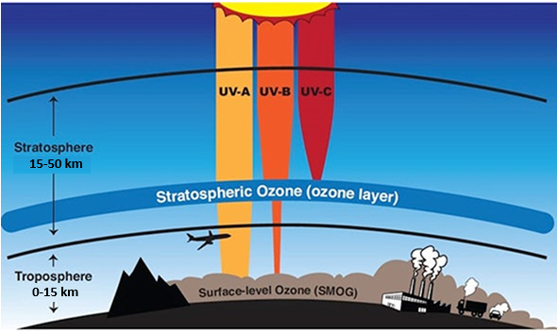
The ozone layer in the stratosphere protects life on Earth by absorbing most of the sun’s harmful, short wavelength ultraviolet radiation. Surface-level ozone is a pollutant that affects the respiratory system.
Image Source: The Ozone Layer | Center for Science Education

Ozone found in the lower atmosphere in a layer called the troposphere is a harmful atmospheric pollutant that is a key part of city smog. This ozone is formed by a photochemical reaction. A photochemical reaction is a chemical reaction initiated by the absorption of energy in the form of light.

How surface-level ozone is formed
Ozone is formed when sunlight interacts with particular pollutant gases in the atmosphere. These gases are oxides of nitrogen, such as nitrogen dioxide (NO₂) and nitric oxide (NO), and volatile organic compounds (VOCs), which are hydrocarbons that evaporate easily into the air and are released from a variety of sources including paints, cleaning products and petrol fumes from filling up petrol-driven cars. Combustion of fossil fuels is a major source of both nitrogen oxides and VOCs, with petrol and diesel driven cars, trucks, and buses being the largest producers of these emissions. Another source is coal-fired power plants. Bushfires also generate large quantities of the pollutant gases that form ozone.

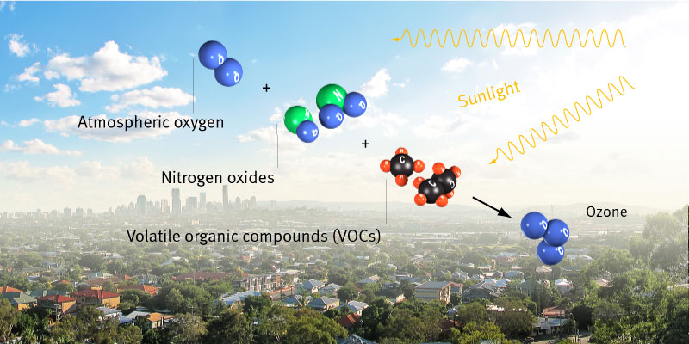
How ozone is formed
Image source: Ozone | Environment, land and water | Queensland Government

The photochemical reaction that produces surface-level ozone occurs mainly in cities which have lots of cars and plenty of sunlight such as Sydney and Brisbane in Australia. Ozone is only produced during daylight hours. As ozone is a highly reactive gas, ozone that is formed during the day is removed from the atmosphere at night through chemical reactions with nitric oxide and nitrogen dioxide, reaching a minimum concentration around late night or early morning.
Surface-level ozone formation takes place over time, and certain conditions can increase its production. As sunlight is needed for the reaction to proceed, greater amounts of ozone are produced when sunlight is most intense in the middle of the day, and especially during summer, when many adults and children may be outside. Temperature also directly influences ozone production as increasing temperature speeds up the rates of chemical reactions and increases the emissions of VOCs. Wind directions and speeds influence ozone concentrations throughout the troposphere as winds can disperse the pollutant gases, nitrogen oxides and VOCs, which are necessary for ozone production. So, ozone pollution concentrations are usually highest on hot, sunny, still days. Heatwaves are very favourable to ground-level ozone formation.
Problems of Surface-level Ozone
Exposure to ozone can cause eye irritation and produce headaches. In addition, it causes inflammation and damage to the airways and lungs resulting in breathing difficulties, especially in people with pre-existing respiratory conditions such as asthma or chronic obstructive pulmonary disease (COPD). It has been estimated that globally 8-20% of the annual number of hospital emergency room visits may be attributed to tropospheric ozone. Even at low levels, exposure to ozone increases the risk of death, with studies having shown that surface-level ozone is responsible for 0.8% of total deaths per year in Sydney.
Clean air is fundamental to human health. That’s why it is important to monitor air quality. Ozone is one of six air pollutants that is monitored across Australia under the National Environment Protection Measure (NEPM), and for which there are national standards indicating the maximum concentration allowable in the air. The National Environment Protection Measure (NEPM) standard for ozone is 0.065 ppm. Also, to minimise ozone formation, governments around the world have set maximum permissible car exhaust emissions for both hydrocarbons and oxides of nitrogen. In Australia, the new noxious emissions standards for light vehicles introduced in 2018 are based on international vehicle standards adopted by the United Nations.
Monitoring ozone levels in the troposphere helps environmental regulators assess whether the levels are meeting the national standards. Frequent measurements also help to identify ozone concentration trends over time, which is essential for evaluating the effectiveness of any actions taken to reduce the amount of ozone produced, for example, reducing vehicle related pollution through the use of electric vehicles. Measuring ozone levels in the air is also important to protect public health by providing alerts about high ozone concentrations, especially for vulnerable groups like children, the elderly, and those with lung conditions such as asthma, as inhaling high levels of ozone can trigger asthma attacks and worsen conditions like bronchitis and emphysema.

Activity 1: Understanding ozone

Read the background information ‘The two sides of ozone’ on pages 4, 5 and 6 and use the information presented to answer the following questions.
- Use the information from the background reading to match the following words with their meaning:
UV-C, oxygen, nitrogen dioxide, smog, troposphere, UV-A, stratosphere, VOCs, ozone
word | meaning
 | A colourless odourless gas that is the life-supporting component of the air
 | A pale blue gas with a pungent odour that is a pollutant in the lower atmosphere
 | Long wavelength ultraviolet radiation
 | Short wavelength ultraviolet radiation that is blocked by the Earth’s ozone layer
 | The lowest layer of the Earth’s atmosphere extending from the Earth’s surface to about 15 km above the surface.
 | The layer of the Earth’s atmosphere in which the ozone layer is located
 | A pollutant gas produced from burning fossil fuels in cars, trucks and power plants
 | Volatile organic compounds that evaporate easily into the atmosphere and are found in paints, fuels, household cleaners and vehicle emissions.
 | a form of air pollution that appears as a brown haze in the sky and can limit visibility. It can affect human health and the environment.

- Use the following words to complete the cloze passage below. Each word can only be used once.
sunlight, oxygen, cars, troposphere, volatile, pollutant, respiratory, asthma, smog, nitrogen, photochemical, stratosphere.

Ozone is a molecule made of three _____________________ atoms. Surface-level ozone is a harmful air _____________________ and is a major component of _____________________. Surface-level ozone is not directly released into the atmosphere. It is formed by a _____________________ reaction that needs _____________________ to start it, and involves oxides of _____________________ and _____________________ organic compounds (VOCs). These pollutant gases are released into the atmosphere by human activities such as from petrol and diesel _____________________, fossil fuel-fired power plants and industrial boilers.
Unlike the beneficial ozone layer high in the _____________________, ozone in the _____________________ is harmful to human health and can cause _____________________ problems and damage lung tissue. High concentrations of surface level ozone can particularly affect people with conditions like _____________________ .
- What is the difference between stratospheric ozone and tropospheric ozone?
………………………………………………………………………………………………………………………………………………………………………………………………………………………………………………………………………………………………………………
………………………………………………………………………………………………………………………………………………………
………………………………………………………………………………………………………………………………………………………
………………………………………………………………………………………………………………………………………………………
………………………………………………………………………………………………………………………………………………………

- (a) What is a photochemical reaction?

………………………………………………………………………………………………………………………………………………………

- Why is the formation of surface-level ozone classified as a photochemical reaction?
………………………………………………………………………………………………………………………………………………………………………………………………………………………………………………………………………………………………………………

- The substances needed for the production of surface-level ozone are nitrogen oxides and VOCs. How do these pollutant substances get into the atmosphere?
………………………………………………………………………………………………………………………………………………………………………………………………………………………………………………………………………………………………………………
………………………………………………………………………………………………………………………………………………………

- What environmental conditions produce the greatest amount of surface-level ozone?
………………………………………………………………………………………………………………………………………………………………………………………………………………………………………………………………………………………………………………

- Why do we need to monitor ozone levels in the air of Australian cities?

………………………………………………………………………………………………………………………………………………………………………………………………………………………………………………………………………………………………………………
………………………………………………………………………………………………………………………………………………………………………………………………………………………………………………………………………………………………………………
………………………………………………………………………………………………………………………………………………………………………………………………………………………………………………………………………………………………………………
………………………………………………………………………………………………………………………………………………………………………………………………………………………………………………………………………………………………………………

Activity 2: Comparing ozone concentrations for July and December 2019

A univariate analysis
Univariate analysis investigates the data for one variable. In this activity the variable you will investigate is the average daily concentration of ozone in the atmosphere over a 31 day period.
The data in the first worksheet of the MS Excel workbook “Investigating Ozone” provides the average daily concentration of ozone for the month of July 2019 and for the month of December 2019. This data was collected using an Air Quality Monitoring Station (AQMS) that was installed on the grounds of the Liverpool Girls High School from March 2019 until February 2020.

- What units are used to measure the average daily concentration of ozone? What does this unit mean?
(HINT: Use the following website to understand the units used Glossary of air quality terms | Air | Environment and Heritage)

………………………………………………………………………………………………………………………………………………………………………………………………………………………………………………………………………………………………………………
………………………………………………………………………………………………………………………………………………………

- To compare these datasets you will consider two features of each dataset:

- Centre: these are the values about which the set of data values for a particular variable are scattered. The two most common measures of centre are the mean and the median. The median is often used as it is less affected by very large or very small values, making it a better measure of centre when there are outliers.

- Spread: this describes the variability of the data, that is, how similar or varied the data values are for a particular variable. Common measures of spread include the range and interquartile range, and standard deviation.

A table explaining these descriptive statistical measures is attached to the end of this document.

Find the mean (a measure of the centre) and the standard deviation (a measure of the spread) for the average daily concentration of ozone in the atmosphere for each of the months, July and December. Quote both these values to 1 decimal place. Record these values in the table below.

HINT: To find the mean and standard deviation of the datasets follow the instructions below:

- In cell A35, at the bottom of the July daily ozone concentrations, type the heading ‘mean’. In cell A36 type the heading ‘standard deviation’.
- To find the mean of the July readings, in cell B35, type the formula ‘=AVERAGE(‘
- Click in cell B3 and, holding the left button down, drag the icon down the column to cell B33 to highlight the data cells (do not include headings) for the July daily ozone concentrations, or you can just type this cell range into the formula, that is B3:B33
- Type ) and press enter. The mean will be shown in the cell.
- To find the standard deviation, in cell B36, type the formula ‘=STDEV.P(‘
- Enter the cell range as indicated in step 3 and type ). Then press enter.

Descriptive Statistic | July 2019 | December 2019
Mean
Standard Deviation

- When using statistical terms, like “mean”, we need to understand what this actually tells about the data. Observe the means of average daily ozone concentration for the months of July and December 2019, then choose the correct word to complete each of the sentences below.

- The mean for the December daily ozone concentrations is much _____________________
(higher / lower)
than for July.

- In other words, July days generally have _____________________ concentrations of
(higher / lower)
surface-level ozone than typical December days.

- Suggest ONE reason to explain any difference in the typical concentration of surface-level ozone in July and December.
(HINT: ozone is formed from a photochemical reaction, so think about the amount of daylight hours for December days compared to July days)
………………………………………………………………………………………………………………………………………………………………………………………………………………………………………………………………………………………………………………
………………………………………………………………………………………………………………………………………………………
………………………………………………………………………………………………………………………………………………………………………………………………………………………………………………………………………………………………………………
………………………………………………………………………………………………………………………………………………………

- Standard deviation tells us about the spread or variability of the data.

Data with a larger standard deviation have a larger spread. We normally say this data is more variable or has more variation around the mean. Data with a smaller standard deviation have a smaller spread. We normally say this data is less variable or more consistent.

During which month, July or December, are more consistent daily ozone levels produced? Why do you think this?

………………………………………………………………………………………………………………………………………………………
………………………………………………………………………………………………………………………………………………………………………………………………………………………………………………………………………………………………………………
………………………………………………………………………………………………………………………………………………………

- Box plots are used to give an overall picture of the distribution of univariate data. Boxplots show five important things about the data - the minimum value, the first quartile (Q1), the median, the third quartile (Q3) and the maximum value.
These descriptive statistics are explained in the table attached to the end of this document.
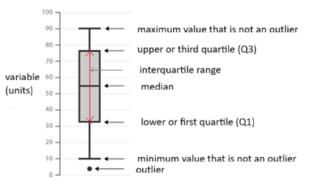
Diagram adapted from Science 7-10 2023 Data Science Guide which can be found at Science 7–10 Syllabus (2023) - Teaching and learning support | NSW Curriculum | NSW Education Standards Authority

Before you can construct a boxplot of the data you need to construct a 5-number summary of the dataset.
For each of the July 2019 and December 2019 average daily concentration of ozone datasets use MS Excel to construct the 5-number summary by determining the following. Quote each value to 1 decimal place.

- minimum
- maximum
- median
- First (lower) quartile (Q1)
- Third (upper) quartile (Q3)
Record the values for each of the above in the table below.
(NOTE: There are several valid calculation methods for Q1 and Q3. MS Excel's function uses a method of calculating Q1 and Q3 involving percentiles, which is different to the common maths textbook method of finding the median of the lower and upper halves of the data.)

HINT: To use MS Excel to find the 5-number summary of the July and December datasets follow the instructions below:

- In cell A37 at the bottom of the July daily ozone concentrations type the heading ‘minimum’. Type ‘maximum’ into cell A38, ‘median’ into cell A39, ‘first quartile (Q1)’ into cell A40 and ‘third quartile (Q3)’ into cell A41.
- To find the minimum of the July readings, in cell B37, type the formula ‘=MIN(‘
- Click in cell B3 and, holding the button down, drag the icon to cell B33 to highlight the cells for the July daily ozone concentrations, or just type this cell range into the formula, that is B3:B33
- Type ) and press enter.
- Repeat steps 2 to 4 in cell E37 for the December daily ozone concentrations and using the cell range E3:E33.
- To find the maximum, repeat steps 2 to 5 in cells B38 and E38 using the formula ‘=MAX(cell range)’
- To find the median, repeat steps 2 to 5 in cells B39 and E39 using the formula ‘=MEDIAN(cell range)’
- To find the first quartile (Q1) of the July daily ozone concentrations, in cell B40 type ‘=QUARTILE.EXC(B3:B33’
- Then type ‘,1)’ with the 1 indicating first quartile, and press enter.
- Repeat for the December readings of ozone concentration in cell E41 using the cell range E3:E33.
- To find the third quartile (Q3) of the July daily ozone concentrations repeat steps 8 to 10, but in step 9 change the number 1 to 3 to indicate the third quartile.

Descriptive Statistic | July 2019 | December 2019
minimum
maximum
median
First (lower) quartile (Q1)
Third (upper) quartile (Q3)

- Outliers are values in a dataset that are significantly different from the other values, often much higher or lower, and they can skew the results if not considered carefully.

One way of identifying outliers is through the use of the Interquartile Range (IQR). Values less than 𝑄1−1.5×𝐼𝑄𝑅 (the lower fence) or values greater than 𝑄3+1.5×𝐼𝑄𝑅 (the upper fence) are considered outliers. Values that are equal to the ‘fence’ are not considered outliers.
(i) What does the interquartile range show about a dataset?
(HINT: refer to the information provided in the table at the end of this document)

………………………………………………………………………………………………………………………………………………………………………………………………………………………………………………………………………………………………………………

(ii) Determine the interquartile range for both the July 2019 data and the December 2019 data.
(HINT: the interquartile range is the difference between the third quartile (Q3) and the first quartile (Q1).)
………………………………………………………………………………………………………………………………………………………………………………………………………………………………………………………………………………………………………………

- Use the formulae to identify any outliers for the July 2019 data or the December 2019 data, and state the date when each outlier value occurred.

HINT: determine the lower and upper ‘fences’ using the formulae stated above and look for values below the lower fence and above the upper fence.
To do this you will need to sort the data from the smallest to largest values for the average daily concentration of ozone for each of the months, July and December.
Click in cell A2 and, holding the left button down, drag the icon down the column to cell B33 to highlight all the July data and headings.
Click on icon from the top tool bar, and click Custom Sort .. in the dialog box.
For Sort by select ‘O3 (pphm)’ and check that Order is from smallest to largest. Then click OK.

For July: ………………………………………………………………………………………………………………………………………..
……………………………………………………………………………………………………………………………………………………..

For December: ………………………………………………………………………………………………………………………………
………………………………………………………………………………………………………………………………………………………

- On the scale below draw two parallel vertical box plots to represent the distribution of average daily ozone concentrations for the months of July and December 2019.
Label the vertical axis with the variable being measured and the units of measurement. Give it an appropriate title that reflects the content of the box plots.
HINT: To construct the box plots you can follow the instructions below:

- Draw a 1 cm horizontal line at the value for the first quartile.
- Draw a second 1 cm horizontal line at the value for the median directly above your first line, and another at the value for the third quartile.
- Draw a rectangle to connect the first quartile line and the third quartile line. This is the box indicating the Interquartile range.
- Plot any outliers using dots.
- Draw a 1 cm horizontal line at the minimum value for the dataset. If the dataset has low outliers, the minimum value is the next value higher than the outliers. Connect the middle of this line to the middle of the line for the lower quartile. This forms a ‘whisker’.
- Draw a 1 cm horizontal line at the maximum value for the dataset. If the dataset has high outliers, the maximum value is the next value lower than the outliers. Connect the middle of this line to the middle of the line for the lower quartile.

Title: ………………………………………………………………………………………………………………………………..


July 2019
December 2019
- Observe your box plots for the July daily ozone concentrations and the December daily ozone concentrations. Use your observations to choose the correct word to complete each of the sentences below.

- The median for the December daily ozone concentrations is _____________________
(higher / lower)
than for July.

- December days typically have _____________________ concentrations of surface-level
(higher / lower)
ozone than average July days.

- The interquartile range (IQR) for July is significantly _____________________ than for
(larger / smaller)
December.

- July daily ozone concentrations are _____________________ varied than for December.
(more / less)

- It can be concluded that, in general, _____________________ tropospheric ozone is
(more / less)
formed on December days than on July days, and that December has a __________________
(larger / smaller)
variation in the daily ozone concentration than July.

- Do your observations of the December daily ozone concentrations and the July daily ozone concentrations match with what we know about the conditions that favour surface-level ozone formation? Give a reason for your answer.

………………………………………………………………………………………………………………………………………………………………………………………………………………………………………………………………………………………………………………
………………………………………………………………………………………………………………………………………………………………………………………………………………………………………………………………………………………………………………
………………………………………………………………………………………………………………………………………………………

- Why might it be better to use the median rather than the mean to compare the centre of univariate datasets?
(HINT: consider how outliers in a dataset will change the median and the mean)

………………………………………………………………………………………………………………………………………………………………………………………………………………………………………………………………………………………………………………
………………………………………………………………………………………………………………………………………………………………………………………………………………………………………………………………………………………………………………
………………………………………………………………………………………………………………………………………………………
- What do you think are the advantages of using boxplots rather than just descriptive statistics, such as mean and standard deviation, to compare these two datasets?

………………………………………………………………………………………………………………………………………………………………………………………………………………………………………………………………………………………………………………
………………………………………………………………………………………………………………………………………………………………………………………………………………………………………………………………………………………………………………
………………………………………………………………………………………………………………………………………………………

Activity 3: Temperature and ozone concentration – a bivariate analysis

A bivariate analysis
Bivariate data is data relating to two variables that have both been measured on the same set of items or individuals, for example, the arm spans and heights of 16-year-old students. A bivariate analysis is a type of statistical analysis which aims to explain how changes in one of these variables affects the other. It is used to determine if there is a correlation between the two sets of data.
A bivariate analysis typically involves creating a scatterplot to visualize the relationship between the two variables. Each data point is clearly plotted with a dot or cross. A line of best fit can be used to show the trend of the data. A line of best fit is a straight line that passes as close as possible to all the data points, with roughly an equal number of data points on either side. The line of best fit helps to visualize the correlation (or lack of correlation) between the variables and is used to make predictions about the data.

The data in the second worksheet of the MS Excel workbook “Investigating Ozone” provides the hourly concentrations of different atmospheric pollutants as well as hourly measurements of different atmospheric variables, such as wind speed and ambient outside temperature, over a 24 hour period for 1 March 2019. On this day sunrise was at 6:43 am and sunset at 7:31 pm.
The data was collected using an Air Quality Monitoring Station (AQMS) that was installed on the grounds of the Liverpool Girls High School from March 2019 until February 2020.
In this activity you will investigate whether a relationship exists between the ambient outside temperature and the concentration of surface-level ozone in the atmosphere, with both variables having been measured every hour over the 24 hour period on 1 March 2019. As the formation of ozone is dependent on the presence of sunlight, only the data from 7 am (after sunrise) to 7 pm (just before sunset) will be considered.

- Use MS Excel to construct a scatter graph of hourly ambient outside temperature (independent variable) versus hourly concentration of ozone (dependent variable) measured on 1 March 2019 at Liverpool Girls High School from 7 am to 7 pm.
Include a line of best fit to indicate the trend.
Give the graph an appropriate title, and label the vertical and horizontal axes appropriately. Don’t forget to include units of measurement where needed.
Include your graph in the space below.

HINT: Perform the following steps to produce the graph using the data from the “hourly ozone conc 1 March 2019” MS Excel worksheet:
- Highlight the hourly ambient outside temperatures in column C from 7 am to 7 pm by clicking on cell C9 and, holding the button depressed, dragging the cursor to cell C21 then releasing the button.
- Holding down the “Command” or “Control” key, click on cell G9 and drag the cursor to cell G21 to highlight the hourly ozone concentrations for the same time period.
- Click the insert tab, click Recommended charts from the Charts, and click on the scatter graph (first graph) in the dialog box. Then click OK.
- Click on your chart. Click Chart Design tab along the top tool bar, then click Add Chart Element on the left-hand side (Chart Design -> Add Chart Element). Scroll down to highlight Trendline, and click linear from the dialog box.
- Click on Add Chart Element, scroll down to highlight Chart Title, then click Above Chart. Type an appropriate title for your graph, then press enter.
- Click on Add Chart Element, scroll down to highlight Axis Titles, then click Primary Horizontal and type an appropriate label. Don’t forget to include the units. Press enter.
- Click on Add Chart Element, scroll down to highlight Axis Titles, then click Primary Vertical and type an appropriate label. Don’t forget to include the units. Press enter.

Title: ………………………………………………………………………………………………………………………………………………….

- Is there a correlation (or strong relationship) between the hourly ambient outside temperature and the hourly concentration of ozone during daylight hours on 1 March 2019? Give a reason for your answer.

………………………………………………………………………………………………………………………………………………………………………………………………………………………………………………………………………………………………………………………………………………………………………………………………………………………………………………………………………
………………………………………………………………………………………………………………………………………………………
- A correlation between variables, however, does not mean that the change in one variable is the cause of the change in the values of the other variable.

Causation indicates that one event is the result of the occurrence of the other event, that is, there is a causal relationship between the two events. This is also referred to as ‘cause and effect’. A scatter graph can only indicate correlation, that is, the size and direction of a relationship between the two variables. More information is needed to show causation.

Is there a ‘cause and effect’ relationship for these two variables, outside temperature and surface-level ozone concentration? Justify your answer.
(HINT: consider what you know about how ozone is produced in the troposphere and what effect temperature has on its production)

………………………………………………………………………………………………………………………………………………………………………………………………………………………………………………………………………………………………………………………………………………………………………………………………………………………………………………………………………
………………………………………………………………………………………………………………………………………………………

- Increases in greenhouse gases, such as carbon dioxide and methane, due to human activity are the main cause of global warming. Continued release of greenhouse gases will cause further warming and changes in the world’s climate system. The CSIRO has used climate modelling to make projections (forecasts of the future based on the study of present trends) about the effect of climate change in Australia into the future. Their projections are outlined on the following webpage: Climate projections for Australia - CSIRO
One of their projections is that hot days will become more frequent and hotter.
How will this affect surface-level ozone concentrations and the people of Sydney in the future? Give reasons for your answer.
………………………………………………………………………………………………………………………………………………………………………………………………………………………………………………………………………………………………………………………………………………………………………………………………………………………………………………………………………
………………………………………………………………………………………………………………………………………………………
………………………………………………………………………………………………………………………………………………………
………………………………………………………………………………………………………………………………………………………
………………………………………………………………………………………………………………………………………………………

Activity 4: Investigating nitrogen Dioxide and surface-Level Ozone

The data in the second worksheet of the MS Excel workbook “Investigating Ozone” provides the hourly concentrations of different atmospheric pollutants, including ozone and nitrogen dioxide, over a 24 hour period for 1 March 2019. Days and nights were warmer than average in March 2019. This particular day was a warm, mainly sunny day with fairly clear skies from around noon until 5 pm (Past Weather in Sydney, New South Wales, Australia — Yesterday or Further Back). Sunrise was at 6:43 am and sunset at 7:31 pm.
The data in the worksheet was collected using an Air Quality Monitoring Station (AQMS) that was installed on the grounds of the Liverpool Girls High School from March 2019 until February 2020.

- Construct a column graph of the hourly nitrogen dioxide concentration versus time for 1 March 2019.
Give the graph an appropriate title and label the vertical and horizontal axes appropriately. Don’t forget to include units of measurement where needed.
Include your graph in the space below.

HINT: Perform the following steps to produce the graph in MS Excel using the data from the “Hourly pollutant conc 01-03-19” worksheet:
- Highlight the 24 hours over which the investigation was conducted in column A by clicking on cell A2 and, holding the button depressed, dragging the cursor to cell A25 then releasing the button.
- Holding down the “Control” or “Command” key, click on cell F2 and drag the cursor to cell F25 to highlight the hourly concentration of nitrogen dioxide.

- Click the insert tab, click insert column graph from the Charts shown, then click on the first 2-D column graph in the dialog box (Insert -> Chart -> 2D column)
- Click on your chart. Click Chart Design tab on the top tool bar, then click Add Chart Element on left-hand side. (Chart Design -> Add Chart Element). Scroll down to highlight Chart Title, then click Above Chart. Type an appropriate title for your graph then press enter.
- Click on Add Chart Element, scroll down to highlight Axis Titles, then click Primary Horizontal and type an appropriate label.
- Click on Add Chart Element, scroll down to highlight Axis Titles, then click Primary Vertical and type an appropriate label. Don’t forget to include the units.

Title: …………………………………………………………………………………………………………………………………………………..

- From your graph, for what times is the concentration of nitrogen dioxide greater than 1.5 pphm?
………………………………………………………………………………………………………………………………………………………

- Give a reason why the concentration of nitrogen dioxide in the air is greatest during these times.

(HINT: Consider the main source for nitrogen dioxide in the atmosphere in an urban environment such as Liverpool, and when this source might be present in the greatest quantity.)
………………………………………………………………………………………………………………………………………………………………………………………………………………………………………………………………………………………………………………………………………………………………………………………………………………………………………………………………………………………………………………………………………………………………………………………………………………………………
………………………………………………………………………………………………………………………………………………………

- From the background information on the formation of ozone, predict the time within a 24 hour time period when the concentration of ozone in the atmosphere over Liverpool should be at its highest on 1 March 2019. Give a reason for your prediction.

………………………………………………………………………………………………………………………………………………………………………………………………………………………………………………………………………………………………………………………………………………………………………………………………………………………………………………………………………………………………………………………………………………………………………………………………………………………………
………………………………………………………………………………………………………………………………………………………

- Construct a column graph of the hourly ozone concentration versus time for 1 March 2019.
Give the graph an appropriate title and label the vertical and horizontal axes appropriately. Don’t forget to include units of measurement where needed.
Include your graph in the space below.
HINT: Perform the following steps to produce the graph in MS Excel using the data from the “Hourly pollutant conc 01-03-19” worksheet:
- Highlight the 24 hours over which the investigation was conducted in column A by clicking on cell A2 and, holding the button depressed, dragging the cursor to cell A25 then releasing the button.
- Holding down the “Control” or “Command” key, click on cell G2 and drag the cursor to cell G25 to highlight the hourly concentration of ozone.
- Click the insert tab, click insert column graph from the Charts shown, then click on the first 2-D column graph in the dialog box (Insert -> Chart -> 2D column)
- Click on your chart. Click Chart Design tab on the top tool bar, then click Add Chart Element on the left-hand side (Chart Design -> Add Chart Element). Scroll down to highlight Chart Title, then click Above Chart. Type an appropriate title for your graph then press enter.
- Click on Add Chart Element, scroll down to highlight Axis Titles, then click Primary Horizontal and type an appropriate label.
- Click on Add Chart Element, scroll down to highlight Axis Titles, then click Primary Vertical and type an appropriate label. Don’t forget to include the units.

Title: ……………………………………………………………………………………………………………………………………………………

- From your graph at what time is the ozone concentration around Liverpool the greatest?

………………………………………………………………………………………………………………………………………………………

- Does this agree with your prediction? Comment on the peak time shown by the graph.
(HINT: In Sydney, Daylight Saving operates until early April)
………………………………………………………………………………………………………………………………………………………………………………………………………………………………………………………………………………………………………………………………………………………………………………………………………………………………………………………………………

- From your graph, predict what will happen to the concentration of ozone after sunset and over night on 1 March 2019? Give a reason for this.
………………………………………………………………………………………………………………………………………………………………………………………………………………………………………………………………………………………………………………………………………………………………………………………………………………………………………………………………………
………………………………………………………………………………………………………………………………………………………………………………………………………………………………………………………………………………………………………………
………………………………………………………………………………………………………………………………………………………

- Explain how moving to the use of electric vehicles, such as cars and buses, will affect surface-level ozone concentrations and the health of people in Liverpool in the future.
………………………………………………………………………………………………………………………………………………………………………………………………………………………………………………………………………………………………………………………………………………………………………………………………………………………………………………………………………………………………………………………………………………………………………………………………………………………………………………………………………………………………………………………………………………………………………………………
………………………………………………………………………………………………………………………………………………………
- What are some other things that we can do to reduce surface-level ozone in the air we breathe in Australian cities?

………………………………………………………………………………………………………………………………………………………
………………………………………………………………………………………………………………………………………………………
………………………………………………………………………………………………………………………………………………………
………………………………………………………………………………………………………………………………………………………
………………………………………………………………………………………………………………………………………………………
………………………………………………………………………………………………………………………………………………………
………………………………………………………………………………………………………………………………………………………
Definitions of descriptive statistical measures

Term | Definition
Mean | A measure of the centre of a dataset (see figure 2)  (also known as the, ‘average') is the sum of values in a dataset, divided by the total number of values in the dataset.  In Excel, use the formula =AVERAGE(cell range)  For cell range write first:last where first is the location (eg B3) of the first data cell (not the column headings) in the column of the variable being examined, and last is the location of the last data cell in that column (eg B33).
Median | - is the middle value of the dataset that has been ordered from smallest to largest, and divides the dataset into 2 parts meaning that half the data points are above the median and half are below it.  - is less affected by very large or very small values, making it a better measure of centre than the mean when there are outliers.  - is also known as the second quartile (Q2).  For an odd number of values, the median is the middle value.  For an even number of values, the median is between the 2 middle values.  To manually find the position of the median:  - Order the data from smallest to largest.  - Count the number of values in the dataset ($n$).  - Add 1 to the count and divide by 2, that is $\left(\frac{n+1}{2}\right)$  - If $\left(\frac{n+1}{2}\right)$is a whole number, count from the smallest data value up to that number. This data value is the median.  - If $\left(\frac{n+1}{2}\right)$made a decimal, round down. Then round up. Count from the smallest data value to these two numbers. Find the mean of the data values at those positions. This value is the median.  In Excel, use the formula =MEDIAN(cell range)
standard deviation | is a measure of the variability, or spread, of a dataset. It gives an indication of how far, on average, individual data values are spread from the mean. (see figure 2)  A small standard deviation means the numbers are clustered closely around the mean indicating consistency, while a large standard deviation means the values have greater variability and are more spread out.  In a normal distribution (or bell-shaped curve), about 68% of the values fall within one standard deviation of the mean, that is between the mean minus 1 SD and the mean plus 1 SD.  In Excel, use the formula =STDEV.P(cell range)
Range | - The difference between the highest and lowest values in a dataset  - provides a simple measure of how widely the data points are distributed  - can be larger, which indicates greater variability (a larger spread), or smaller, which indicates less variability (a smaller spread)  - is affected by the existence of outliers
first quartile (Q1) | Also known as the lower quartile.  The value below which one quarter or 25% of the data points lie when the dataset has been ordered from smallest to largest. (see figure 1)  In Excel, use the formula =QUARTILE.EXC(cell range,1)
Third quartile (Q3) | Also known as the upper quartile.  The value below which three quarters or 75% of the data points lie when the dataset has been ordered from smallest to largest. (see figure 1)  In Excel, use the formula =QUARTILE.EXC(cell range,3)
interquartile range (IQR) | is the difference between the third quartile and the first quartile.  Is a measure of the spread of the data. It shows the spread of the middle 50% of the data values. (see figure 1)
Figure1: The parts of a box plot
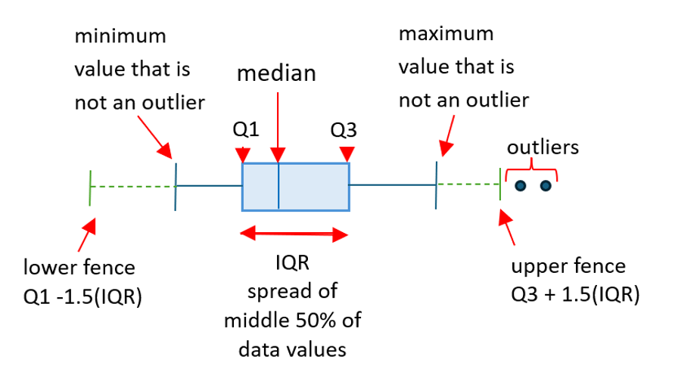
Figure 2: Plot of a normal distribution
Source: https://en.wikipedia.org/wiki/File:Standard_deviation_diagram.svg
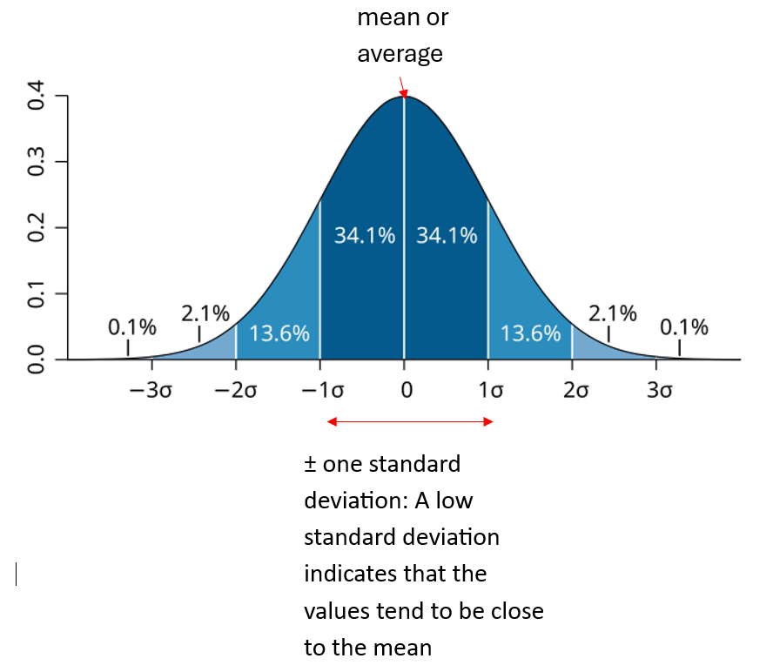

Information adapted from the document ‘Data representation 7-10’ which can be found at Science 7–10 Syllabus (2023) - Teaching and learning support | NSW Curriculum | NSW Education Standards Authority

