

Radioisotopes in Medicine


The following link/QR code provides access to the ‘Radioisotopes in Medicine’ online learning module required to complete the activities:
Radioisotopes in Medicine

This document is designed to supplement and support students as they utilise the ANSTO ‘Radioisotopes in Medicine’ online learning module. The module engages the students in scenario-based learning, putting them in the position of a nuclear medicine technician to choose the best radioisotope according to the needs of a patient.

These activities are suitable for Senior Chemistry students, as well as Years 9 and 10 science students.

Students will:
- Choose an appropriate radioisotope according to the needs of a patient, based on the type of radiation and half-life of the radioisotope
- Identify and describe the different uses of radioisotopes in medicine
- Complete nuclear decay equations for select radioisotopes
- Discuss and evaluate the benefits and considerations of the use of radioisotopes in medicine


Australian Curriculum Content Descriptions and Skills
The activities provided address the following Australian Curriculum Science Understanding from

Chemistry Unit 1: Chemical fundamentals: structure, properties and reactions

Science as a Human Endeavour
- Advances in science understanding in one field can influence other areas of science, technology and engineering (ACSCH011)
- The use of scientific knowledge may have beneficial and/or harmful and/or unintended consequences (ACSCH013)

Science Understanding
Radioisotopes
Radioisotopes have a wide variety of uses, including Carbon-14 for carbon dating in geology and palaeobiology; radioactive tracers such as Iodine-131 in nuclear medicine; radioimmuno-assays for testing constituents of blood, serum, urine, hormones and antigens; and radiotherapy that destroys damaged cells (ACSCH011). Use of radioisotopes requires careful evaluation and monitoring because of the potential harmful effects to humans and/or the environment if their production, use and disposal are not managed effectively (ACSCH013). Risks include unwanted damage to cells in the body, especially during pregnancy, and ongoing radiation produced from radioactive sources with long half-lives.

The activities provided address the following Australian Curriculum Science Inquiry Skills (Chemistry Unit 1)

Science Inquiry Skills

- Interpret a range of scientific and media texts, and evaluate processes, claims and conclusions by considering the quality of available evidence; and use reasoning to construct scientific arguments (ACSCH005)
- Select, construct and use appropriate representations including chemical symbols and formulae, molecular structural formulae, physical and graphical models of structures, chemical equations and thermochemical equations, to communicate conceptual understanding, solve problems and make predictions (ACSCH006)

Australian Curriculum Content Descriptions and Skills
The activities provided address the following Australian Curriculum Science Understanding from

Year 9 Science

Science as a Human Endeavour
Nature and development of science
AC9S9H02
- investigate how advances in technologies enable advances in science, and how science has contributed to developments in technologies and engineering
  - examining how advances in understanding of radioactivity and radioisotopes have led to new applications and technologies

Science Understanding
Chemical sciences
AC9S9U06
- explain how the model of the atom changed following the discovery of electrons, protons and neutrons and describe how natural radioactive decay results in stable atoms
  - identifying where applications of radioactivity are used in medicine and industry such as diagnosing and treating cancer and checking for faults in materials used in aircraft and spacecraft

NSW Syllabus (2026) Outcomes and Content
The activities provided address the following New South Wales Curriculum Outcomes and Content

Stage 5 Science

Outcomes
SC5-RXN-01
- describes a range of reaction types
SC5-WS-07
- selects suitable problem-solving strategies and evaluates proposed solutions to identified problems

Content
Nuclear reactions
- represent alpha and beta reactions as nuclear reactions
- identify that the half-life of a radioactive isotope is the time taken for half of the atoms in a sample to undergo radioactive decay
- evaluate the societal benefits and considerations of using radioisotopes in medicine, industry and environmental monitoring
NSW Syllabus (2025) Outcomes and Content
The activities provided address the following New South Wales Curriculum Outcomes and Content

Stage 6 Chemistry

Outcomes
CH-11WS-06
- apply scientific principles to address real-world applications and problems
CH-11-01
- explains physical, structural and chemical properties of matter and their trends

Content
Properties and structure of matter
Atomic structure and electron configuration
- Describe the mass and charge properties of alpha (α), beta (β) and gamma (γ) radiations
- Construct balanced nuclear equations for nuclear decay and nuclear fission
- Explain how the emitted radiation type and half-life determine the use of natural and human-made radioisotopes
- Conduct a secondary-source investigation to justify the use of a selected radioisotope in medicine, industry or environmental monitoring

Activity 1: Patient Nozomi

At the Radioisotopes in Medicine home page, choose Nozomi as the patient and complete the module. Then answer the questions below.
- What is the purpose of the PET scan after Nozomi’s biopsy?
……………………………………………………………………………………………………………………………………………………………………………………………………………………………………………………………………………………………………

- Medical radioisotopes used for diagnostic scans produce which type of radiation (directly or indirectly)? (please circle one)

alpha | beta | gamma

- Using what you know about this type of radiation, give reasons why it would be chosen for diagnostic scans. (see Types of Radiation module for more information)
………………………………………………………………………………………………………………………………………………………………………………………………………………………………………………………………………………………………………………………………………………………………………………………………………………………………………………………

- Fill in the blanks with the following words:
cancer | glucose | dividing | energy | FDG | fluorine-18

Fluorine-18 is used to diagnose some types of via a PET scan. Radioactive is connected to a -like molecule to form fluorodeoxyglucose (FDG). Cancer cells are rapidly and growing, and use glucose for . The accumulates in cancer cells, then as the fluorine-18 decays, the radiologist can see where the cancer is located.
- Describe the type of radioactive decay that Fluorine-18 undergoes by annotating the diagram below.

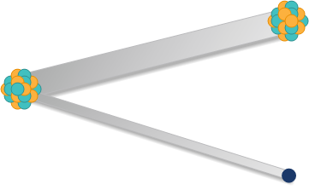
decays to
radiation emitted
+

- In the body, a positron meets an oppositely charged particle and annihilates, producing gamma radiation. Circle the name of this particle.
proton | electron | neutron

- Please complete the decay equation for fluorine-18 below.

18
e
F

+

9

Activity 2: Patient John

At the Radioisotopes in Medicine home page, choose John as the patient and complete the module. Then answer the questions below.
- Medical radioisotopes used to treat cancer typically emit which type of radiation? (please circle one)

alpha | beta | gamma

- Using what you know about this type of radiation, give reasons why it would be chosen for cancer treatment. (see Types of Radiation module for more information)
……………………………………………………………………………………………………………………………………………………………………………………………………………………………………………………………………………………………………………………………………………………………………………………………………………………………………………………………………………………………………………………………………………………………………………………………………………………………………………………………………………………………………………………………………………………………

- Fill in the blanks with the following words:
ligand | lutetium-177 | beta | cells | binds

Lutetium-177 alone does not target prostate cancer cells. Lutetium-177 must be connected to a molecule, which to specific marker antigens on the outside of prostate cancer cells. When the decays, the radiation travels only a short distance, killing nearby .

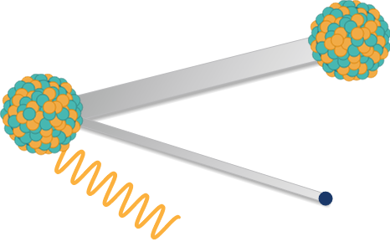
- Describe the type of decay that Lutetium-177 undergoes by annotating the diagram below.
decays to
radiation emitted

-

- Please complete the decay equation for lutetium-177 below.

177777
0
γ
+
+

e
Lu

0
71

Activity 3: Patient Yusuf

At the Radioisotopes in Medicine home page, choose Yusuf as the patient and complete the module. Then answer the questions below.
- For what reasons has a SPECT scan been selected for Yusuf?
……………………………………………………………………………………………………………………………………………………………………………………………………………………………………………………………………………………………………

- Select two properties of technetium-99m that make it a good radioisotope for a SPECT scan.
- It only emits weak gamma radiation, minimising harm to the patient.
- It is very difficult to pronounce.
- It has a short 6-hour half-life, so it doesn’t stay in the body too long after the scan.
- It is very expensive to produce.

- What does the ‘m’ indicate about technetium-99m? (see About ANSTO Radioisotopes for more information)
……………………………………………………………………………………………………………………………………………………………………………………………………………………………………………………………………………………………………

- Radioactive decay graphs show us how the radioactivity level of a radioisotope decreases over time. Here is the decay graph for technetium-99m, showing its half-life:

You can see that not much of the technetium-99m remains after 24 hours. This means it won’t stay in the body too long after having a SPECT scan.

ANSTO is the ONLY place in Australia that makes nuclear medicine for SPECT scans and sends it to locations all over the country.

How does the short half-life of technetium-99m impact on the ability to deliver across Australia?
……………………………………………………………………………………………………………………………………………………………………………………………………………………………………………………………………………………………………………………………………………………………………………………………………………………………………………………….

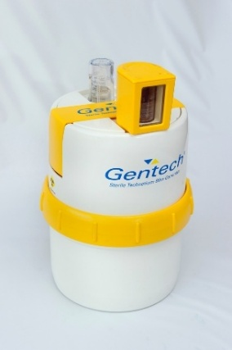
Hospitals and clinics in Australia obtain their supply of technetium-99m through the distribution of ANSTO’s Gentech generators.
These generators contain molybdenum-99 which decays into technetium-99m over time.

Here is the decay graph for molybdenum-99 and technetium-99m together:

What do you notice about the radioactivity levels of molybdenum-99 over time compared to the radioactivity levels of technetium-99m? (Choose one answer)
- There is no difference in radioactivity levels over time
- The radioactivity level for molybdenum-99 decreases more slowly over time
- The radioactivity levels for molybdenum-99 decrease more rapidly over time

What is the reason that molybdenum-99 is delivered to hospitals and clinics and not technetium-99m?
………………………………………………………………………………………………………………………………………………………………………………………………………………………………………………………………………………………………………………………………………………………………………………………………………………………………………………………

Activity 4: Patient Indira

At the Radioisotopes in Medicine home page, choose Indira as the patient and complete the module. Then answer the questions below.
- Circle where the cancer is in Indira’s body?

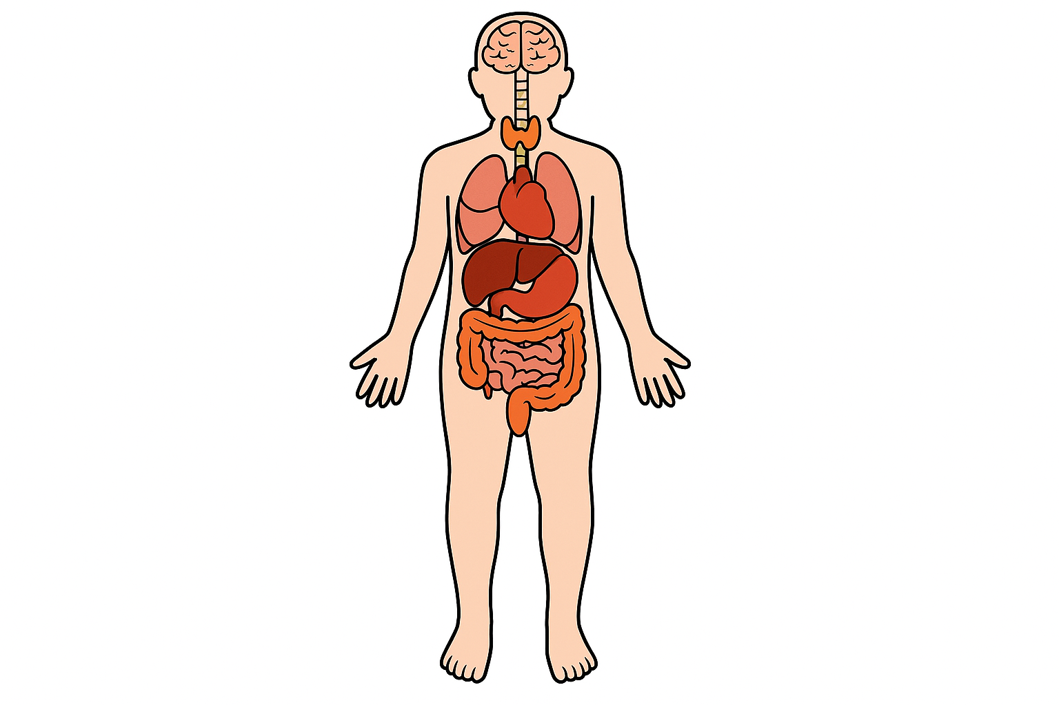

- Number the steps 1-4 to describe Indira’s treatment.
Iodine-131 accumulates in the thyroid gland
Beta radiation kills tissue in Indira’s thyroid gland
Indira swallows a capsule of radioactive iodine-131
Iodine-131 decays by emitting beta radiation

- Describe the type of decay that Iodine-131 undergoes by annotating the diagram below.
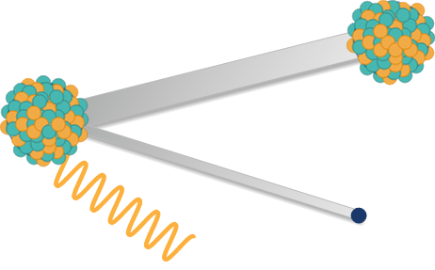
decays to
radiation emitted

-

- Please complete the decay equation for iodine-131 below.

131777
0
γ
+
+

e
I

0
53

Activity 5: Extension activities
- Explore the ‘About Radioisotopes’ online module. Use the information from the module to fill in the table below:
Radioisotope | Diagnostic or treatment? | Half-life
Iodine-131
Fluorine-18
Technetium-99m
Lutetium-177

- Do diagnostic or therapeutic (treatment) radioisotopes have longer half-lives? What are the reasons for this difference?
……………………………………………………………………………………………………………………………………………………………………………………………………………………………………………………………………………………………………………………………………………………………………………………………………………………………………………………………………………………………………………………………………………………………………………………………………………………………………………………………………………………………………………………………………………………………

- Sort the statements about the use of radioisotopes in medicine in Australia below into two categories: benefits and considerations, by writing the letter in the columns below.
- Radioactive waste needs to be managed correctly to prevent contamination.
- Radioisotopes can allow for imaging many different organs of the body with high accuracy to enable early detection of many diseases and conditions.
- The general public can have negative perceptions about radiation exposure, so there needs to be clear communication with patients.
- Therapeutic radioisotopes can target certain parts of the body, reducing damage to healthy tissue.
- Strict protocols are required to be followed to protect patients, workers and the environment from unnecessary exposure.
- The use of radioisotopes is highly regulated, so clinics must be licensed and monitored.
- The use of radioisotopes is less invasive than other diagnostic methods, meaning that patients are more comfortable and recover more quickly.
- Australia has strong nuclear medicine infrastructure at ANSTO to secure and maintain local production and distribution of radioisotopes.
- Guidelines need to be followed for the disposal of radioactive waste.
- Many radioisotopes used in medicine have short half-lives meaning that production and distribution must be as efficient as possible.
- It is very time-sensitive, so delays can have a significant impact on supply and patient care as a result.
- Requires specialised equipment and staff, which can be costly to acquire, especially in regional and rural areas.
Benefits | Considerations

- Use the information from the statements in Question 3 to write a response to the following:
Evaluate the use of radioisotopes in medicine in Australia.
HINT: You can use the scaffold (based on the ALARM process) below to plan your response and write notes. You might like to use the links in the additional resources section to do some extra research.
Question:
Evaluate the use of radioisotopes in medicine in Australia.
Criteria for Evaluation: (what are some of the value judgement words that can be used to demonstrate whether the use of radioisotopes in medicine is positive or negative? For example, words like ‘benefit’ and ‘risk’)

Brief Introduction
Identify and Outline:
What is a radioisotope?

Describe:
How can radioisotopes be used in medicine?
Diagnostic Radioisotopes
Explain:
Explain the use of radioisotopes in medicine for diagnosis. (How? Why? Refer to the radiation type and half-life, and give some examples)
Analyse:
What are the benefits/impacts of using diagnostic radioisotopes?
Therapeutic Radioisotopes
Explain:
Explain the use of radioisotopes in medicine for the treatment of disease (How? Why? Give some examples and refer to the radiation type and half-life)
Analyse:
What are the benefits/impacts of using radioisotopes to treat diseases such as cancer?
ANSTO Nuclear Reactor
Explain:
Explain the use of the OPAL reactor in producing Australia’s nuclear medicine. (How? Why?)
Analyse:
What are the benefits/impacts of ANSTO’s nuclear reactor for nuclear medicine production in Australia?
Nuclear Waste
Explain:
Explain the formation of nuclear waste from nuclear medicine production and use (How? Why? Give some examples)
Analyse:
What are some of the impacts/concerns of nuclear waste?
Safety Requirements and Regulations
Explain:
Explain why strict safety regulations and training is needed for producing, transporting and using nuclear medicine. (How? Why? Give some examples)
Analyse:
What are the positives/advantages and negatives/disadvantages of these safety requirements and regulations?
Conclusion
Critically analyse:
Compare and contrast the benefits/value and disadvantages/concerns of producing and using radioisotopes in medicine.
Evaluate:
Do the positives/advantages outweigh the negatives/ disadvantages for the production and use of radioisotopes in medicine?
Make an overall judgement about whether radioisotopes should be used in medicine.

Additional resources
The following lists further resources that students may like to read as part of these activities:

- https://www.ansto.gov.au/education/nuclear-facts/what-are-radioisotopes

- https://www.ansto.gov.au/education/nuclear-facts/nuclear-medicine-and-health

- https://www.youthstem2030.org/youth-stem-matters/read/the-role-of-radioisotopes-in-medical-diagnostic-procedures

- https://www.iaea.org/newscenter/news/what-are-radiopharmaceuticals

- https://www.britannica.com/story/how-radioactive-isotopes-are-used-in-medicine

- https://www.arpansa.gov.au/understanding-radiation/radiation-sources/more-radiation-sources/radioactive-waste-safety/frequently-asked-questions

- https://www.industry.gov.au/australian-radioactive-waste-agency/radioactive-waste-australia

- https://www.ansto.gov.au/education/nuclear-facts/managing-radioactive-waste

- https://www.ansto.gov.au/education/nuclear-facts/benefits-of-nuclear-science

