

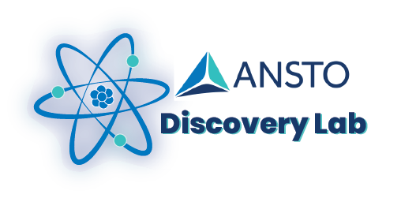

Electricity in Action!
Year 5-6 Science Excursion Outline
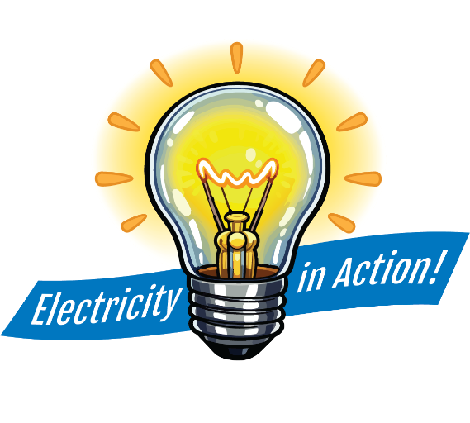

Your tour
The Electricity in Action! Primary Tour is conducted at ANSTOs Lucas Heights campus in Southern Sydney. It is offered to school groups in Years 5-6 (NSW Stage 3) and takes 3.5 hours.

This tour experience assumes no background science knowledge. Students will be given opportunities to ask questions to clarify their understanding or share any thoughts and knowledge. Our staff are passionate and experienced science-qualified education specialists. They aim to engage primary students (and their teachers!) to inspire a life-long interest in science and learning.
For further enquiries or to book a tour for your primary group, contact the ANSTO Education Team:
phone: 02 9717 3090 email: education@ansto.gov.au

Electricity in Action! Stage 3 Tour Outline
The primary school tour experience starts at the ANSTO Discovery Centre at Lucas Heights. This large room, open to the public, contains interactive displays and science information about the work that ANSTO does, as well as the control room panels from the first nuclear reactor at Lucas Heights called HIFAR.
Students are given some time to engage with the displays upon arrival, before taking a seat in the Discovery Centre Theatre.
Inside the theatre, students are introduced to ANSTO’s major functions as a large public research organisation and explore the important role science plays in society. They learn about the definition and properties of energy and electricity, including static electricity and electrical sources. Students also discuss the transfers of energy involved in electrical circuits. Students participate in hands-on activities to build, test and draw simple circuits.
The group then plans and conducts a scientific investigation comparing the electrical conductivity of different materials. Guided by the educator, students follow the science inquiry process and receive real data to analyse and evaluate at school. Teachers can use the workbook questions to help students prepare a scientific report when they return to the classroom.
After a 30-minute break, students commence the site tour. Travel is by bus around ANSTOs 70-hectare site, visiting 2-3 key science facilities.
A live camera is used to view the OPAL reactor and students learn about the importance of nuclear medicine in modern society. Students also visit one of our four large particle accelerator machines, which are used for carbon-dating material that was once living and for important environmental applications. If time permits, students may also visit a key research facility that uses neutron beams produced from the reactor to look inside materials and structures.

SCHEDULE (GUIDE ONLY):
30 mins | Introduction to ANSTO & interactive science lesson: “Electricity in Action!”
30 mins | Hands-on Activities:
30 mins | Whole group investigation: Insulators and Conductors
30 mins | Break
90 mins | Site tour, visiting 2-3 key science facilities

Contact the Discovery Centre by phone (02 9717 3090) or email (education@ansto.gov.au) to discuss how we can accommodate the needs of your group.
Links to the NSW Science and Technology K-6 Syllabus (2024)
The Electricity in Action! tour gives students an overview of how a large scientific organisation operates across several areas of science and technology and includes different occupations. The content provided is of a broad nature and links to several areas across the science syllabus for Stage 3.
Stage 3 Outcomes
Knowledge of our world and beyond inspires sustainable solutions
ST3-SCI-01: uses evidence to explain how scientific knowledge can be used to develop sustainable practices
ST3-PQU-01: poses questions to identify variables and conducts fair tests to gather data
ST3-DAT-01: interprets data to support explanations and arguments
Stage 3 Content
Main content covered
Electrical energy can be transferred and transformed
Students will:
- Recognise that an electrical circuit transfers electrical energy from a source, through a pathway, to a device that transforms electrical energy into other forms of energy
- Plan and construct simple electrical circuits to model the transfer and transformation of energy
- Pose questions, identify variables and safely conduct fair tests to identify materials that act as electrical conductors or insulators
- Explain how electrical insulators can ensure electrical safety in everyday life
- Identify renewable and non-renewable energy sources
- Recognise that in a fair test, an independent variable is changed, a dependent variable is measured, and controlled variables remain the same

Other content that may be covered during the on-site visit
Living things may change over millions of years, in response to their environments
Students will:
- Examine evidence that environments have changed over time and continue to change
Body systems coordinate for survival
Students will:
- Identify the main organs and their functions in the human digestive, respiratory and circulatory systems
- Recognise that the human digestive, respiratory and circulatory systems work together

Earth's climate is affected by natural and human activities
Students will:
- Identify the technologies used to collect weather data and describe how they are used
- Describe the differences between climate and weather
- Research the effects of natural events on the atmosphere
- Explain the effects of natural events and human activities on climate

Our solar system is a part of one of billions of galaxies in the Universe
Students will:
- Recognise stars, galaxies, nebulae, exoplanets and black holes as astronomical features that exist beyond our solar system
- Research how living things can travel and survive in space
- Examine the development of our knowledge through discoveries and technologies, and how these benefit humankind

