

PFAS in fibre-based food packaging
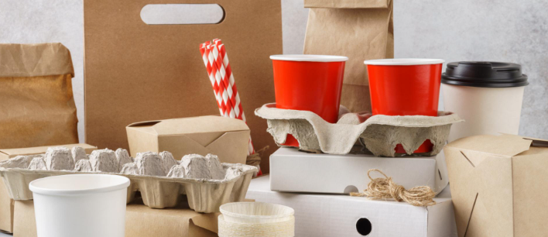
Image source: Nuclear technique supports industry-led action plan to phase out packaging with PFAS chemicals | ANSTO
The following link provides access to the data spreadsheet required to complete these activities: Education Resources | ANSTO under the heading ‘PFAS in fibre-based food packaging’.

This document enables students to interpret and analyse authentic research data, presented in the accompanying ‘PFAS in fibre-based food packaging’ Student Data MS Excel spreadsheet. The source datasets were generated from scientific testing undertaken by ANSTO as part of a study carried out by the Australian Packaging Covenant Organisation Ltd (APCO) which is detailed in the report ‘2021 PFAS in fibre-based packaging’. The study involved the use of particle induced gamma ray emission (PIGE) analysis as a quick and reliable method for indicating the presence and amount of PFAS in fibre-based, food-contact packaging.

These activities are suitable for students in Years 9 and 10.
Students will:-
- investigate the structure of human-made PFAS molecules
- examine the impact of PFAS chemicals on the natural world
- construct simple graphs of the provided data using MS Excel, and interpret and analyse these graphs
- use data to make evidence-based decisions about the use of PFAS in fibre-based, food-contact packaging, and assess the implications of these decisions
The activities provided address the following Australian Curriculum Version 9 Science Inquiry Skills for Years 9 and 10

Science Inquiry Skills

- select and construct appropriate representations, including tables, graphs, descriptive statistics, models and mathematical relationships, to organise and process data and information (AC9S9I04; AC9S10104)
- analyse and connect a variety of data and information to identify and explain patterns, trends, relationships and anomalies (AC9S9I05; AC9S10105)
- construct arguments based on analysis of a variety of evidence to support conclusions or evaluate claims, and consider any ethical issues and cultural protocols associated with accessing, using or citing secondary data or information (AC9S9I07; AC9S10107)
- write and create texts to communicate ideas, findings and arguments effectively for identified purposes and audiences, including selection of appropriate content, language and text features, using digital tools as appropriate (AC9S9I08; AC9S10108)

The activities provided address the following Focus Areas from NSW Science 7-10 syllabus (implementation from 2026) - Stage 5

Environmental Sustainability

Outcomes
A student:
- analyses the impact of human activity on the natural world SC5-ENV-01

Alternative resource use and recycling
- Describe the causes of environmental pollution and discuss its implications

Environmental sustainability in context
- Discuss the link between human activity and one specific environmental pollution concern

Data Science 2

Outcomes
A student:
- assesses the use of scientific knowledge and data in evidence-based decisions and when verifying the legitimacy of claims SC5-DA2-01

Investigating questions and claims
- Identify a claim that can be scientifically tested with an investigation, or series of investigations, to test the claim
- Explain the evidence and reasoning used to support conclusions about claims, using data from investigations

Data science 2 in context
- Use data to make evidence-based decisions about a familiar issue and assess the implications of these decisions

Contents

Background Information
The trouble with PFAS
What are PFAS? ……………………………………………………………………………………………………………………4
Environmental Impacts of PFAS …………………………………………………………………………………………….5

Activities
Activity 1: Investigating PFAS ………………………………………………………………………………………………………….7

Activity 2: Testing for oil resistance ………………………………………………………………………………………………10

Activity 3: Determining total fluorine concentration at ANSTO …………………………………………………….15
Use of standard samples …………………………………………………………………………………………………… 18

Activity 4: Assessing fluorine in fibre-based food packaging …………………………………………………………21

The trouble with PfAS

We all love fast food once in a while - hot chips or a burger at lunchtime, or a milkshake after school may not be the healthiest of food choices, but they are tasty and quick! However, you may be consuming more than you bargained for. This is because many fast-food containers contain PFAS, and different forms of PFAS have been shown to transfer from the packaging into the food itself. And, of course, when we throw this packaging away, PFAS chemicals can enter the environment!

What are PFAS?
PFAS is short for per- and polyfluoroalkyl substances, which are a group of human-made, organic compounds. PFAS molecules have two parts - a ‘water-loving head’ which often contains charged oxygen atoms (such as carboxylic acid functional group or sulfonate functional group shown below), and a ‘water-repelling tail’ consisting of a chain of carbon atoms with fluorine atoms bonded to most of these carbon atoms. The diagram below shows the molecular structure of five different PFAS molecules.
The fluorinated carbon chain tail also repels oil and grease, so PFAS molecules are both hydrophobic (water repelling) and lipophobic (repels fats and oils). The carbon-fluorine (C-F) bond is one of the strongest bonds known in nature, making PFAS molecules exceptionally durable and resistant to heat and chemical degradation.
PFAS were first developed in the 1940s, with two of the best-known PFAS chemicals being PFOA (Perfluorooctanoic acid) which was used to make Teflon non-stick cookware, and PFOS (Perfluorooctane sulfonic acid) which was used in Scotchgard, a stain and water repellent chemical for carpets and upholstery. Today, over 14 000 different PFAS chemicals exist!
Perfluorooctanoic acid (PFOA)
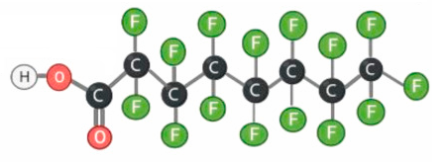

water-loving head
(carboxylic acid)

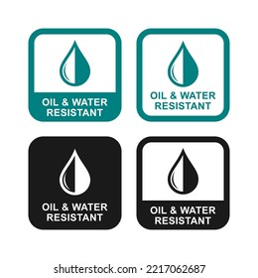
Fluorinated carbon chain tail
Perfluorohexane sulfonic acid
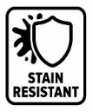
Perfluorobutanoic acid (PFBA)
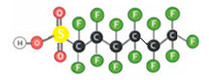
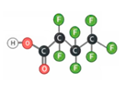

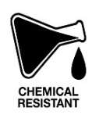
Perfluorobutane sulfonic acid
1H,1H,2H,2H-perfluoro-1-decanol
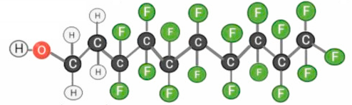
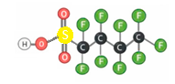

Heat resistant

Molecular structures of 5 PFAS chemicals of the more than 14 000 different PFAS chemicals that exist.
Images adapted from Health-related toxicity of emerging per- and polyfluoroalkyl substances: Comparison to legacy PFOS and PFOA - ScienceDirect
Because of their special ability to repel both water and oil, PFAS substances have been used in a wide range of everyday consumer products, such as water-resistant clothing, in cosmetics and in sunscreens. As they are heat resistant and form a film on water (lowering surface tension), they have been used in fire-fighting foams to extinguish jet-fuel fires.
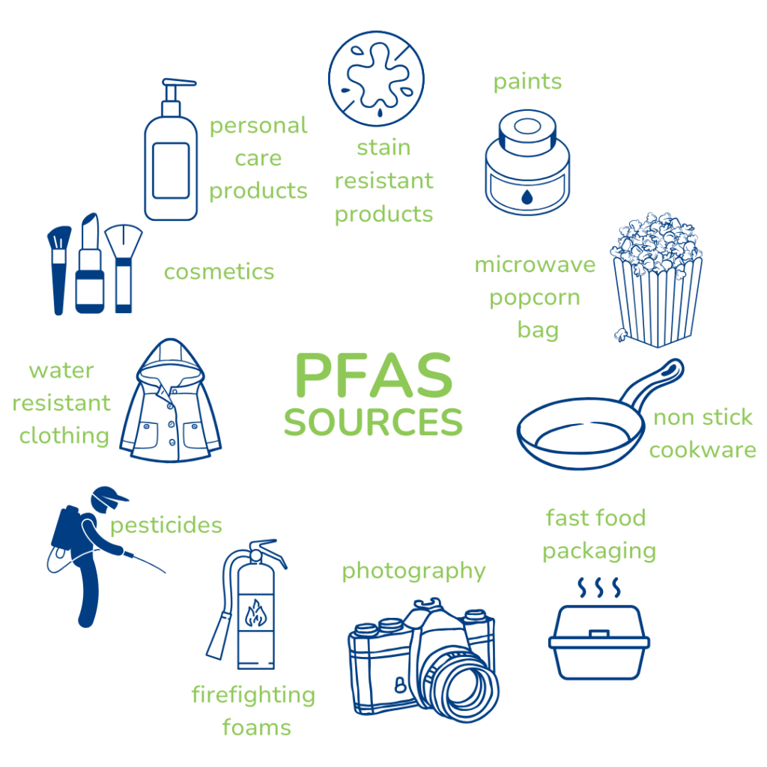

PFAS are often added to fibre-based food packaging, such as fast-food wrappers and containers, pizza and burger boxes, and microwave popcorn bags, as a barrier to heat, and to prevent grease and moisture from the food affecting the strength of the packaging. PFAS chemicals are even found in food packaging made from moulded plant fibre such as bagasse or sugarcane pulp - containers that are often advertised as biodegradable and compostable.
Image from European Environmental Bureau PFAS

When used as a surface coating on fibre-based food packaging, the PFAS molecules orientate so that the water-loving head is attached to the surface, and the fluorinated carbon chain tail is facing toward the outside. This enables the coating to repel both oil and water from food that is in contact with it.
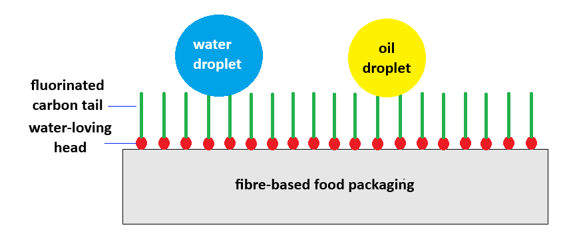
Image adapted from Oil- and water-resistant paper coatings: A review
Authors: Sumanta Basak, Milind Shrinivas Dangate, Shanumgha Samy

Environmental impact of PFAS
Because of the strength of the carbon-fluorine (C-F) bond, PFAS chemicals are exceptionally durable and don’t break down in nature so, even many years after production, they remain in the environment and have become known as the ‘forever chemicals’. Their molecular structure, with both a water-loving head and a water-repelling tail, enables them to travel long distances through air, water, and soils, so they are now found in every part of the world, even in the Arctic and Antarctica!
PFAS in air, water and soil can enter the food chain, contaminating plants and then animals that consume these plants, resulting in significantly increased PFAS concentration in the blood and organs of animals higher up in the food chain. Because PFAS chemicals are difficult to break down, they bioaccumulate in plants and animals, that is, PFAS build up in the bodies of living organisms, including humans, over time.
Most people in Australia are likely to have very low levels of PFAS in their bodies resulting from exposure to everyday household items including cosmetics, sunscreens, some non-stick cookware, and stain-resistant sprays for carpet and upholstery. People can also be exposed to PFAS by consuming it, through drinking contaminated water and eating contaminated food. Food packaging with PFAS can transfer PFAS from the packaging into the food.

All Australian governments agree that we should attempt to prevent further release of PFAS into the environment where possible, and that actions need to be taken to reduce or phase out the use of PFAS chemicals. ANSTO is supporting an industry-led initiative to identify and phase out PFAS in fibre-based food packaging. As part of this project, packaging suppliers voluntarily sent samples of their fibre-based food packaging to ANSTO for testing. ANSTO's Centre for Accelerator Science performed rapid, non-destructive tests on pieces of the packaging samples, testing for fluorine as fluorine is a key component of all PFAS chemicals. The test results enabled ANSTO scientists to determine the total fluorine concentration of the packaging material, which indicated the level of PFAS present.
ANSTO scientist, Dr Madhura Manohar, uses the 2MV STAR Tandem accelerator for Ion Beam Analysis of fibre-based food packaging samples to determine the total fluorine concentration



The project illustrated how using ANSTO’s screening approach for the amount of fluorine could quickly inform companies about the presence of PFAS in their fibre-based food packaging products and would lead to phasing out these products containing PFAS.

Further background reading

The following websites provide further information about the use and problems of PFAS.
- PFAS 'forever chemicals' are all around us. What does it mean for our health? - ABC News (includes a video on the potential health impacts of PFAS)

- Per- and Polyfluoroalkyl Substances (PFAS) | Australian Government Department of Health, Disability and Ageing

- Per- and poly-fluoroalkyl substances (PFAS) - DCCEEW

Activity 1 - Investigating PFAS

Read the background information ‘The trouble with PFAS’ on pages 4 and 5, and use the information presented to answer the following questions.
- Use the information from the background reading to match the following words with their meaning:
bioaccumulation, PFOS, lipophobic, PFAS, hydrophobic

Word | Meaning
 | tending to repel water; cannot be mixed with or dissolved in water
 | repels fats, grease, and oils; cannot be mixed with or dissolved in fats and oils
 | the build-up over time of a contaminant substance in a living organism due to its direct uptake from the environment or through food
 | one example of a larger group of related chemicals called per- and polyfluoroalkyl substances
 | a group of human-made, organic compounds that consist of a carbon chain with fluorine atoms bonded to the carbon atoms in the chain.

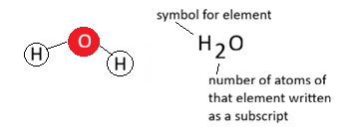
- We use a chemical formula to represent the type and number of each atom present in a molecule.
For example, a water molecule consists of two hydrogen atoms and one oxygen atom, so its chemical formula is H₂O

Write the chemical formula for each of the PFAS molecules shown in the background information. Start by counting the carbon atoms, then the hydrogen atoms followed by the fluorine atoms, oxygen atoms, and any other atoms.

Chemical name | Chemical formula
Perfluorooctanoic acid (PFOA)
Perfluorohexane sulfonic acid
Perfluorobutanoic acid (PFBA)

1H,1H,2H,2H-perfluoro-1-decanol

Perfluorobutane sulfonic acid
- (i) In the space below, draw a diagram of the perfluorooctane sulfonic acid (PFOS) molecule.

HINT: Use the names and diagrams of the PFAS molecules on page 4 to infer the structure of the PFOS molecule. Remember that ‘oct’ means it has 8 carbon atoms in the carbon chain.
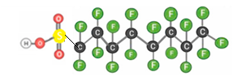

(ii) Annotate your diagram to show the TWO parts of the PFAS molecule.

(iii) Explain how the unique structure of PFAS molecules accounts for their properties.

……………………………………………………………………………………………………………………………………………………………………………………………………………………………………………………………………………………………………………………………………………………………………………………………………………………………………………………………………………………………………………………………………………………………………………………………………………………………………………………………………………………………………………………………………………………………………………………………………………………………………………………………………………………………………………………………………………..
………………………………………………………………………………………………………………………………………………………………………………………………………………………………………………………………………………………………………………

- Name five consumer products in which PFAS are found.
………………………………………………………………………………………………………………………………………………………………………………………………………………………………………………………………………………………………………………………………………………………………………………………………………………………………………………………………………
- Why are PFAS often used in pizza boxes?
………………………………………………………………………………………………………………………………………………………………………………………………………………………………………………………………………………………………………………………………………………………………………………………………………………………………………………………………………
- Why are PFAS chemicals often referred to as the ‘forever chemicals’?
………………………………………………………………………………………………………………………………………………………………………………………………………………………………………………………………………………………………………………………………………………………………………………………………………………………………………………………………………
- Explain how PFAS chemicals bioaccumulate.
………………………………………………………………………………………………………………………………………………………………………………………………………………………………………………………………………………………………………………………………………………………………………………………………………………………………………………………………………
………………………………………………………………………………………………………………………………………………………………………………………………………………………………………………………………………………………………………………………………………………………………………………………………………………………………………………………………………
………………………………………………………………………………………………………………………………………………………………………………………………………………………………………………………………………………………………………………

- Explain why PFAS chemicals have been found in the blood of humans and animals worldwide, even in animals in Antarctica.

…………………………………………………………………………………………………………………………………………………………………….…………………………………………………………………………………………………………………………………………………………………….……………………………………………………………………………………………………………………………………………………………………………………………………………………………………………………………………………..
………………………………………………………………………………………………………………………………………………………………………………………………………………………………………………………………………………………………………………………………………………………………………………………………………………………………………………………………………
………………………………………………………………………………………………………………………………………………………

Activity 2 – TESTING for oil REsistance

Oil resistance is an essential characteristic of packaging materials used for oily and fat-containing foods such as fried foods, pizzas, and donuts. Oil-resistant coatings provide important barriers to stop oil and grease from the food soaking into the packaging and affecting its strength, preventing the packaging from tearing while extending the shelf life of the food. Several different materials are commonly used as oil-resistant linings or coatings for fibre-based food packaging including paraffin wax, plant-based wax, traditional plastic films such as polyethylene (PE) and polyethylene terephthalate (PET), biopolymers like PLA (polylactic acid bioplastic), as well as PFAS.
In this activity, you will conduct a simple oil-drop test to assess the oil barrier performance of different fibre-based food packaging samples. You will investigate how the oil drop behaves on the packaging surface and whether the packaging resists oil wicking (the spread of the oil across the surface), oil migration through the packaging, and softening of the packaging. The information below will help you to assess the oil barrier performance of the food packaging samples.
- Where oil soaks into the packaging it can be assumed that an oil-proof barrier is not present.
- If the oil droplet spreads out, this indicates the presence of an oil-proof barrier, however, the spread indicates no physical repulsion between the oil and the food packaging surface.
- If the oil droplet forms a bead making minimal contact between the oil and the food packaging surface, this indicates the oil barrier is effectively repelling the oil.

Aim: Write an aim for this investigation.

…………………………………………………………………………………………………………………………………………………………………………………………………………………………………………………………………………………………………………………………

Materials required

12 different fibre-based food packaging samples | Scissors
Olive oil | Pen or pencil
Pasteur pipette or similar small dropper | Labels
Clean flat surface such as plastic sheet | Timer

Risk Assessment

Identify a possible danger or risk to yourself or others from this investigation, and state how you could minimise this danger or risk.

…………………………………………………………………………………………………………………………………………………………………………………………………………………………………………………………………………………………………………………………………………………………………………………………………………………………………………………………………………………………………………………………………………………………………………………………………………………………………………………..
Method
- Collect 12 different fibre-based food packaging samples, including pizza boxes, bakery product bags, drink cartons, microwave popcorn bags, takeaway coffee cups, cardboard food containers, and moulded fibre takeaway containers.
- Record the type/ description of each of the fibre-based food packaging samples in your results table on the next page.
- Cut a 3cm x 5cm flat, unfolded piece of each of the fibre-based food packaging samples. Folds and creases create weak points where oil penetrates faster. Handle the samples by the edges only as oils from fingers will contaminate the test surface.
- Use the labels to label each sample with its number from the results table.
- Place samples 1 to 6 on the clean flat surface so that the side of the packaging that touches the food is facing upwards.
- Using a Pasteur pipette or similar small dropper, squeeze one single drop of olive oil into the centre of each sample’s test area. Apply a single oil drop to all six samples within 30 seconds so timing remains comparable.
- Start the timer. Observe the oil drop at 30 seconds, 1 minute, 2 minute and 5 minute intervals for each of the following:
- appearance: forms a bead on top of sample, or spreads into a halo, or is fully absorbed
- ‘halo’ diameter: If the drop is spreading, estimate the diameter of the ‘halo’ in millimetres
- translucency: has the packaging sample become see-through at the oil contact point

- Record your observations in the results table.
- After 5 minutes, lift each sample carefully and note any visible oil, staining or wet appearance on the underside of the food packaging sample. Assess whether the packaging sample feels weaker and more pliable around the oil drop. Record your observations in the results table.
- Repeat steps 5 to 8 using samples 7 to 12.

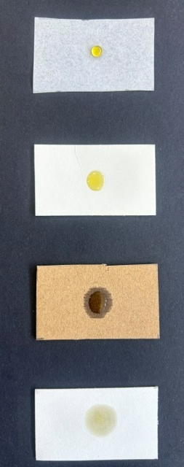
Oil drop fully soaks in
Oil drop spreads out
Oil drop forms a bead
Oil drop spreads and forms a halo
Results
No. | Type/ description of fibre-based food packaging | Observation of oil droplet  Drop sitting on top, spreading into a halo, or fully absorbed. If spreading, estimate diameter of halo in centimetres |  |  |  | Underside at 5 min | Softening at 5 min
No. | Type/ description of fibre-based food packaging | 30 sec | 1 min | 2 min | 5 min | Underside at 5 min | Softening at 5 min
1
2
3
4
5
6
7
8
9
10
11
12

Discussion
- Identify the variables in this investigation by completing the table below:

Independent variable  (what is changed) | Dependent variable  (what is measured) | Controlled variables

- Explain why you need to handle the samples by the edges prior to testing.

…………………………………………………………………………………………………………………………………………………………………………………………………………………………………………………………………………………………………………………………

- From your results, identify the fibre-based food packaging samples that exhibit the greatest oil-resistant properties. Justify your choice.

…………………………………………………………………………………………………………………………………………………………………………………………………………………………………………………………………………………………………………………………
……………………………………………………………………………………………………………………………………………………………

- Identify possible materials that could have been used as the oil-resistant coatings on the fibre-based food packaging you have tested.
………………………………………………………………………………………………………………………………………………………………………………………………………………………………………………………………………………………………………………………………………………………………………………………………………………………………………………………………………………………
……………………………………………………………………………………………………………………………………………………………

- How could you improve the reliability of this investigation?
…………………………………………………………………………………………………………………………………………………………………………………………………………………………………………………………………………………………………………………………
……………………………………………………………………………………………………………………………………………………………
- What would you observe if a single drop of olive oil was squeezed into the centre of a test sample that was known to be coated with PFAS? Explain your answer.

………………………………………………………………………………………………………………………………………………………………………………………………………………………………………………………………………………………………………………………………………………………………………………………………………………………………………………………………………………………………………………………………………
……………………………………………………………………………………………………………………………………………………………………………
……………………………………………………………………………………………………………………………………………….………………………………………………………………………………………………………………………………………………………………………….

- An Australian fast food retailer wants to purchase oil and water resistant, fibre-based food packaging for their fast food products. They were sent different samples of fibre-based food packaging from their supplier, and they tested them using this oil resistance test. All packaging samples exhibited great oil-resistant properties. They repeated the tests using water instead of oil and the results were similar.
However, the retailer wants to buy PFAS-free, fibre-based food packaging so they decided to send the packaging samples to ANSTO.
- PFAS coatings are highly oil and water resistant, so why would the retailer want to buy PFAS-free, fibre-based packaging for their fast food products?
……………………………………………………………………………………………………………………………………………….………………………………………………………………………………………………………………………………………………………………………….
…………………………………………………………………………………………………………………………………………………………….
- Explain why the retailer sent their packaging samples to ANSTO.

………………………………………………………………………………………………………………………………………………………………………………………………………………………………………………………………………………………………………………………………………………………………………………………………………………………………………………………………………………………………………………………………………
……………………………………………………………………………………………………………………………………………………………………………
……………………………………………………………………………………………………………………………………………….………………………………………………………………………………………………………………………………………………………………………….
Conclusion
Write a conclusion for your experiment.
………………………………………………………………………………………………………………………………………………………………………………………………………………………………………………………………………………………………………………………………………………………………………………………………………………………………………………………………………………………………………………………………………
……………………………………………………………………………………………………………………………………………………………………………

Activity 3 – Determining Total FluorinE concentration AT ANSTO

Recently ANSTO has supported an industry-led initiative to identify and phase out PFAS chemicals in food packaging. ANSTO's Centre for Accelerator Science can perform rapid testing for fluorine (the F in PFAS) in the packaging material. This testing was carried out on the ANSTO STAR particle accelerator, a 2 million volt Tandetron accelerator.
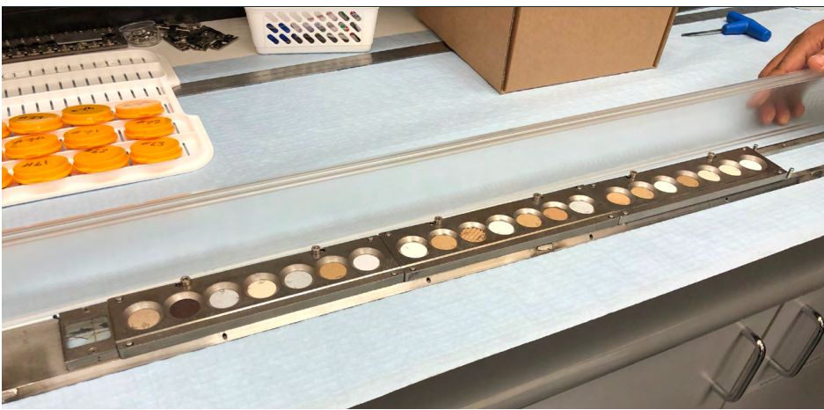
Food packaging sample discs loaded into the carousel
Image source: APCO 2021 PFAS in packaging report
75 fibre-based food packaging samples were provided for testing, covering a wide range of packaging applications and types. Each sample was allocated a sample ID number. For each packaging sample, two 25 mm diameter discs (A and B) were punched out of a part of the packaging that would be exposed to food. The sample discs were then loaded into a carousel for automated loading into the target chamber of the STAR particle accelerator.

The STAR accelerator uses a method called Ion Beam Analysis to determine the total fluorine concentration of the packaging samples. This method involves generating a beam of very fast-moving protons. The STAR particle accelerator tank speeds up the protons so that they travel at 2-3% the speed of light. Electromagnets are used to direct these fast-moving protons to the centre of the sample disc. The accelerated protons penetrate the top 100 µm layer of the sample disc and interact with the atoms in the packaging material. A fast-moving proton has enough energy to overcome the repulsion of an atom’s positively charged nucleus and so can collide with an atom’s nucleus. The resultant nuclear reaction causes the atom’s nucleus to emit a high energy gamma ray which can be detected. The energy of the gamma radiation emitted is different for each type of atom, and the atom the scientists are looking for to provide evidence that PFAS is present is fluorine. This process is known as Particle Induced Gamma-ray Emission (PIGE).
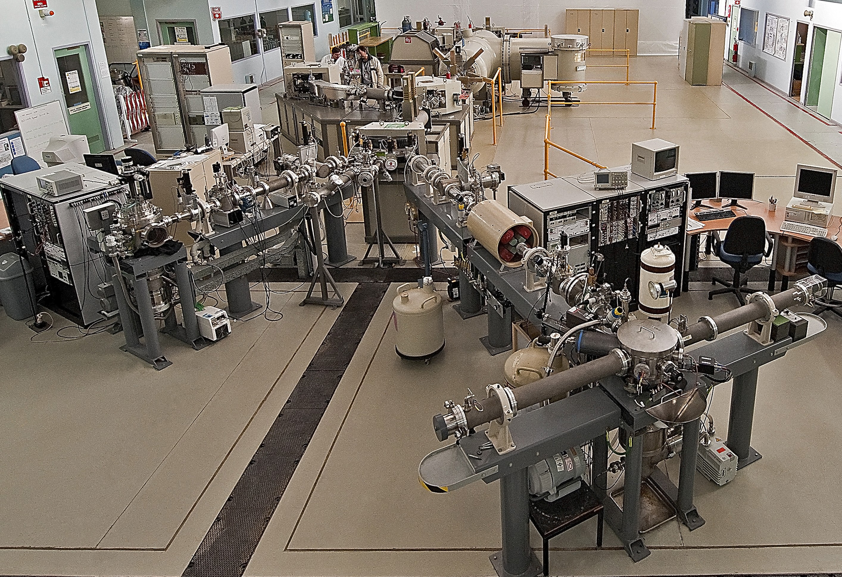

high speed protons generated here
accelerator tank
electromagnet
beamline
ANSTO’s STAR particle accelerator generates a stream of high-speed protons and directs them at food packaging samples in the target chamber. A high-speed proton collides with the nucleus of a fluorine atom in the food packaging sample. The collision produces a gamma ray having a characteristic energy of 197 keV. Image source: APCO 2021 PFAS in packaging report

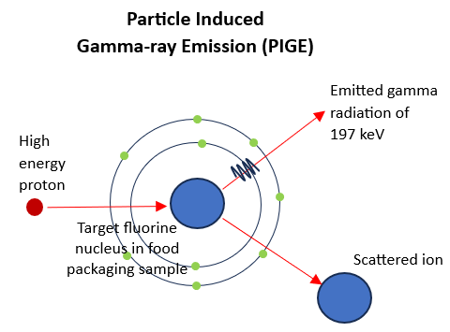
target chamber
Fluorine atoms emit gamma rays having a characteristic energy of 197 keV. The total energy emitted by all the fluorine atoms in the packaging sample is recorded as a peak at 197 keV. The area under the peak indicates the total number of fluorine atoms in the packaging sample and can be used to determine the total fluorine content of the packaging.
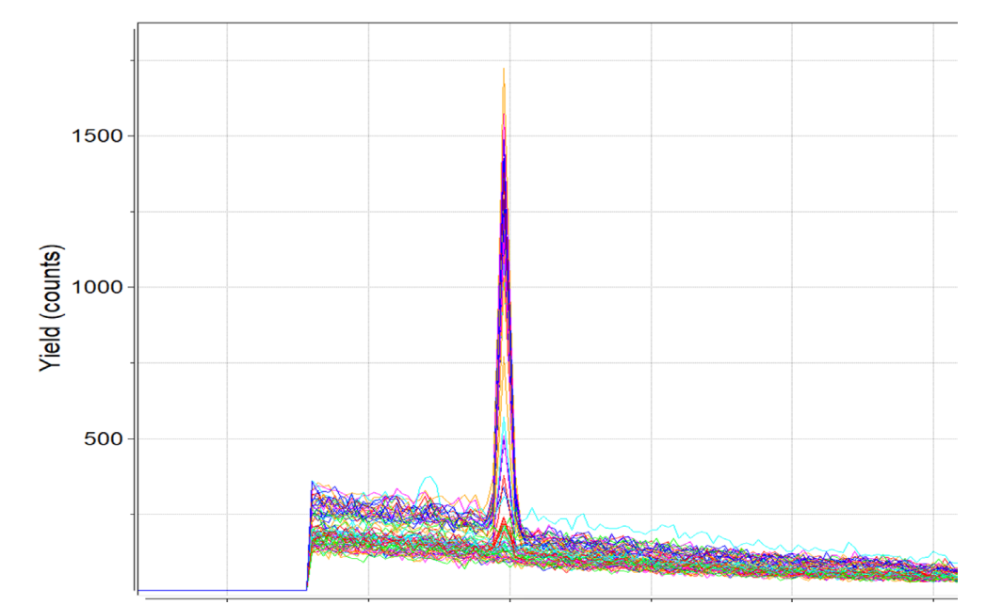

Experimenters use standard samples, which are samples of known fluorine concentration, in order to convert the area under the peak at 197 keV into the total fluorine concentration in parts per million (ppm) or µg/g.
The emission peaks at 197 keV for all 75 samples tested. The area under the emission peak at 197 keV indicates the total fluorine content of the packaging.
Image source: APCO 2021 PFAS in packaging report

This nuclear technique takes only a few minutes per sample. It is non-destructive, which means the food packaging sample has not been damaged during the testing and remains in its original state, so the same sample can undergo a repeat test or be used for further testing if needed.

- How does testing food packaging samples for the presence fluorine atoms indicate the presence of PFAS?

………………………………………………………………………………………………………………………………………………………………………………………………………………………………………………………………………………………………………………………………………………………………………………………………………………………………………………………………………………………………………………

- Number the steps from 1 to 5 to show how ANSTO’s STAR particle accelerator is used to detect PFAS in food packaging samples.
(HINT: use the photo and diagram at the bottom of page 15 to help you)

Number | Steps
 | The fluorine nucleus emits a gamma ray of 197 keV
 | High speed protons travel down the beamline
 | High speed protons are generated in the STAR accelerator tank
 | Electromagnets direct the high speed protons to the centre of the food packaging sample in the target chamber
 | A proton collides with the nucleus of a fluorine atom in a PFAS molecule in the food packaging sample

- Why do we need high speed protons to test food packaging samples for the presence of fluorine?

………………………………………………………………………………………………………………………………………………………………………………………………………………………………………………………………………………………………………………………………………………………………………………………………………………………………………………………………………………………………………………

- What is the energy of the gamma radiation that is uniquely emitted by a fluorine nucleus when it is struck by a high speed proton?

………………………………………………………………………………………………………………………………………………………

- Look at the graph on page 16. What does the peak on the graph represent, and what is the area under the peak used to determine?

………………………………………………………………………………………………………………………………………………………………………………………………………………………………………………………………………………………………………………………………………………………………………………………………………………………………………………………………………………………………………………

- This testing is non-destructive. What does this mean?

…………………………………………………………………………………………………………………………………………………………………………………………………………………………………………………………………………………………………………………………………………
Use of standard samples
How can we use the area under the peak at 197 keV to determine the amount of PFAS present in a packaging sample?
The answer is to use a standards graph (also known as a calibration graph or curve) which shows the relationship between the two quantities, the area under the peak at 197 keV from the particle-induced gamma-ray emission (PIGE) and the total fluorine concentration in parts per million (ppm). Total fluorine concentration indicates the amount of PFAS present.
The standards graph is constructed using standard samples with known concentrations of fluorine, and determining the area under the peak for each of these known fluorine concentrations.
Seven standard samples of known fluorine concentration were analysed by ANSTO scientists using ion beam analysis on ANSTO’s STAR particle accelerator. Each standard sample was analysed twice (Trial A and Trial B). The values for the area under the peak at energy 197 keV, from the particle-induced gamma-ray emission (PIGE) of these standard samples, are provided in the ‘Standards’ worksheet of the ‘PFAS in fibre-based food packaging’ MS Excel workbook.
View the table of data in the ‘Standards’ worksheet. You are going to create a standards graph showing the 197 keV Peak Area (counts/ µC) versus Fluorine Concentration (ppm) for these reference samples.

- What is a standard sample?

………………………………………………………………………………………………………………………………………………………………

- Which of the two variables involved in the construction of the graph is the independent variable?
(HINT: This is the variable that the experimenter changed.)
………………………………………………………………………………………………………………………………………………

- State the units used for fluorine concentration.
………………………………………………………………………………………………………………………………………………

- Why were each of the standard samples tested twice for particle induced gamma ray emission (PIGE)?
………………………………………………………………………………………………………………………………………………………………………………………………………………………………………………………………………………………………………………………………………………………………………………………………………………………………………………
- Determine the average 197keV Peak Area in counts/µC of Trial A and Trial B for each of the standard samples 1 -7.

HINT: to find the average 197keV Peak Area of Trial A and Trial B, you can follow the instructions on the following page:
- In cell E3, type =average(
- Click in cell C3, and, holding the left mouse button depressed, drag to cell D3 to highlight both cells. C3:D3 will appear in the formula in cell E3
- Type ) and press enter.
- Right click in cell E3 and choose copy from the dialog box that opens.
- Click in E3 and, holding the mouse button depressed, drag to cell E9. This will highlight the cells from E3 to E9.
- Click on Home from the top tool bar, then click on the fill icon in the editing box



- Choose ↓ down from the dialog box that opens. This will show the average of Trial A and Trial B for all standard samples.

- Create the standards graph showing the average 197 keV Peak area (counts/ µC) versus fluorine concentration (ppm) for each of the standards given in the table. Add a line of best fit passing through (0,0). Give your graph a title.
HINT: To construct your graph using MS Excel you can follow the instructions below:

- Click in cell B3 and, holding the left mouse button down, drag the cursor to cell B9. This will highlight the data in Column B (fluorine concentration (ppm))
- Holding down the CTRL button or Command button, click in cell E3, and holding the left mouse button down, drag to cell E9. This will highlight the data in Column E (average 197 keV Peak area (counts/ µC))
- Select insert tab and click on scatter graph from the Charts shown, and then click on the first scatter.

- Click on your chart, then select chart design from the top tool bar.
- Click on Add Chart Element in the top left-hand corner. Scroll down to highlight Chart Title, then choose Above Chart. Type the title ‘Relationship between fluorine concentration and 197 keV Peak Area’ and press enter.
- Click on Add Chart Element, scroll down to highlight Axis Titles, then choose Primary Horizontal. Type the title ‘fluorine concentration (ppm)’ then press enter.
- Click on Add Chart Element, scroll down to highlight Axis Titles, then choose Primary Vertical. Type the title ‘197 keV Peak area (counts/ µC)’ and press enter.
- Right click on the vertical axis scale and a dialog box will open. Choose format axis and a ‘Format Axis’ box will appear on the right-hand side.
- Scroll down to number and click on the arrow to expand the category.
- For Decimal places type 0 and press enter. Close the ‘Format Axis’ dialog box by clicking on the cross (x) in the top right hand corner.
- To add a trendline, select chart design from the top tool bar, then click on Add Chart Element, scroll down to trendline, and choose linear.
- Right click on the trendline and a dialog box will open. Choose format trendline and a ‘Format Trendline’ box will appear on the right-hand side.
- Tick set intercept and check it is 0.0 and tick display equation on chart. An equation of the form y = m x will appear on the line.
- Close the ‘Format Trendline’ dialog box by clicking on the cross (x) in the top right hand corner.

Insert graph here:

- What is the relationship between Fluorine Concentration (ppm) and 197 keV Peak Area (count/UC).
HINT: Write the equation that connects the two variables, x (fluorine concentration) and y (197 keV Peak Area), that is, the equation for the line of best fit.

………………………………………………………………………………………………………………………………………………………………………………………………………………………………………………………………………………………………………………………………………………………………………………………………………………………………………………………………………………………………
………………………………………………………………………………………………………………………………………………………………
……………………………………………………………………………………………………………………………………………….
- The table below shows the 197 keV Peak Area in counts/ µC of four samples of fibre-based food packaging.

- Using the equation of the line of best fit, calculate the fluorine concentration for each sample in ppm, and record your answer to 0 decimal places in the table.

- Samples were classified according to their fluorine concentration as follows:

High > 800 ppm
Medium 200 - 800 ppm
Low 100 - 200 ppm
Very low < 100 ppm

Use this information to classify the samples in the table as high, medium, low, or very low.

Sample | 197 keV Peak area (counts/µC)  y value | Fluorine concentration (ppm)  x value = y/ 0.4722 | Classification
19 Disk B | 498.54
47 Disk B | 160.65
55 Disk A | 54.56
64 Disk A | 717.20

- Sample 64 in the table above was from microwavable popcorn packaging. Explain the fluorine concentration classification in terms of the use of this packaging.
(HINT: think about the properties of PFAS)

………………………………………………………………………………………………………………………………………………………………………………………………………………………………………………………………………………………………………………………………………………………………………………………………………………………………………………………………………………………………
………………………………………………………………………………………………………………………………………………………………

Activity 4 – Assessing Fluorine in fibre-based Food Packaging

75 confidential fibre-based, food contact packaging samples were provided to ANSTO. The samples were analysed using particle-induced gamma-ray emission (PIGE) carried out on ANSTO’s STAR particle accelerator. This method (which is discussed on pages 15 and 16 in Activity 3) measures the ‘total fluorine concentration in ppm’ of each sample and can be done relatively quickly.
Total fluorine concentration is an indicator of the amount of PFAS, with high total fluorine concentration (> 800 ppm) indicating a high level of PFAS, resulting from intentionally added PFAS to form a heat, grease, and moisture barrier. Low or no total fluorine concentration (< 200 ppm) indicates low levels or no PFAS. Low and very low levels of PFAS could result from non-intentionally added PFAS, possibly due to the use of recycled fibre in the packaging.
It is also important to note that, while total fluorine concentration measurements using PIGE screen for the presence of PFAS, fluorine can also come from non-PFAS sources such as inorganic fluorine (e.g. sodium fluoride which is used to fluoridate water for cavity prevention, and other fluorine-based minerals). These non-PFAS sources typically show low fluorine concentrations below 100 ppm.
Each of the 75 packaging samples were tested twice, using two 25 mm diameter discs (A and B) that were punched out of parts of the packaging exposed to food.
The results of these tests are provided in the ‘Packaging Total-F concentration’ worksheet of the MS Excel workbook ‘PFAS in fibre-based food packaging’.

- Determine the average total fluorine concentration of Disc A and Disc B for each of the packaging samples.

HINT: to find the average total fluorine concentration of Disc A and Disc B, you can follow the instructions below:

- In cell F3, type =average(
- Click in cell C3, then type , (a comma) and then click in cell E3
- Type ) and press enter.
- Right click in cell F3 and choose copy from the dialog box that opens.
- Click in F3 and, holding the button depressed, drag to cell F77. This will highlight the cells from F3 to F77.
- Under Home from the top tool bar, click on the fill icon in the editing box

- Choose ↓ down from the dialog box that opens. This will show the average of Disc A and Disc B for all packaging samples.

- Create a column graph of the average total fluorine concentration (ppm) versus the packaging sample. Give your graph a title.
HINT: To construct your column graph using MS Excel you can follow the instructions below:
- Click in cell A3 and, holding the mouse button down, drag the cursor to cell A77, OR simultaneously hold down CTRL, Shift, and down arrow (↓) keys. This should highlight the data in Column A (packaging sample ID number)
- Holding the CTRL button depressed, click in cell F3 and, holding the mouse button down, drag the cursor to cell F77, OR simultaneously hold down CTRL, Shift, and down arrow (↓) keys. This should highlight the data in Column F (Average total fluorine concentration (ppm))
- Select insert tab and click on recommended charts in the Charts box, and then click on the clustered column graph from the graphs shown, and click OK.

- Click on your chart, then select chart design from the top tool bar.
- Click on Add Chart Element in the top left-hand corner. Scroll down to highlight Chart Title, then choose Above Chart. Type the title ‘Fluorine concentrations of fibre-based food packaging samples’ and press enter.
- Click on Add Chart Element, scroll down to highlight Axis Titles, then choose Primary Vertical. Type the title ‘fluorine concentration (ppm)’ and press enter.
- Click on Add Chart Element, scroll down to highlight Axis Titles, then choose Primary Horizontal. Type the title ‘packaging sample ID number’ and press enter.

Insert graph here:

- State the highest average total fluorine concentration recorded for the fibre-based food packaging tested.
……………………………………………………………………………………………………………………………………………………

- How many fibre-based food packaging samples had high concentrations of PFAS, that is total fluorine concentrations greater than 800 ppm?
……………………………………………………………………………………………………………………………………………………

- What percentage of the fibre-based food packaging samples had levels of PFAS greater than 200 ppm fluorine concentration, indicating that PFAS has more likely been intentionally added to the packaging?

HINT: determine how many columns are higher than 200 ppm fluorine concentration and determine the percentage of the total number of samples tested.
………………………………………………………………………………………………………………………………………………………

- Account for the presence of low concentrations of fluorine, that is, less than 100 ppm fluorine concentration, in some fibre-based food packaging samples.

………………………………………………………………………………………………………………………………………………………………………………………………………………………………………………………………………………………………………………………………………………………………………………………………………………………………………………………………………
………………………………………………………………………………………………………………………………………………………

- In the APCO study, all 13 samples of bagasse food packaging that were tested contained high average levels of total fluorine. Bagasse is made from sugar cane pulp which can be moulded into various formats.
Bagasse packaging is often marketed as ‘compostable’. Is it safe to put this packaging in your compost bin? Explain your answer.
………………………………………………………………………………………………………………………………………………………………………………………………………………………………………………………………………………………………………………………………………………………………………………………………………………………………………………………………………
………………………………………………………………………………………………………………………………………………………

- In the APCO study, all samples with high total fluorine concentration (greater than 800 ppm) were tested for the presence of 28 common members of the PFAS family. The results showed that the 28 PFAS chemicals were not present in most of these samples.

Does this mean that the samples which gave negative results for the 28 PFAS chemicals do not contain PFAS? Justify your answer.
………………………………………………………………………………………………………………………………………………………………………………………………………………………………………………………………………………………………………………………………………………………………………………………………………………………………………………………………………
………………………………………………………………………………………………………………………………………………………

- Over 60% of fibre used in Australia for the manufacture of fibre-based food packaging is sourced from recycled products. How will this affect the PFAS concentration in food packaging in Australia over time?

………………………………………………………………………………………………………………………………………………………………………………………………………………………………………………………………………………………………………………………………………………………………………………………………………………………………………………………………………
………………………………………………………………………………………………………………………………………………………………………………………………………………………………………………………………………………………………………………………………………………………………………………………………………………………………………………………………………

- Suggest actions that you can take to lower your exposure to PFAS and to minimise the impact of PFAS on the environment.

………………………………………………………………………………………………………………………………………………………………………………………………………………………………………………………………………………………………………………………………………………………………………………………………………………………………………………………………………
………………………………………………………………………………………………………………………………………………………………………………………………………………………………………………………………………………………………………………………………………………………………………………………………………………………………………………………………………
………………………………………………………………………………………………………………………………………………………………………………………………………………………………………………………………………………………………………………

