|  |
| --- |
|  |
| Year 7-10 Science |
| Excursion workbook |
|  |
| Your visit to ANSTO  In the Discovery Centre, you will:   * Review atomic structure, isotopes and radioactivity * Draw traces left by alpha particles, beta particles, protons and muons in the cloud chamber * Use a scintillation counter to measure radiation from low level sources. * Model radioactive decay and half-life * Investigate medical applications of radioisotopes.   On site, you will visit:   * The OPAL (Open Pool Australian Lightwater) Research Reactor * The Australian Centre for Neutron Scattering * The Centre for Accelerator Science * The ANSTO Nuclear Medicine Facility |
|  |

# 1. It’s elementary!

*All matter is made of atoms. Atoms are composed of protons, neutrons and electrons*.

## Fill in the blanks with the following words:

***neutrons nucleus positive electrons***

Protons have a ____________ charge and are found in the ____________ of an atom.

____________ have a negative charge and surround the nucleus.

____________ have no charge and are found inside the nucleus.

## Colour the protons (red), neutrons (blue) and the electrons (green) using the pencils provided

*Below is a representation of a carbon-12 atom and the symbol for carbon on the periodic table*

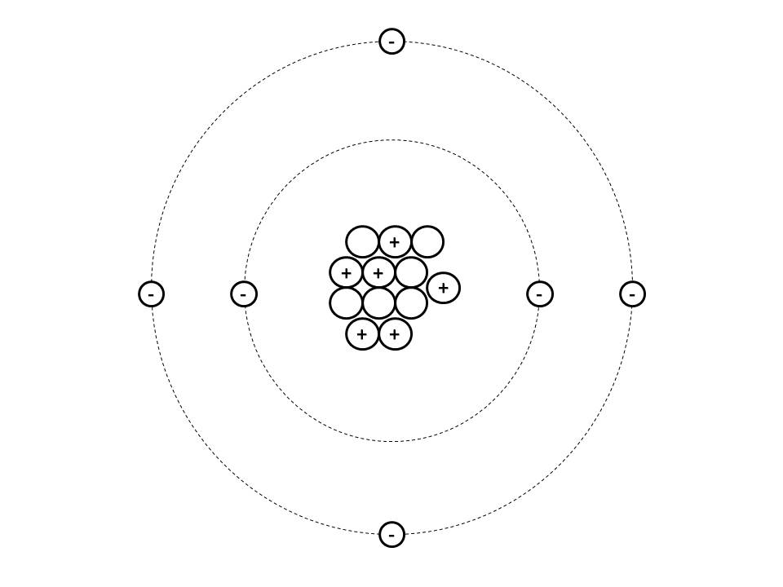

The symbol for carbon is **C**

This is the **atomic number** of carbon. It means carbon has **6 protons** in its nucleus

**

**

**

**

This atom is **carbon-12** because the number of **protons** + number of **neutrons** = **6 + 6 = 12**

## Using the periodic table fill in the table below:

|  |  |  |  |  |
| --- | --- | --- | --- | --- |
| **Isotope** | **Element symbol** | **Number of protons** | **Number of neutrons** | **Protons + neutrons** |
| Carbon-12 | C | 6 | 6 | 12 |
| Lithium-5 | Li | 3 |  | 5 |
| Carbon-14 |  | 6 |  | 14 |
| Silicon-30 |  | 14 |  |  |
| Potassium-40 |  |  |  | 40 |
| Cobalt-60 |  |  |  |  |
| Uranium-235 |  | 92 |  |  |

# 2. Why are some isotopes radioactive?

*An isotope is radioactive if it has an unstable nucleus. An unstable nucleus will break down or “decay” over time to become more stable. An atom’s nucleus will be unstable if:*

* *it contains an unbalanced number of protons and neutrons*
* *it is too large and has too many protons (all elements with more than 82 protons are radioactive because they have an unstable nucleus)*

## Calculate the number of protons and neutrons in each isotope in the table below: (you will complete the last column when you do part b)

|  |  |  |  |  |
| --- | --- | --- | --- | --- |
| **Isotope** | **Number of protons** | **Number of neutrons** | **Protons + neutrons** | **Part b)**  **identify if**  **Stable or unstable?** |
| Hydrogen-1 |  |  | 1 |  |
| Hydrogen-2 |  |  | 2 |  |
| Hydrogen-3 |  |  | 3 |  |
| Carbon-12 |  |  | 12 |  |
| Carbon-13 |  |  | 13 |  |
| Carbon-14 |  |  | 14 |  |

## Use the “Build an atom” simulator on the small Smartboard to build the isotopes in the table. Fill in the last column of the table above.

Add the correct number of neutrons, protons and electrons. Record whether each isotope is either stable or unstable (radioactive).

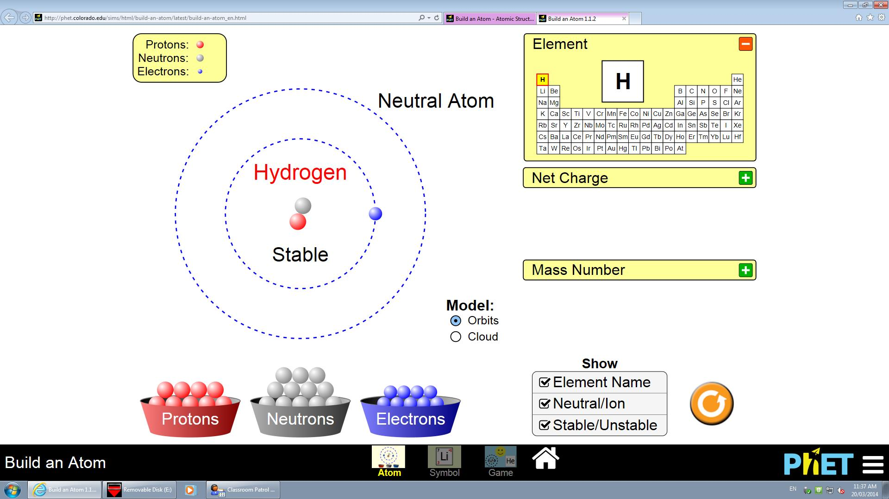

# 3. Nuclear radiation – alpha, beta and gamma radiation

*When an unstable nucleus decays, it gives off nuclear radiation. There are three main types of nuclear radiation – alpha (α), beta (β) and gamma (γ).*

## Read the posters about alpha, beta and gamma radiation

1. Using the large laminated table, place smaller cards into correct positions.
2. Have table checked by teacher
3. Copy information into table below, with any corrections.

|  |  |  |  |
| --- | --- | --- | --- |
|  | **Alpha** | **Beta** | **Gamma** |
| Symbol |  |  |  |
| Energy or a particle? |  |  |  |
| Labelled diagram |  |  |  |
| Penetrating ability  (What types of materials stop it?) |  |  |  |

# 4. Managing nuclear waste: With benefits come responsibility

## Use the wall display to fill in the blanks:

Nuclear waste is a ____________ of producing nuclear medicine and operating nuclear facilities and is classified as _________, ___________________, and ___________level. Around 80 percent of all waste produced by ANSTO is linked to the production of ____________ ____________.

## What type of nuclear waste am I?

|  |  |  |
| --- | --- | --- |
| I contain high levels of radioactivity. I need to be shielded and cooled, since I generate my own heat. I am produced by activities at nuclear power plants. I am not produced or stored at ANSTO.  I am **_______** level waste | I contain small amounts of short-lived radioactivity & do not require shielding. I will decay to a natural level of radiation in a relatively short period of time. I make up 92% of the waste generated at ANSTO.  I am ________ level waste | I make up 8% of ANSTO’s nuclear waste. I require some shielding during handling, transport and shielding. I am a necessary by-product of making nuclear medicines.  I am _______________ level waste |

## List 6 items you can see in the low level waste barrels.

## What are the advantages of ANSTO Synroc?

## Examine the photos of ANSTO Synroc containers before and after. Estimate the size reduction.

## Do the benefits of nuclear medicine outweigh the issues of nuclear waste? Why?

# 5. Measuring radiation

A special type of Geiger counter called a scintillation counter can be used to measure radioactivity.

**Instructions**

Turn on the scintillation counter by turning the settings knob. You should hear a static crackly sound and the occasional high pitched beep. Point the detector of the scintillation counter at the radioactive sources on the table.

## Fill out the table below by measuring the radioactivity of the objects

The black scale shows counts per seconds on the dial, write down why each object is radioactive.

|  |  |  |
| --- | --- | --- |
| **Radiation source** | **Radioactivity (counts per second)** | **What element makes**  **this radioactive?** |
| Background radiation  (point the detector at empty space in the room) |  |  |
| Potassium sulfate fertiliser |  |  |
| Uranium glass |  |  |
| Fiestaware plate |  |  |
| Thorium gas mantle |  |  |

## How does the reading on the scintillation counter differ when the detector is close to the radioactive source compared to when it is further away?

## Compare your group’s results with another group. Why are some values different.

**Turn off Scintillation counter when finished**

# 6. Half-life simulation

The decay of radioactive atoms occurs in a predictable way: During a certain period of time, one-half of the original atoms will have changed, leaving the other half unchanged. The length of time it takes for half of the atoms to decay is called a **half-life**. Each radioactive isotope has a unique half-life different from all other isotopes.

Knowing the half-life of a radioactive isotope is very useful. For example, radiocarbon dating uses the half-life of carbon-14 to estimate the age of certain objects.

## Run 1: Simulate the half-life of an imaginary radioactive isotope called

## ‘Anstonium’ using 50 coloured discs. If you have time do a ‘Run 2’.

1. Put exactly 50 discs into the cup.
2. Shake the cup and empty it onto the table. Each shake and release of the cup represents a half-life.
3. Remove the discs that land with the black side up – these are the atoms that have “decayed.”
4. Record the number of remaining, un-decayed discs in the table below in the column headed *Run 1*. Put the undecayed discs back into the cup.
5. Repeat this procedure until there are less than two discs left.

**Graph of ‘Anstonium’ decay**

**Radioactive atoms remaining**

50 -

40 -

30 -

20 -

10 -

0

**Half-Lives Elapsed**

0 1 2 3 4 5 6 7 8 9 10

**My results and**

**Average of all results**

|  |  |  |  |
| --- | --- | --- | --- |
| **Half**  **Life** | **Run1** | **Run2** | **Ave** |
| **0** | **50** | **50** | **50** |
| **1** |  |  |  |
| **2** |  |  |  |
| **3** |  |  |  |
| **4** |  |  |  |
| **5** |  |  |  |
| **6** |  |  |  |
| **7** |  |  |  |
| **8** |  |  |  |
| **9** |  |  |  |
| **10** |  |  |  |

|  |  |  |  |  |  |  |  |  |  |  |  |  |  |  |  |  |  |  |  |
| --- | --- | --- | --- | --- | --- | --- | --- | --- | --- | --- | --- | --- | --- | --- | --- | --- | --- | --- | --- |
|  |  |  |  |  |  |  |  |  |  |  |  |  |  |  |  |  |  |  |  |
|  |  |  |  |  |  |  |  |  |  |  |  |  |  |  |  |  |  |  |  |
|  |  |  |  |  |  |  |  |  |  |  |  |  |  |  |  |  |  |  |  |
|  |  |  |  |  |  |  |  |  |  |  |  |  |  |  |  |  |  |  |  |
|  |  |  |  |  |  |  |  |  |  |  |  |  |  |  |  |  |  |  |  |
|  |  |  |  |  |  |  |  |  |  |  |  |  |  |  |  |  |  |  |  |
|  |  |  |  |  |  |  |  |  |  |  |  |  |  |  |  |  |  |  |  |
|  |  |  |  |  |  |  |  |  |  |  |  |  |  |  |  |  |  |  |  |
|  |  |  |  |  |  |  |  |  |  |  |  |  |  |  |  |  |  |  |  |
|  |  |  |  |  |  |  |  |  |  |  |  |  |  |  |  |  |  |  |  |
|  |  |  |  |  |  |  |  |  |  |  |  |  |  |  |  |  |  |  |  |
|  |  |  |  |  |  |  |  |  |  |  |  |  |  |  |  |  |  |  |  |
|  |  |  |  |  |  |  |  |  |  |  |  |  |  |  |  |  |  |  |  |
|  |  |  |  |  |  |  |  |  |  |  |  |  |  |  |  |  |  |  |  |
|  |  |  |  |  |  |  |  |  |  |  |  |  |  |  |  |  |  |  |  |
|  |  |  |  |  |  |  |  |  |  |  |  |  |  |  |  |  |  |  |  |
|  |  |  |  |  |  |  |  |  |  |  |  |  |  |  |  |  |  |  |  |
|  |  |  |  |  |  |  |  |  |  |  |  |  |  |  |  |  |  |  |  |
|  |  |  |  |  |  |  |  |  |  |  |  |  |  |  |  |  |  |  |  |
|  |  |  |  |  |  |  |  |  |  |  |  |  |  |  |  |  |  |  |  |
|  |  |  |  |  |  |  |  |  |  |  |  |  |  |  |  |  |  |  |  |
|  |  |  |  |  |  |  |  |  |  |  |  |  |  |  |  |  |  |  |  |
|  |  |  |  |  |  |  |  |  |  |  |  |  |  |  |  |  |  |  |  |
|  |  |  |  |  |  |  |  |  |  |  |  |  |  |  |  |  |  |  |  |
|  |  |  |  |  |  |  |  |  |  |  |  |  |  |  |  |  |  |  |  |

# 7. Medical uses of nuclear energy

## Use the wall displays to fill in the blanks:

**1** in **2** Australians will benefit from nuclear medicine in their lifetime.

Nuclear medicines are widely used to help diagnose **heart** **disease**, **cancer** and **skeletal** injuries.

Each week ANSTO distributes **10,000** patient doses of nuclear medicine to **hospitals** and **clinics** across Australia.

Go to the touch screen labelled “Medical uses of nuclear energy”. You’ll need to use the correct medical scans and radioisotopes to diagnose two patients, George and Fran.

# george image.gifGeorge

## What symptoms is George exhibiting?

Mild chest pains, dizzy spells and irregular heartbeat

## Circle the type of scan George needs:

Gamma scan CT scan SPECT scan MRI scan PET scan

## Circle the name of the isotope George needs for his scan:

Molybdenum-99 Technetium-99m Iodine-123 Fluorine-18 Iodine-131

1. The scan shows that George is at risk of what disease?

# fran image bw.gifFran

## What type of cancer did Fran have removed during surgery?

## Circle the type of scan Fran needs to find out whether her surgery removed all the cancer:

Gamma scan CT scan SPECT scan MRI scan PET scan

## Circle the name of the isotope Fran needs for this scan:

Molybdenum-99 Technetium-99m Iodine-123 Fluorine-18 Iodine-131

The scan showed that Fran’s surgery did not remove all the cancer. She will need treatment with another radioisotope that will attack any remaining cancer cells.

## Circle the isotope Fran needs for her treatment and follow-up scan?

Molybdenum-99 Technetium-99m Iodine-123 Fluorine-18 Iodine-131

# 8. Detecting nuclear radiation

Nuclear radiation is silent and invisible, but we can use different instruments to detect it.

A **cloud chamber** allows us to see the effect of different nuclear radiation. Radioactive particles move through the alcohol vapour in the cloud chamber and strip electrons from surrounding atoms. This leaves a white trail in the cloud chamber that you can see.

Read the information about the different types of nuclear radiation

1. Look in the cloud chamber and observe the white vapour trails produced by different particles.

2. Draw the trails left by each particle and describe the trail and length of time it lasts.

## Alpha

|  |  |
| --- | --- |
|  |  |
|  |
|  |
|  |
|  |
|  |

# Beta

|  |  |
| --- | --- |
|  |  |
|  |
|  |
|  |
|  |
|  |

# Proton

|  |  |
| --- | --- |
|  |  |
|  |
|  |
|  |
|  |
|  |

# 9. Radiocarbon dating

ANSTO scientists use radiocarbon dating to determine the age of ancient artefacts and to study climate change.

This dating method works by measuring the ratio of different isotopes of carbon in a sample using a particle accelerator.

There are three main isotopes of carbon on earth.

1. Carbon-12 isotope ( 99% of all carbon on earth)
2. Carbon-13 (almost 1% of all carbon on earth)
3. Carbon-14 (trace amounts only)

Carbon-12 and carbon-13 are both stable isotopes, but carbon-14 is unstable and is radioactive.

## Use the information above and the words provided to fill in the blanks:

**seven (7) trace stable most common radioactive eight (8) nucleus six (6)**

Carbon-12 is the ________ __________ carbon isotope. It is __________ and contains 6 protons and 6 neutrons in its ____________. Carbon-13 makes up almost 1% of all carbon on earth. It is also stable and contains 6 protons and ______ neutrons in its nucleus. Carbon-14 is found in ___________ amounts. It is unstable and ___________________, and its nucleus contains ______ protons and __­___ neutrons.

## **Draw an atom of carbon-12 and an atom of carbon-14 using the key supplied. The atoms should show the number of protons, neutrons and electrons in each**.

-

-

-

## Proton Neutron Electron

**Carbon-14**

**Carbon-12**

Nucleus

Nucleus

## 9. Radiocarbon dating (cont.)

Living things contain carbon-14 and carbon-12 in a ratio that is the same as in the atmosphere at the time. When the organism dies, the ratio of carbon-14 to carbon-12 decreases, as carbon-14 decays and is no longer incorporated into the organism.

Using carbon dating, scientists can calculate how much carbon-14 decay has occurred by measuring the ratio of carbon-14 to all carbon atoms in the sample. The extent of carbon-14 decay will reveal the age of the sample. The half-life of carbon-14 is 5730 years and a graph of carbon-14 is below:

For example, a scientist calculates that an artefact contains only 50% of the original amount of carbon-14 it contained when it died. The scientist would use a graph like the one above to calculate that the artefact is approximately 5730 years old.

# 9. Radiocarbon dating (cont.)

Use the graph of carbon-14 decay on the previous page to solve these real-life science puzzles:

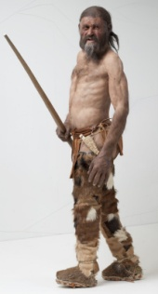

1. In 1991, hikers in Northern Italy found the perfectly preserved frozen body of a prehistoric man. Scientists named him Ötzi. Samples of his bones, hair, boots and clothes were carbon dated and revealed that Ötzi lived almost 5500 years ago.

## What percentage of the original carbon-14 in Ötzi’s body was remaining in 1991?

**About 53%**

1. 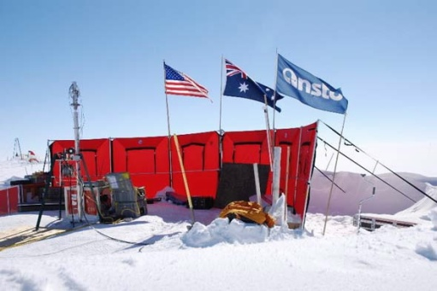Climate scientists, including Dr Andrew Smith at ANSTO, drill deep into Antarctic ice to find out more about the gases in our atmosphere thousands of years ago. As layers of snow and ice form year after year, air bubbles become trapped deep in the ice and serve as a frozen historical record of the gases in our atmosphere over time.

The eldest ice core from Antarctica so far was 3200m deep. Scientists carbon dated the gases in the air bubbles at the bottom of this ice core and found that only 29% of the original carbon-14 remained.

## **How long ago were these air bubbles trapped in the ice?**

**About 10,000 years ago**

1. 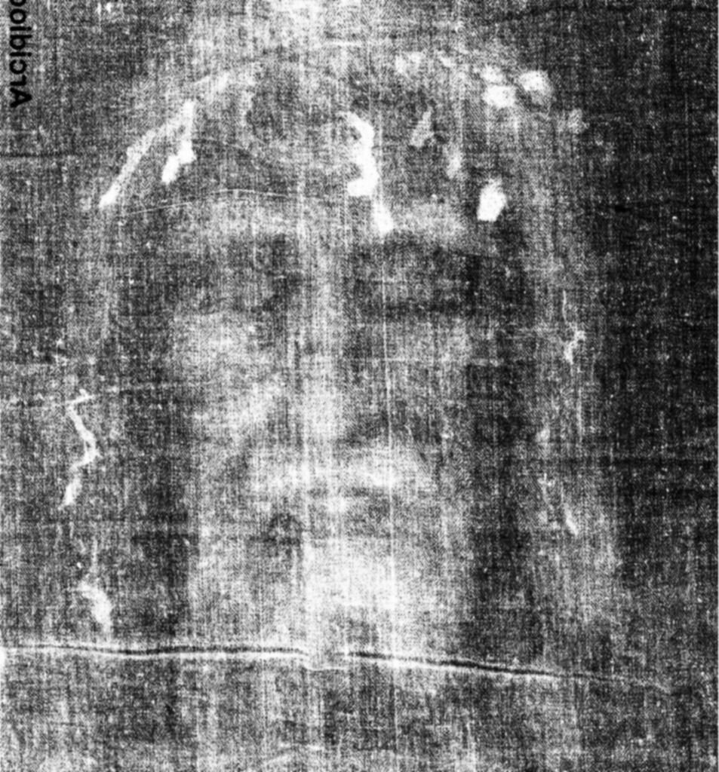The authenticity of the Shroud of Turin had long been debated. The shroud is said to be a piece of cloth that was used to wrap the body of Jesus after he was crucified. In 1988, scientists received permission from the Vatican to remove small samples for carbon dating. Three different laboratories around the world analysed the samples. All three laboratories came to a similar conclusion: The shroud had lost about 8 percent of its carbon- 14 atoms to radioactive decay.

## What is the approximate date of origin of the Shroud of Turin?

(Note: Despite these and other scientific investigations, the origin and date of the Shroud of Turin remains a subject of controversy.)

1. Carbon dating is most useful for determining the age of objects up to about 50,000 years old.

## Why is carbon dating less accurate for objects older than this?

**The half-life of carbon-14 is 5,730 years. The percentage of carbon-14 remaining in artefacts older than 50,000 years is less than 1% of the original amount. Accuracy decreases as scientists try to measure very small differences. Generally carbon-dating (and other forms of dating) are accurate up to 10 half-lives (57,300 years)**