Guide to using GeoPIXE on MASSIVE

Table of Contents

Guide to using GeoPIXE on MASSIVE 1
Getting a user account on MASSIVE 1
Using the MASSIVE desktop launcher 1
Installation Instructions 1
Transferring data to MASSIVE 2
Running GeoPIXE 3

Getting a user account on MASSIVE
User accounts can be requested from the MASSIVE website www.massive.org.au. Go to the Access page the Access tab and follow the prompts to create and account. When applying select the “Join an existing project” application type and join the Async013 project.
It may take one or two days for your account to be approved and created, you will receive an email when it is active. Also check in the MASSIVE user guide that you have the correct client software installed.

Using the MASSIVE desktop launcher
A convenient way to run GeoPIXE on MASSIVE is to use the MASSIVE Desktop Launcher. The MASSIVE/CVL Launcher is a cross-platform application which launches the MASSIVE Desktop by programmatically requesting a visualisation node on the MASSIVE server, creating an SSH tunnel and launching TurboVNC. This is a very convenient to run GeoPIXE on MASSIVE. Download the current version of the MASSIVE desktop launcher from the link below and then follow the installation instructions. https://massive.org.au/userguide/cluster-instructions/massive-launcher

Installation Instructions
- Install TurboVNC if it is not already installed. TurboVNC v1.1 or later is recommended, otherwise you will need enter your password twice - once for SSH, and once for TurboVNC.
- If using Mac OS X and running TurboVNC 1.1 or earlier, you will also need to install Xquartz (X11). If using Mac OS X and running a TurboVNC 1.2 pre-release build, you won't need to install XQuartz, but you will need to install a Java Runtime Environment if you don't already have one.
- Download and install the MASSIVE Launcher for your system.

Alternatively, you can log in to MASSIVE through a shell, such as provided with linux or using Putty under windows. Putty which can be downloaded from:
http://www.chiark.greenend.org.uk/~sgtatham/putty/download.html

Running the launcher will bring up a window to enter your MASSIVE login credentials and other options. Choose m1-login1.massive.org.au as the host and ASync013 as the MASSIVE project, as shown in illustration 1
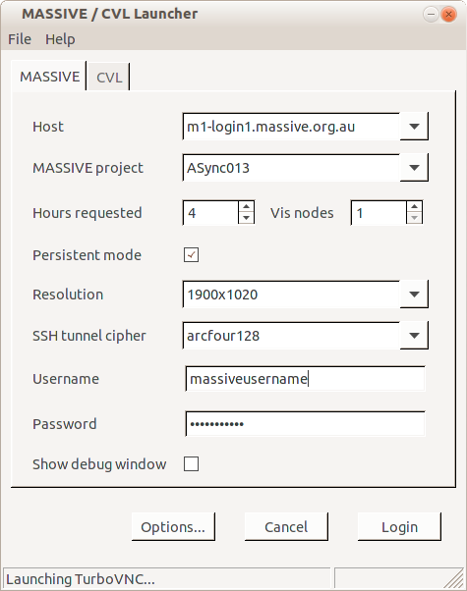Illustration 1: MASSIVE desktop launcher login

This will then create a MASSIVE desktop session.

Transferring data to MASSIVE
Data can fetched from the Synchrotron storage gateway using sftp via the 'konquerer' web browser supplied in the MASSIVE desktop. Enter the url into the address field:
sftp://data.synchrotron.org.au/
You will be prompted to supply your VBL username and password when prompted for login credentials as shown in figure 2

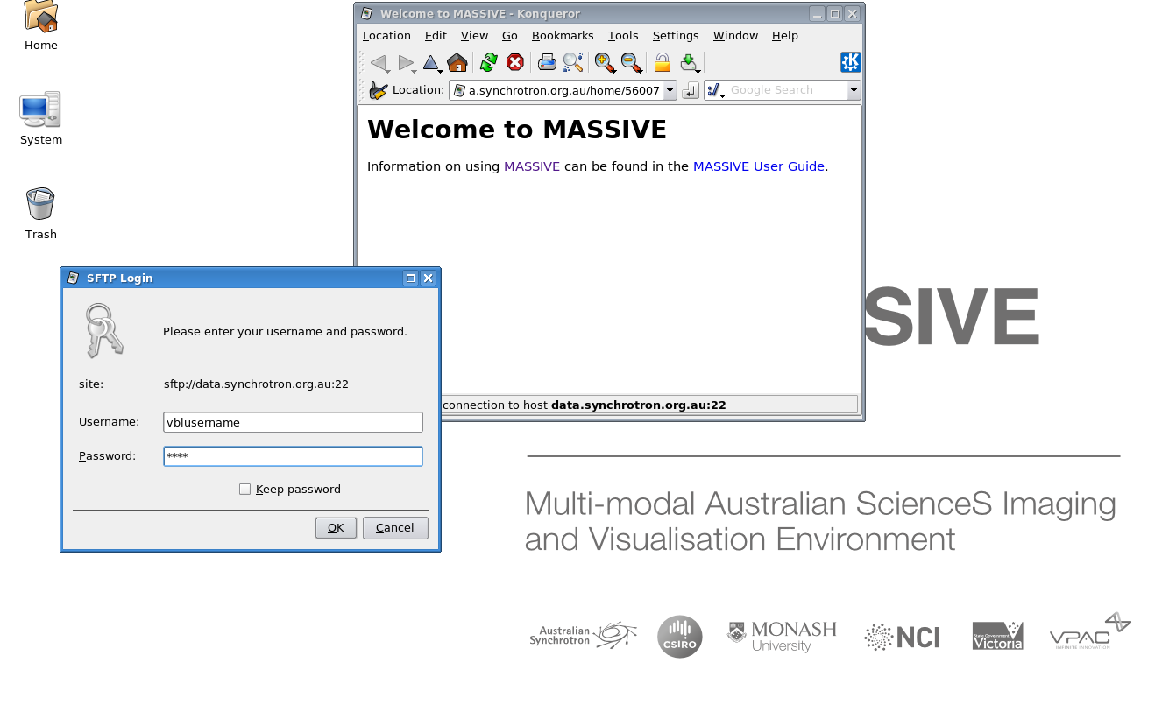Illustration 2: Using sftp to transfer data from the synchrotron storage gateway to MASSIVE
Once authenticated you can navigate to your home directory on the XFM beamline file server to see the experimental data sets available to you, and can copy directories from the storage gateway to a location on MASSIVE. You may be asked for your username and password again to copy data. You should create a directory to put your data in under ASync013_scratch named the same as your username.

Running GeoPIXE
Access to GeoPIXE on MASSIVE is provided for all licensed users of GeoPIXE. To obtain a license for use at your home institution and on MASSIVE, send an email to geopixe@csiro.au.

GeoPIXE is launched from the command line. If using the MASSIVE desktop open a 'konsole' shell. The geopixe module must first be loaded. This is done using the command:
module load geopixe
GeoPIXE is then launched by the command
geopixe
To process your data, in the “Sort EVT Files” window, after filling in the sort parameters, click on “cluster” to process the data in cluster mode as shown in figure 3. In “cluster” mode, GeoPIXE writes log files into your home .geopixe directory (see “/home/name/.geopixe” for user “name”). These may help diagnose problems processing data in cluster mode. Note: there is a bug which could result in an error message that it cannot write to dai.0 file. In this case, uncheck the cluster mode box, start the processing and then cancel. You can then turn cluster mode back on and restart the data processing.

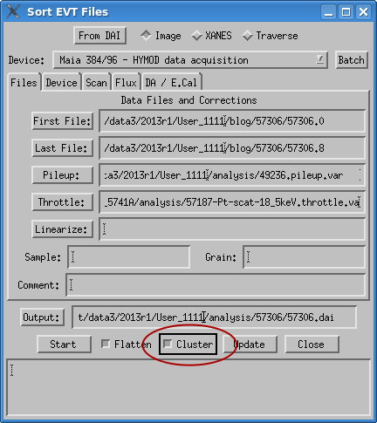Illustration 3: Processing the blog files in cluster mode

