ANSTO makes nuclear medicines
ANSTO makes more than 10,000 doses of nuclear medicine every week. Our nuclear medicines are used to diagnose and treat diseases like cancer. Our employees need to work quickly and safely to make and distribute these nuclear medicines.

Pre-work activity: Play the Half-life Hero game (https://www.ansto.gov.au/education/apps) and practice making medicines as a reactor operator

Question 1: Why do ANSTO employees need to work quickly to make nuclear medicines?
____________________________________________________________
____________________________________________________________
____________________________________________________________
____________________________________________________________

Activity 1: Participate in the hands-on activity to learn about half-life during the videoconference. You’ll need an A4 piece of paper and scissors.

Question 2: Do nuclear medicines usually have long or short half-lives? Why?
____________________________________________________________
____________________________________________________________
____________________________________________________________
ANSTO has Australia’s only nuclear reactor
Question 3: Complete the table below during the videoconference.
 | ANSTO’s OPAL reactor | Average power reactor
 | 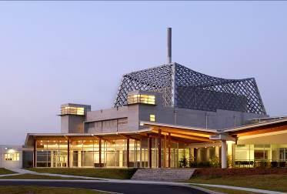 | 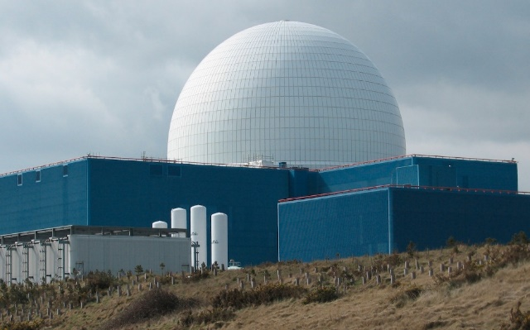
Thermal power
Uranium
Temperature
Pressure
Purpose

Activity 2: Watch the mousetrap fission video during the videoconference.

Question 4: The mousetrap fission video is an example of a scientific model. What did the following represent in your model?
Mousetraps: ________________________________________________
Ping pong balls: ______________________________________________

Activity 3: Watch the ANSTO fission animation during the videoconference.

Question 5: What products of the fission reaction weren’t represented in the mousetrap model of fission?
_____________________________________________________________
ANSTO uses radiation safely
Large amounts of radiation can be dangerous, but we work safely with radiation by:
1. Reducing time spent near the radioactive source
2. Increasing distance from the radioactive source
3. Using shielding
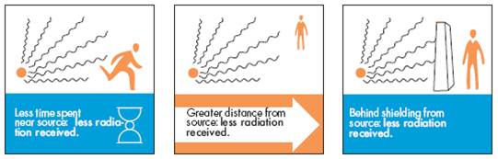
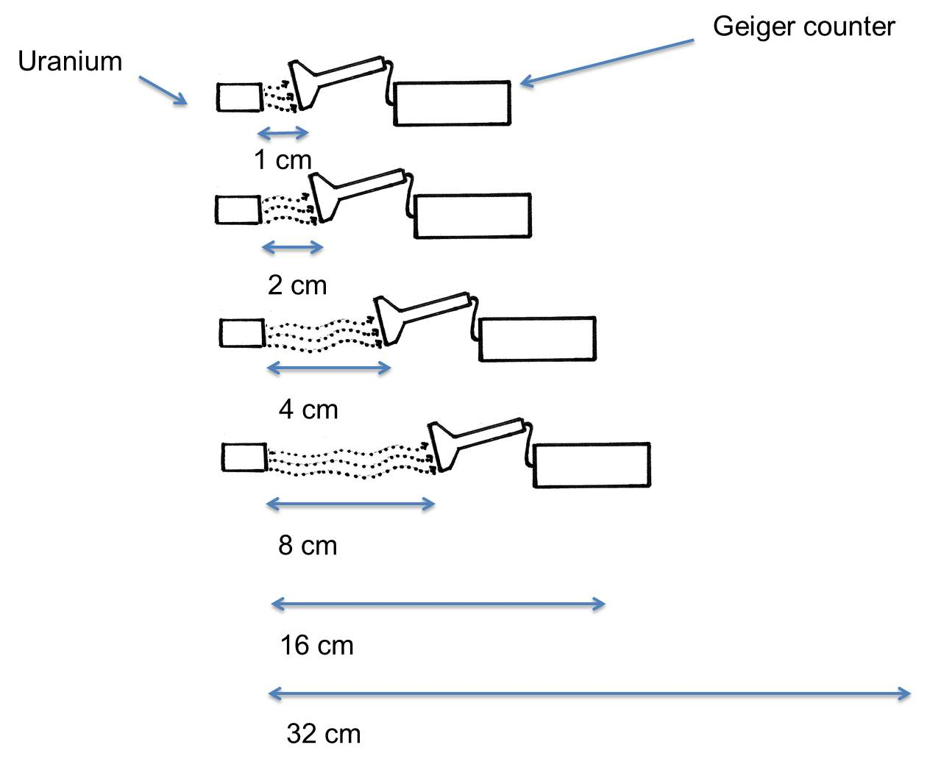
Activity 4: You will do an experiment to test how distance affects radiation count.

Prediction: As the distance from the radioactive source gets larger, I think the radiation count on the Geiger Counter will:
=
Stay the same
Decrease
Increase

Write down the results of your experiment:

Distance from the source (cm) | Radiation (Counts per second)
1 cm
2 cm
4 cm
8 cm
16 cm
32 cm

Graph your results:
Distance from the source (cm)
2
4
6
8
10
12
14
16
18
20
22
24
26
28
30
32
0
2000
1500
1000
500
2500
Radioactivity (counts per second)

Conclusion:
____________________________________________________________
____________________________________________________________
Extension question: What shape is the graph? Is it a straight line or a curve? Why?

