**Equipment list**

You can choose any of the equipment below to perform your experiment:

**Measuring and detection equipment**

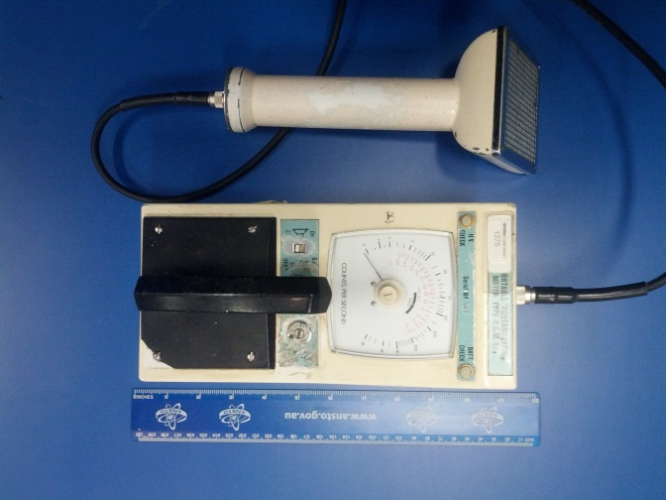

**Scintillation counter:** This device measures radioactivity in counts per second. It makes different sounds when alpha, beta and gamma radiation hits the detector

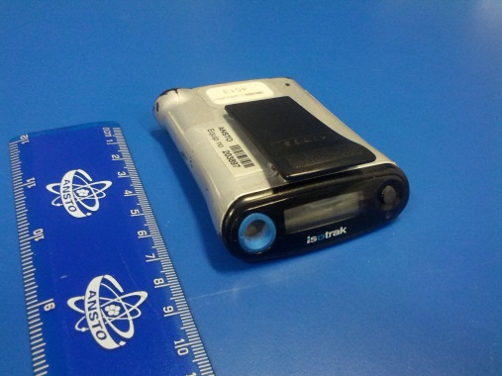

A **personal dosimeter** measures radiation dose, which is the potential biological effect of radiation on living things.

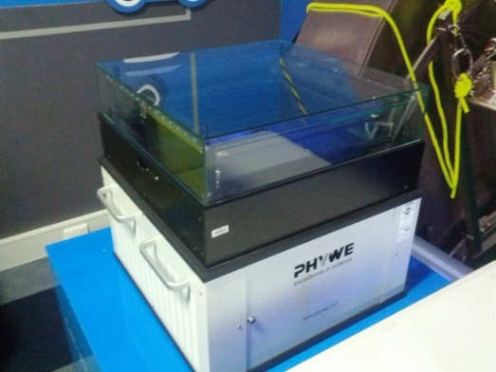

A **cloud chamber** allows you to see vapour trails left by different types of radioactive particles, like alpha and beta particles, protons and muons. The cloud chamber has a small entrance where you could insert a tungsten welding rod containing radioactive thorium and observe the radiation emitted.

A **meter ruler** could help you measure distance between a source of radiation and the detector.

**Radioactive sources**

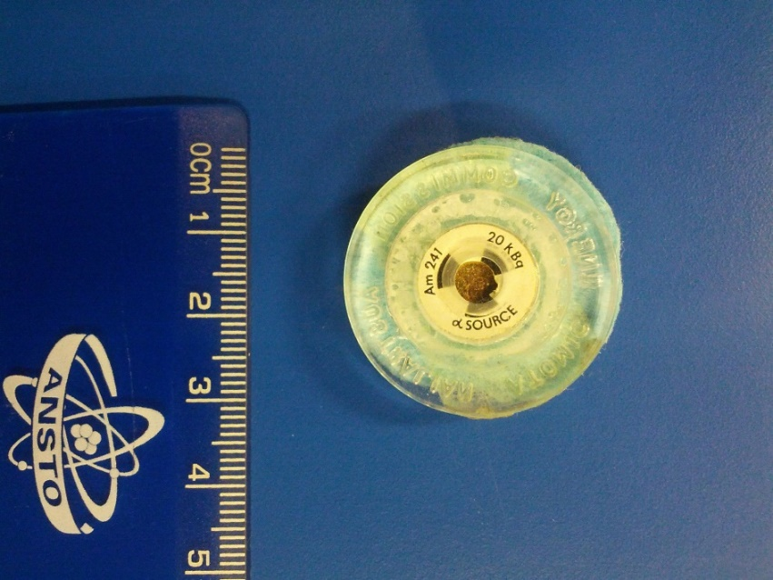

**Alpha, beta and gamma radiation sources:**

These three little discs contain:

- Americium-241 (an alpha emitter)

- Strontium-90 (a beta emitter)

- Cobalt-60 (a gamma emitter)

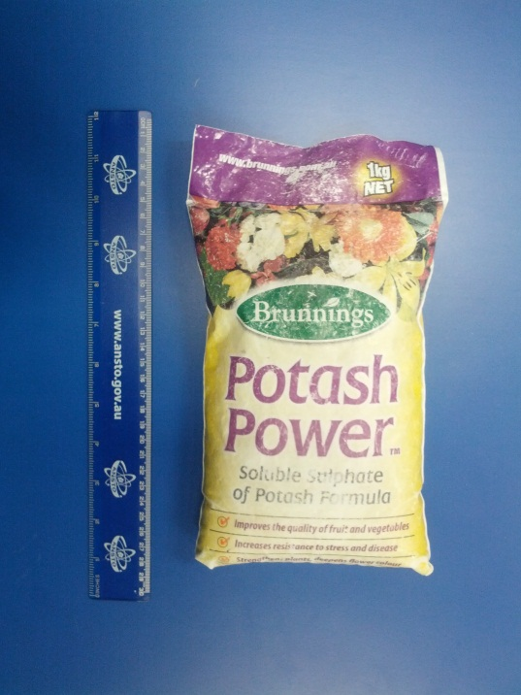**Radioactive objects**

**Potash fertiliser:** This fertiliser contains potassium sulphate and is used to promote growth in flowering and fruiting plants. It is radioactive because 1% of all potassium atoms are a radioactive isotope called potassium-40.

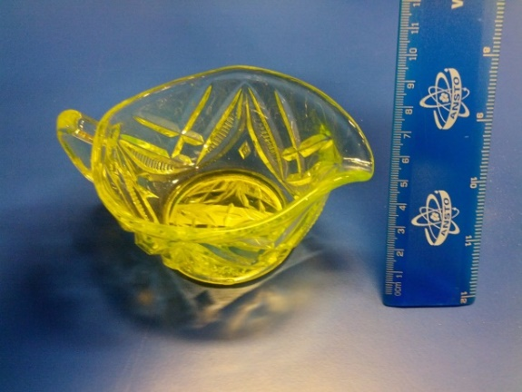

**Uranium glass:** This type of glass was made by adding uranium to the glass mix before melting. The uranium makes the glass a yellow colour, and the glass glows green under ultraviolet light. Uranium glass was most popular from the 1880s to the 1920s.

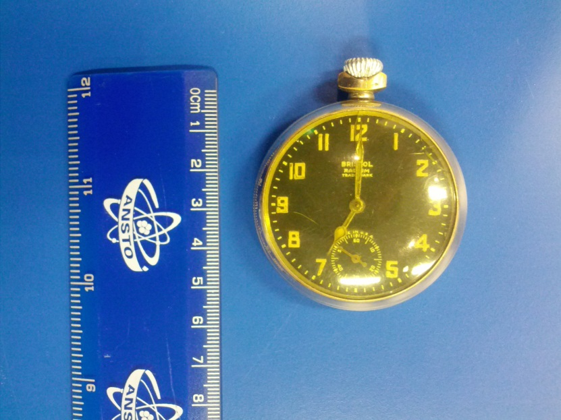

**Radium watch:** Some old watch and clock dials were painted with radioluminescent paint containing radium so that the hands and numbers glowed in the dark. Modern glow-in-the dark paint does not contain radioactive material.

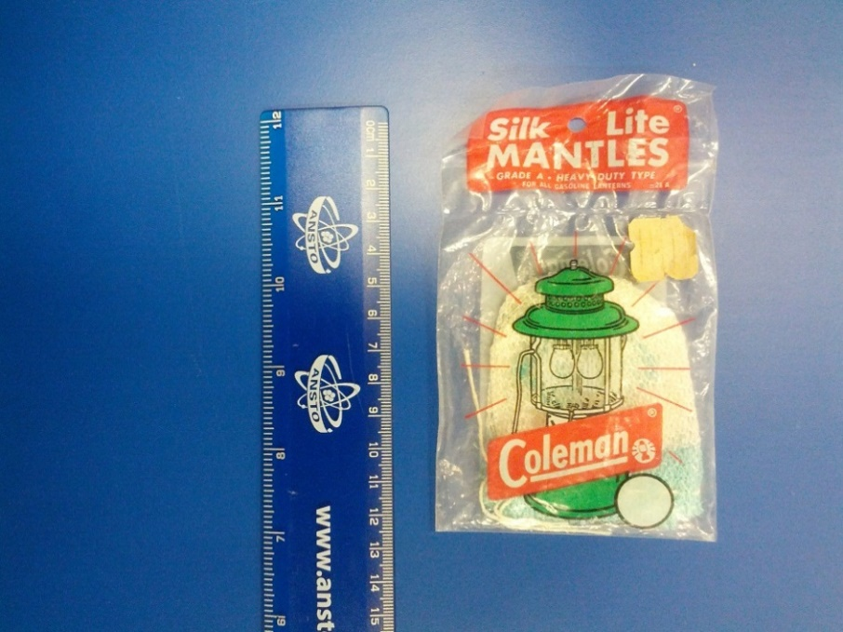

**Gas mantle:** When placed inside a gas lantern, a gas mantle generates a bright white light when heated by a flame. Gas mantles used to contain radioactive thorium, but this has now been replaced by other compounds in most brands

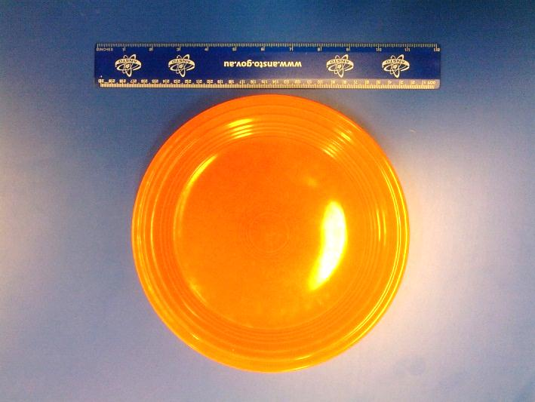

**Fiestaware:** Fiestaware was a brand of brightly-coloured ceramic plates made in the United States. Up until 1973, the Fiesta company produced their orange-red coloured products by mixing uranium oxide into their ceramic glazes

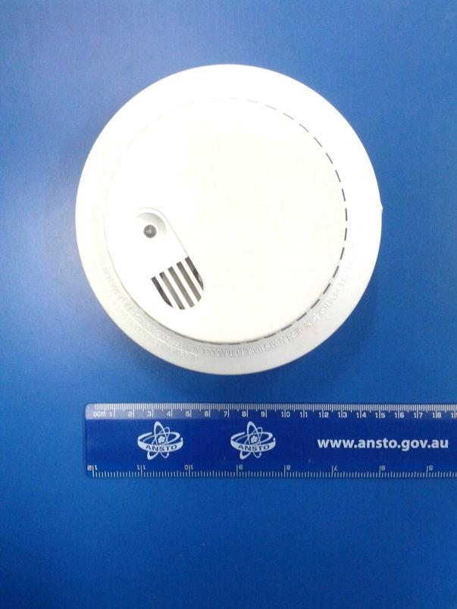

**Smoke detector:** These contain a small amount of radioactive Americium-241. Ionised gas particles formed near the radioactive source complete the electric circuit in the device. If smoke particles interrupt the electrical circuit, then the alarm sounds.

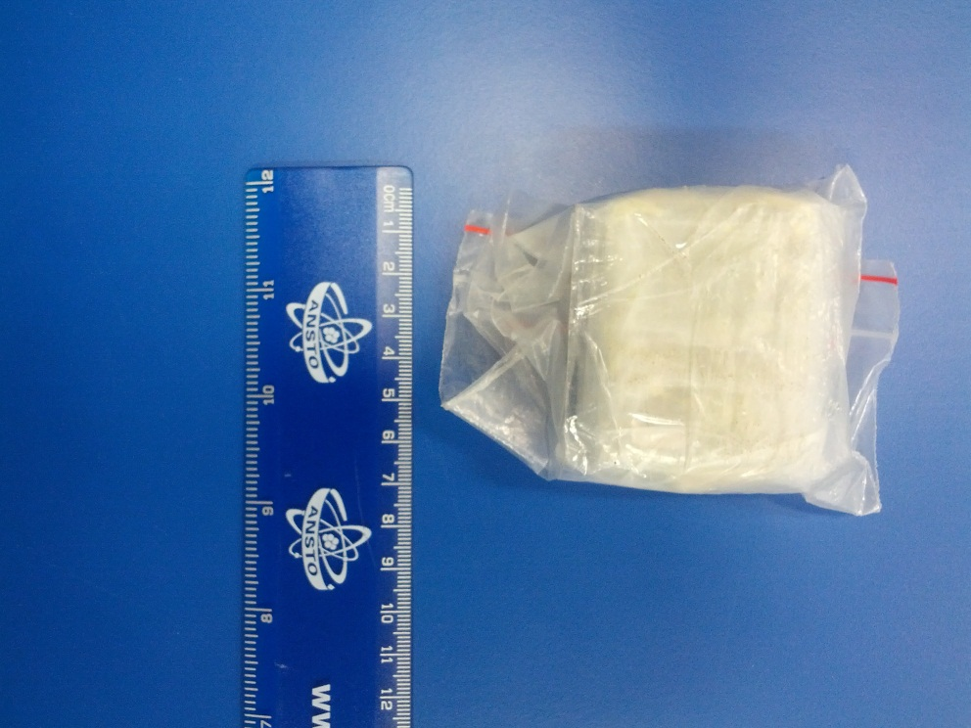

**Uranium ore (Autunite):** Uranium is a weakly radioactive element naturally found in rocks and minerals in the earth’s crust.

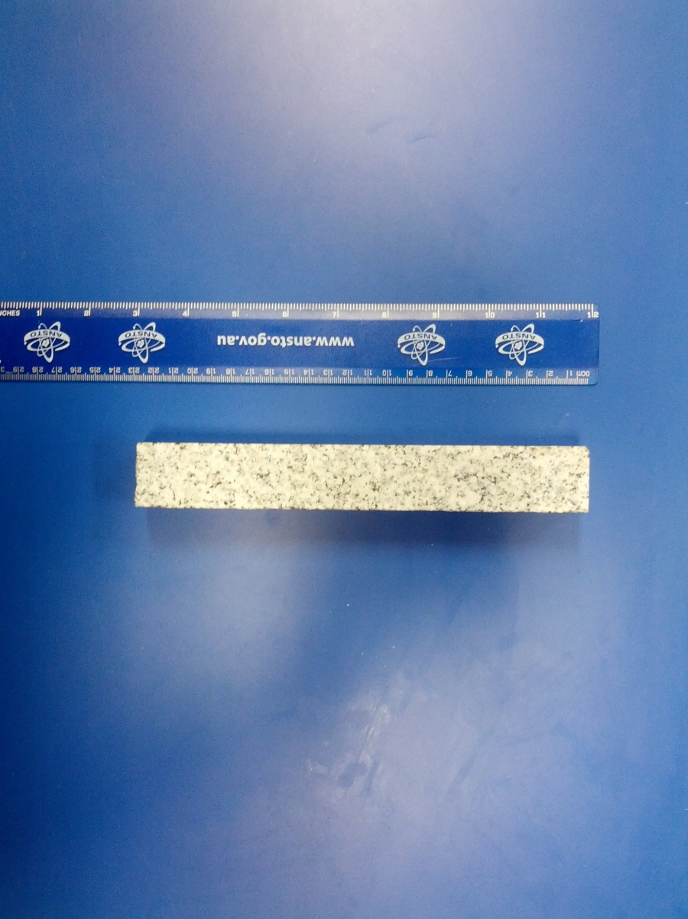

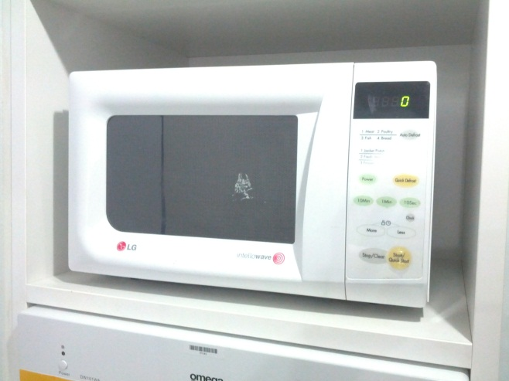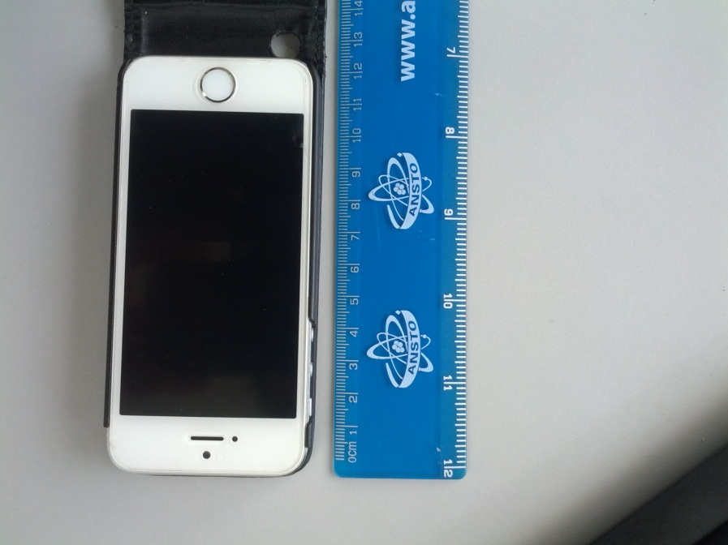

**Microwave oven:** Microwave ovens heat your food using microwave radiation. But are they radioactive?

**Mobile phone:** Mobile phones use electromagnetic radiation in the microwave range. But are they radioactive?

**Granite:** Granite naturally contains varying amounts of radioactive uranium and thorium.

**Radiation shielding**

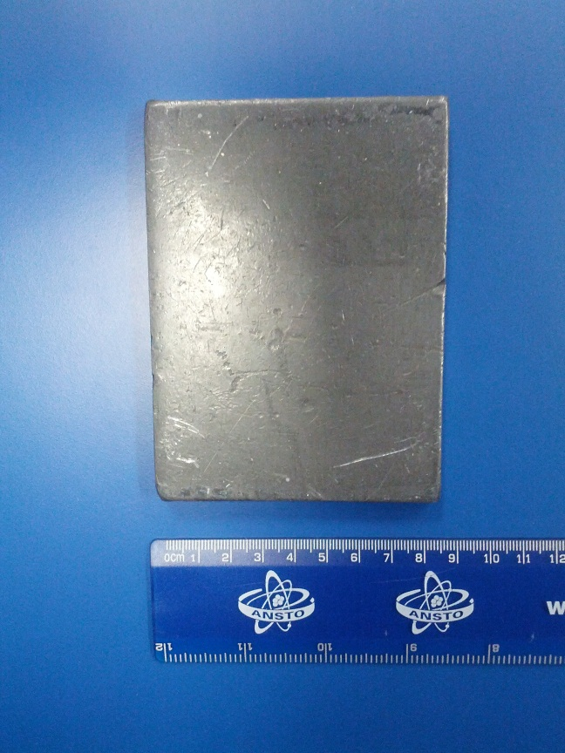

**Lead sheet:** This sheet of lead is about 7 mm thick

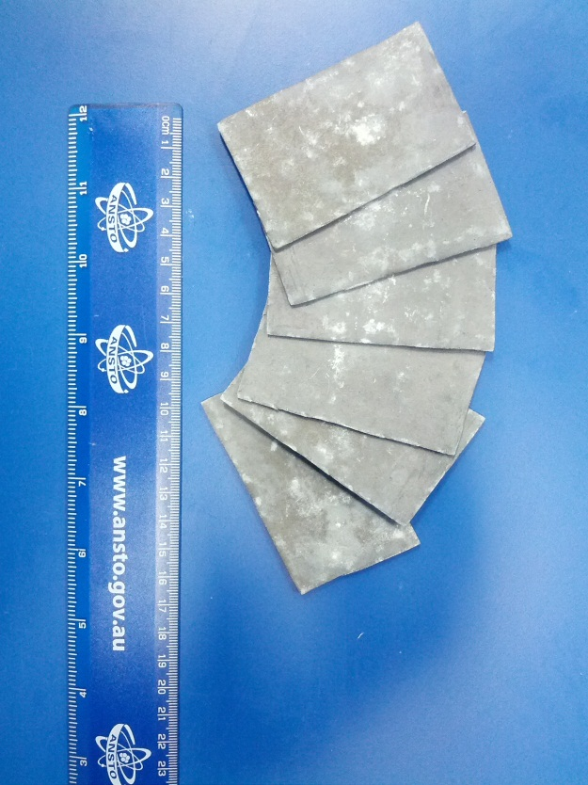

**Lead sheets:** There are 6 sheets of lead, each 1.5 mm thick

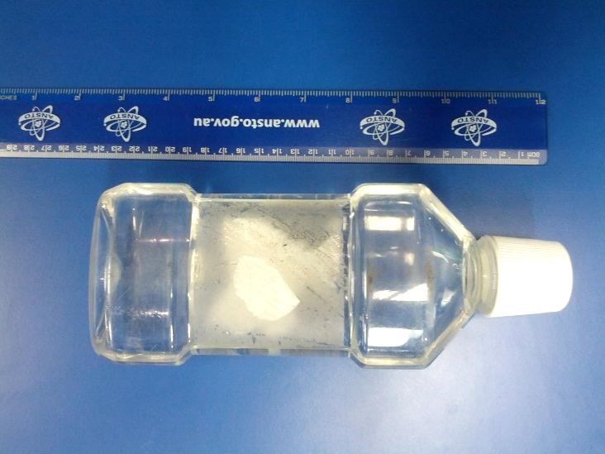

**Water-filled zip-lock bag:** We can fill a plastic bag with water up to 1 cm thick

**Aluminium foil:** We can fold aluminium foil to make a sheet up to 1 cm thick

**Paper:** A4 sheets of white paper. We can make a pile of paper up to 1 cm thick

**Plastic bottle of water:** This bottle is filled with tap water. It is 3.5 cm thick.