2021 Shorebirds Competition Accompanying Unit
Years 5-6 Geography
This unit of work has been prepared to develop student learning and understanding of migratory shorebirds and their wetland habitats in Australia, and support participation in the 2021 ANSTO Shorebirds Competition. In this unit, students will study migratory shorebirds and their habitats to support their investigation of how people change and influence the natural environment in Australia. The unit incorporates themes of diversity across Asia and global connections as students compare environmental areas and conservation activities on the migratory route of shorebirds through Asia.
The unit is based on one 50 minute geography lesson per week, however activities can be adapted to suit individual class requirements.
Additional information and resources for teachers have been included at the end of the lesson outlines.
Strand | Sub-strand | Content Description | Lesson
Inquiry and Skills | Researching | Organise and represent data in a range of formats including tables, graphs and large- and small-scale maps, using discipline-appropriate conventions (ACHASSI096) | 2, 3, 4
 |  | Locate and collect relevant information and data from primary sources and secondary sources (ACHASSI095) | 2, 3, 4, 5, 6
 | Evaluating and reflecting | Evaluate evidence to draw conclusions (ACHASSI101) | 4, 5, 6, 7, 8
 |  | Reflect on learning to propose personal and/or collective action in response to an issue or challenge, and predict the probable effects (ACHASSI104) | 7, 8
 |  | Present ideas, findings, viewpoints and conclusions in a range of texts and modes that incorporate source materials, digital and non-digital representations and discipline-specific terms and conventions (ACHASSI105) | 6, 8
Knowledge and Understanding | Geography | The environmental and human influences on the location and characteristics of a place and the management of spaces within them (ACHASSK113) | 3, 4, 5, 7, 8
 |  | Australia’s connections with other countries and how these change people and places (ACHASSK141) | 3, 5, 6
 |  | The geographical diversity of the Asia region and the location of its major countries in relation to Australia (ACHASSK138) | 2, 3, 4, 5

Cross-curriculum Priorities and General Capabilities
- Sustainability  - Civics and citizenship | - Critical and creative thinking  - Ethical understanding | - Literacy

Suggested Learning and Teaching Sequence
Lesson | Activity |  | Resources
1 | Introduction to Migratory Shorebirds  What is migration?  What animals can you think of that migrate?  What do you know about birds that migrate?  Migration comes with a lot of risks (eg. use of energy, predators, and weather conditions). What are the upsides for these animals?  We are going to learn about some amazing birds that can fly over 11, 000 km straight! Some of these birds travel the distance from Earth to the moon and back in their lifetimes. One shorebird, the bar-tailed godwit, holds the world record for the longest non-stop flight ever recorded for any bird species!  Pack your Bags activity  In groups, make a list of everything you/your family do to prepare for a long trip away somewhere.  Students share responses and these are noted on table on the board.  As a class, discuss similar ways migratory birds might prepare before a long flight (ie – pack your bag with correct clothing = change in feathers; pack food = feed and store extra weight; pack a map = use instinctive navigational route [East Asian-Australasian Flyway]; get your family together = migratory birds travel together at the same time and take turns leading the flock; sleep well the night before= rest before flight).  Complete Activity Sheet 1 with students, labelling the essential things a shorebird does to help prepare for a long flight. |  | See Teacher Resources for background reading  Activity Sheet 1  View the link in teacher resources for a live map of shorebird migrations along the East Asian-Australasian Flyway.
2 | First reading: Circle by Jeannie Baker. Read text to class, giving students time to view the illustrations.  In small groups, have students re-tell the story of the bar-tailed godwits life to each other.  Explain the migration route of the godwits is called the East Asian-Australasian Flyway.  Using internet research or materials provided by the teacher, students create a migration map to illustrate this route. Annotate the map appropriately with months of the year, specific examples of locations the birds stop and what the birds do at each of the locations. (Note – a godwit migration map is included at the end of the text, Circle). |  | Circle by Jeannie Baker  Alternative picture books:  Windcatcher: Migration of the Short-tailed Shearwater by Diane Jackson Hill and Craig Smith  Red Knot by Nancy Carol Willis  Map provided by teacher
3 | What are Wetlands?  Many migratory shorebirds rely on healthy wetlands for their survival. View the video “Australia's amazing wetlands, World Wetlands Day 2012”.  Mind Map  Students create a mind map using Activity Sheet 2. They should consider: What are wetlands? What are the benefits of wetlands? What types of animals do wetlands support? Why should we conserve wetlands?  Provide students with a 5 minute internet research challenge to explain what the Ramsar Convention is and when it commenced? |  | “Australia's amazing wetlands, World Wetlands Day 2012” https://www.youtube.com/watch?v=eotxzebGLQw  Activity Sheet 2
4 | How are people changing the natural environment of wetlands in the Yellow Sea of South East Asia?  Ask students to consider this during a second reading of Circle.  As a class, discuss how the text implies that changes have occurred to the Yellow Sea where the bar-tailed godwits stop on their migratory journey. What impacts might this have on shorebirds?  Show students how to navigate the Ramsar Sites Information Service website (rsis.ramsar.org). Zoom in to the Ramsar sites located within the Yellow Sea. Students select one site from this region to explore further and record information on Activity Sheet 3.  Bring students together to share their findings. |  | Circle by Jeannie Baker  RSIS website – information for students can be found in the Overview and Download materials for each site.  Activity Sheet 3
5 | How are people changing the natural environment of wetlands in Australia?  Recall some of the findings from the previous lesson regarding the Ramsar sites in the Yellow Sea. In this lesson, students will compare the threats and management of these sites to a Ramsar site in Australia.  Select a Ramsar wetland area that is closest to your school community* using the list provided at Australia's Ramsar Sites (environment.gov.au)  Direct students to research how people have changed the natural environment of this area (e.g. note building development in surrounding areas, possible sources of pollution, uses by the community, changes in ecosystem due to the introduction of other species etc.). Students complete Activity Sheet 4.  Students share their findings and make comparisons with the Yellow Sea sites from the previous lesson. |  | *Or a Ramsar wetland in your State or Territory.  Map of wetland area (teacher to source)  Activity Sheet 4
6 | Shorebird Migrations – A Global Event  World Migratory Bird Day is held on the second Saturday in May and in October each year to celebrate and raise awareness of the importance of conserving environments visited by migratory birds at a local, regional and global level. The theme of World Migratory Bird Day in 2020 was “Birds Connect our World”. View the video issued to commemorate this:  [EAAFP] World Migratory Bird Day 2020 (Eng) - YouTube  Guide students to the East Asian - Australasian Flyway Partnership website for more information: https://www.eaaflyway.net/activities/world-migratory-bird-day-2020/  Working in small groups, students plan an activity to celebrate Word Migratory Bird Day this year. The activity could be for just one location, or it could involve many places in the world joining together. Students prepare their idea and present to the class.
7 | Eco-tourism Poster (assessment task)  Conservation of wetlands are vital to the survival of many creatures, including migratory shorebirds. Students consider how they could effectively communicate this message by planning and creating an eco-tourism poster of a local wetland (or Ramsar site in their State or Territory). Posters may then be considered for entry in the ANSTO 2021 Shorebirds Competition (please refer to competition guide for further information). |  | Refer to ANSTO website for competition details.
8 | Continue previous lesson.
Assessing student learning
Formative |  | Monitor students’ developing understanding throughout the unit.
Summative |  | Assessment task: Considering the ways people change and influence places and the environment, students investigate a local wetland area and create an eco-tourism poster to effectively communicate messages of conservation. By incorporating a migratory shorebird in their poster, students will be able to demonstrate how a local environmental area supports global connections.

Additional activities for other Key Learning Areas:
English | A student communicates effectively for a variety of audiences and purposes using increasingly challenging topics, ideas, issues and language forms and features EN3-1A | Write an information report on a shorebird of own choice.  Write a persuasive letter to your local council to help the shorebirds or your local wetland area.  Write a newspaper report to inform local residents of their role in protecting these birds.  Create a poem about your favourite shorebird.
Mathematics | A student:  - locates and describes position on maps using a grid-reference system MA3-17MG  - uses appropriate methods to collect data and constructs, interprets and evaluates data displays, including dot plots, line graphs and two-way tables MA3-18SP | Create a map with the navigational route of a shorebird outlined (e.g. the East Asian-Australian Flyway). Describe the route using landmarks and directional language.  Visit a local park or wetland area and collect data on birds sighted (use a bird ID program to help http://www.birdsinbackyards.net/finder). Record data in appropriate table and graphs using digital technologies.
Science | A student examines how the environment affects the growth, survival and adaptation of living things ST3-4LW-S | Adaptation of living things: students study the different shapes of a variety of shorebird bills (beaks) and why they are considered to be adaptations. Draw diagrams of the bills and annotate.

Resources for Teachers
Information on migratory shorebird species that visit Australia https://wingthreads.com/about/
Video made by a shorebird enthusiast regarding shorebirds in southern Sydney Birdlife Southern Presentation Port Hacking Shorebirds
Wetlands and Migratory Shorebirds fact sheet https://www.environment.gov.au/system/files/resources/fd288ccf-ba11-468b-ac36-3f871ea8cbe7/files/factsheet-wetlands-migratory-shorebirds.pdf
Migratory shore birds information https://www.youtube.com/watch?v=fSRrDlrB26w
Live map displaying locations of tagged migratory shorebirds Map -> East Asian, Australasian flyway (globalflywaynetwork.org)
ABC News article regarding some of the threats faced by shorebirds https://www.abc.net.au/news/2016-06-17/flying-for-your-life-ann-jones/7459288
Ramsar Sites Information Service https://rsis.ramsar.org/
Bird ID http://www.birdsinbackyards.net/finder
Citizen science project: Aussie Backyard Bird Count 19-25 October https://aussiebirdcount.org.au/
Shorebird ID sheets and monitoring citizen science projects https://birdlife.org.au

Activity Sheet 1 – How do Shorebirds prepare for a long flight?

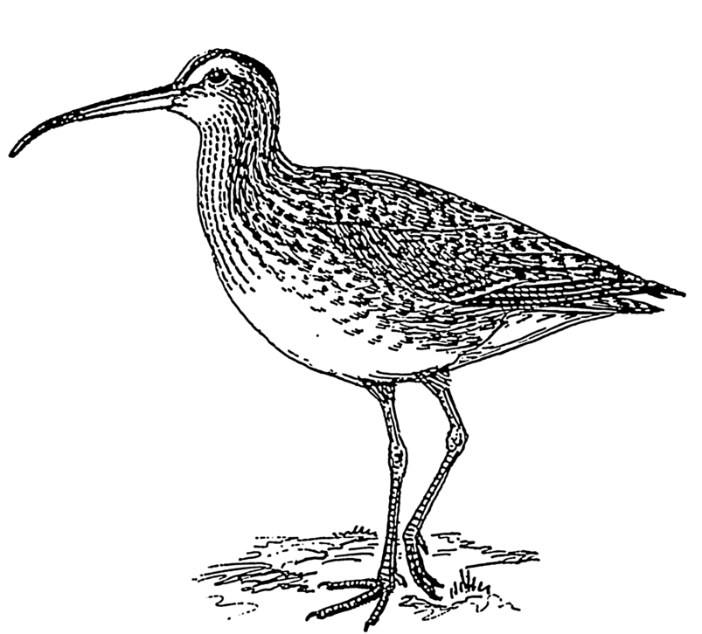

Image: https://commons.wikimedia.org/wiki/File:Curlew_(PSF).png
Activity Sheet 2 – Mind Map

Wetlands

What is the Ramsar Convention and when did it commence?

Why is it important?

Activity Sheet 3 – Ramsar Sites in the Yellow Sea
Name of Ramsar site: _______________________________________________
What country is this site located in? Draw a simple map of the Yellow Sea and label its location. | What kind of environment is located at this site?
 | Provide information about the number and/or types of shorebirds that use this site as a stopover.
What are some of the threats to this site? | How could people protect this environment further?
Activity Sheet 4 – Australian Ramsar Site Case Study
Name of Ramsar site: _______________________________________________
Where is this site located in? Draw a simple map of the site and its surrounding area. | What kind of environment is located at this site?
 | Provide information about the number and/or types of shorebirds that use this site as a feeding ground.
What are some of the threats to this site? | How could people protect this environment further?

