Senior Physics/Year 12 Physics
Videoconference workbook

The videoconference addresses the following syllabus content:

Unit 1: Thermal, nuclear and electrical physics, specifically the section ‘Ionising radiation and nuclear reactions’

Module 8: From the Universe to the Atom of the NSW Physics Stage 6 Syllabus for the Australian Curriculum, specifically the section ‘Properties of the Nucleus’, Inquiry question: How can the energy of the atomic nucleus be harnessed?

During the videoconference, students will:
- Investigate the properties of the three main types of radiation (alpha, beta and gamma)
- Collect data during a demonstration of a radiation experiment, using low level radioactive sources and radiation detection equipment.
- Observe background radiation in our cloud chamber
- Understand how half-life of a radioisotope is determined experimentally
- Understand the operation and uses of OPAL (Open Pool Australian Lightwater) Research Reactor
- Explore a model of the process of nuclear fission
- Examine the interconnectedness of the concepts of the law of conservation of energy, mass defect, binding energy and Einstein’s mass–energy equivalence relationship 𝐸 = 𝑚𝑐², and the application of these concepts to nuclear fission and nuclear fusion
- Understand the operation of ANSTO’s tandem particle accelerators and their uses

During your videoconference your Education Officer will provide students with information from which they will be required to select and process the appropriate material to complete the activities and answer the questions.

Students will also need further time after the presentation to complete some of the activities.

Investigating the properties of alpha, beta and gamma radiation
View the demonstration and record the radioactivity measured by the scintillation counter in each of the following situations.

Source | Radioactivity (counts per second)
 | No cover | Paper | Aluminium | Lead
A
B
C

Use the data you have recorded to identify the type of radiation produced by each source. Justify your choice.

Source | Type of radiation | Justification: Why do you think it is this radiation?
A
B
C

Give a reason why the radioactivity of the gamma source decreases slightly when the 1 mm thick piece of paper is placed over this source.
…………………………………………………………………………………………………………………………………………………………………………………………………………………………………………………………………………………………………………………………

Investigating radiation
The Education Officer will demonstrate how the radiation count changes with distance from a source.
Record the data in the table below.

Use the data to sketch a curve on the grid below to show how the radiation count changes with distance from a source.

Detecting Radiation - Cloud Chamber

A cloud chamber allows us to see the effect of different nuclear radiation. Radioactive particles move through the cold supersaturated alcohol vapour in the cloud chamber and strip electrons from surrounding atoms in the air. The alcohol vapour then condenses on the charged particles, leaving a trail of droplets along the path. These tracks disappear almost immediately.
The Education Officer will give you information about the different types of nuclear radiation and the tracks that they leave.

- Name two particles whose tracks have been identified.
- Draw an example track for each of these particles
- Explain the type of track left by the particle in terms of the properties of the particle.

Particle name | Track diagram | Explanation of track

- The cloud chamber also shows muon tracks. Muons are leptons, a type of fundamental particle in the Standard Model of matter.
Muons have a charge equal to that of an electron, but they are about 200 times heavier. They have a half-life of 2.2 microseconds (µs).
They are produced in the upper atmosphere, about 15 km above the surface of Earth, and travel at 0.99C (that is, at 2.99 x10⁸ ms⁻¹).

Using the equation $speed =\frac{distance }{time}$ we can determine the time it should take them to reach the Earth’s surface travelling at this speed:

$$time = \frac{15 000 m}{2.99 x{10}^{8} {ms}^{-1}} =0.00005016…=50 microseconds$$

This is approximately 20 times their average half-life! Hence, fewer than 10⁻⁶ should reach the Earth’s surface.

However, we can usually detect some muons in our cloud chamber.

Suggest a plausible explanation for their appearance on Earth.
…………………………………………………………………………………………………………………………………………………………………………………………………………………………………………………………………………………………………………………………
…………………………………………………………………………………………………………………………………………………………………………………………………………………………………………………………………………………………………………………………
Radioactive Decay
The radioactive decay of technetium-99m
time  (hours) | activity (counts per second, cps)
0 | 1250
0.25 | 1215
0.5 | 1180
0.75 | 1146
1 | 1114
2 | 992
4 | 788
24 | 78

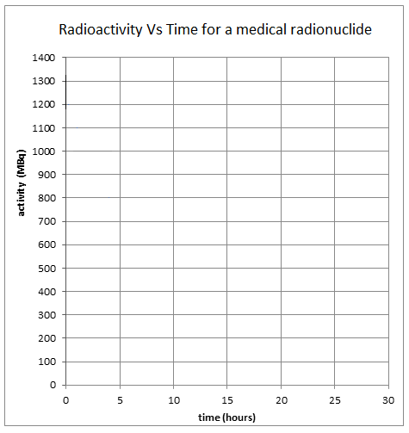

Using your graph determine the half-life of technetium-99m ……………………………………………….

Radioactive Decay Law
The following equation, known as the radioactive decay law, allows you to quantitatively predict the amount of a radioactive sample that still remains and has not yet decayed after a time t, where
N_{t} = number of radioactive nuclei present at time t, and N₀ = the initial number of radioactive nuclei present (that is, at t = 0)
N_{t} = N₀e^{-λt}
The number of radioactive nuclei present at time t (N_{t}) is proportional to the level of radioactivity of the source. Hence the radioactive decay law can also be represented by
A_{t} = A₀e^{-λt}
where λ = ln(2)
t_{1/2}
where A_{t} = the activity of the sample at time t,
A₀ = the initial activity of the sample that is the activity at t = 0,
λ = decay constant,
t_{1/2} = time for half the radioactive amount to decay,
ln 2 (the natural log of 2) equals 0.693.

For the radionuclide technetium-99m, use the table on the previous page to state the activity (A_{t}) after the number of stated hours in the table below to calculate the half-life of the technetium-99m.

Number of hours (x) | Initial activity  (A_{o}) | Activity after x hours (A_{t}) | calculated half life
1
4

Compare the values of the half-life determined for each of the number of hours. Comment on the accuracy of the values.

…………………………………………………………………………………………………………………………………………………………………………………………………………………………………………………………………………………………………………………………

How might a more accurate value be determined?

………………………………………………………………………………………………………………………………………………………………………………………………………………………………………………………………………………………………………………………….
…………………………………………………………………………………………………………………………………………………………………………………………………………………………………………………………………………………………………………………………

OPAL research reactor

Label the diagram and complete the table below:

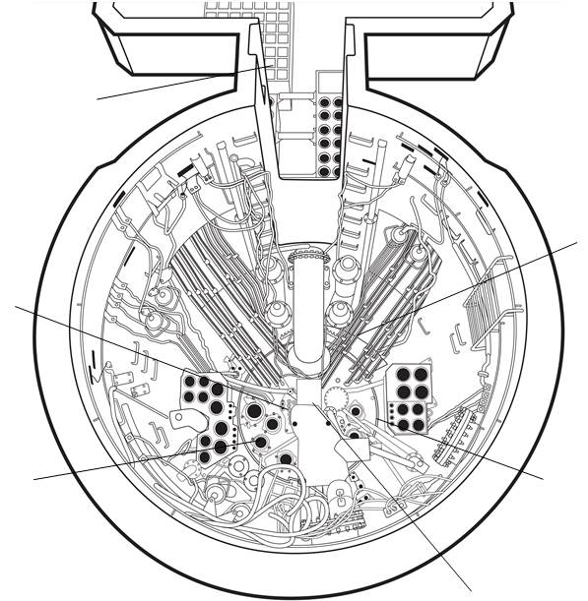

Material | Reactor component | Function
Heavy water
made with deuterium $({}_{1}^{2}{H)}$
Hafnium
encased in stainless steel
Light water
made with hydrogen $({}_{1}^{1}{H)}$
Uranium
enriched with 19.75 % U-235

Modelling Fission

During the presentation you will view an animation of the fission process. This animation can also be found at a video - OPAL research reactor animation - YouTube (from 0.45 – 1.21)
View the animation to answer the questions below:

- What does this model show about fission?
…………………………………………………………………………………………………………………………………………………………………………………………………………………………………………………………………………………………………………………………
…………………………………………………………………………………………………………………………………………………………….
- Identify any deficiencies in this model.
…………………………………………………………………………………………………………………………………………………………………………………………………………………………………………………………………………………………………………………………
…………………………………………………………………………………………………………………………………………………………….
- Does it simulate a controlled or uncontrolled fission reaction?
…………………………………………………………………………………………………………………………………………………………….
- Describe how fission reactions are controlled in fission reactors.
…………………………………………………………………………………………………………………………………………………………………………………………………………………………………………………………………………………………………………………………
…………………………………………………………………………………………………………………………………………………………….
- How is the fission process started for the very first time in a reactor (or after it has been shut down for many months)?
…………………………………………………………………………………………………………………………………………………………………………………………………………………………………………………………………………………………………………………………
…………………………………………………………………………………………………………………………………………………………….
- Account for the release of energy in the fission process.
…………………………………………………………………………………………………………………………………………………………………………………………………………………………………………………………………………………………………………………………
…………………………………………………………………………………………………………………………………………………………….

Centre for Accelerator Science

- a) Choose from the following list to label the parts of the tandem accelerator
shown in the diagram below.
positive high voltage terminal, steel pressure tank, pelletron charging chain, evacuated accelerator beam tube, stripping chamber, equipotential rings, magnet.
- Indicate the flow direction and charge of the ions on the diagram.

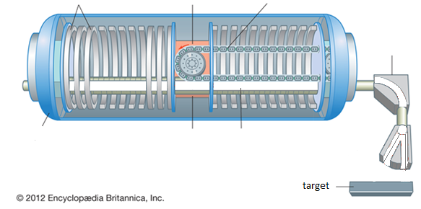

In the tandem accelerator, what is the purpose of each of the following:

electric field
magnetic field

- Describe one use of ANSTO linear particle accelerators.

………………………………………………………………………………………………………………………………………………………………………………………………………………………………………………………………………………………………………………………………………………………………………………………………………………………………………………………………………
………………………………………………………………………………………………………………………………………………………………………………………………………………………………………………………………………………………………………………………………………………………………………………………………………………………………………………………………………

Nuclear Fission and Fusion

The Education Officer will discuss the process of nuclear fission and nuclear fusion, and mass defect accounting for release of energy in each process, as well as a discussion of binding energy and its importance in terms of nuclear fission and nuclear fusion (mass defect/Einstein’s equation/binding energy)

Source: 2014 HSC Physics Exam, New South Wales Education Authority.

Explain what is meant by the terms mass defect and binding energy.
Using the diagram above, explain the release of energy during nuclear fission and nuclear fusion. In your answer refer to mass defect and binding energy.

………………………………………………………………………………………………………………………………………………………………………………………………………………………………………………………………………………………………………………………………………………………………………………………………………………………………………………………………………………………
………………………………………………………………………………………………………………………………………………………………………………………………………………………………………………………………………………………………………………………………………………………………………………………………………………………………………………………………………………………
………………………………………………………………………………………………………………………………………………………………………………………………………………………………………………………………………………………………………………………………………………………………………………………………………………………………………………………………………………………
……………………………………………………………………………………………………………………………………………………………………………………………………………………………………………………………………………………………………………………………………………………………………………………………………………………………………………………………………………………….

Further Notes

Use the space below for any notes you wish to take down during the presentation and to record any question you may have. The Education Officer will allocate 10 minutes at the end of the presentation for questions.
………………………………………………………………………………………………………………………………………………………………………………………………………………………………………………………………………………………………………………………………………………………………………………………………………………………………………………………………………
………………………………………………………………………………………………………………………………………………………………………………………………………………………………………………………………………………………………………………………………………………………………………………………………………………………………………………………………………
………………………………………………………………………………………………………………………………………………………………………………………………………………………………………………………………………………………………………………………………………………………………………………………………………………………………………………………………………
………………………………………………………………………………………………………………………………………………………………………………………………………………………………………………………………………………………………………………………………………………………………………………………………………………………………………………………………………
………………………………………………………………………………………………………………………………………………………………………………………………………………………………………………………………………………………………………………………………………………………………………………………………………………………………………………………………………
………………………………………………………………………………………………………………………………………………………………………………………………………………………………………………………………………………………………………………………………………………………………………………………………………………………………………………………………………
………………………………………………………………………………………………………………………………………………………………………………………………………………………………………………………………………………………………………………………………………………………………………………………………………………………………………………………………………
………………………………………………………………………………………………………………………………………………………………………………………………………………………………………………………………………………………………………………………………………………………………………………………………………………………………………………………………………

Post Presentation Activities
Question 1: Nuclear Equations
The following table shows some information on the radioactive decay of several radioisotopes. Use the ANSTO periodic table of the elements (https://www.ansto.gov.au/education/resources/posters) to help you fill in the missing details

Radioactive parent isotope | Products of decay of parent nucleus
 | Daughter element | Symbol for radiation emitted
$$\begin{matrix}230 \\ 90\end{matrix}Th$$ |  | $$\begin{matrix}4 \\ 2\end{matrix}He$$
$$\begin{matrix}241 \\ 95\end{matrix}Am$$ |  | $$\begin{matrix}4 \\ 2\end{matrix}He$$
$$\begin{matrix}131 \\ 53\end{matrix}I$$ |  | $$\begin{matrix}0 \\ -1\end{matrix}e + \overline{v}$$
$$\begin{matrix}18 \\ 9\end{matrix}F$$ |  | $$\begin{matrix}0 \\ 1\end{matrix}e + v$$
$$\begin{matrix}14 \\ 6\end{matrix}C$$ | $$\begin{matrix}14 \\ 7\end{matrix}N$$
$$\begin{matrix}36 \\ 17\end{matrix}Cl$$ |  | $$\begin{matrix}0 \\ -1\end{matrix}e + \overline{v}$$

Question 2: Half life
The following equation allows you to quantitatively predict the remaining radioactivity of a sample using its half-life:
N_{t} = N₀e^{-λt}
λ = ln(2)/t_{1/2}
where N_{t} = number of particles at time t, N₀ = number of particles present at t = 0, λ = decay constant, t_{1/2} = time for half the radioactive amount to decay.

- The half-life of the isotope U-238 is 4.51 x 10⁹ years. The age of the Earth is estimated to be about 4.6 x 10⁹ years. Based on this, predict what proportion of this isotope of uranium would be found on Earth today compared to when the Earth first formed (N_{t}/N₀).

………………………………………………………………………………………………………………………………………………………………………………………………………………………………………………………………………………………………………………………………………………………………………………………………………………………………………………………………………
………………………………………………………………………………………………………………………………………………………………………………………………………………………………………………………………………………………………………………………………………………………………………………………………………………………………………………………………………

- Carbon-14 is a naturally occurring isotope of carbon that is radioactive. All living things absorb carbon from the environment while they are alive, and then stop taking it in when they die. By analysing the carbon found in ancient remains derived from once living things, the ratio of C-14 to other isotopes of carbon (C-12 or C-13) in the sample can reveal the age of an artefact up to 50,000 years old. Carbon-14 has a half-life of about 5,730 years.

An ancient wooden artefact from a human settlement contains about 12.5% of the C-14 that would be expected if it were alive in the environment today. Based on this result, calculate an approximate age for the ancient artefact.

………………………………………………………………………………………………………………………………………………………………………………………………………………………………………………………………………………………………………………………………………………………………………………………………………………………………………………………………………
………………………………………………………………………………………………………………………………………………………………………………………………………………………………………………………………………………………………………………………………………………………………………………………………………………………………………………………………………

Question 3: Mass defect and energy
- Nuclear fusion of hydrogen in the core of the Sun can be summarised by the following equation:
4$\begin{matrix}1 \\ 1\end{matrix}H→\begin{matrix}4 \\ 2\end{matrix}He+2\begin{matrix}0 \\ 1\end{matrix}$β$+2v$
The information below shows the mass of the various components in the equation. The masses are given in atomic mass units (u), where 1.0 u = 1.6605 x 10⁻²⁷ kg
Rest mass of proton (hydrogen nucleus) = 1.007267 u
Rest mass of helium nucleus = 4.001506 u
Rest mass of positron = 0.0005486 u
Rest mass of neutrino = ~ 0.0000 u

- Determine the mass of the reactants and the mass of the products, and then use them to calculate the amount of mass lost (mass defect) in this solar reaction.

………………………………………………………………………………………………………………………………………………………………………………………………………………………………………………………………………………………………………………………………………………………………………………………………………………………………………………………………………

- Using Einstein’s equation E=mc², calculate the energy in joules released from
this fusion reaction. (Note: The mass must be in kg before you use the equation.)

………………………………………………………………………………………………………………………………………………………………………………………………………………………………………………………………………………………………………………………………………………………………………………………………………………………………………………………………………

- The natural radioisotope, radium-226, undergoes a radioactive decay where it emits an alpha particle to become radon-222. The mass of the radium-226 nucleus is 226.0254 u and the α-particle has a mass of 4.001506 u. If the α-particle is ejected with a kinetic energy of 7.665 x 10⁻¹³ J, and you assume it receives all the energy produced by the decay, explain how the mass of the radon-222 nucleus could be determined and calculate a result in atomic mass units. Be sure to use masses in kg.

(Note: In the actual decay of a Ra-226 nucleus, the alpha particle does not really receive all the energy involved, because a gamma ray is also released).

………………………………………………………………………………………………………………………………………………………………………………………………………………………………………………………………………………………………………………………………………………………………………………………………………………………………………………………………………
………………………………………………………………………………………………………………………………………………………………………………………………………………………………………………………………………………………………………………

- Different fission fragments are produced during the fission of uranium-235. Fill in the blanks in the example fission equation below:

$$\begin{matrix}235 \\ 92\end{matrix}U+\begin{matrix}1 \\ 0\end{matrix}n→\begin{matrix}⎕ \\ 56\end{matrix}Ba+\begin{matrix}92 \\ 36\end{matrix}⎕+3\begin{matrix}1 \\ 0\end{matrix}n+γ+heat$$

- The fission of one uranium-235 nucleus yields an average energy of about 200MeV = 3.2 x 10⁻¹⁴J. Considering that 1.0kg of pure uranium-235 contains approximately 2.56 x 10²⁴ uranium atoms, calculate the total energy released if the nucleus of every atom in the 1.0kg of uranium undergoes fission.

………………………………………………………………………………………………………………………………………………………………………………………………………………………………………………………………………………………………………………………………………………………………………………………………………………………………………………………………………

