In Their Element
Online learning workbook

The videoconference addresses:

Components of Year 9 and 10 Chemical Sciences in the Australian Science Curriculum.
- Components of CW1 and CW2, Chemical World of the Stage 5 NSW Science Syllabus.

During the ANSTO videoconference
Students will:
- Review atomic structure (protons, neutrons and electron shells).
- View real samples of example elements, hear about their history, properties and uses.
- Learn how, in 1869, Dmitri Mendeleev used the properties of known elements to invent the periodic table that forms the basis of our modern periodic table, and even predicted the properties of as yet undiscovered elements.
- Listen to ANSTO scientists about careers in STEM and participate in a Q&A session.
- Understand that elements have a wide variety of uses, including in engineering, materials science, human health, industry and environmental science.
- Discuss the order of elements in today’s periodic table according to atomic number and electronic structure of an atom.
- Discuss the electronic structure of elements in the same period and same group.
- Discuss periodic trends, such as changes in types of elements across a period (metal/semi-metal/non-metal) and metallic character down a group.
- Play a game using the periodic table.

Pre-Videoconference Activities

We ask students to complete this pre-work prior to the videoconference. It consists of questions on concepts from junior years that are essential to an understanding of the science to be covered in the videoconference.

Activity 1: Structure of atoms

Everything in the universe is made up of atoms –air, water, rocks and soil, stars and you! The atom is the basic building block for all matter. There are around 94 different naturally occurring atoms and everything in the universe is made up of combinations of these 94 different atoms.

Atoms are very small. In fact 10 million atoms would fit in one millimetre on your ruler. And every atom is made up of even smaller parts called protons, neutrons and electrons. If you could see inside an atom, you would find mostly empty space. At the centre you would find an extremely small nucleus made up of the protons and neutrons, while the electrons orbit in the space around this nucleus. If the atom was the size of a football field the nucleus would be only a small grape at the centre!

Atoms are electrically neutral and have the same number of electrons orbiting the nucleus as there are protons within the nucleus. This is because electrons have a negative charge (-1), whereas protons have the opposite, a positive charge (+1). Neutrons have no charge, but they are able to interact with the protons and counterbalance the electric repulsion of the protons, helping to hold the nucleus together.

- Label the diagram of an atom with the following words:
electron nucleus proton neutron
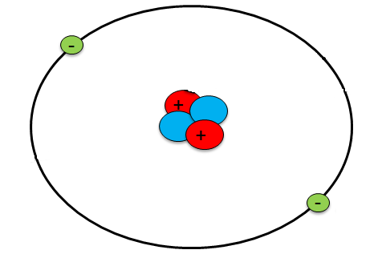
_______________
___________

____________

___________

electron

- Fill in the blanks with the following words: neutrons, nucleus, inside, protons, atoms, orbit, positive, electrons.
All matter is made of ____________. Atoms are composed of ____________, neutrons and electrons.
Protons have a ____________ charge and are found in the ____________ of an atom.
____________ have a negative charge and ____________ the nucleus.
____________ have no charge and are found ____________ the nucleus.

Activity 2: Elements and atomic number

Each element has its own unique atom with a specific number of protons. The number of protons determines the atomic number of the element, which is the number for the element in the periodic table.

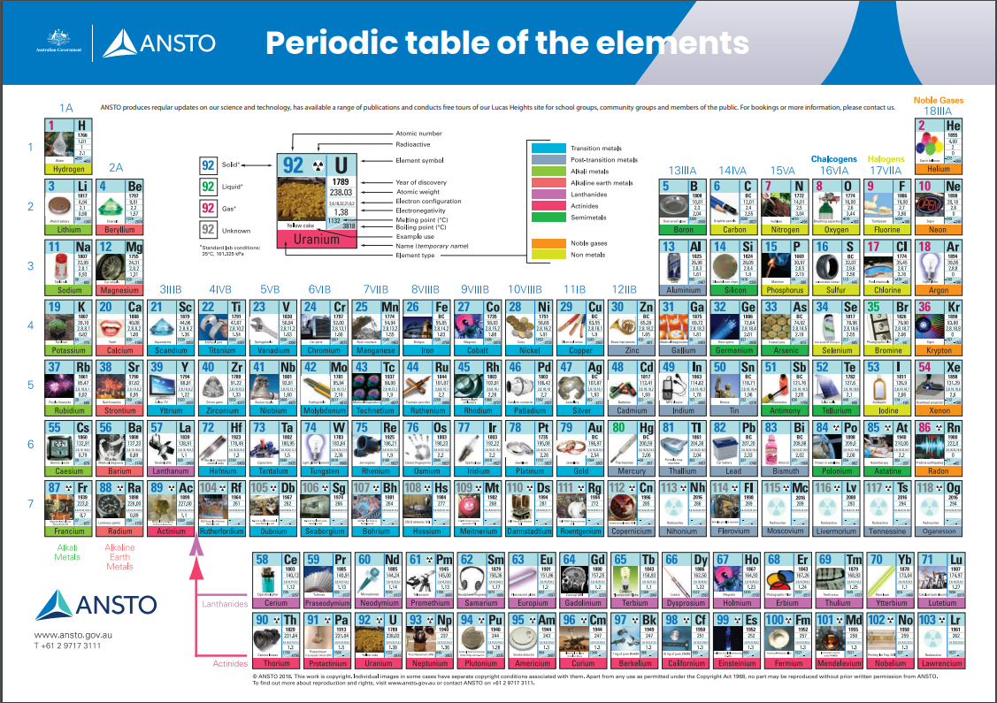

Elements in the periodic table are listed in order of increasing atomic number. The periodic table presents certain information about each element.
Atomic number: The number of protons in the nucleus
Element symbol: A one or two letter symbol unique to each element
8
O
Oxygen
16.00

Atomic mass: The sum of the number of protons and neutrons in the nucleus

- Refer to a periodic table to complete the table below. ANSTO has a periodic table online you can use: https://www.ansto.gov.au/education/resources/posters
Element | Element Symbol | Number of protons | Atomic mass (to the nearest whole number) | Number of neutrons
Hydrogen | H | 1 | 1 | 0
 | C | 6 |  | 6
Sodium |  | 11
 | K |  | 39
Argon |  |  | 40
 |  | 53

Activity 3: Electrons and electron shells

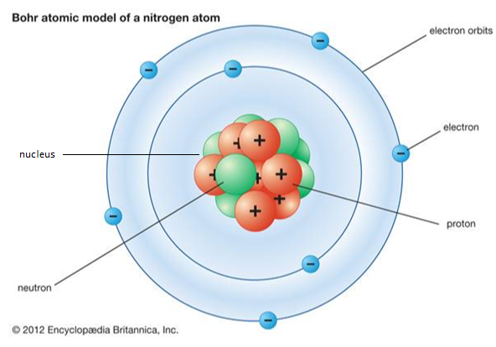
Elements in the periodic table are organised based on their atomic number but also their electronic structure. Electronic structure is the distribution of electrons in an atom. Niels Bohr developed a model of the atom in 1913 that describes electronic structure and this is still the most commonly used model of the atom today.
Bohr explained that the electrons travel in discrete shells, each with its own radius. Think of shells as a series of concentric spheres, each centred at the nucleus. Electrons travel around the surface of these spheres.

Only two electrons can fit in the first shell closest to the nucleus, the second shell can only hold eight electrons and the third shell can, for the first twenty elements, also only hold eight electrons. Ordinarily, the inner shells must be filled with electrons before an electron can occupy a space in any shell that is further out. For example, lithium has three electrons, so two electrons orbit in the first shell which is then full, and the third one orbits in the second shell.
- Complete the table below by stating the maximum number of electrons allowed in each of the electron shells of an atom for the first 18 elements.
Shell | first shell closest to the nucleus | second shell from the nucleus | third shell from the nucleus
maximum number of electrons allowed in this shell

- Draw protons, neutrons and electrons on the template below to make an oxygen atom, using the information on the previous page.

- Which element has electrons filling the first two shells, and none in the third shell?
……………………………………………………………………………………………………………………………

During-Videoconference Activities

Activity 1: Discovery of the elements and the early periodic table

You will see different element samples and hear about properties, uses and history of these elements.
- For THREE elements of your choosing, write down ONE interesting fact that you didn’t know before this online class

Element | Interesting fact

- Write these metals in order of reactivity, from least reactive to most reactive:
Iron, Magnesium, Copper, Gold, Lead.

- Describe how their reactivity is linked to their discovery and use by humans.

………………………………………………………………………………………………………………………………………………………

………………………………………………………………………………………………………………………………………………………

………………………………………………………………………………………………………………………………………………………

- Mendeleev left gaps in his periodic table for elements that had not been discovered yet in 1869. Name ONE element that Mendeleev predicted and at least ONE property of this element.

………………………………………………………………………………………………………………………………………………………

………………………………………………………………………………………………………………………………………………………

Activity 2: Today’s periodic table

Fill in the blanks using the word bank:
number poor non-metals period (row)
good group (column) metals decreases

- Elements in the periodic table occur in order of their atomic ________________ .

- Elements in the same ________________ have the same number of electron shells.

- Elements in the same ________________ have the same number of electrons in their outer shell.

- ________________ are usually shiny, ductile, malleable and ________________ conductors of heat and electricity.

- ________________ are usually dull, brittle and ________________ conductors of heat and electricity.

- Metallic character ________________ from left to right across a period.

Activity 3: Periodic table game

You’ll need a periodic table to play along. ANSTO has a periodic table online you can use: https://www.ansto.gov.au/education/resources/posters
- Element Who Am I?
Listen to the clues and check your periodic table to find out the answer. Once you have the answer, either raise your hand or type your answer into the chat box.
- ………………………………………..

- ………………………………………..

- ………………………………………..

- Rapid fire quiz: Use your recall of the first 20 elements, and your periodic table if you need it, to answer these five quick questions.

- ………………………………………..

- ………………………………………..

- ………………………………………..

- ………………………………………..

- ………………………………………..

Post-Videoconference Activities

Activity 1: Isotopes
You now know that each element has its own unique atom with a specific number of protons. The number of protons determines the atomic number of the element, which is the number for the element in the periodic table. Isotopes are atoms of the same element and thus have the same number of protons in the nucleus, but have a different number of neutrons, giving each isotope a different atomic mass.
The atomic mass is determined by the total number of protons and neutrons in a nucleus (protons and neutrons together are called nucleons). We use the atomic mass to identify the specific isotope. For example, the diagram on page 4 of this worksheet shows an atom of nitrogen-14. Nitrogen-15 is another isotope of nitrogen (N) which also has seven protons in its nucleus, and eight neutrons. The word isotope comes from the Greek, meaning “having the same place” in the Periodic Table.
- Complete the table below
Isotope | Element Symbol | Number of protons | Number of neutrons | Number of nucleons
Hydrogen-1 | H |  | 0 | 1
Lithium-5 |  | 3 | 2
Fluorine-18 | F | 9 |  | 18
Nitrogen-15 | N |  | 8
 | K |  |  | 40

- The free ANSTO XR app uses a mix of AR and VR to transport you to the scale of an atom and discover the world of protons, neutrons, and electrons.
- Download the ANSTO XR app from Google Play or the App store (https://www.ansto.gov.au/education/apps).
- Use the AR component of the app together with the ANSTO periodic table to bring the periodic table to life and find out more about isotopes used by or made at ANSTO.
- For an element of your choosing, complete the table below:
Element name
Element symbol
Key isotope
Number of neutrons in isotope
Fun fact about isotope

