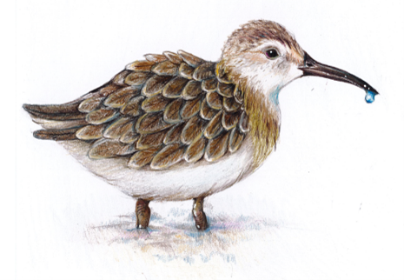
PROGRAM
Shorebirds and Wetlands: A lesson in Science and Sustainability
Teacher Professional Development Session
Wednesday 28 April 2021
Time | Details
4.00pm – 4.05pm | Official welcome and introduction.
 | Presenter: Dr Stephanie McCready, Community and Primary Education Manager, ANSTO
4.05pm – 4.20pm | Presentation 1: Shorebirds – What are they, why do they matter and their migration story
 | Presenter: Milly Formby, Migratory Shorebirds Program Officer (Newcastle Office) Birdlife Australia
4.20pm – 4.30pm | Presentation 2: Threats to Shorebirds at the local level
 | Presenter: Julie Keating, Citizen Scientist
4.30pm – 4.40pm | Presentation 3: Wetlands – Their ecology and importance
 | Presenter: Dr Debashish Mazumder, Senior Research Scientist, ANSTO
4.40pm – 4.50pm | Presentation 4: Linking wetlands and the Feathermap project
 | Presenter: Dr Kate Brandis, Senior Research Scientist, Centre for Ecosystem Science, UNSW
4.50pm – 5.00pm | Question and Answer Session
 | Chaired by: ANSTO.
5.00pm – 5.10pm | Refresh Break
5.10pm – 5.25pm | ANSTO Education Materials and Post TPD Work
Presenter: Janelle Townsend, Primary teacher and Education Officer at ANSTO
An introduction to the sample lessons and units of work developed by ANSTO. Instructions will also be given on the post TPD work needed to receive 5 NESA accredited hours.
5.25pm – 5.30pm | Evaluation and wrap up
 | Final questions and feedback

Speaker profiles:
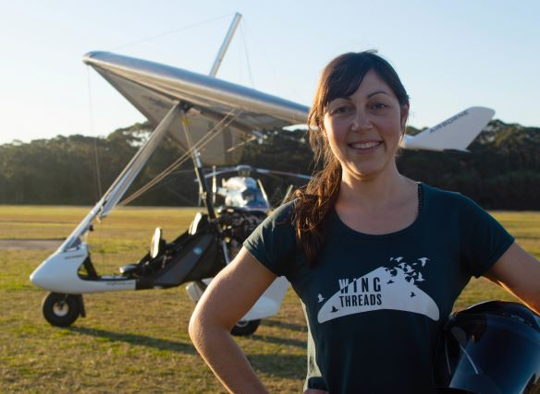 | Milly Formby, Migratory Shorebirds Program Officer (Birdlife Australia)  Milly joined BirdLife Australia in 2019 and is based in Newcastle, NSW. She was awarded her Masters in Zoology from the University of Melbourne in 2014 and is an avid birdwatcher and bird bander. Milly also holds a Bachelor of Visual Arts and is the co-author and illustrator of the non-fiction children’s book Shorebirds Are Awesome, due to be published by CSIRO Publishing in 2022 as part of her project, Wing Threads.  A Shorebird Flying Adventure is a non-fiction storybook to educate mid-primary age students about the importance of wetland ecosystems using migratory shorebirds as a model. Milly is planning to undertake her own shorebird flying adventure when she flies her microlight around Australia in 2022 to bring the book to schools and libraries all around Australia.
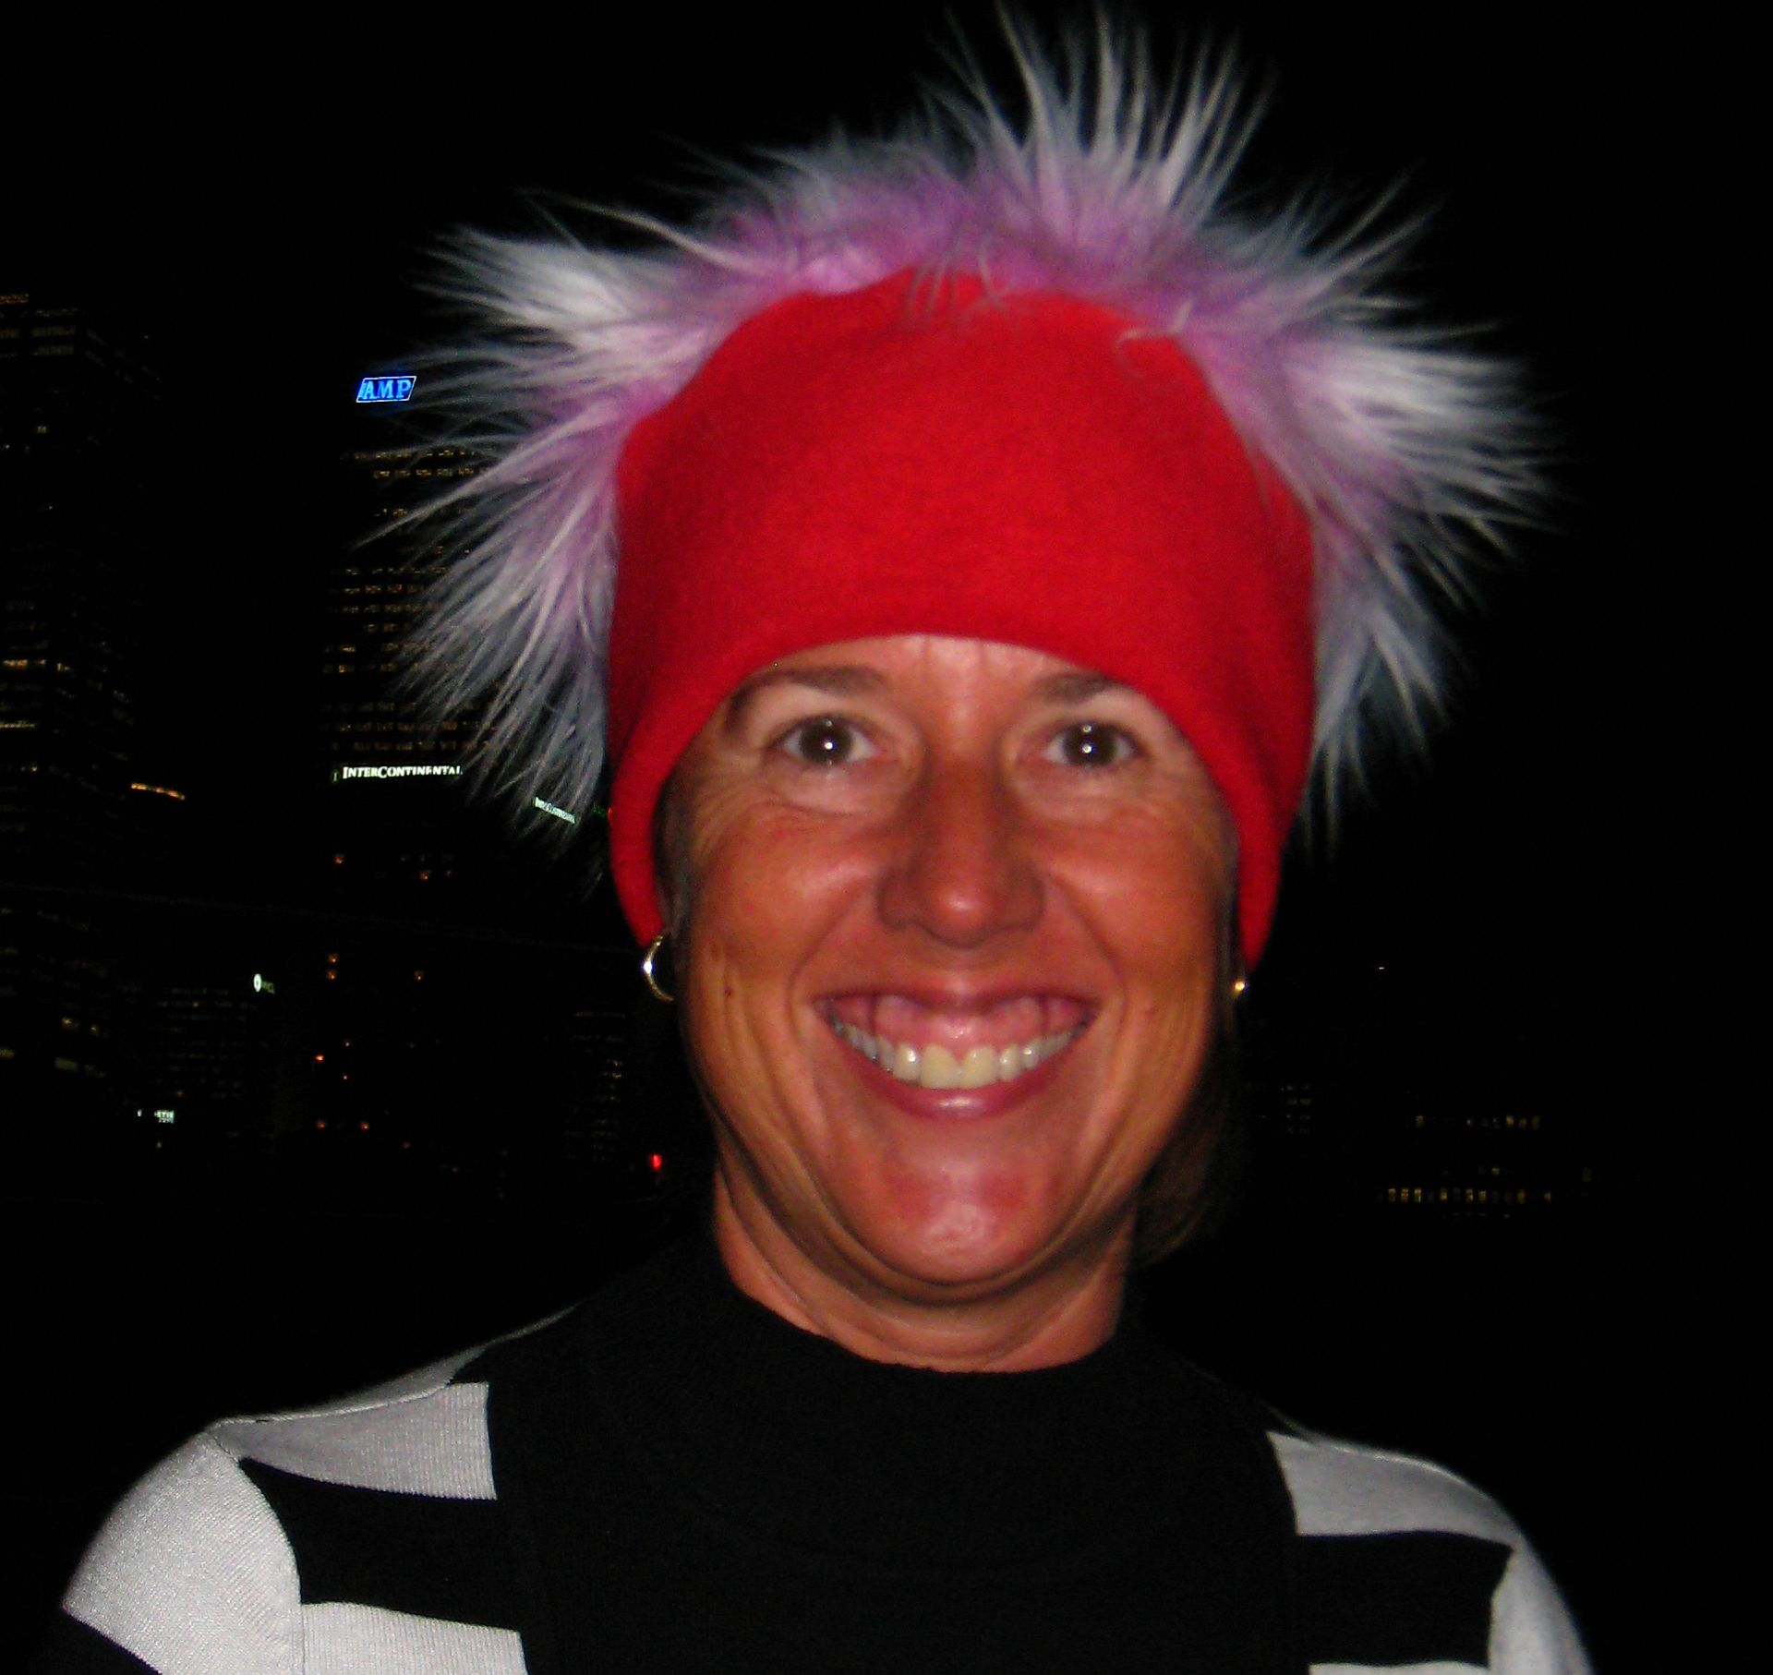 | Julie Keating, Citizen Scientist  Julie is a resident of Maianbar in southern Sydney, a non-breeding site for migratory shorebirds including Critically Endangered Eastern Curlews, Vulnerable Bar-Tailed Godwits, along with Endangered non-migratory Pied Oystercatchers, which use the local beaches as nesting sites. Located on Port Hacking, the mudflats of Deeban Spit provide a food source for the birds but they are also very popular with recreational boaters, dog walkers and fishers from southern Sydney, which means the birds are frequently disturbed and there is a clash of interests and needs. Julie has been very active in the community, engaging with the locals and Council on why protecting shorebirds is important. She has also been a presenter on the threat to shorebirds with the local Birdlife Australia Branch.
Dr Debashish Mazumder, Senior Research Scientist, ANSTO

Debashish leads the Aquatic Ecosystems and Food Provenance projects at ANSTO, where he uses isotopic and nuclear techniques to advance fisheries, aquaculture and wetlands research into the 21st century, providing contemporary solutions to a number of issues facing Australian industries and environments. His research offers insight into the structure, function and health of aquatic ecosystems. In 2019 he was part of a team that won the Eureka Award NSW Environment, Energy and Science (DPIE) prize for environmental research
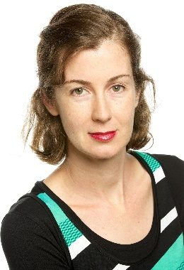 | Dr Kate Brandis, Senior Research Scientist, Centre for Ecosystem Science, UNSW  Kate is a freshwater ecologist and has worked in the wetlands of the Murray Darling Basin for the past 20 years studying waterbirds and water management to achieve the best possible outcomes for Australia's waterbirds. Her research informs government policy development and provides advice to state and federal governments for water management and delivery decisions. Kate has worked at UNSW for the past 15 years on a wide range of research topics including wetland mapping, tracking water flows, waterbird ecology, waterbird disease, tracking waterbird movements and nesting studies and she has collaborated with a wide range of people from universities, government agencies, CSIRO, ANSTO, IUCN and Taronga Zoo.
ANSTO Shorebirds Team:

Stephanie McCready, Community and Primary Education Manager, has a background in environmental science and has worked in the ANSTO Education Team for seven years. Stephanie is responsible for developing and running programs to engage primary students and is the creator of the ANSTO Shorebirds Competition.
Kim Whitbread, Education Officer, has a background as a secondary teacher and has worked in the ANSTO Education Team for twelve years. Kim supports the delivery of many educational programs at ANSTO and is passionate about shorebird conservation.
Janelle Townsend, Education Officer, has a background as a primary teacher and administrator. A recent member of the ANSTO Education Team, Janelle uses her primary expertise to assist the development of new education programs and professional development sessions for primary teachers
Thank you for participating in this TPD.
Please contact us if you require further information or support: competition@ansto.gov.au

